University of California, Santa Barbara

Lexical flexibility in discourse:

A quantitative corpus-based approach

A dissertation submitted in partial satisfaction of the requirements for the degree Doctor of Philosophy in Linguistics

by

Daniel W. Hieber

Committee in Charge: Professor Marianne Mithun, Chair

Professor Bernard Comrie Professor Stefan Th. Gries

Professor William Croft (University of New Mexico)

January 2021

The dissertation of Daniel W. Hieber is approved.

Bernard Comrie

Stefan Th. Gries

William Croft

Marianne Mithun, Committee Chair

January 2021

Lexical flexibility in discourse:

A quantitative corpus-based approach

Copyright © 2021 by

Daniel W. Hieber

Typeset using LATEX software and the Linux Libertine family of fonts.

Published under a Creative Commons Attribution 4.0 License (CC BY 4.0): <https://creativecommons.org/licenses/by/4.0/>

This thesis may be downloaded at: <https://files.danielhieber.com/publications/dissertation.pdf>

The source code, data, and accompanying scripts for this thesis are available on GitHub: <https://github.com/dwhieb/dissertation>

Dedication

## AcKnowledgments

Lorem ipsum dolor sit amet, consectetur adipisicing elit, sed do eiusmod tempor inci- didunt ut labore et dolore magna aliqua. Ut enim ad minim veniam, quis nostrud ex- ercitation ullamco laboris nisi ut aliquip ex ea commodo consequat. Duis aute irure dolor in reprehenderit in voluptate velit esse cillum dolore eu fugiat nulla pariatur. Ex- cepteur sint occaecat cupidatat non proident, sunt in culpa qui officia deserunt mollit anim id est laborum.

## CuRRiculum Vitae

Daniel W. Hieber

### **Education**

March 2021 Ph.D. in Linguistics, University of California, Santa Barbara March 2016 M.A. in Linguistics, University of California, Santa Barbara

June 2008 B.A. in Linguistics & Philosophy, The College of William & Mary (magna cum laude)

### **PRofessional ExpeRience**

2018–2019 Editor, Custom Language Products, Rosetta Stone

2015–2019 Teaching Assistant, Department of Linguistics, University of California, Santa Barbara

2014–2015 Research Assistant (under Prof. Carol Genetti), Department of Linguistics, University of California, Santa Barbara

2011–2013 Associate Researcher, Research Labs, Rosetta Stone 2008–2011 Editor, Endangered Languages Program, Rosetta Stone 2007–2008 Intern, Endangered Languages Program, Rosetta Stone 2006 Spanish Instructor, Nielsen Builders

2004–2006 Lab Assistant, Language Lab, The College of William & Mary 2003–2004 Latin Instructor, Bridgewater Home School Unit

### **Publications**

2023 Chitimacha. In Carmen Jany, Marianne Mithun, & Keren Rice (eds.),

*The languages and linguistics of indigenous North America: A*

*comprehensive guide* (The World of Linguistics 13). Mouton de Gruyter.

2023 Word classes. In Carmen Jany, Marianne Mithun, & Keren Rice (eds.),

*The languages and linguistics of indigenous North America: A*

*comprehensive guide* (The World of Linguistics 13). Mouton de Gruyter.

2019 The Chitimacha language: A history. In Nathalie Dajko & Shana Walton (eds.), *Languages in Louisiana: Community & culture* (America’s Third Coast Series). University Press of Mississippi.

2019 Semantic alignment in Chitimacha. *International Journal of American Linguistics* 85(3): 313–363. doi:[10.1086/703239](https://doi.org//10.1086/703239).

2018 Category genesis in Chitimacha: A constructional approach. In Kristel Van Goethem, Muriel Norde, Evie Coussé, & Gudrun Vanderbauwhede (eds.), *Category change from a constructional*

*perspective* (Constructional Approaches to Language 20), 15–46. John Benjamins. doi:[10.1075/cal.20.02hie](https://doi.org/10.1075/cal.20.02hie).

2016 *The cohesive function of prosody in Ékegusií (Kisii) narratives: A functional-typological approach*. M.A. thesis, University of California, Santa Barbara.

2013 On linguistics, language, and our times: A linguist’s narrative reviewed. *Linguistic Typology* 17(2): 291–321. Review article of *I am a linguist* by R. M. W. Dixon (Brill, 2010). doi:[10.13140/RG.2.2.13238.96329](https://doi.org/10.13140/RG.2.2.13238.96329).

2013 (with Sharon Hargus & Edward Vajda, eds.) *Working papers in*

*Athabaskan (Dene) languages 2012*. Alaska Native Language Center Working Papers 11. ANLC.

### **AwaRds**

2019 SSILA Best Student Presentation Award

2015 National Science Foundation (NSF) Graduate Student Research Fellowship (GRFP)

|  |  |
| --- | --- |
| 2015 | 2nd place, University of California Grad Slam |
| 2015 | Winner, University of California, Santa Barbara Grad Slam |
| 2013 | Chancellor’s Fellowship, University of California, Santa Barbara |
| 2006 | Boren Scholarship, National Security Education Program (NSEP) |

### **Fields of Study**

Major Fields: Linguistic Typology, Language Documentation & Description, Language Revitalization, Prosody, Discourse, Language Change, Language Contact, Digital Linguistics, Corpus Linguistics

Linguistic Typology with Professor Bernard Comrie & Professor Marianne Mithun

Language Documentation & Description with Professor Eric Campbell, Professor Carol Genetti, & Professor Marianne Mithun

Language Revitalization with Professor Carol Genetti

Prosody with Professor Carol Genetti, Professor Matthew Gordon, & Professor Marianne Mithun

Discourse with Professor Patricia Clancy, Professor John W. DuBois, Professor Carol Genetti, & Professor Marianne Mithun

Language Change with Professor Marianne Mithun

Language Contact with Professor Marianne Mithun

Digital Linguistics with Professor Eric Campbell & Professor Stefan Th. Gries

Corpus Linguistics with Professor Eric Campbell, Professor John W. DuBois, & Professor Stefan Th. Gries

## AbstRact

Lexical flexibility in discourse:

A quantitative corpus-based approach by

Daniel W. Hieber

This thesis is a quantitative corpus-based study of lexical flexibility in English (Indo- European) and Nuuchahnulth (Wakashan). *Lexical flexibility* is the capacity of lexical items to serve in more than one discourse function—reference, predication, or modification (or more traditionally, noun, verb, or adjective). In this thesis I develop a procedure and metric for quantifying the lexical flexibility of words in a corpus and apply that metric to English and Nuuchahnulth by analyzing the discourse function of nearly 400,000 tokens of English and nearly 9,000 tokens of Nuuchahnulth. I find that the two languages differ drastically in not only their degree of lexical flexibility, but the way in which that flexibility is realized. This study advances the discussion of lexical flexibility—as well as parts of speech more generally— by adding a new kind of empirical evidence to the discussion (quantitative corpus-based data), and in doing so provides answers to several longstanding and much-debated questions about how lexical categories operate in English and Nuuchahnulth.

The abstract should include 1) a brief statement of the problem; 2) a description of the methods and procedures used to gather data or study the problem; 3) a condensed sum- mary of the findings. The abstract should be double-spaced. The recommended length

is 1–2 pages. ([add Abstract](https://trello.com/c/DBE4nD65/26-abstract))

# **Table of Contents**

Acknowledgments v

Curriculum Vitae vi

Abstract ix

Table of Contents x

List of Figures xi

List of Tables xii

List of Abbreviations xiii

List of Languages xiv

Conventions xvii

1. **Introduction****1**
   1. The “problem” of lexical flexibility 1
   2. Previous research 9
   3. Overview of this study 14
2. **Background****25**
   1. Introduction: Approaches to lexical flexibility 25
   2. Traditional approaches 27
      1. Universalism 27
      2. Relativism 30
      3. Structuralism 31
   3. Flexible approaches 36
      1. Key concepts 37
         1. Lexical flexibility 38
         2. Polycategoriality 40
         3. Multifunctionality / Polyfunctionality 40
         4. Precategoriality / Acategoriality 42
         5. Monocategoriality 45
         6. Transcategoriality 45
         7. Conversion / Zero derivation 46
         8. Functional shift / Functional expansion 47
      2. Key findings 47
         1. Parts-of-speech hierarchy 48
         2. Reference-predication asymmetries 49
         3. Locus of categoriality 51
         4. Item-specificity 53
      3. Problems & critiques 56
         1. Methodological opportunism 57
         2. Semantic shift 58
         3. Lexical gaps 60
         4. Counterarguments 61
   4. Functional approaches 67
      1. Prototype theory 67
      2. Typological markedness theory 73
   5. Lexical flexibility: A functional definition 79
3. **Data & Methods****84**
   1. Introduction 84
   2. Data 86
   3. Methods 89
   4. Analysis 95
      1. Measuring lexical flexibility 95
      2. Flexibility and corpus size 97
      3. Frequency vs. dispersion 98
   5. Summary 101
4. **Results****103**
   1. Introduction 103
   2. Interpreting the results 104
   3. R1: Degree of lexical flexibility 111
   4. R2: Lexical flexibility and corpus size 118
   5. R3: Lexical flexibility and frequency / dispersion 123
   6. R4: The semantics of lexical flexibility 127
      1. English 128
      2. Nuuchahnulth 130
5. **Conclusion****137**

**Appendices**

1. **Early grammatical descriptions****139**
2. **100-item samples****141**
   1. English 141
   2. Nuuchahnulth 145
3. **Sample annotations****149**
   1. English 149
   2. Nuuchahnulth 150

**Backmatter**

**References****108**

**Language Index****125**

# **List of Figures**

* 1. Timeline of early grammatical descriptions of European vs. American languages 29
  2. Monocentric vs. polycentric categories 44
  3. Hengeveld’s (1992) typology of parts-of-speech systems 48
  4. Semantic map of English *run*70
  5. Crosslinguistic differences in the encoding of spatial relationships 71
  6. Typological prototypes for noun, verb, and adjective 77

3.1 The relation between word frequency and dispersion (DP) 99

* 1. Flexibility of English *difficult*105
  2. Flexibility of English *anything*106
  3. Flexibility of English *childhood*107
  4. Flexibility of Nuuchahnulth *ʔu·q* ‘good’ 108
  5. Flexibility using frequency vs. corpus dispersion for English *favorite*110
  6. Distribution of flexibility ratings for the 100-item samples of English and Nu- uchahnulth 112
  7. Distribution of flexibility ratings for the small corpus samples of English and Nuuchahnulth 113
  8. Distribution of functions for the 100-item samples of English and Nuuchahnulth 115
  9. Distribution of functions for the small corpus samples of English and Nu- uchahnulth 116
  10. Cumulative lexical flexibility for English (10 most frequent words) 119
  11. Cumulative lexical flexibility for Nuuchahnulth (10 most frequent words) 120
  12. Cumulative lexical flexibility for English (all words) 120
  13. Cumulative lexical flexibility for Nuuchahnulth (all words) 121
  14. Cumulative lexical flexibility for English (*log*10 scale) 121
  15. Cumulative mean flexibility for English 123
  16. Cumulative mean flexibility for Nuuchahnulth 123
  17. Interactions among frequency, dispersion, and flexibility for English vs. Nu- uchahnulth (heat map) 125
  18. Interactions among frequency, dispersion, and flexibility for English vs. Nu- uchahnulth (3D map) 126
  19. Interactions among frequency, dispersion, and flexibility for English vs. Nu- uchahnulth, with standard deviations (3D map) 126

# **List of Tables**

|  |  |  |
| --- | --- | --- |
| 1.1 | Types of conversion in English (Indo-European > Germanic) . . . . . . . . . . | 9 |
| 1.2 | Percentage of lexical items used as nouns, verbs, or both in Mundari (Aus- troasiatic > Munda) . . . . . . . . . . . . . . . . . . . . . . . . . . . . . . | 10 |
| 1.3 | Percentage of roots used as nouns, verbs, or both in Central Alaskan Yup’ik (Eskimo-Aleut > Yupik) . . . . . . . . . . . . . . . . . . . . . . . . . . . . | 11 |
| 1.4 | Distribution of functions of property words in English (Indo-European > Ger- manic) and Mandarin (Sino-Tibetan > Sinitic) . . . . . . . . . . . . . . . . | 12 |
| 2.1 | Distribution of English Verbs and Adjectives . . . . . . . . . . . . . . . . . . . | 32 |
| 2.2 | Distributional analysis of English (Indo-European > Germanic) temporal nouns | 33 |
| 2.3 | Distributional analysis of Russian (Indo-European > Slavic) numerals . . . . . | 34 |
| 2.4 | Distributional analysis of French (Indo-European > Romance) verbs . . . . . . | 35 |
| 3.1 | Distribution of discourse functions for a perfectly flexible lexical item . . . . . | 95 |
| 3.2 | Distribution of discourse functions for a perfectly rigid/inflexible lexical item . | 96 |
| 4.1 | Stems with different distributions of discourse functions and the same flexibility | 104 |
| 4.2 | One-sided, one-sample sign tests for deviation from zero for each corpus sample | 114 |
| 4.3 | Low-flexibility stems in English . . . . . . . . . . . . . . . . . . . . . . . . . . | 129 |
| 4.4 | High-flexibility stems in Nuuchahnulth . . . . . . . . . . . . . . . . . . . . . . | 131 |
| 4.5 | Flexibility of numerals in Nuuchahnulth . . . . . . . . . . . . . . . . . . . . . | 134 |
| 4.6 | Low-flexibility stems in Nuuchahnulth . . . . . . . . . . . . . . . . . . . . . . | 135 |
| A.1 | Some first grammatical descriptions of European vs. American languages . . . | 139 |
| B.1 | Corpus statistics for the 100-item English sample . . . . . . . . . . . . . . . . | 141 |
| B.2 | Corpus statistics for the 100-item Nuuchahnulth sample . . . . . . . . . . . . . | 145 |

**List of Abbreviations**

The following table provides the meaning of each abbreviation used in interlinear glossed examples throughout this thesis.

|  |  |  |  |
| --- | --- | --- | --- |
| 1 | first person | mom | momentaneous |
| 2 | second person | name | proper name |
| 3 | third person | neg | negative |
| acc | accusative | neut | neutral position |
| agR | agreement | nf | non-first person |
| agt | agent | past | past |
| caus | causative | pfv | perfective |
| compl | completive | pl | plural |
| cond | conditional | plact | pluractional |
| conn | connective | poss | possessive |
| def | definite | pRed | predicate |
| dub | dubitive | pRes | present tense |
| dup | reduplication | puRp | purposive |
| emph | emphatic | ot | quotative |
| ep | epenthetic | Ref | referent |
| fin | finite | Refl | reflexive |
| fut | future | Rel | relative |
| hab | habitual | sg | singular |
| hum | human | spec | specific |
| imp | imperative | ss | same subject |
| incep | inceptive | subj | subject |
| ind | indicative | suboRd | subordinate |
| indef | indefinite | tR | transitive |
| instR | instrumental | vzR | verbalizer |
| inteR | interrogative |  |  |
| ipfv | imperfective |  |  |
| linK | linker |  |  |
| mod | modifier |  |  |

# **List of Languages**

The following table provides information about each language mentioned in this thesis: the name of the language in English (following Haspelmath [2017]), the [International Standards](https://iso639-3.sil.org/) [Organization (ISO) 693-3 language code](https://iso639-3.sil.org/), and the [Glottolog](https://glottolog.org/) code (Hammarström, Forkel & Haspelmath 2019). Genealogical information follows the format family > phylum.

|  |  |  |  |
| --- | --- | --- | --- |
| **Language Name (English)** | **ISO 639-3** | **Glottocode** | **Genetic Affiliation** |
| Basque | eus | basq1248 | isolate |
| Castilian Spanish | spa | cast1244 | Indo-European > Romance |
| Cayuga | cay | cayu1261 | Iroquoian > Northern Iroquoian |
| Chamorro | cha | cham1312 | Austronesian > Malayo-Polynesian |
| Cherokee | chr | cher1273 | Iroquoian > Southern Iroquoian |
| Chitimacha | ctm | chit1248 | isolate |
| Central Alaskan Yup’ik | esu | cent2127 | Eskimo-Aleut > Yupik |
| Classical Greek | grc | anci1242 | Indo-European > Hellenic |
| Classical Nahuatl | nci | clas1250 | Uto-Aztecan > Nahuan |
| Dutch | nld | mode1257 | Indo-European > Germanic |
| English | eng | stan1293 | Indo-European > Germanic |
| French | fra | stan1290 | Indo-European > Romance |
| German | deu | uppe1397 | Indo-European > Germanic |
| Gooniyandi | gni | goon1238 | Bunuban |
| Indonesian | ind | indo1316 | Austronesian > Malayan |

|  |  |  |  |
| --- | --- | --- | --- |
| Irish (Gaelic) | gle | iris1253 | Indo-European > Celtic |
| Latin | lat | lati1261 | Indo-European > Italic |
| Kuikuro | kui | kuik1245 | Cariban > Nahukwa |
| Kutenai | kut | kute1249 | isolate |
| Mandarin Chinese | cmn | mand1415 | Sino-Tibetan > Sinitic |
| Mandinka | mnk | mand1436 | Mande > Manding |
| Middle English | enm | midd1317 | Indo-European > Germanic |
| Mixtec | various | mixt1427 | Oto-Manguean > Mixtecan |
| Mundari | unr | mund1320 | Austroasiatic > Munda |
| Munya (Muya) | mvm | muya1239 | Sino-Tibetan > Qiangic |
| Narragansett | xnt | narr1280 | Algic > Eastern Algonquian |
| Navajo | nav | nava1243 | Na-Dene > Athabaskan |
| North Efate (Nguna) | llp | nort2836 | Austronesian > Oceanic |
| Nuuchahnulth (Nootka) | nuk | nuuc1236 | Wakashan > Southern Wakashan |
| Occitan | oci | occi1239 | Indo-European > Romance |
| Old English | ang | olde1238 | Indo-European > Germanic |
| Quechua | qwe | quec1387 | Quechuan |
| Quiché Maya | quc | kich1262 | Mayan > Quichean |
| Russian | rus | russ1263 | Indo-European > Balto-Slavic |
| Soddo | gru | kist1241 | Afroasiatic > Ethiopic |
| Spanish | spa | stan1288 | Indo-European > Romance |
| Standard Arabic | ara | arab1395 | Afroasiatic > Semitic |
| Sundanese | sun | sund1251 | Austronesian > Malayo-Polynesian |
| Tagalog | tgl | taga1280 | Austronesian > Philippine |
| Tarascan (Purépecha) | tsz | tara1323 | isolate |
| Timucua | tjm | timu1245 | isolate |
| Tongan | ton | tong1325 | Austronesian > Polynesian |

|  |  |  |  |
| --- | --- | --- | --- |
| Tuscan (Italian) | cay | cayu1261 | Indo-European > Romance |
| Tzeltal Maya | tzh | tzel1254 | Mayan > Cholan > Tzeltalan |
| Ute | ute | utee1244 | Austronesian > Polynesian |
| Wambon | wms | ketu1239 | Trans-New Guinea > Awyu-Dumut |
| Welsh | cym | wels1247 | Indo-European > Celtic |
| Wolof | wol | wolo1247 | Niger-Congo > Senegambian |
| Yucatec Maya | yua | yuca1254 | Mayan > Yucatec |
| Zapotec | zap | zapo1437 | Oto-Manguean > Zapotecan |

## Conventions

This note documents the conventions I have adopted regarding linguistic data, terminology, and presentation of data throughout this thesis.

### **Interlinear Examples**

It is well known that the world’s languages realize widely different sets of morphosyntactic categories (Whaley 1997: 58; Haspelmath 2007). Moreover, even when these categories bear the same name, they may differ drastically in their behavior (Dixon 2010: 9). It is the subject of much debate whether these language-specific categories can be mapped onto each other or compared in any useful way (Croft 1995; Song 2001: 10–15; Croft 2003: 13–19; Haspelmath

2010a,c; Newmeyer 2010; Stassen 2011; Hieber 2013: 308–310; Croft 2014; Plank 2016; Song 2018: 44–58). Recognizing these difficulties, I have made no attempt to standardize the lin- guistic terminology used in examples from different languages. I have, however, standardized the abbreviations used to refer to those terms. For example, even though one researcher may abbreviate Subject as subj and another researcher abbreviate it as sub, I nonetheless gloss all Subject morphemes as subj. See the List of Abbreviations for a complete list of glossing abbreviations.

I have not attempted to standardize the transcription systems and orthographies used in examples. All examples are given as transcribed in their original source. The reader should consult those original sources for further details regarding orthography.

In all interlinear glossed examples, I follow the formatting conventions (but not necessar- ily the recommended abbreviations) of the Leipzig Glossing Rules (Bickel, Comrie & Haspel- math 2015). The source of each example is always provided after the example itself.

### **Prose**

It is increasingly common in typological studies to write language-particular terms and cat- egories with an initial capital letter, and to write terms that refer to language-general or semantic/functional concepts (e.g. the crosslinguistic notion of subject) in lowercase (Comrie 1976: 10; Bybee 1985: 47 (fn. 3), 141; Croft 2000: 66; Haspelmath 2010a: 674; Croft 2014: 535). For example, the English Participle suffix *‑ing* is, obviously, specific to English, and does not exist in any other language; therefore it is capitalized and written as *Participle*. If, however, a writer is discussing the category of participles generally and crosslinguistically, not specific to any particular language, the term is written in lowercase as *participle*. I follow these same capitalization conventions in this thesis.

### **Quotations**

Within quotations, *italics* indicate emphasis in the original, while **boldface** indicates my em- phasis.

# **Chapter 1**

**Introduction**

This chapter motivates the need for research on lexical flexibility by situating it within broader concerns regarding linguistic categories more generally, and categories in hu- man cognition. The specific problem addressed is our lack of understanding regarding what lexical flexibility looks like, and how it varies across languages. This thesis con- tributes to answering these questions via a quantitative corpus-based study of lexical flex- ibility in English (Indo-European > Germanic) and Nuuchahnulth (Wakashan > Southern Wakashan). I analyze approximately 400,000 tokens of English and 9,000 tokens of Nu- uchahnulth for their discourse function to determine the overall prevalence of lexical flexibility in these languages. This is the first study to examine lexical flexibility using natural discourse data from corpora. This chapter provides an overview of the thesis, in- cluding the specific research questions addressed, the data and methods used, a concise summary of the results, and a preview of the conclusions.

## **The “problem” of lexical flexibility**

Word classes such as noun, verb, and adjective (traditionally called *parts of speech*) were once thought to be universal, easily identifiable, and easily understood. Today they are one of the most controversial and least understood aspects of language. While language scientists agree that word classes exist, there is much disagreement as to whether they are categories of indi- vidual languages, categories of language generally, categories of human cognition, categories of language science, or some combination of these possibilities (Mithun 2017: 166; Haspel-

math 2019; Hieber forthcoming). Lexical categorization—how languages assign lexical items1 to categories—is of central importance to theories of language because it is tightly intercon- nected with linguistic categorization generally, which in turn informs (and is informed by) our understanding of cognition. Categorization is a fundamental feature of human cognition (Taylor 2003: xi; van Lier & Rijkhoff 2013: 2–3), and lexical categorization is perhaps the most foundational issue in linguistic theory (Croft 1991: 36; Vapnarsky & Veneziano 2017a: 1).

One challenge for traditional theories of word classes is the existence of *lexical flexibil- ity*—the use of a lexical item in more than one discourse function with no overt derivational morphology, whether it is used to refer (like a noun), to predicate (like a verb), or to mod- ify (like an adjective). In traditional terms, flexible words are those which may be used for more than one part of speech. (A more precise definition of lexical flexibility is given in §2.5.) Examples of flexible lexical items in several languages are shown below. In the examples, **Ref** stands for a lexical item being used for reference, **Pred** for a lexical item being used for predication, and **Mod** for a lexical item being used for modification. The flexible item in each set of examples is shown with **emphasis**. Here and throughout this thesis, I use the terms *reference*2, *predication*, and *modification* so as to focus on the functions of lexical items and avoid committing to any analysis regarding their part-of-speech classification.

* + 1. English (Indo-European > Germanic)

**Ref:** And the spots of **paint** would change every hundred degrees.

(Ide & Suderman 2005: FrancisClem)

**Pred:** One story does come to my mind though where you **painted** the foundation coating on the house and got tar all over you.

(Ide & Suderman 2005: BorelRaymondHydellII)

1I use the term *lexical item* as a convenient cover term for root, stem, or fully inflected word. This term does not here refer to the phonological word, syntactic word, or any other concept of word. The reason for this vague usage is because languages vary as to which linguistic level bears category information. This issue is discussed more fully in Section 2.3.2.3. I use *lexical item* instead of *lexeme* because the concept of a lexeme implies lexical unity, that is, that we are discussing a single polysemous item rather than two homophonous ones. Use of the term *lexical item* is intended to bypass this distinction in favor of a focus on form. However, I also avoid the term *(lexical) form* because some lexical items have multiple forms (in the case of suppletion).

2*Reference* is different than *referentiality*. Reference is a pragmatic function, having to do with discourse.

Referentiality is ontological, having to do with the state of reality. Thus a *referent* can be *non-referential*, such as with indefinites (*a nap would be a good idea*) or when referring to entities which do not exist (*the unicorn*).

**Mod:** And it happened to be one of the rare **paint** jobs.

(Ide & Suderman 2005: sw2236)

* + 1. Mandinka (Mande > Manding)

**Ref: Kuuráŋ**‑o

**sick**‑def

mâŋ pfv.neg

díyaa. pleasant

‘Sickness is not pleasant.’ (Creissels 2017: 46)

**Pred:** Díndíŋ‑o

child‑def

máŋ pfv.neg

**kuraŋ**. **sick**

‘The child is not sick.’ (Creissels 2017: 46)

* + 1. Mundari (Austroasiatic > Munda)

**Ref: buru**=ko

**mountain**=3pl.subj

bai‑ke‑d‑a. make‑compl‑tR‑ind

‘They made the mountain.’ (Evans & Osada 2005: 354)

**Pred:** saan=ko

firewood=3pl.subj

**buru**‑ke‑d‑a.

**mountain‑**compl‑tR‑ind

‘They heaped up the firewood.’ (Evans & Osada 2005: 355)

* + 1. Nuuchahnulth (Wakashan > Southern Wakashan)

**Ref:** watqšiƛ

watq‑ši(ƛ) swallow‑mom completely.swallowed

ʔaƛimt …

**ʔaƛa**‑imt …

**two**‑past …

two …

‘He swallowed two of them […]’ (Louie 2003: Qawiqaalth 57)

**Pred:** wik̓aƛ

wik‑ʼaƛ not‑fin didn’t

haʔukšiƛ haʔuk‑ši(ƛ) eat‑mom ate

ʔaƛiičiƛ

**ʔaƛa**‑ʽi·čiƛ **two**‑incep

became.two

‘He (Mink) didn’t eat them and the crabs became two.’ (Louie 2003: Mink 266)

**Mod:** hiiɬtqyaap̓ up

hiɬ‑tqya·p̓ i‑up there‑back‑mom.caus put.on.the.back

ʔaƛa **ʔaƛa two** two

qʷayac̓iik qʷayac̓iːk wolf wolf

‘Two wolves put (the dead wolf) on their back.’ (Louie 2003: FoodThief 46)

* + 1. Quechua (Quechuan)

**Ref:** rikaškaː

I.saw

**hatun**‑(kuna)‑ta **big**‑(pl)‑acc

‘I saw the big one(s)’ (Schachter & Shopen 2007: 17)

**Pred:** chay

that

runa man

**hatun big**

(kaykan) is

‘that man is big’ (Schachter & Shopen 2007: 17)

**Mod:** chay

that

**hatun big**

runa man

‘that big man’ (Schachter & Shopen 2007: 17)

* + 1. Tongan (Austronesian > Polynesian)

**Ref:** naʼe

past

lele run

e spec

kau pl.hum

**fefiné**

**woman**.def

‘The women were running.’ (Broschart 1997: 134)

**Pred:** naʼe

past

**fefine woman**

kotoa all

e spec

kau pl.hum

lelé run.def

‘The ones running were all female.’ (Broschart 1997: 134)

* + 1. Central Alaskan Yup’ik (Eskimo-Aleut > Yup’ik)

|  |  |  |
| --- | --- | --- |
| a. | *iqa‑* | ‘dirt’; ‘be dirty’ |
|  | *‑ngtak* | ‘very’ |
| **Ref:** | ***iqa‑ngtak*** | ‘one that is very dirty’ |
| **Pred:** | ***iqa‑ngtaq‑*** | ‘be very dirty’ |

(Mithun 2017: 159)

b. *tangerr‑* ‘see’

*‑uaq* ‘imitation, inauthentic’; ‘pretend to, without serious purpose’

**Ref: *tangerr‑uaq*** ‘movie, vision, hallucination’

**Pred: *tangerr‑uar‑*** ‘hallucinate, watch a movie’

(Mithun 2017: 159)

|  |  |  |
| --- | --- | --- |
| c. | *iqeq‑* | ‘corner of mouth’ |
|  | *‑mik* | ‘thing held in one’s mouth’; ‘to put in one’s’ |
| **Ref:** | ***iq‑mik*** | ‘chewing tobacco’ |
| **Pred:** | ***iq‑mig‑*** | ‘put in one’s mouth’ |

(Mithun 2017: 160)

In the English example in (1), the predicative use of *paint* takes the English Past Tense suffix

*‑ed* like any prototypical verb in English, but there is no morpheme present that explicitly converts the stem from noun to verb (or vice versa). The remaining examples illustrate the same situation for a variety of language families around the world. Even though in some cases there is inflectional morphology indicating the function of the word, none of these examples have explicit derivational morphology converting the target lexical items from one function

to another.

Flexible items like those in the examples above create an analytical problem for traditional theories of parts of speech. Traditional theories assume that lexical items can be partitioned into mutually exclusive categories based on a clear set of criteria, an approach that has its roots in the Aristotelian tradition of defining a category via its necessary and sufficient conditions. Flexible items would seem to violate this assumption because they appear to be members of more than one category at once, and the criteria for classifying them yield conflicting results. Researchers have proposed numerous solutions to this problem. One response is to ana- lyze different uses of a putatively flexible item as instances of *heterosemy*—a special case of homonymy in which two lexemes share the same form but belong to different word classes (Lichtenberk 1991). In this view, heterosemous items are related only historically, via a pro- cess of conversion or functional shift, in essence denying the existence of lexical flexibility (Evans & Osada 2005). However, this perspective fails to answer why functional shift is ram- pant in some languages but not others, or why it happens to some lexemes but not others, or what motivates this functional conversion. Morever, as will be discussed in Section 2.3.3.4, it is difficult to maintain a principled distinction between polysemy and heterosemy. Seman- tic, distributional, and formal similarity between words are continua, meaning that questions like “are uses X and Y of a form instances of the same or different lexemes?” cannot be an- swered categorically. Questions about multifunctional uses of the same form—call it lexical flexibility, conversion, or something else—merit empirical investigation irrespective of one’s

analytical position on the matter.

A more common approach to lexical flexibility is to adjust the selectional criteria so that only certain features are considered definitional of the class, allowing these researchers to dis- miss other, potentially contradictory evidence as irrelevant (M. C. Baker [2003]; Dixon [2004]; Palmer [2017]; Floyd [2011] for Quechua; Chung [2012] for Chamorro). Another approach is to say that languages exhibiting flexibility have only some of the traditional categories. A notable example of this is Launey’s (1994; 2004) analysis of Classical Nahuatl, which he calls

an *omnipredicative* language. In this analysis, all lexical items are predicates, so there is just one giant class of verbs.

Some researchers enthusiastically embrace the existence of lexical flexibility and abandon a commitment to the traditional categories of noun, verb, and adjective. Instead they analyze flexible lexemes as belonging to a broader, flexible word class such as “flexibles”, “contentives” or “non-verbs”, etc. (Hengeveld & Rijkhoff 2005; Luuk 2010). Other researchers abandon the commitment to word classes entirely. Mandarin, Tagalog, Tongan, Riau Indonesian, and Proto-Indo-European have each been analyzed as lacking parts of speech by some researchers (see Simon [1937], McDonald [2013], and Sun [2020] for discussions of early analyses of Man- darin; Gil [1995] for Tagalog; Broschart [1997] for Tongan; Gil [1994] for Riau Indonesian; Kastovsky [1996] for Proto-Indo-European). Within generative linguistics, the Distributed Morphology framework takes it as an assumption that all roots are category-neutral (Siddiqi 2018). Farrell (2001) argues that *all* instances of flexible items (which he describes as cases of “functional shift”) involve roots underspecified for category.

Note that these differences in perspective do not arise from disagreements about the em- pirical facts. Researchers mostly agree on the empirical data, but disagree on the relative importance of various pieces of evidence, and on which criteria should be taken as diagnostic of a category (Wetzer 1992: 235; Stassen 1997: 32; Croft & van Lier 2012: 58). Examples of contested languages include those of the Iroquoian family (Chafe 2012), Mundari (Evans & Osada 2005; Hengeveld & Rijkhoff 2005), Quechua (Schachter & Shopen 2007: 17; Floyd 2011),

and Sundanese (Robins 1968: 352; Hardjadibrata 1985: 62–63), with many others that could be cited as well. It is rare that an argument for flexibility is refuted by linguistic facts alone (though see Mithun’s [2000] response to Sasse [1988] regarding Cayuga).

Since analyses of lexical flexibility depend more on the theoretical commitments of the researchers involved rather than any crucial pieces of evidence, this leads to an intractable problem: researchers cannot agree on the criteria that should be considered diagnostic for a given category in a specific language, let alone crosslinguistically. Instead they partake in

*methodological opportunism* (Croft 2001b: 30), choosing the evidence and criteria which best support their theoretical commitments. Discussions in the literature about the existence of a particular category in a particular language are therefore often unproductive, and devolve into debates about theoretical assumptions or the relevance or importance of various pieces of evidence, which are ultimately unresolvable (Croft 2005: 435).

This is particularly unfortunate because lexical flexibility is by no means an isolated or minor phenomenon. Additional examples like those above could be provided for many or per- haps even all the world’s languages. Lexical flexibility is not as rare or marginal as traditional approaches to word classes lead one to believe. In a survey of word classes in 48 indigenous North American languages (Hieber forthcoming), every language surveyed exhibits lexical flexibility in at least some area of the grammar (although not all authors analyzed these cases as such). In my own experience studying lexical flexibility over the last decade, I have yet to encounter a language that does not exhibit a degree of flexibility in at least some lexical items, however marginally. The prevalence with which different areas of the grammars of the world’s languages lack sensitivity to the distinctions between reference, predication, and modification suggests that the existence of lexical categories in a language is not necessarily a given (Hieber forthcoming).

Given what we know from both cognitive science and diachronic linguistics, it would be surprising if clear-cut categories *did* exist. Cognitive science tells us that mental categories, word meanings, and lexical categories are all prototypal3 (Taylor 2003). What it means for a category to be *prototypal* is that category membership is graded so that some members of the category are perceived as better representatives of that category than others. The pro- totypical meaning or concept within a category is the one that speakers conceive of as the most basic. The fact that mental categories are prototypal leads to various *prototype effects* in

3In this thesis, I use the term *prototypical* to mean ‘having the properties of the prototype, exemplar, or

central member of a category’ and the term *prototypal* to mean ‘having a prototype structure, with central and less central members’. The term *prototypal* is borrowed from the programming community, where it is used to describe programming languages (such as JavaScript) in which objects inherit properties from shared prototypes. Word classes may be described as prototypal, and their members as prototypical or non-prototypical.

both everyday life and language. More prototypical members of a category are learned ear- lier in development and acquisition, are used more frequently, can be recalled more quickly, are more likely to be represented using a simple lexical item rather than a complex word or compound, and are more strongly primed by the name of the category itself (Croft & Cruse 2004: 78–79). Exactly which of these observed effects best picks out the most prototypical meaning of a category is an open question and an area of active research (Gries 2006: 75; Gries & Divjak 2009: 58–59). Regardless, given the prototypal nature of mental categories, it would be quite surprising if lexical categories did not also exhibit prototype effects.

We also know from diachronic linguistics that language change is both gradual and gradi- ent (Hopper & Traugott 2003; Traugott & Trousdale 2010). At any given point in time a lexical item might be in a stage of transition or expansion from one category into another, meaning that it will show attributes of both. Likewise, languages develop constructions dedicated to signaling the discourse functions of reference, predication, and modification over time, but at any given point in time, a language may have few or many of these constructions, and they may be at various stages of development (Vogel 2000). Given these facts, the real curiosity is how discourse functions come to be grammaticalized in language over time, not why it is that some languages lack such distinctions in certain areas of their grammars. Lexical flexi- bility is not so much a problem as it is a design feature of language. It is precisely the liminal categorial4 status of flexible items that makes them interesting:

In the functionalist view, linguists should recognize the boundary status of the cases in question and try to understand why they are boundary cases. The major empirical fact that has led to concrete results for typology is the discovery that the cross-linguistic variation in such things as the basic grammatical distinctions is patterned. (Croft 1991: 23)

It is only recently that lexical flexibility has become an object of study in itself, rather than a problem to be solved. As explained above, most prior studies aim to advance a particular

4In this thesis, I use the term *categorical* to mean ‘without exception; unconditional’ and the term *categorial*

to mean ‘having to do with categories’.

analysis rather than to expand empirical coverage of the phenomenon. While they often pro- vide numerous examples, they are neither quantitative nor comprehensive. As yet, there are only a small number of empirical investigations into the extent and nature of lexical flexibility in individual languages (let alone crosslinguistically). What follows is a brief synopsis of the existing studies of this latter type.

## **Previous research**

The existing studies on the empirical extent of lexical flexibility are of two types: lexicon- based studies which examine dictionaries to determine whether lexical items may be used for multiple functions, and corpus-based studies which examine whether and how often lexical items are used for multiple functions in discourse.

Cannon (1985) is an early lexicon-based study of functional shift in the history of English. Functional shift became an especially common pattern of word formation in early Middle English as inflectional paradigms were leveled (Cannon 1985: 414). Cannon examines 13,805 lexical items from three English dictionaries with etymological information, and finds that just 541 entries (3.92%) were created via conversion. Conversion from noun > verb is the most common, adjective > noun conversion the second most common, and verb > noun conversion the third most common. The full results from the study are shown in Table 1.1.

**Table 1.1:** Types of conversion in English (Indo-European > Germanic) (Cannon 1985: 416)

|  |  |  |
| --- | --- | --- |
| from | to | count |
| noun | verb | 189 |
| adjective | noun | 121 |
| verb | noun | 114 |
| noun | adjective | 77 |
| verb | adjective | 19 |
| adjective | verb | 11 |
| adverb | adjective | 10 |
|  | Total | 541 |

Another lexicon-based study, though not explicitly focused on lexical flexibility, is Croft’s (1984) study of categories of Russian roots (summarized in Croft [1991: 66]). Croft finds that Russian roots are unmarked, or among the least marked forms, when their semantic category (object, action, or property) aligns with their discourse function (reference, predication, or modification respectively). When roots are used for discourse functions that are atypical for their meaning—in other words, when they are used flexibly—they are marked in some way (or at least as marked as their prototypical uses). These data suggest that lexical flexibility is constrained in a principled way, by what Croft calls the *typological markedness of parts of speech* (explained in detail in §2.4).

In a study of Mundari, Evans & Osada (2005) conduct a dictionary analysis using a focused 105-entry sample as well as a larger 5,000-entry-sample. In the 105-entry sample, 74 stems (72%) could be used as either noun or verb. In the larger sample, 1,953 stems (52%) could be used as both noun and verb. The complete figures for the large sample are shown in Table 1.2. Evans & Osada argue on the basis of these data that, because not all the items in the Mundari lexicon are flexible, Mundari is *not* a flexible language. As with any whole-language typology, however, this is an oversimplification. To overlook the flexibility of these items ignores the behavior of a vast portion of the lexicon. It is exactly this flexible behavior which is of interest in this thesis. Evans & Osada’s study nonetheless constitutes an important contribution to our knowledge of the empirical extent of lexical flexibility across languages.

**Table 1.2:** Percentage of lexical items used as nouns, verbs, or both in Mundari (Austroasiatic > Munda) (Evans & Osada 2005: 383)

|  |  |  |
| --- | --- | --- |
| noun only | 772 | 20% |
| verb only | 1,099 | 28% |
| noun and verb | 1,953 | 52% |
| Total | 3,824 | 100% |

Mithun (2017: 163) also conducts a lexicon-based analysis of roots in Central Alaskan Yup’ik using Jacobson’s (2012) exhaustive dictionary, and shows that only a small minority of roots (12%) are flexible, and can be used as both nouns and verbs. The results of this study

are shown in Table 1.3. Mithun reports that the words in these groups cannot be characterized in any general or semantic way. Mithun’s finding that flexibility in Yup’ik is rather marginal is surprising given that Yup’ik was the focus of an extensive debate about whether the lan- guage distinguished nouns and verbs (Sadock 1999). The fixation with these marginal cases in the literature seems disproportionate to their actual type frequency of occurrence, again illus- trating the disconnect between research advancing a particular analysis and research aiming to improve empirical coverage of the phenomenon. Just as with Mundari, however, it would be an oversight to simply ignore these flexible cases. Instead we should ask what accounts for the large difference in the extent of flexibility in the lexicons of Mundari versus Yup’ik.

**Table 1.3:** Percentage of roots used as nouns, verbs, or both in Central Alaskan Yup’ik (Eskimo-Aleut > Yupik) (Mithun 2017: 163)

|  |  |
| --- | --- |
| noun only | 35% |
| verb only | 53% |
| noun and verb | 12% |
| Total | 100% |

In summary, existing lexicon-based studies have yielded differing results, each contribut- ing to our understanding of lexical flexibility, but there are still too few such studies to draw any general conclusions. Since lexicon-based studies report only type frequencies, we do not know whether the flexible lexemes in these studies account for a greater or lesser portion of tokens in a corpus.

Corpus-based studies of lexical flexibility are also scarce. In a study of the discourse func- tions of property words in English and Mandarin, Thompson (1989) reports that predicative uses of adjectives are in fact more common than attributive (modifying) uses of adjectives in conversation. The resulting figures from this study are shown in Table 1.4. Some of the attributive adjectives reported in Table 1.4 have “anaphoric head nouns” (Thompson 1989: 258), meaning that they are adjectives functioning to refer, so the figures presented are not entirely representative of the pragmatic functions of these items. The study also does not dis- cuss the extent to which *individual* lexical items exhibit this predicate-modifier flexibility—we

only have the data in aggregate—and it also excludes any prototypical nouns being used to modify. These methodological choices are appropriate for a study of the discourse uses of prototypical adjectives, but the result is that we cannot infer much about the extent of lexical flexibility in English or Mandarin from this study.

**Table 1.4:** Distribution of functions of property words in English (Indo- European > Germanic) and Mandarin (Sino-Tibetan > Sinitic) (Thompson 1989: 253, 257)

English Mandarin

predicative adjectives 209 86% 243 71%

attributive adjectives 34 14% 97 29%

Nonetheless, Thompson’s study suggests a functional underpinning to the observed flex- ibility in prototypical property words. She finds that property words have primarily two functions in discourse: 1) to introduce new referents; and 2) to predicate an attribute about a referent. It is therefore no surprise that property words in some languages have their own specialized constructions since they represent a unique mix of referring and predicating func- tions. However it is equally unsurprising that some languages encode property concepts using either referring or predicating constructions, since prototypical adjectives exhibit be- havior related to both functions.

A similar study to Thompson’s is Croft’s (1991: §2.5) investigation of the frequencies with which different semantic classes of lexical items (object words, action words, and property words)5 are used for different discourse functions (reference, predication, and modification) in four languages: Quiché Maya (Mayan), North Efate (Austronesian), Soddo (Austroasiatic), and Ute (Uto-Aztecan). In all four languages, the most frequent use of lexical items is when their discourse function aligns with their semantic class. Object words are most frequently used to refer, action words are most frequently used to predicate, and property words are most frequently used to modify. Together with data from morphological markedness, se-

5I use the terms *object word*, *action word*, and *property word* when referring to the semantic class of a word

rather than its discourse function. Object words are object-denoting, action-words are action-denoting, and property words are property-denoting.

mantic shifts, and combinatorial possibilities, Croft takes this as evidence that these are the most prototypical discourse functions for those semantic classes. As with other prototype categories, then, lexical categories display prototype effects in grammar. This fact is a key component of Croft’s typological-markedness theory of lexical categories, to be explained fully in Section 2.4.2. Like Thompson’s (1989) study, however, Croft’s study does not tell use the distributions for individual lexemes. Additionally, Croft’s data include cases of overtly marked uses of lexical items in non-prototypical functions, which would not be considered instances of lexical flexibility.

Finally, there are some studies which count the proportion of nouns vs. verbs. vs. ad- jectives in English texts (Hudson 1994; Polinsky & Magyar 2020). Again, the data are not disaggregated to the item level, so no firm conclusions can be draw about the extent of lexical flexibility.

In sum, no existing studies examine the distribution of pragmatic functions for individual items and limit themselves to only flexible (morphologically unmarked) cases. To my knowl- edge, the studies just reviewed exhaust those that take an empirical approach to determining the extent of lexical flexibility in or across languages. There are numerous additional stud- ies of lexical flexibility, but these either a) focus on particular analyses or theories of flexible items rather than attempt to expand the empirical coverage of lexical flexibility, as mentioned earlier; or b) focus on various dimensions of the *behavior* of flexible items rather than study- ing the overall *prevalence* of flexibility. This point is not a criticism, but simply a recognition of a lacuna in existing research. The emergent literature which treats lexical flexibility as a phenomenon of interest in its own right and applies empirical data to the task of understand- ing its behavior has advanced our knowledge of the various ways lexical flexibility can be realized, and what the constraints on that variation are. Existing research shows, for exam- ple, that lexical flexibility is constrained and shaped by the very principles that give rise to the crosslinguistic categories of noun, verb, and adjective in the first place (Croft 2000; 2005; Croft & van Lier 2012). This literature and its many findings are reviewed in Section 2.3.

There is however still much to discover about lexical flexibility. Most significantly, we do not yet know the overall prevalence of the phenomenon. Most grammatical descriptions of flexibility present a relatively small set of handpicked examples, so that we do not know how representative these examples are. Croft (2001b: 70) makes this point nicely:

Does English have too few N/V lexemes to qualify as a flexible N/V language? If not, then how many is enough? […] How do we know that when we read a grammar of an obscure “flexible” language X that the author of the grammar has systematically surveyed the vocabulary in order to identify what proportion is flexible? If English were spoken by a small tribe in the Kordofan hills, and all we had was a 150 page grammar written fifty years ago, might it look like a highly flexible language? (Croft 2001b: 70)

Equally significant (and equally unknown) is whether there are any commonalities among lexical items or languages which exhibit greater flexibility than others. These questions are relevant even if one adopts the position that flexible uses of lexical items are truly heterose- mous, related only historically. There remains the question of how such rampant heterosemy arises in the first place. Are there patterns or principles that guide the emergence of heterose- mous forms? Whether one prefers to analyze this phenomenon as conversion, zero derivation, functional shift, polycategoriality, heterosemy, acategoriality, or something else, the fact is we do not yet have a strong empirical grasp of just how this phenomenon is realized in the world’s languages. This thesis is a first foray into filling that empirical gap. The following section describes the contribution made by this thesis to addressing this gap and gives an overview of the present study.

## **Overview of this study**

This thesis is a quantitative corpus-based study of lexical flexibility in English (Indo-European

> Germanic) and Nuuchahnulth (Wakashan > Southern Wakashan). It is exploratory and descriptive, with the primary goal of describing the prevalence of lexical flexibility within and across languages. The specific research questions investigated are as follows:

**R1:** How flexible are lexical items in English and Nuuchahnulth?

**R2:** Is there a correlation between degree of lexical flexibility and size of the corpus?

**R3:** Is there a correlation between degree of lexical flexibility for a lexical item and frequency (or corpus dispersion)?

**R4:** How do the semantic properties of lexical items pattern with respect to their flexibility?

I explore each of these questions from several angles. R1, “How flexible are lexical items in English and Nuuchahnulth?” is the core empirical focus of this thesis. To answer it, I count the frequency with which stems are used for each of the three functions of reference, predication, and modification in a corpus of spoken texts for each language. I annotated nearly 400,000 tokens of English and 9,000 tokens of Nuuchahnulth for their discourse function. Based on these data, each stem is then given a flexibility rating from 0 to 1 based on how evenly its uses are distributed across the three function, computed using a normalized Shannon diver- sity/entropy index (Shannon 1948). A rating of 0 indicates that the stem is highly inflexible, with all its occurrences being used for a single function; a rating of 1 indicates that the stem is maximally flexible, with its occurrences evenly distributed across the three functions. By quantifying the flexibility of each stem in this way, it then becomes possible to look for statis- tical correlations between the flexibility of a stem and other factors, such as those addressed by the other two research questions. It also enables us to answer the question of just how pervasive flexibility is in the two languages.

R2, “Is there a correlation between degree of lexical flexibility and size of the corpus?”, is motivated by claims made by some researchers that all items exhibit flexibility if you examine enough of their tokens (Mosel & Hovdhaugen 1992: 77). If true, this would lend some empir- ical support to the claim that all items are (or least can be) to some degree flexible, or perhaps even acategorial.

R3, “Is there a correlation between degree of lexical flexibility for a lexical item and frequency (or corpus dispersion)?”, uses the flexibility ratings calculated in R1 to consider whether the flexibility of a stem correlates with either its overall frequency or with its corpus

dispersion. *Corpus dispersion* refers to how evenly/regularly the item appears in a corpus, a measure which is thought to more accurately capture the notion of frequency of exposure (Gries 2008; forthcoming). This question has two motivations: First, higher-frequency items often preserve irregular or atypical forms or functions (Bybee 2007: Ch. 13), such that items with higher frequencies might be more likely to retain their non-prototypical, flexible uses. Second, the fact that a lexical item is flexible means that there is a wider range of construc- tions it can appear in. This could reasonably result in a higher overall frequency for flexible items. Both of these potential factors invite inquiry into the relationship between frequency and flexibility.

R4, “How do the semantic properties of lexical items pattern with respect to their flexi- bility?”, is investigated using a mix of quantitative and qualitative methods. Unlike the other two research questions, which are intended to capture the extent of flexibility in and across languages, R4 is an inquiry into the semantic *behavior* of flexible (and inflexible) lexical items. This research question is directly motivated by Croft’s (1991; 2000; 2001b; forthcoming) typo- logical markedness theory of lexical categories, which claims among other things that lexical items used in non-prototypical functions (for example, a property word being used to refer, as a noun) will always show a semantic shift in the direction of the meaning typically as- sociated with that function. So, if a property word is used to refer, its meaning should be more object-like than property-like; that is, it should mean something like ‘an entity with the property X’ rather than ‘the abstract property X’. Croft’s (1991) seminal work in this area provides strong empirical evidence for this semantic markedness principle, but is nonetheless somewhat preliminary. Croft himself has in various places implored linguists to investigate the lexical semantics of these functional shifts further (Croft 2005: 440; Croft & van Lier 2012: 70), but as yet little research has responded to this call (though see Rogers [2016] and Mithun [2017]). Investigating the semantic patterns that appear in cases of lexical flexibility is there- fore another contribution of this thesis, addressed by question R4.

The preceding notes are a high-level summary of the principal research questions investi-

gated in this thesis. A complete description of the methods used in answering each question is given in Chapter 3.

This study aims to be framework neutral in the sense of Haspelmath (2010b). Its findings should be interpretable and of interest to researchers working in a range of linguistic theories and with different approaches to lexical categories. As mentioned in §1.2, the results of this study do not depend on whether one analyzes lexical flexibility as polycategoriality, conver- sion, or something else. While my own perspective on language is decidedly functional, this is of little relevance to how I coded the data, the procedures for which are described in detail in Chapter 3. The relevant factors in this study are operationalized in a theory-neutral way (to the extent such a thing is possible), and I expect that my coding decisions for individual data points will be found largely unobjectionable. Thus some researchers may choose to view this study as an empirical investigation into the frequency of conversion in languages rather frequency or degree of lexical flexibility.

While the methods used in this study are compatible with a variety of theories of lexical flexibility, I nonetheless argue in Chapter 2 for a cognitively informed, typological-constructional theory of word classes and flexible items. It is cognitively informed in that it treats mental categories as *prototypal* and recognizes the existence of various prototype effects in language.

I also adopt a Radical Construction Grammar approach (Croft 2001b) in which the basic cat- egories in language are *constructions* rather than *parts of speech* (see also [Langacker 1987; Fillmore, Kay & O’Connor 1988; Goldberg 1995; 2006]). In construction grammar, language is viewed as a structured taxonomic network of constructions, whether those constructions are *substantive* (like words and morphemes) or *schematic* (like grammatical relations).

Several principles guided the choice of data used for this study. First, a self-imposed requirement for this project is that of empirical accountability and replicability. It should be possible for other researchers to apply the measure of lexical flexibility defined in Chapter 3 to new corpora, or to replicate the results of the present study on the existing dataset. As such, I only used data that were publicly available and, if possible, open access. Second, since

the aim of this study is to investigate lexical flexibility in actual language *use*, I rely solely on naturalistic data from spoken texts. This has the additional advantage of abetting comparison between other, less well documented languages since most corpora of minority languages consist mainly of spoken texts. Third, I sought to examine data from languages that have featured prominently in discussions of lexical flexibility in the literature, with the intention of offering a more expansive empirical foundation for future discussions. With these principles in mind, I chose to focus this study on English and Nuuchahnulth.

English has at various times been described as both a highly flexible language with fluid category membership (Crystal 1967: 47–48; Vonen 1994; Croft 2000: 75–76; 2001b: 69; Farrell 2001; Cannon 1985) and a fairly rigid language with clearly-delineated categories (Rijkhoff 2007: 710; Schachter & Shopen 2007: 4, 11, 12; Velupillai 2012: 122, 126). It is used as a point of comparison for nearly every discussion of lexical flexibility, but we do not have a clear idea of just how flexible items in English are. Its inclusion in this study is therefore well justified. The data for English are from the [Open American National Corpus](http://www.anc.org/) (OANC), a 15-million-token corpus of American English comprising numerous genres of both spoken and written data, all of which is open access (Ide & Suderman 2005). This study uses just the spoken portion of the corpus, consisting of approximately 3.2 million tokens, which is itself composed of two distinct subcorpora—the [Charlotte Narrative & Conversation Collection](https://newsouthvoices.uncc.edu/) (or simply “the Charlotte corpus”) and the [Switchboard Corpus](https://catalog.ldc.upenn.edu/LDC97S62).

Nuuchahnulth (formerly referred to in the literature as Nootka) is a Wakashan language presently spoken by a hundred or so people on and around Vancouver Island, British Columbia, in the Pacific Northwest. Nuuchahnulth, together with the other members of the Wakashan family (especially Makah and Kwakʼwala / Kwakiutl) is one of the widely discussed languages in the literature on lexical flexibility (Swadesh 1939b; Jacobsen 1979; Braithwaite 2015). This is due largely to the following examples of flexible items from Swadesh (1939b).

Nuuchahnulth (Wakashan > Southern Wakashan)

1. a. qo·ʔas‑ma

man‑3sg.ind

ʔi·ḥ‑ʔi large‑def

‘The large one is a man.’ (Swadesh 1939b: 78)

b. ʔi·ḥ‑ma

large‑3sg.ind

ʔo·ʔas‑ʔi man‑def

‘The man is large.’ (Swadesh 1939b: 78)

1. a. mamo·k‑ma

work‑3sg.ind

ʔo·ʔas‑ʔi man‑def

‘The man is working.’ (Swadesh 1939b: 78)

b. ʔo·ʔas‑ma man‑3sg.ind

mamo·k‑ʔi work‑def

‘The working one is a man.’ (Swadesh 1939b: 78)

Hardly a single typological survey of lexical categories or study of lexical flexibility has failed to include these examples since (see especially the much-cited chapter by Schachter & Shopen [[1985] 2007: 12]). Yet we still do not know how representative these examples are of Nuuchahnulth in general. What is more, lexical flexibility is an areal feature of the entire Pacific Northwest. The nearby Chimakuan, Chinookan, Coosan, Sahaptian, Salishan, and Tsimshianic families as well as the isolate Kutenai each exhibit lexical flexibility to a pre- sumably strong degree, since they have caught the attention of so many researchers in this regard (Chimakuan: Andrade [1933: 179]; Chinookan: Duncan, Switzler & Zenk [forthcom- ing]; Coosan: Frachtenberg [1922: 318]; Sahaptian: Wetzer [1996: 142]; Salishan: Kuipers

[1968], Hébert [1983], Kinkade [1983], van Eijk & Hess [1986], Jelinek & Demers [1994], Mat-

tina [1996], Beck [2002: §4.1.1], Montler [2003], Beck [2013], Davis, Gillon & Matthewson [2014]; Tsimshianic: Davis, Gillon & Matthewson [2014]; Kutenai: Morgan [1991]). Again, we do not actually know whether this literature is truly representative of the pervasiveness of the phenomenon, or whether its “exotic” nature as compared to Indo-European languages has simply garnered undue attention to the topic in this geographic region. Nuuchahnulth, being the most discussed of these languages, is therefore nearly obligatory to include in a study such as this one.

The data used for the investigation of Nuuchahnulth come from a corpus of texts collected

and edited by Toshihide Nakayama and published in Little (2003) and Louie (2003). The corpus consists of 24 texts dictated by speakers Caroline Little and George Louie, containing 2,081 utterances and 8,366 tokens (comprising 4,216 distinct wordforms). The texts cover a variety of genres, including procedural texts, personal narratives, and traditional stories. I manually retyped these texts as [scription](https://scription.digitallinguistics.io/) files for analysis. Scription is a simple text format for rep- resenting interlinear glosses in a way that is both familiar to linguists and computationally parseable (Hieber 2021a). The resulting digitally searchable corpus is available on GitHub at <https://github.com/dwhieb/Nuuchahnulth>.

Other languages that would have been obvious choices for inclusion in this study are Riau Indonesian (Austronesian > Malayo-Polynesian) (Gil 1994), Mundari (Evans & Osada 2005; Hengeveld & Rijkhoff 2005), Classical Nahuatl (Uto-Aztecan) (Launey 1994; 2004), and Central Alaskan Yup’ik (Eskimo-Aleut > Yupik) (Thalbitzer 1922; Sadock 1999; Mithun 2017). Each of these has generated contested claims about their flexibility and the existence of flexi- bility more generally. However, practicalities have limited me to examining just English and Nuuchahnulth for the time being. I leave investigations of other languages to future research and researchers.

Both the English and Nuuchahnulth corpora were converted to the [Data Format for Digital](https://format.digitallinguistics.io/) [Linguistics](https://format.digitallinguistics.io/) (DaFoDiL) (a JSON format for representing linguistic data; Hieber [2021b]) for tagging and scripting purposes. This made it possible to use the [Digital Linguistics](https://digitallinguistics.io/) (DLx) ecosystem of tools and software to more quickly tag and analyze the data. More information about Digital Linguistics may be found at [https://digitallinguistics.io](https://digitallinguistics.io/).

The datasets, scripts, and source files for this thesis are publicly available on GitHub at

<https://github.com/dwhieb/dissertation>.

Turning now to results:

Regarding R1, “How flexible are lexical items in English and Nuuchahnulth?”, I find that English and Nuuchahnulth differ significantly not only in their overall degree of flexibility, but also in how that flexibility is realized. In English, the majority of items surveyed are

flexible, but only to a small degree. Most lexical items of English can be used for multiple discourse functions, but there is a strong tendency for each item to be used for primarily one function. English thus shows a consistent but somewhat marginal degree of flexibility. In contrast, most lexical items in Nuuchahnulth are highly flexible, but primarily along the reference-predication axis; Nuuchahnulth lexical items are very freely used for both refer- ence and predication, but only infrequently used as modifiers. Nuuchahnulth thus shows a consistently high degree of flexibility, but primarily in just one dimension.

In relation to R2, “Is there a correlation between degree of lexical flexibility and size of the corpus?”, I find that once a sufficient number of tokens are encountered to establish a reliable flexibility rating, that rating does not change noticeably as the size of the corpus continues to grow. The exact number of tokens it takes to determine a reliable flexibility rating varies from word to word, likely due to the fact that some words appear in a wider variety of discourse contexts than others. While larger corpora do make it more likely to encounter *some* flexibility, the overall flexibility rating of each word is synchronically fixed, suggesting that speakers know the specific functions that a word may be used for. The data for Nuuchahnulth are consistent with the findings for English, but the overall corpus size for Nuuchahnulth is too small to say with confidence that the same findings hold. The point of diminishing returns on flexibility for Nuuchahnulth could be quite different from that of English.

For R3, “Is there a correlation between degree of lexical flexibility for an item and fre- quency (or corpus dispersion)?”, I find that higher frequency items are more flexible than lower frequency items, but that the effect is very small. The same facts hold when comparing degree of lexical flexibility with corpus dispersion. Items that are more evenly dispersed in a corpus have a slight tendency to be more flexible than those that are less evenly dispersed. These findings suggest that the degree of flexibility exhibited by an item does depend in part on how regularly speakers use it.

Lastly, R4 asks “How do the semantic properties of lexical items pattern with respect to

their flexibility?”. With respect to Nuuchahnulth, I find that property words, especially nu- merals and quantifiers, are the most flexible semantic class of items. Nearly all of the most flexible items denote property concepts. Deictic expressions such as *this*, *that*, *here*, *there* also rank very highly in their flexibility. I also find that there are strong correlations between mor- phologically marked aspect (durative, continuative, inceptive, etc.) and discourse function. In Nuuchahnulth, aspect markers may be used with either predicates or referents; they are not an exclusively verbal category. However, I find that the presence of any aspect marker does correlate strongly with predication, lending additional empirical evidence to Hopper & Thompson’s (1984) claim that items used in their prototypical function will show the in- flectional behaviors typical of that function, and Croft’s (1991) behavioral potential hypoth- esis. The momentaneous and telic aspect markers are the only ones in Nuuchahnulth which show any sort of tendency towards use with referents, while the durative was the only aspect marker to show any sort of tendency towards use with modifiers. Since aspect is a gram- matical category that expresses how speakers construe the temporal structure of an event, these data suggest that flexibility has a great deal to do with how speakers conceptualize or construe concepts—as an action, object, or property—as has been suggested by Croft (1991: 99; 2001b: 104).

Nuuchahnulth also has a definite suffix *‑ʔiː* used with referents. Nakayama (2001: 48) states that this suffix is used with action words being construed as objects. This observation suggests that the definite suffix may have a clarifying function, appearing whenever an ac- tion word is used for the atypical role of reference (as predicted by Croft’s structural coding hypothesis; see §2.4 for more details). One hypothesis that arises from applying typolog- ical markedness theory to Nuuchahnulth is that aspect markers which correspond to more object-like construals of an item (durative, telic, momentaneous) are more likely to be marked with the definite suffix. This turns out to be true, but only trivially so—only a tiny percent- age (7.98%) of tokens with definite markers also had aspect markers. However, this leads to the far more interesting observation that the definite marker and the aspect markers in Nu-

uchahnulth are *almost* entirely mutually exclusive. They only rarely co-occur. These facts demonstrate that even in a language with rampant flexibility, as this study shows Nuuchah- nulth to be, flexibility is nonetheless bound by universal typological constraints.

To summarize, this thesis makes contributions in several areas. The first is methodolog- ical: this thesis lays out a procedure for quantifying lexical flexibility for individual lexical items in a corpus that can be replicated for other languages and corpora (Chapter 3). The second is empirical and descriptive: I describe the extent of lexical flexibility and the way it operates in English and Nuuchahnulth (Chapter 4). The final contribution is analytical and theoretical: I argue that the data and statistical analysis presented in this thesis support Croft’s typological markedness theory of word classes, in which lexical categories such as noun, verb, and adjective are not in fact categories of particular languages as has been his- torically assumed, but instead are emergent patterns that arise from how speakers use object, action, and property words for different functions in discourse (reference, predication, and modification). Lexical items used for functions that are not prototypical of their meaning *tend* to be more marked (morphologically, behaviorally, semantically, and/or frequentially) than prototypical uses, but this is not an absolute universal. Lexical flexibility is the natural and expected result of the fact that these non-prototypical uses are *not* always morphologically marked, even when they are marked in other ways (Chapter 5).

The remainder of this thesis is organized as follows: Chapter 2: Background summarizes previous definitions of lexical flexibility and discusses their shortcomings. I propose an al- ternative, functionally oriented definition that is consistent with cognitive and typological approaches to word classes instead. Chapter 3: Data & Methods describes in detail how the data were coded and analyzed for each of the major research questions (and contributing subquestions) in this study. I discuss factors that influenced how the data were coded and outline the various coding decisions that were made. I present and explain a measure of cor- pus dispersion that is used partly in place of, and partly as a complement to, raw frequencies of items. Lastly, I set forth a procedure for operationalizing and quantifying lexical flexibility

in a crosslinguistically comparable way. Chapter 4: Results presents the empirical findings from this study. I demonstrate how the methodological techniques from Chapter 3 are ap- plied to individual lexical items, and then present aggregated views of the data for English and Nuuchahnulth respectively. Chapter 5: Discussion & Conclusion considers the implications of the results in Chapter 4 for theories of lexical categories. I argue that the data support a typological-universal theory of word classes, and that lexical flexibility should be viewed as a natural result of the cognitive and diachronic processes at work in language, rather than as an exceptional phenomenon. I conclude by discussing some limitations of the present study and avenues for future research, followed by closing remarks.

# **Chapter 2**

**Background**

The focus of this chapter is to explain the concept of lexical flexibility, consider its crit- icisms, and offer a more robust, functionally grounded definition instead. I first briefly describe how flexible approaches to lexical categories developed as a response to weak- nesses in traditional theories of parts of speech. I then survey the landmark studies and important findings on lexical flexibility, along with criticisms of this research. Following that, I present the typological markedness theory of lexical categories, which states that lexical categories are epiphenomenal markedness patterns regarding how different se- mantic classes of words are used for different discourse functions. I conclude by offering a revised formulation of lexical flexibility which is in line with typological markedness theory.

## **Introduction: Approaches to lexical flexibility**

The field of linguistics as a whole and the subfield of typology in particular is undergoing a radical shift in how we understand lexical categories, along primarily two dimensions. The first dimension is our understanding of what lexical categories are a property *of*. Early re- searchers viewed categories as universal properties of both language generally and specific languages. I call this the *universalist* position. After Boas, many researchers then came to view categories as language-specific, with patterned similarities across languages. I call this the *relativist* approach. Most recently, some researchers view categories as typological pat- terns rather than properties of any particular language. This is the *typological* position, and

the one I adopt here.

The second dimension of historical change in linguistic theories of categories is in the *nature* of the categories themselves. In the Classical tradition, categories were thought to be categorical and well-defined by a set of necessary and sufficient conditions in the tradition of Aristotle. After the cognitive turn in the 1960s and 1970s, many linguists came to view cat- egories as prototypal, with some members of a category being more central, or better exem- plars, than others. Cognitive research into the nature of idioms then led to the development of construction grammar, which sees language as consisting of a network of constructions rather than monolithic categories. I adopt a constructional approach to categories in this thesis.

These theoretical paradigm shifts are summarized in (10). At each stage of development, there has not been a wholesale displacement of previous theories. There are still many who regard word classes as universal and categorical, and the typological-constructional approach is still nascent.

1. a. universal > language-specific > typological

b. categorical > prototypal > constructional

Section 2.2 gives a synopsis of these theoretical positions and shows how research on lexical flexibility developed in recognition of the shortcomings of traditional approaches. Section 2.3 summarizes the key concepts and findings that have arisen from the research on lexical flexibility. Such research, however, is not without its own shortcomings. Sec- tion 2.3 also presents the main criticisms that have been leveled against flexible analyses of word classes. Section 2.4 then presents an alternate, functionally-oriented approach—the typological-constructional perspective. The final section of this chapter (§2.5) then applies this functional perspective to formulate an improved definition of lexical flexibility.

## **Traditional approaches**

This section is a necessarily brief history of approaches to lexical categories up until the cog- nitive turn of the 1960s. It covers the universalist position that developed in the Classical tradition, the relativist position that developed as a result of Boas’ cultural relativism, and the structuralist (or “distributionalist”) position that developed in the tradition of Saussure. De- pending on how one understands and applies these different perspectives, none of them are mutually exclusive. It is especially common for linguists to simultaneously hold that lexical categories must be identified on the basis of language-internal evidence alone (the relativist position) and that lexical categories are universal in some sense or another (the universalist position).

### **Universalism**

Historically and still presently, many researchers assumed that a small set of lexical cate- gories are basic and universal to all languages (Bolinger & Sears 1981: 81; Croft 1991: 2; Payne 1997: 32; Stassen 2011: 95). The set typically consists of some variation of the fol- lowing: Noun, Verb, Adjective, Adverb, Pronoun, Adposition, Conjunction, Numeral, and Interjection (Haspelmath 2001: 16538). This list has its origins in the *Τέχνη Γραμματική* / *Tékhnē Grammatiké* (‘The art of grammar’) of the 2nd century B.C.E. grammarian Dionysius Thrax. The *Tékhnē* synthesizes the work of Dionysius’ predecessors, describing eight parts of speech for Classical Greek. These parts of speech were based largely on morphological (especially inflectional) criteria (Rauh 2010: 17–20). The *Tékhnē* was then translated and its model applied to Latin in the *Ars Grammatica* of Remnius Palaemon. The *Ars Grammatica* initiated a tradition wherein the languages of Europe and eventually the world (e.g. Man- darin [McDonald 2013]) were described using both Dionysius’ categories (with occasionally additions / subtractions) as well as his method of identifying those categories on the basis of morphological criteria (Rauh 2010: 20). Because of the strong association of the term *parts of*

*speech* with this Classical perspective, I prefer the term *lexical categories* in this thesis.

Implicit in the Classical method is the assumption that lexical categories are universal in the sense of being instantiated in all languages. However, as European scholars began to en- counter non-Indo-European languages (or even non-Romance languages) in both Europe and abroad, this assumption was challenged, as early as the first grammatical descriptions of Irish in the 7th century. At first, these languages either had Classical grammar imposed upon them or were deemed grammatically deficient (Suárez 1983: 3). Nonetheless, missionary linguists in the early colonial era were aware of the significant grammatical differences between these languages and Latin and made their best attempts at describing them (Suárez 1983: 3–4). It is also important to realize that the project of describing the languages in the Americas and other zones of colonial influence was partially contemporaneous with the publication of the first grammars of the vernacular languages of Europe, as illustrated in Figure 2.1 (the data for which are given in Appendix A). Between 1524 and 1572, over 100 catechisms, manuals for confession, collections of sermons, grammars, and vocabularies were written in or about ten languages within the Viceroyalty of New Spain alone (an area smaller than present-day Mexico), mostly by Spanish Franciscan and Jesuit missionaries (Suárez 1983: 2). The task of converting the indigenous peoples to Christianity via the medium of their own languages was so important to the Spanish crown that the first bishop of Mexico, Francisco de Zumár- raga, brought a printing press to Mexico in 1534 (just 15 years after the arrival of the first Spaniards in Mexico in 1519). The first book printed in Mexico was a Spanish-Nahuatl cat- echism by Alonso de Molina (Suárez 1983: 2). All this is merely to illustrate that language scholars in the colonial era were still in the early stages of discovering the complexities of the world’s languages and how much they differed from Latin and Greek. Nonetheless, they were aware of the challenges that non-Indo-European languages posed to Classical theories at an early stage.

As documentary linguistics turned its attention to North American (as opposed to Mesoamer-

ican) languages, lexical flexibility in particular became a more prominent issue. In fact, even

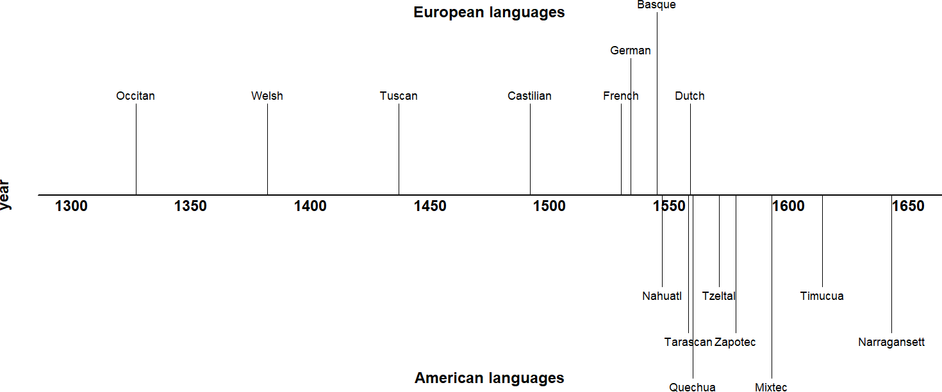

**Figure 2.1:** Timeline of early grammatical descriptions of European vs.

American languages

the first comprehensive survey of North American languages contains an entire section on “Conversion of nouns into verbs” (Gallatin 1836: 174–177), in which Gallatin depicts lexical flexibility as a rampant feature of all languages on the continent:

It is the substantive [i.e. copula / auxiliary] verb which we [speakers of Indo-European languages] conjugate; whilst the [Native American] conjugates what we call the adjective and even the noun itself, in the same manner as [s/he] does other intransitive verbs. […] I believe it must appear sufficiently obvious, that this general if not universal character of the [Native American] languages, the conversion into verbs and the conjugation, through all the persons, tense, and moods, of almost all the adjectives and of every noun which, without a palpable absurdity, is susceptible of it, is entirely due to the absence of the substantive verb. (Gallatin 1836: 175–176)

As evidenced by the above passage, increasing familiarity with non-Indo-European lan- guages prompted some writers to abandon the universalist commitment. However, categorial universalism is still a widely-held position today, either in the sense of a) categories being uni- versally instantiated in all languages (commonly assumed by most generative frameworks; although see Culicover [1999]), or b) categories being available to all languages, but only instantiated in some (sometimes called the “smörgåsbord” or “grab bag” approach, as exem- plified by Dixon’s Basic Linguistic Theory framework [2010: 9, 11, 14, 27, 50; 2011: 26]; see

Hieber [2013: 298] and Croft [2001b: 10] for discussion).

### **Relativism**

American ethnographers in the tradition of Franz Boas questioned the universalist assump- tion in a programmatic and comprehensive way. Writing on grammatical categories, Boas states, “Grammarians who have studied the languages of Europe and western Asia have de- veloped a system of categories which we are inclined to look for in every language” (Boas 1911: 35). He concludes that this endeavor is a folly, and that “in a discussion of the charac- teristics of various languages **different fundamental categories** will be found” (Boas 1911: 35). Boas’ students all adopted his grammatical relativism, and it became a foundational principle of the American linguistics tradition. His student Edward Sapir, writing on lexical categories specifically, makes one of the best-known and strongest statements of this position in his influential textbook *Language*: “[N]o logical scheme of the parts of speech—their number, nature, and necessary confines—is of the slightest interest to the linguist. Each language has its own scheme. Everything depends on the formal demarcations which it recognizes.” (Sapir 1921: 125).

Many linguists today hold to Boas’ grammatical relativism in some fashion or another. Textbooks and typological surveys commonly state that languages have varying numbers of lexical categories, though usually with the caveat that all languages seem to differentiate at least noun and verb (e.g. Velupillai 2012: §6.2). Some researchers, especially those working in typology, argue that linguists are still not rigorous *enough* in their application of grammatical relativism; they criticize certain kinds of crosslinguistic comparisons for imposing the cate- gories of one language onto another (Croft 2001b; Gil 2001; Haspelmath 2010a; 2012; LaPolla 2016). This position is discussed further in §2.4.

### **Structuralism**

Developing alongside the early anthropological linguistics of Boas was the linguistic struc- turalism of Ferdinand de Saussure. His work informed both the Prague school under Nikolay Trubetzkoy and Roman Jakobson, and the distributional method of Leonard Bloomfield. The term *structuralism* has any number of uses (P. Matthews 2001: Ch. 1); here I refer to the idea that “language is a […] self-contained, self-regulating system, whose elements are defined by their relationship to other elements” (P. H. Matthews 2014: 383). In particular, I am referring to the positivistic flavor of structuralism as practiced by Bloomfield, which focused on the structural relations between elements, and on establishing a set of rigorous scientific discov- ery procedures for linguistic structures (Bloomfield 1933). Bloomfield saw lexical categories as something to be empirically discovered in the different syntactic distributions of words, rather than imposed on a language a priori (Rauh 2010: 33). Zellig Harris later refined and expanded this methodology (Harris 1951), which was in turn incorporated into Chomsky’s early Phrase Structure Grammar (Chomsky 1957).

The signature methodological feature of this form of structuralism is the *distributional method*, a procedure for defining categories in terms of the set of contexts in which its words can appear—that is, their distributions (Harris 1951: 5; Croft 2001b: 11). As an illustration of distributional analysis applied to lexical categories, Croft (1991: 11–12) considers the distribu- tions of the English words *cold*, *happy*, *dance*, and *sing* in two constructions: in the Predicate construction after *be*, and in the 3rd Person Singular Present Tense (*‑s*) construction. Example data are shown below.

1. English (Indo-European > Germanic)
   1. i. Jack is cold.
      1. * Jack colds.
   2. i. Jack is happy.
      1. * Jack happies.
   3. i. * Jack is dance.
      1. Jack dances.
   4. i. * Jack is sing.
      1. Jack sings.

We can see that *cold* and *happy* have the same distributions in these tests (both may appear in the Predicate construction but not the Person-Tense inflection construction), while *dance* and *sing* have the same distribution (the inverse situation as *cold* and *happy*). The results of these two distributional tests are summarized in Table 2.1. Data like these are used to justify categories like Adjective and Verb in English.

**Table 2.1:** Distribution of English Verbs and Adjectives (adapted from Croft [2001b: 12])

Predicate Inflectional

Construction Construction

|  |  |  |
| --- | --- | --- |
| **Adjective**: *cold*, *happy*, etc. | ✔ | ✘ |
| **Verb**: *sing*, *dance*, etc. | ✘ | ✔ |

As applied in practice, however, the distributional method suffers from one serious draw- back when used to argue for large, traditional categories like noun, verb, and adjective: distri- butional tests yield conflicting and overlapping results. Perhaps no two lexical items behave the same way in every distributional test. Each new test that is introduced therefore partitions the lexicon into smaller and smaller classes. This fact has been demonstrated empirically for English temporal nouns (Crystal 1967: 54), Russian numerals (Corbett 1978), and French verbs (Gross 1979). Distributional tables from each of these studies are reproduced in Table 2.4, Ta- ble 2.3, and Table 2.2 respectively. It is clear from these studies that distributional analysis does *not* lead to large, unified categories like noun, verb, and adjective, but rather a myriad of small constructions (Crystal 1967: 27; Croft 2005: 434). Each distributional test is in fact its own construction (Croft 2005: 436). This fact is a major motivation underlying constructional approaches to language.

Many scholars nonetheless choose to retain lexical categories as a necessary component of their linguistic theories or descriptions, at the expense of consistent application of the dis-

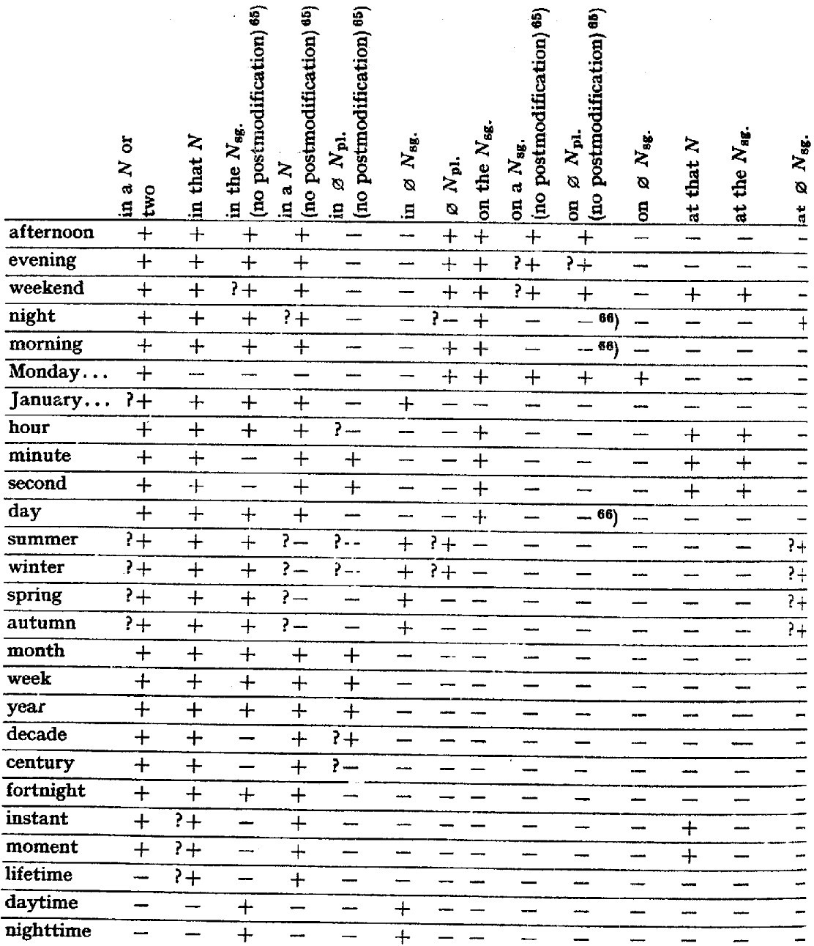

**Table 2.2:** distributional analysis of English (Indo-European > Germanic) temporal nouns (Crystal 1967: 54)

tributional method. Rather than considering all possible distributional contexts for a word, these scholars instead treat certain constructions as definitional of the category. Other dis- tributional tests which yield cross-cutting results are either ignored or treated as evidence

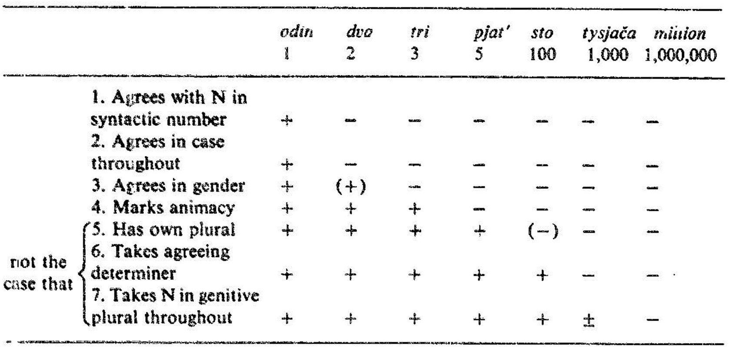

**Table 2.3:** distributional analysis of Russian (Indo-European > Slavic) nu- merals (Corbett 1978: 359)

of subcategories instead of categories. Many researchers even prefer the term *syntactic cate- gories* over *lexical categories* for this reason, focusing on just the syntactic evidence for cate- gories (M. C. Baker 2003; Rauh 2010). A severe methodological problem for this approach is that there are no generally agreed-upon principles for determining which distributional tests should be considered definitional. In this regard, Schachter & Shopen (2007: 4) note, “there may be considerable arbitrariness in the identification of distinct parts of speech rather than subclasses” (see also Crystal [1967]). Different scholars choose or prioritize different kinds of evidence for lexical categories over others based on their theoretical commitments. This is the reason, as stated in Section 1.1, that disagreements about the existence of particular lexical categories in particular languages are typically *not* about the empirical facts. The results of a given distributional analysis are not usually controversial; the choice of distributional tests used to support one’s analysis are. Unsurprisingly, then, debates over how to analyze lexical categories in various languages have been largely unproductive and unresolved (Croft 2005: 435). The problem only worsens when scholars attempt to apply the same criteria across lan- guages. Distributions of lexical items with similar meanings vary drastically across languages (Croft 2001b: §1.4.1).

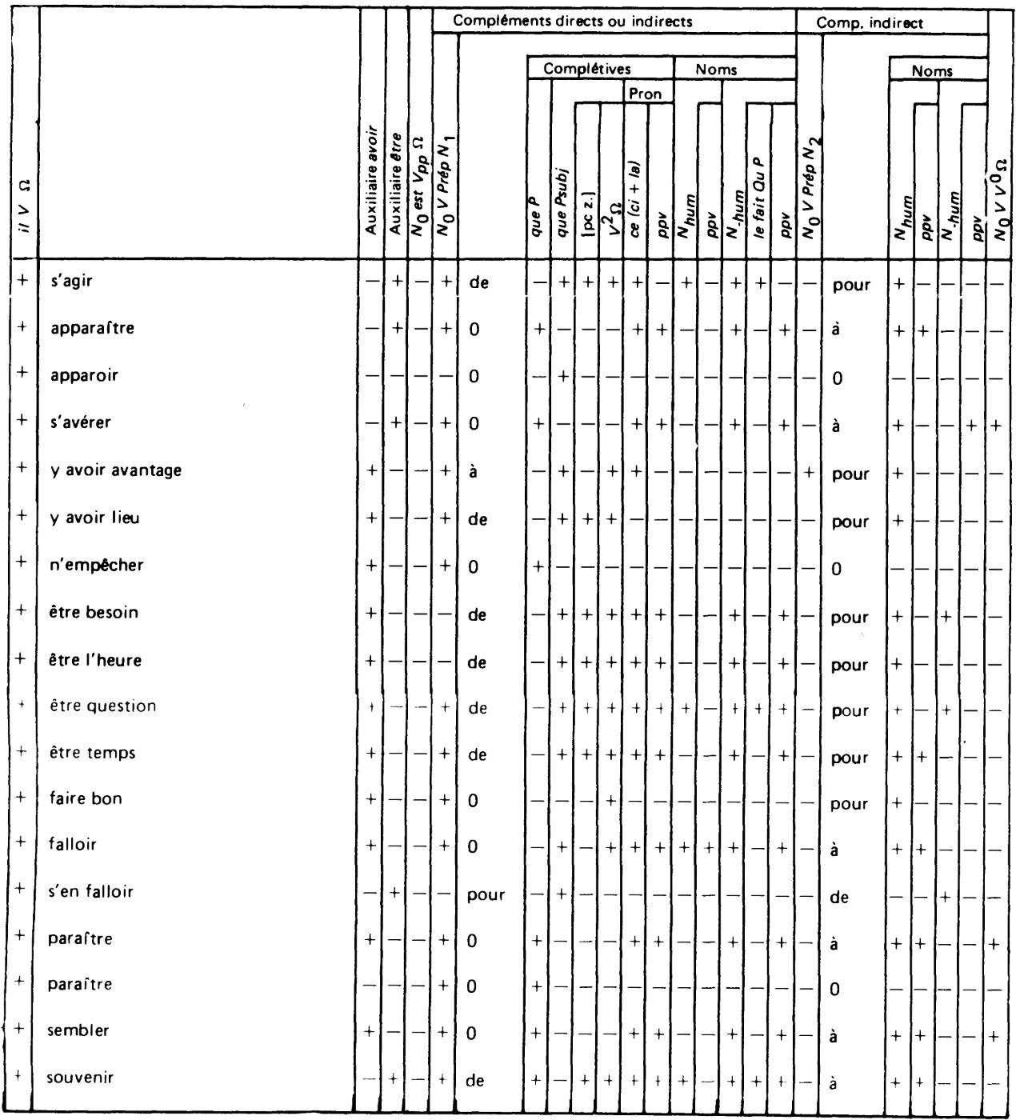

**Table 2.4:** distributional analysis of French (Indo-European > Romance) verbs (Gross 1979: 860)

The real methodological problem here is *not* that we have yet to ascertain the correct principles for selecting the right distributional tests. The problem is being selective regard- ing which tests to apply in the first place. If we take the distributional method seriously, then we must apply it consistently, without ignoring distributional evidence that contradicts

our theoretical or pretheoretical assumptions. To do otherwise is a kind of *methodological opportunism* (Croft 2001b: 30, 41).

Other scholars treat flexible items as members of *hybrid* or *mixed* categories simultane- ously possessing properties of more than one part of speech (Lois et al. 2017: 149; Malouf 1999; Nikolaeva & Spencer 2020). Adjectives are frequently described as a hybrid category (Wetzer 1996; Stassen 1997: 343; Pustet 2003: 13–16; Genetti & Hildebrandt 2004: 95; van Lier 2017), as are participles (Hopper & Thompson 1984: 704) and gerunds (Denison 2001). Lois et al. (2017: 149) also distinguish hybridity from polycategoriality, stating that polycategori- ality applies to roots or stems, while hybridity is a matter of the syntactic context that a word appears in.

An analysis couched in mixed categories does not avoid the problem of methodological opportunism, however. The existence of a mixed category implies that there are other, more basic categories that the mixed category is a hybrid of. Hybrid models of parts of speech merely exacerbate the distributional problem. There is however a sense in which thinking of minor lexical categories as “mixed” categories is useful: typological markedness theory states that lexical categories are epiphenomenal patterns that arise from combinations of the semantic classes of object, action, or property words with the discourse functions of reference, predication, and modification. Categories frequently discussed as “mixed” in the literature are precisely those combinations which are non-prototypical and therefore more likely to be typologically marked. Section 2.4.2 explains this approach to lexical categories in more detail. Partly in response to these problems, a growing cadre of linguists in the last 30 years have adopted one of various *flexible* approaches to word classes. Flexible analyses of word classes come in many flavors, some of which arguably still commit methodological opportunism, and others of which introduce new difficulties. These flexible approaches are reviewed in the

following section.

## **Flexible approaches**

In this section I summarize the key concepts (§2.3.1), findings (§2.3.2), and criticisms (§2.3.2) of lexical flexibility research. Section 2.3.1 surveys the wide variety of definitions and the- oretical perspectives on lexical flexibility. This review of the literature reveals that there is little consensus as to what exactly constitutes “lexical flexibility”; as such, there are numerous alternative terms for the phenomenon. Despite these incongruities, a few important findings do consistently surface across different empirical studies. These findings are summarized in Section 2.3.2. Then Section 2.3.3 looks at the arguments and evidence that researchers have presented against the notion of lexical flexibility, and some counterarguments.

### **Key concepts**

It is only a small exaggeration to say that there are as many definitions and terms for what I am here calling “lexical flexibility” as there are scholars who research it. I use the term *lexical flexibility* in this thesis merely because it is the most widely recognized of the cluster of terms that are used, not because it is necessarily the most precise or accurate. My own choice would be *functional expansion*, for reasons discussed below. The analytical or theoretical perspective adopted by each researcher generally determines their choice of terminology. The remainder of this section is devoted to explaining these perspectives in more detail.

Generally speaking, there are two ways to analyze flexible items. The first method assigns flexible items to members of specific categories in a language, whether those categories are the canonical four major classes (Noun, Verb, Adjective, Adverb), or a new large supercat- egory subsuming multiple discourse functions (e.g. Contentives, Non-Verbs, Flexibles), or a smaller subcategory of an existing major lexical category (e.g. Adjectival Verbs, Verbonom- inals). The second method of analysis assumes that leixcal items are uncategorized at some level (root, stem, or inflected word), and that items receive their categorial assignment from context. Different researchers posit different mechanisms for how lexical items receive their

categorization in context.

The traditional approaches to lexical flexibility summarized in Section 2.2 are all instances of the former method of analysis, while the flexible approaches outlined in this section are a mix of categorial and acategorial analyses.

* + - 1. **Lexical flexibility**

Though awareness of lexical flexibility can be traced back to at least Gallatin (1836: 174–177) if not earlier, the term *lexical flexibility* itself seems to have originated with Hengeveld (1992: Ch. 4). This publication, perhaps because it was the first to assign a technical term to the concept, marks a shift in how scholars frame the concept of lexical flexibility. Previously, the issue was framed in terms of whether particular languages (especially those of the Pacific Northwest) distinguished noun from verb (Kuipers 1968; Jacobsen 1979; Hébert 1983; Kinkade 1983; van Eijk & Hess 1986; Jelinek & Demers 1994). After this point, an increasing number of publications began to ask whether lexemes were *flexible* instead. Though the difference in emphasis seems subtle, this change constitutes a turning point because it fostered an increased interest in lexical flexibility as a grammatical phenomenon in its own right instead of just a problem for traditional categorization schemes.

Hengeveld’s (1992: Ch. 4) typology of parts-of-speech systems is a whole-language typol- ogy wherein languages are either *specialized*, with one morphosyntactic category for each of the functions of reference (Noun), predication (Verb), referent modification (Adjective), and predicate modification (Adverb1), or *non-specialized*. Non-specialized languages deviate from the four-category canon in one of two ways: one part of speech may assume more than one function with no additional morphosyntactic marking, in which case the language is consid- ered *flexible*; or the language may lack a dedicated part of speech for that function entirely and use other, marked constructions instead, in which case the language is considered *rigid*. Hengeveld gives examples from Dutch and Wambon to illustrate the distinction between

1Note that Hengeveld’s typology only includes manner adverbs, not other semantic types of adverbs.

rigid and flexible languages. In the Dutch examples in (12), the same word *mooi* is used for both referent modification (12a) and predicate modification (12b), with no overt morphology indicating its function in either case. Wambon on the other hand uses medial verbs for manner expressions and must take the overt verbalizing suffix *‑mo* shown in (13). In Hengeveld’s framework, Dutch is a flexible language because one category subsumes both the functions of referent modification and predicate modification, while Wambon is a rigid language because derivational morphology (here, the verbalizing suffix *‑mo*) is required to indicate the function of predicate modification.

1. Dutch (Indo-European > Germanic)
   1. een indef

**mooi beautiful**

kind child

‘a beautiful child’ (Hengeveld 1992: 65)

* 1. het def

kind child

dans‑t dance‑3sg.pRes

**mooi**

**beautifully**

‘the child dances beautifully’ (Hengeveld 1992: 65)

1. Wambon (Trans-New Guinea > Greater Awyu)

jakhov‑e they‑conn

**matet‑mo good‑vzR.ss**

ka-lembo go‑3pl.past

‘did they travel well?’ (de Vries [1989: 49], cited in Hengeveld [1992: 65])

Hengeveld’s analysis is of the categorial type discussed at the beginning of Section 2.3.1, specifically the supercategory kind. Each lexeme is assumed to have a category, and new supercategories are introduced for lexemes which have multiple functions: *Contentives* for lexemes which perform all four functions, *Non-Verbs* for lexemes which perform all non- predicating functions, and *Modifiers* for lexemes which perform referent modifier and predi- cate modifier functions.

Hengeveld’s parts-of-speech typology and the subsequent research it inspired (Don & van Lier 2013; Hengeveld & Rijkhoff 2005; van Lier 2006; Hengeveld & van Lier 2012; Luuk 2010; van Lier & Rijkhoff 2013; van Lier 2016) constitute important empirical contributions to the study of lexical flexibility. However, Hengeveld’s definition of flexible languages and

his parts-of-speech typology still rely on large, language-specific categories of the kind that have been problematized by Croft (2001b: §2.2.2) and Croft & van Lier (2012), and are there- fore subject to the same difficulties as traditional approaches to parts of speech. However, numerous scholars have since adopted Hengeveld’s term *lexical flexibility* to describe cases where lexical items serve more than one discourse function, regardless of their theoretical commitments or analysis of flexible items. As a convenient cover term, *lexical flexibility* is now well established.

* + - 1. **Polycategoriality**

Vapnarsky & Veneziano (2017b: 4) introduce the alternative term *polycategoriality* as their preferred characterization of flexible items. (The term is also used by Carter (2006), but he does not give a precise definition for it.) While Vapnarsky & Veneziano use this term mostly interchangeably with *lexical flexibility*, there are important differences between the two con- cepts. Hengeveld’s use of *lexical flexibility* is meant to imply the existence of large, flexible supercategories that subsume multiple discourse functions, whereas Vapnarsky & Veneziano are not committed to any particular schema for parts of speech. Central to their notion of polycategoriality is the idea that lexical categories exist, but that “there are lexical forms that are not specified for lexical category (or are not specified fully, or univocally) on some level of representation.” (Vapnarsky & Veneziano 2017b: 4). In other words, one lexeme may belong simultaneously to multiple lexical categories. Under this definition, a language could still have all four major lexical categories but nonetheless exhibit rampant polycategoriality; this is not a possibility in Hengeveld’s framework. Like Hengeveld, however, Vapnarsky & Veneziano are committed to the existence of large lexical categories in particular languages. Their anal- ysis is therefore also of the categorial kind discussed at the beginning of Section 2.3.1.

* + - 1. **Multifunctionality / Polyfunctionality**

Another term for our phenomenon of interest, introduced by (van Lier 2012), is *multifunc- tionality*, in which a single lexical item can have multiple discourse functions. An advantage of this analysis is that it takes no theoretical position on the issue of whether lexical items are categorial or acategorial; it just focuses on their functions. The term *multifunctionality* is meant to stand in contrast with *conversion* or *zero derivation*. Van Lier takes conversion to be idiosyncratic and unproductive, producing meanings for forms in alternate discourse functions that are not predictable (see §2.3.2.4 and §2.3.3.2 for further discussion). Multifunc- tionality is also distinct from zero derivation from a common root. Instead, multifunctional lexemes are those whose semantic interpretation is entirely predictable from context, and whose uses in different contexts are productive. Their meanings should be *compositional*. For example: when an action word is used in a referring construction its predicted meaning is that of an *action nominalization*, ‘(the act of) X‑ing’; and when an object word is used in a predicate construction its predicted meaning is that of a *predicate nominal*, ‘be an X’. Exam- ples of these predictable, compositional meanings for flexible items in Chamorro are shown in (14).

1. Chamorro (Austronesian > Malayo-Polynesian)
   1. para fut

**batångga‑n shed‑linK**

karabåo carabao

esti this

‘this is going to be a carabao shed’ (Chung 2012: 8)

* 1. para fut

**gatbesa**

**decoration**

ha’ emph

‘[she] is going to be a decoration’ (Chung 2012: 20)

In the two examples above, the meaning of the object words ‘shed’ and ‘decoration’ are pre- dictable when used in a predicative context: ‘be a shed/decoration’. However, lexical items used in their non-prototypical functions very frequently do not have predictable meanings. Consider the example in (15).

1. Chamorro (Austronesian > Malayo-Polynesian)

ma agR

**se’si’ knife**

i the

babui pig

‘they stabbed the pig’ (Chung 2012: 29)

In this example, the meaning ‘stab’ cannot be predicted from the meaning of the object word ‘knife’. It could have just as easily meant ‘be a knife’ or ‘cut’.

Van Lier takes examples like those in (14) to be instances of genuine multifunctionality, and those in (15) to be cases of conversion. Others have also adopted a position similar to van Lier’s, in which only the semantically compositional / predictable uses of a lexical item in different discourse functions are considered flexible (Croft 2001b: §2.2.2–§2.2.3; Evans & Osada 2005: §3.2).

* + - 1. **Precategoriality / Acategoriality**

The various approaches which analyze flexible items as being at some level uncategorized un- til they receive their interpretation from context may be lumped together under the umbrella terms *precategoriality* or *acategoriality*. Hopper & Thompson’s influential (1984) paper is an early application of the concept of acategoriality to the analysis of flexible items:

[L]inguistic forms are in principle to be considered as *lacking categoriality* completely un- less nounhood or verbhood is forced on them by their discourse functions. To the extent that forms can be said to have an apriori existence outside of discourse, they are charac- terizable as *acategorial*; i.e. their categorical classification is irrelevant. Categoriality-the realization of a form as either a N or a V-is imposed on the form by discourse. (Hopper & Thompson 1984: 747)

The term *precategorial* has become a somewhat more common term for roughly the same concept (though some researchers use the term in more strictly-delineated ways) (Evans & Osada 2005: 357, 362–364; Bisang 2008; 2013). It is especially preferred by morphological models that presuppose stages of derivation, such that lexical items are precategorial before they reach a certain stage of the derivation (Halle & Marantz 1994; Arad 2005; McGinnis- Archibald 2016; Siddiqi 2018). Vapnarsky & Veneziano (2017b: 5) distinguish polycategori- ality from acategoriality by defining acategoriality as implying “no primitive / original cat-

egorial marking at all”, and polycategoriality as allowing a lexical item “to be only partially unspecified for category, with possible constraints on the relevant categories”. Languages for which precategorial analyses have been advanced include Cherokee (Haag 2017), Gooniyandi (McGregor 2013), Kuikuro (Franchetto & Santos 2017), Mundari (Hengeveld & Rijkhoff 2005). Pfeiler (2017) also presents psycholinguistic evidence that the earliest utterances of L1 learn- ers of Yucatec Maya are acategorial.

A central concern in precategorial approaches is the precise mechanism by which a lexi- cal item receives its categorization in context (Hengeveld, Rijkhoff & Siewierska 2004: §3.7). There are two main theories of semantic indeterminacy in flexible items: *underspecificity* (Farrell 2001; Rijkhoff & van Lier 2013) and *vagueness* (Tuggy 1993; Hengeveld, Rijkhoff & Siewierska 2004; Hengeveld & Rijkhoff 2005). The essential difference is that underspecificity entails semantic minimalism, while vagueness entails semantic maximalism. An underspec- ified lexeme has a minimal, core meaning, and receives its categorial meaning from the dis- course context it appears in; a vague lexeme has a maximal, broad meaning that covers all the possible discourse contexts it appears in. (There is of course quite a deal of variation in the literature as to how scholars use these terms, with many researchers conflating the two.) Hengeveld & Rijkhoff (2005: 414) offer the example of English *cousin* as a word that is seman- tically underspecified for gender, such that the gender of the referent must be understood from context. Denison (2018) argues that the English word *long* exhibits adjective ~ adverb underspecification in Old English and Middle English.

In contrast, Hengeveld, Rijkhoff & Siewierska (2004: 539–541) outline a theory regarding exactly how vagueness operates in the context of lexical flexibility:

[E]ach flexible lexeme has a single (vague) sense. By placing the flexible lexeme in a par- ticular syntactic slot or by providing it with certain morphological markers, the speaker highlights those meaning components of the flexible lexeme that are relevant for a certain lexical (verbal, nominal, etc.) function. Thus we contend that the meaning of a flexible lexeme always remains the same, and that morphosyntactic and other contextual clues signal to the addressee how to interpret this lexeme in an actual utterance. In other words, it is the use of a vague lexeme in a certain context (an actual linguistic expres- sion) that brings out certain parts of its meaning, giving the category-neutral lexeme a

particular categorial (verbal, nominal, etc.) flavour. (Hengeveld & Rijkhoff 2005: 541)

(Note that while vagueness implies a certain potential ambiguity, Hengeveld & Rijkhoff re- serve the term *ambiguity* for cases of distinct, homophonous lexemes.)

Evans & Osada (2005: 363–364) and Kihm (2017) criticize both precategorial approaches for their imprecision, claiming that it would be impossible to formulate a definition for many flexible items that is broad enough to encompass all their uses. Kihm (2017: 87) illustrates this difficulty with the various meanings of the Arabic root *s‑q‑t*, which could arguably be glossed fall. A selection of stems containing this root are given in (16).

1. Standard Arabic (Afroasiatic > Semitic) saqata ‘to fall’

saqiit ‘hail’

saqqaata ‘door latch’

masqat ‘place where a falling object lands; waterfall’

isqaat ‘overthrow; shooting down; miscarriage; substraction’ tasaaqut ‘fall of hair’

saaqita ‘fallen woman; harlot’ suquut ‘fall; crash; collapse’ saqt ‘dew’

siqt ‘miscarried fetus’

suqt ‘sparks flying from a flint’

saqat ‘offal; rubbish’

saqta ‘tumble; slip; mistake’

saaqit ‘fallen; mean; missing’

It is difficult to imagine a single definition of *s‑q‑t* which could adequately demarcate just this set of meanings. This difficulty could perhaps be overcome, however, by loosening the requirement that the meaning of a lexical item be unitary. Word meanings are *polycentric*, where different senses of an item are related through *meaning chains* rather than all through a single, central member (Taylor 2003: 110). This is often referred to as a *family resemblance* structure for categories. The difference between monocentric and polycentric categories is illustrated schematically in Figure 2.2. In both diagrams, each letter A–E represents a sense of a lexical item. In the monocentric case, all the senses of the lexical item are related through its core sense A. In the polycentric case, senses A and E are related only through their intervening

connections.2

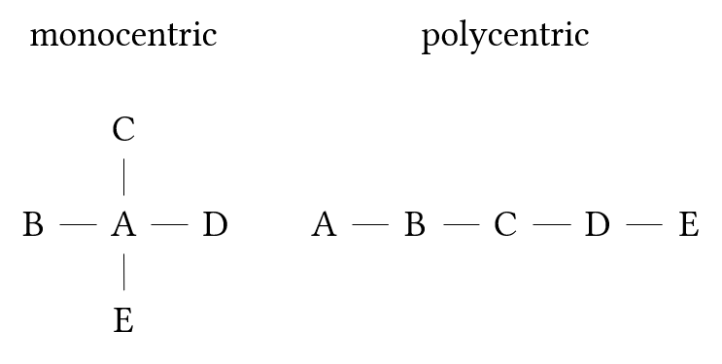

**Figure 2.2:** Monocentric vs. polycentric categories

Recognizing that word meanings are polycentric addresses Evans & Osada’s (2005) and Kihm’s (2017) criticisms of vagueness theory because it shows that the disparate senses of a lexical item can be related without having to share any core component of their meanings. The use of a lexeme in a certain context then profiles one of these senses over others. Kihm himself hints at this solution by referring to the related Arabic stems in (16) as a *lexical family*.

* + - 1. **Monocategoriality**

In the extreme case where all lexical items in a language are precategorial, the language could be considered *monocategorial*, possessing a single, open syntactic category. This is effectively the same as saying that the language lacks lexical categories altogether, the difference be- ing primarily one of emphasis. David Gil analyzes both Tagalog (1995) and Riau Indonesian (1994) as being of this extreme monocategorial type. Moreover, he argues that monocatego- riality must have been typical of an earlier stage of language evolution in which dedicated morphosyntactic constructions for different discourse functions had yet to evolve (Gil 2005; 2006; 2012). He names this abstract language type an *isolating-monocategorial-associational* (IMA) language.

2The terms *monothetic* and *polythetic* are sometimes used for this distinction instead (Lewandowska-

Tomaszczyk 2007: 146).

* + - 1. **Transcategoriality**

It is also worth briefly mentioning *transcategoriality*, since the term arises occasionally in con- nection with lexical flexibility and is potentially easily confused with other terms mentioned above. Robert (2003) uses *transcategoriality* to describe the ability for a single form to serve both lexical and grammatical functions. This is common in grammaticalization scenarios in which the original, lexical use of a form continues to exist alongside its newer, functional use. This is commonly referred to in the grammaticalization literature as *divergence* (Hopper & Traugott 2003: 118). Since the focus of lexical flexibility is on *lexical* items and categories rather than *functional* ones, the concept of transcategoriality is not directly relevant to the study of lexical flexibility.

* + - 1. **Conversion / Zero derivation**

*Conversion* is the process whereby a lexical item simply changes its word class with no overt morphological marker of that change (Crystal 2008: 114). *Zero derivation* is an alternate analysis of the same phenomenon that posits the presence of a derivational marker with no phonological realization. I prefer the term *conversion* in this thesis. Since the literature on conversion and zero derivation is extensive and the concepts are well-established, I will treat them only summarily here, focusing on their relationship to lexical flexibility.

The concept of conversion is based on the premise that lexical items in a language are fully categorized for part of speech, meaning that an analysis of lexical flexibility as conversion falls under the categorial (as opposed to acategorial) analyses of lexical flexibility mentioned at the beginning of Section 2.3.1. Conversion is generally characterized as a kind of word formation, implying that a new lexeme has been created. Therefore, conversion and lexical flexibility are mutually exclusive analyses of multifunctional items; lexical flexibility implies the existence of one polysemous lexeme which can fulfill multiple discourse functions, while conversion implies the existence of two homonymous / heterosemous lexemes with different discourse functions. Remember too from Section 2.3.1.3 that van Lier (2012) distinguishes

conversion from multifunctionality, where conversion is reserved for unproductive / unpre- dictable derivations. Not all scholars would delimit conversion in this way, however.

Conversion also implies directionality. In cases of conversion, one of the two uses of a form is in some way basic or prior to the other (Mithun 2017: 156; Vapnarsky & Veneziano 2017b: 5). Under a flexible analysis, by contrast, the different functions of a single flexible item have equal theoretical status. If it could be shown that certain seemingly flexible uses of a lexical item were in some way marked in relation to each other, this would therefore constitute potentially disconfirming evidence against a flexible analysis. This is in fact one of the major arguments presented against flexible analyses, to be discussed in Section 2.3.3. There are at least four ways in which one member of a putatively flexible set of lexical items might be considered more basic than the others: 1) diachronically, in which one use of the lexical item appears before the others historically; 2) semantically, in which the meaning of the derived item is more semantically complex than that of the basic one; 3) morphologi- cally, in which the more basic item is irregularly inflected but the derived item is regularly inflected; or 4) frequentially, in which derived lexical items are used less frequently than their more basic counterpart (Plag 2003: 108–111). Speakers themselves also have intuitions about which member of a flexible set is basic and which are derived (Mithun 2017: 166). As will be explained in Section 2.4.2, the idea that certain uses of a lexical item are marked in relation to each other is also central to the typological markedness theory of lexical categories.

* + - 1. **Functional shift / Functional expansion**

Especially in the American context, another common term for conversion is *functional shift* (Cannon 1985). In most research, the term is used essentially interchangeably with *conversion* or *zero derivation*. However, functional shift can be usefully distinguished from conversion by its emphasis on function over than category, paralleling the distinction between polycat- egoriality (implying language-specific categories) and polyfunctionality (with no such impli- cation). In its literal interpretation, the term suggests a shift in the meaning of a lexical item

from one discourse function to another, an analysis amenable to a constructional approach, and one that is not committed to the existence of language-particular categories. A slight improvement on this term would be *functional expansion*, since it emphasizes the expansion of a linguistic form into new functions / contexts as opposed to the wholesale shift from one function to another implied by *functional shift*.

### **Key findings**

The emergence of lexical flexibility as an object of study has led to a number of edited col- lections or journal volumes focused on flexibility and word classes more generally (Vogel & Comrie 2000, Evans & Osada 2005 (target article), Ansaldo, Don & Pfau 2010, Lois & Vap- narsky 2003, Rijkhoff & van Lier 2013, Simone & Masini 2014, Błaszczak, Klimek-Jankowska & Migdalski 2015, Vapnarsky & Veneziano 2017a, van Lier 2017 (target article), Vapnarsky & Veneziano 2017b, Cuyckens, Heyvaert & Hartmann 2019), plus any number of individual ar- ticles (see especially Farrell [2001], Rijkhoff [2007], van Lier [2012], and Mithun [2019]). Out of these collections have emerged several recurring findings, each of which is summarized in this section.

* + - 1. **Parts-of-speech hierarchy**

In addition to laying out a theory of flexible categories, Hengeveld (1992) presents the results of a 30-language survey of parts of speech in which he finds that the categories which are most likely to occur as an independent class in a language are subject to an implicational hierarchy, shown in (17), which Hengeveld refers to as the *parts-of-speech hierarchy*.

1. Verb > Noun > Adjective > Adverb

Categories to the left of the hierarchy are more likely to occur as a distinct part of speech than categories to the right. Applying this hierarchy to Hengeveld’s flexible vs. rigid distinction yields the parts-of-speech typology in Figure 2.3 (adapted from Hengeveld [1992: 69] and

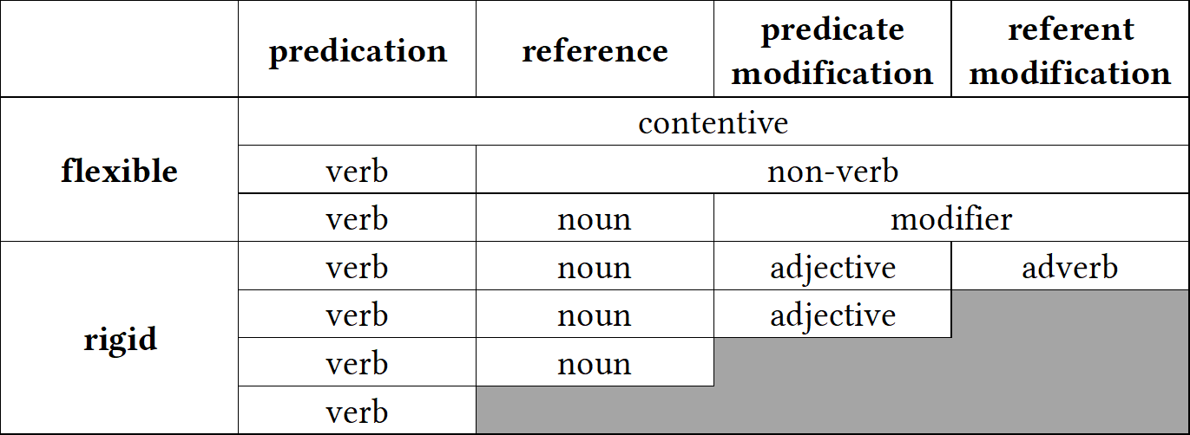Rijkhoff [2007: 718]). The terms for the different categories in flexible languages are from Hengeveld, Rijkhoff & Siewierska (2004). Hengeveld points out that this is not a strict classi- fication scheme; languages may sit at the boundaries between types and exhibit exceptions.

**Figure 2.3:** Hengeveld’s (1992: 69) typology of parts-of-speech systems

As mentioned in Section 2.3.1.1, Hengeveld’s typology could be criticized for its reliance on large, language-specific lexical categories instead of constructions. One could however reframe Hengeveld’s implicational hierarchy in terms of functions rather than categories, as in (18). I call this the *hierarchy of discourse functions*.

1. predicate > referent > predicate modifier > referent modifier

In (18), functions to the left of the hierarchy are more likely to have dedicated morphosyn- tactic constructions than those to the right. This reformulation avoids a commitment to any language-particular categories while still capturing the implicational trend observed by Hengeveld.

This hierarchy of discourse functions has proven to be a fairly robust finding in the liter- ature on lexical flexibility, now supported by a number of subsequent studies (Anward 2000; Rijkhoff 2000; Vogel 2000; Beck 2002; Rijkhoff 2002; 2003; Hengeveld, Rijkhoff & Siewierska

2004; van Lier 2006; Hengeveld 2007; Hengeveld & van Lier 2012; Hengeveld & Valstar 2010;

Beck 2013; Bisang 2013; Hengeveld 2013).

* + - 1. **Reference-predication asymmetries**

The hierarchy of discourse functions also hints at another important feature of lexical cate- gories: there is something privileged about the predicating function. A survey of the literature on lexical flexibility reveals patterned asymmetries in the behavior of lexical items with re- gard to predication vs. reference, even in very flexible cases. For starters, while it is quite common for languages to freely allow object words to be used as predicates with no special marking, the reverse case is much less likely Hopper & Thompson (1984: 745). The functional expansion of an item’s uses from predication into reference always seems to be more marked (or at least as marked) as the shift from a referring function to a predicating function.

This fact has been observed independently by numerous researchers. For example, Stevick (1968: 251) and Marchand (1969: 373–374) both observe that conversion from noun to verb in English has always been more common than from verb to noun, and Kastovsky (1996: 98) points out that English does not even have a native noun > verb derivational suffix—any affixes of this type are borrowed from Romance languages. Central Alaskan Yup’ik is another example of a language with very many nominalizers but few verbalizers (Mithun 2017: 158).

Flexibility itself is frequently *unidirectional*, meaning that any object word many be used for predication, but that action words used for reference are marked (Croft 2001b: 69; Evans & Osada 2005: §3.3; Beck 2013). Nakayama (2001: 44) frames flexibility in Nuuchahnulth in terms of a stem’s ability to predicate, reporting that “all inflectional stems are potentially predicative”, but the reverse is not true. Discussing Classical Nahuatl, Launey (1994; 2004) in- troduces the term *omnipredicativity* to describe languages in which all lexical items are poten- tially predicative, but no corresponding term *omnireferentiality* has appeared in the literature. That said, languages which have undergone *insubordination* (in which subordinate, usually nominalized clauses are reanalyzed as main clauses, and the nominal inflectional marking of the subordinate clause is reinterpreted as verbal inflectional marking [Evans 2007; Mithun 2008; Evans & Watanabe 2016]) do exhibit noun-oriented flexibility in the sense that verbal inflection mirrors nominal inflection. This famously led to the claim that all lexical items in

Eskimo languages are fundamentally nominal in nature (Sadock 1999). However, cases of insubordination do not constitute counterexamples to the predicating tendency in language. Even in these languages, the use of action words for reference is still less marked than the use of object words for predication.

Kastovsky (1996) argues that this asymmetry arises from the fact that “deverbal nouns have a much more diversified semantics than denominal verbs” (Kastovsky 1996: 96), mean- ing that the range of possible meanings for a deverbal noun (a noun derived from a verb) is broader than for a denominal verb (a verb derived from a noun). Examining data from English, Kastovsky shows that when an object word is used to predicate, its possible meanings are lim- ited to combinations of be, be liKe, be in, become, have, do, do with, and cause. When an action word is used as a predicate, however, the range of meanings include any abstract representation of the event itself (an action nominalization), or any one of the arguments associated with the verb, which come in a variety of semantic roles.

A similar, cognitively oriented explanation for reference-predication asymmetries is given by Hopper & Thompson (1984: 745):

* + - * 1. nominalization names an event taken as an entity; however, a “verbalization” does not name an “entity taken as an event”, but simply names an event associated with some entity. In other words, a nominalization still names an event, albeit one which is being referred to rather than reported on in the discourse; it is, accordingly, still in part a [verb], and not a “bona fide” [noun]. However, a denominal [verb] no longer names an entity at all, and thus has no nominal “stains” to prevent its being a bona fide [verb]. (Hopper & Thompson 1984: 745)

Hopper & Thompson (1984: 746) analyze nominalizations as a kind of metaphor following Lakoff & Johnson (1980: 3a), in which an abstract event is conceptualized as a concrete ob- ject. However, no such metaphor exists for verbalizations, explaining the asymmetry in the directionality of lexical flexibility.

* + - 1. **Locus of categoriality**

The grammatical level at which a language exhibits flexibility—the root, the stem, or the fully inflected word—differs from one language to the next. In some languages, roots are strongly associated with a particular discourse function, but stems are flexible; in other languages, the reverse is true. I refer to the linguistic level at which a language associates different discourse functions as its *locus of categoriality*. Some linguistic theories include a premise that the locus of categoriality in every language always sits at a certain level (Halle & Marantz 1994; M. C. Baker 2003; 2015; Booij & Audring 2018; Siddiqi 2018), but the evidence from research on lexical flexibility gives strong empirical support to the position that locus of categoriality varies from language to language. In contrast, Błaszczak, Klimek-Jankowska & Migdalski (2015) argue that category information is distributed across different levels of representation. As one illustration of how flexibility depends on grammatical level, we have seen that roots in Central Alaskan Yup’ik are generally categorical—except for 12% of roots, they are typically strongly associated with just one discourse function, and derivational affixes select for roots of a particular category (Mithun 2017: 162–167). While many derived stems are also strictly associated with just one discourse function, a large but indeterminate number have both referential and predicative uses. Examples of such flexible stems have already been shown in (7) in Section 1.1. Fully inflected words in Central Alaskan Yup’ik, however, never exhibit flexibility (Mithun 2019: 6). So Central Alaskan Yup’ik displays partial flexibility at

the root and stem level but not the inflected word level.

As another example, in Mandinka all stems are flexible. No Mandinka stem except for *sǎa* ‘die’ is used in just one discourse function (Creissels 2017: 46). At the level of the inflected word, however, lexical items in Mandinka belong unambiguously to one category or another (Creissels 2017: 37). Mandinka therefore shows complete flexibility at the stem level but complete rigidity at the inflected word level. (Creissels does not include an analysis of roots in his discussion.)

Surprisingly, some languages display flexibility even at the level of the fully inflected word.

In many North American languages, it is common for fully morphological verbs to function as referents (Hieber forthcoming), as shown in the following examples.

1. Chitimacha (isolate)
   1. dzampuyna dza‑ma‑(p)uy‑na thrust‑plact‑hab‑nf.pl

‘they usually thrust / spear with it’

‘spear’ (Swadesh 1939a: 56)

* 1. pamtuyna pamte‑(p)uy‑na ford‑hab‑nf.pl

‘they usually cross (it)’

‘bridge’ (Swadesh 1939a: 17)

1. Cayuga (Iroquoian > Lake Iroquoian)
   1. ǫtekhǫnyáʔthaʔ ye‑ate‑khw‑ǫni‑aʔt‑haʔ indef.agt.Refl‑meal‑make‑instR‑ipfv ‘one makes a meal with it’

‘restaurant’ (Mithun 2000: 200)

* 1. kaǫtanéhkwih ka‑rǫt‑a‑nehkwi neut.agt‑log‑ep‑haul.ipfv ‘it hauls logs’

‘horse’ (Mithun 2000: 200)

1. Navajo (Na-Dene)
   1. tsinaaʼeeɬ tsi(n)‑naaʼeeɬ

wood‑it.moves.about.floating

‘ship, boat’ (Young 1989: 316)

* 1. chahaɬheeɬ it.is.dark

‘darkness’ (Young 1989: 316)

Each of these flexible uses of a morphological verb sits somewhere on a continuum between being fully lexicalized as a referent, so that its predicating use is no longer available, to being a fully productive predicate, with both predicative and referential uses (Mithun 2000: 413).

The reason that lexical items may exhibit flexibility at one level of analysis but not another is because “*categorial* shift is often not *categorical*” (Mithun 2019: 1). When an item expands its use into new contexts, not all the morphological, syntactic, and semantic properties of the item shift to accommodate that new use at the same time. It takes time before the morphosyn- tactic properties of a item adjust to reflect its new use, a process referred to as *actualization* in the grammaticalization literature (De Smet 2012) and *post-constructionalization constructional changes* in the framework of diachronic construction grammar (Hopper & Traugott 2003: 27). It is in part because the locus of categoriality can vary from language to language that

I have used the vague term *lexical item* throughout this thesis, which is intended to be a convenient cover term for root, stem, or inflected word.

* + - 1. **Item-specificity**

A final significant finding to emerge from the empirical research on lexical flexibility is the fact that flexibility is *item-specific* and even *sense-specific*. Individual lexical items or even individ- ual senses of an item that are otherwise very similar in their meanings and morphosyntactic behavior can nonetheless differ in terms of their flexibility.

This fact is nicely illustrated by both Mithun’s (2017) study of lexical flexibility in Cen- tral Alaskan Yup’ik and Creissels’s (2017) study of Mandinka. Mithun (2017: 163–164), for example, considers roots for meteorological concepts, and shows that even within this small semantic domain, roots vary as to whether they exhibit flexibility. In (22a) the meteorological roots have predicative counterparts but in (22b) the meteorological roots do not.

1. Central Alaskan Yup’ik (Eskimo-Aleut > Yupik)

|  |  |  |  |
| --- | --- | --- | --- |
| a. *amirlu* | ‘cloud’ | *amirlu‑* | ‘be cloudy’ |
| *kaneq* | ‘frost’ | *kaner‑* | ‘be frosted’ |
| *aniu* | ‘snow on ground’ | *aniu‑* | ‘to snow’ |
| b. *taituk* | ‘fog, mist’ | \**taitug‑* | ‘be foggy’ |
| *kavtak* | ‘hailstone’ | \**kavtag‑* | ‘to hail’ |
| *mecaliqaq* | ‘sleet’ | \**mecaliqar‑* | ‘to sleet’ |

(Mithun 2017: 163)

Mithun also provides similar data illustrating flexibility gaps for the domains of clothing and instruments:

1. Central Alaskan Yup’ik (Eskimo-Aleut > Yupik)

|  |  |  |  |
| --- | --- | --- | --- |
| a. *taqmak* | ‘dress’ | *taqmag‑* | ‘put on a dress’ |
| *nacaq* | ‘hat, parka hood, cap’ | *nacar‑* | ‘put on a hat, hood’ |
| *atkuk* | ‘parka’ | *atkug‑* | ‘put on a parka’ |
| b. \**piluk* | ‘footwear’ | *pilug‑* | ‘put on footwear’ |
| \**at’e* | ‘clothing’ | *at’e‑* | ‘don, put on clothing’ |
| \**kive* | ‘pants’ | *kive‑* | ‘pull down pants’ |

1. Central Alaskan Yup’ik (Eskimo-Aleut > Yupik)
   1. *ay’uytaq* ‘hockey stick’ *ay’utar‑* ‘play hockey’

*iqsak* ‘fishhook’ *iqsag‑* ‘to jig for fish’

*kapkaanaq* ‘trap’ *kapkaanar‑* ‘to trap, get trapped’ *keviq* ‘plug, cork, stopper’ *kevir‑* ‘to plug, stuff, caulk’ *kuvya* ‘fishnet’ *kuvya‑* ‘fish by driftnetting’

* 1. \**kagi* ‘broom’ *kagi‑* ‘sweep’

\**ipuk* ‘ladle’ *ipug‑* ‘ladle, move with bow of boat high in air’

\**pangeq* ‘double-bladed

paddle’

*panger‑* ‘paddle with a double-bladed paddle’

On the basis of data like these and discussion with speakers, Mithun observes, “Speakers simply know whether a given root functions as a noun and what its meaning is, and whether it functions as a verb and what its meaning is. Gaps are not predictable[.]” (Mithun 2017: 163). These gaps also vary from dialect to dialect. While the dialect in the above examples has no predicative counterpart for *taituk* ‘fog’, the Nunivak Island dialect does have a pair of roots *nugu* ‘fog’ and *nungu‑* ‘be foggy’.

Creissels’s (2017) study of Mandinka is another good illustration of the item-specific na- ture of flexibility. While Mandinka has nominal and verbal constructions that allow the pred- icative and referring functions of inflected words to be distinguished unambiguously, it is not as easy to separate stems into similar classes. In Mandinka, all items are flexible, but the *way* in which items are flexible varies. Stems in Mandinka may be divided into three classes based

on their semantic behavior with regards to flexibility:

* *verbal* lexemes are those whose meaning is predictable when used to refer and therefore analyzable as a case of “morphologically unmarked nominalization”; these are always event nominalizations
* *verbo-nominal* lexemes are those whose meaning in referring constructions is idiosyn- cratic and therefore not predictable
* *nominal* lexemes are those whose meaning when used as predicates is predictable and limited to ‘provide someone with X’

In Mandinka, therefore, flexibility must be considered on an item-by-item basis since the behavior of each item with regard to flexibility may differ.

In fact, flexible behavior in Mandinka is not just item-specific, but sense-specific as well. Creissels (2017: 54) reports that polysemous lexemes may show different behavior for their different senses. The stem *díŋ*, for example, has two senses: ‘child, young (of an animal)’ and ‘fruit’. However, only the ‘fruit’ sense is available for predication: when used as an intransitive verb, *díŋ* may only mean ‘bear fruit’, not ‘give birth’, even though ‘give birth’ is a perfectly conceivable meaning of this stem in predication. In the sense of ‘child, young (of an animal)’, *díŋ* behaves as a nominal lexeme, but in the sense of ‘fruit’ it behaves as a verbo-nominal lexeme.

When lexical items undergo functional expansion into new discourse functions, it is also only specific senses that do so, not every one of its senses. More evidence for this comes from the diachronic development of the word *run* in English: though the word *run* when used as a predicate has numerous senses, the earliest attestations of *run* used referentially are by and large with just the prototypical sense of ‘fast pedestrian motion’ (the exceptions to this stem from just one corpus file) (Gries 2006: 76). Other referential uses of *run* did not develop until later.

The existence of dialectal differences for flexibility as well as the unpredictable meanings of lexical items when used in various discourse functions show that the development of flexi- bility depends on conventionalization—whether a given form has assumed a conventionalized

meaning in its role for a specific discourse function. These conventionalizations are language- specific, dialect-specific, item-specific, and even sense-specific (Croft 2000: 97). Speakers can and do playfully use existing lexical items for new discourse functions, but it is not until that combination of form and discourse function is conventionalized with a specific meaning in a community of speakers that we can say the lexical item has undergone functional expansion. An excellent illustration of this is the word *friend* in English. Prior to the widespread adop- tion of the social networking sites MySpace and Facebook around 2006, the use of *friend* as a predicate had not been widely conventionalized. The growth of social networking sites then led to the specific use of *friend* to mean ‘add as a connection on a social networking site’. Note that it does *not* have the more general sense of ‘be a friend’ or ‘befriend’. Like with Yup’ik and Mandinka, this shows not just that flexibility is item-specific, but that the meaning of flexible uses is often item-specific as well; in many cases it is unpredictable and must be memorized by speakers.

### **Problems & critiques**

Despite the robust findings in Section 2.3.2, researchers have challenged the very possibility of lexical flexibility and its presence in various languages. Some of these challenges stem from the fact that certain conceptions of lexical flexibility are based on traditional ideas about the existence of large, language-specific parts of speech, and therefore subject to the same set of criticisms. Other challenges stem from precisely the facts presented in the previous section, namely that both flexibility and the meaning of flexible words are item-specific and often unpredictable, such that these words are not truly “flexible”. Moreover, languages must indicate the discourse function of their leixcal items *somehow*—this is basic to our ability to communicate. In a certain sense, the idea that there are items which are fully ambiguous in their discourse function is doomed at the outset. The question is really where these indications of pragmatic function live—the root, the stem, the inflected word, or the clausal context. This section summarizes the main criticisms that scholars have raised against flexible analyses. In

Section 2.4, we then look at alternative theories of word classes and their approach to lexical flexibility.

* + - 1. **Methodological opportunism**

A methodological problem with certain theories of flexible items is that they, like traditional theories, commit the fallacy of *methodological opportunism* (Croft 2001b: 30, 41) presented in Section 2.2.3. They do not apply the distributional method consistently. Instead, the criteria which separate lexical items into categories are determined on the basis of additional theoret- ical commitments. Croft (2001b: §2.2.2) criticizes Hengeveld’s parts-of-speech typology on this basis, noting that Hengeveld ignores distributional evidence for classes smaller than the ones he posits in his typology (noun, contentive, etc.). Evans & Osada (2005) raise similar concerns for Hengeveld’s theory as applied to Mundari. They state that in order for two lex- ical items to be members of the same lexical class, they must have *equivalent combinatorics*, which is to say that their distributions should be identical (Evans & Osada 2005: 366). Evans & Osada also state that for a language to flexible, that flexibility must be *exhaustive* in the sense that all members of a putatively flexible class must show equal degrees of flexibility and *bidirectional* in the sense that nouns may be used as verbs and vice versa. Both these cri- teria are merely different ways of reframing the broader principle that items in a class should share the same distributions (Croft 2005: 434). Evans & Osada proceed to show various ways in which these criteria are not applicable to Mundari, and that Mundari is therefore not a flexible language. At the same time, however, Evans & Osada use these facts to argue for the existence of the equally problematic categories of Noun and Verb in Mundari, using just a “canonical subset of distributional facts” (Evans & Osada 2005: 434, fn. 17). Croft’s (2005) commentary on Evans & Osada’s (2005) target article is partially devoted to critiquing them on this point. The problem of methodological opportunism is present for any analysis which assumes that languages have a small set of large lexical categories—whether that analysis is flexible or traditional.

* + - 1. **Semantic shift**

Broadly speaking, however, the primary argument against theories of flexible word classes is that they ignore a great deal of item-specific knowledge that speakers have about lexical items and their uses in different functions (Evans & Osada 2005: §3.2; Beck 2013: 216). This issue has already been discussed in some detail in Section 2.3.2.4, but it bears explaining precisely why such item-specific knowledge constitutes a problem for theories of lexical flexibility.

For starters, when a lexical item expands into a new discourse function, there is a *semantic shift* in the direction of the meaning typically associated with the new context (Croft 1991: 74–77; 2001b: 73). For example, when a property word is used in a referring expression, its meaning shifts to a person or thing possessing that property, not a reference to the ab- stract property itself. These semantic shifts cannot be attributed to some broader pragmatic principles—they are a matter of convention and require broader uptake in a community of speakers in order to be conventionalized (as illustrated with the English word *friend* above). Because the meaning that results from this semantic shift is conventional, language-specific, and often idiosyncratic, flexible items cannot be truly productive, as is implied by the term “flexible”. There is always a conventionalized component to their meanings.

Examples of idiosyncratic and unproductive shifts in the meaning of flexible items abound in the literature. Consider again the examples from Mundari in (3), repeated here as (25).

1. Mundari (Austroasiatic > Munda)
   1. buru=ko mountain=3pl.subj

bai‑ke‑d‑a. make‑compl‑tR‑ind

‘They made the mountain.’ (Evans & Osada 2005: 354)

* 1. saan=ko firewood=3pl.subj

buru‑ke‑d‑a. mountain‑compl‑tR‑ind

‘They heaped up the firewood.’ (Evans & Osada 2005: 355)

As a predicate, the stem *buru* means ‘heap up’, but this meaning is not predictable from just the combination of the nominal sense ‘mountain’ and its predicative use. The word could have just as easily meant ‘climb a mountain’ or ‘overcome’ or simply ‘be a mountain’. No

general pragmatic principles could have predicted this meaning. Likewise consider the Cen- tral Alaskan Yup’ik examples in (7c) from Chapter 1. Why does the combination of *iqeq‑* ‘corner of mouth’ + *‑mik* ‘thing held in one’s mouth’, ‘to put in one’s mouth’ result in *iqmik* ‘chewing tobacco’? Why not ‘oral thermometer’ or ‘toothpick’? Mithun provides many more unpredictable examples, shown in (26).

1. Central Alaskan Yup’ik (Eskimo-Aleut > Yupik)
   1. *mecur‑* ‘get blood poisoning’

*mecuq* ‘liquid part of something, sap, juice, green/waterlogged wood’

* 1. *melug‑* ‘suck; eat roe directly from the fish’

*meluk* ‘fish eggs, roe, fish eggs prepared by allowing them to age and become a sticky mess’

* 1. *qager‑* ‘explode, to pop’

*qageq* ‘blackfish which is boiled, allowed to set in its cooled, jelled broth’

* 1. *qumig‑* ‘hold inside (of clothing)’

*qumik* ‘enclosed thing, thing inside, fetus’

* 1. *aveg‑* ‘divide in half, to halve’

*avek* ‘half’; also ‘half-dollar; person who is half Native’

* 1. *napa‑* ‘stand upright’

*napa* ‘tree’

* 1. *yuurqar‑* ‘sip’

*yuurqaq* ‘hot beverage, tea’

Or consider the example from Cayuga in (20b), repeated here as (27).

1. Cayuga (Iroquoian > Lake Iroquoian) kaǫtanéhkwih

ka‑rǫt‑a‑nehkwi

neut.agt‑log‑ep‑haul.ipfv ‘it hauls logs’

‘horse’ (Mithun 2000: 200)

Of all the possible nominal meanings that could reasonably derive from ‘it hauls logs’—cart, tractor, ox—the fact that its nominal use means ‘horse’ is specific to Cayuga and must be

memorized by speakers.

Conventionalizations of lexical items used in new discourse functions also vary across languages. While the principle of semantic shifts still broadly holds, the specific meanings of these conventionalizations are unpredictable. Croft exemplifies this point by comparing English *school* with Tongan *ako* ‘school / study’.

English *school* used predicatively does not mean the same thing as Tongan *ako* used predicatively, namely ‘study’. Going in the opposite direction, English *study* used refer- entially does not mean the same thing as Tongan *ako* used referentially, namely ‘school’. Finally, English *small* used referentially does not mean the same thing as Tongan *si’i* ‘childhood’ used referentially. (Croft 2000: 71)

Since the meanings of putatively flexible items in different discourse functions are not pre- dictable, many scholars reason that these lexical items cannot be truly “flexible” in the sense of multifunctional or precategorial.

* + - 1. **Lexical gaps**

Just as unpredictable in flexible cases is which sense of a item will be co-opted into the new discourse function. In Wolof, for example, the referential use of the word *ndaw* can only mean ‘young’, whereas the predicative use may mean either ‘be young’ or ‘be little, small’ (Kihm 2017: 91). We have also already seen similar lexical gaps for Central Alaskan Yup’ik and Mandinka in Section 2.3.2.4 above. If a lexical item lacks any conventionalized use in different discourse functions, than it cannot rightly be considered flexible, or a member of a flexible word class.

* + - 1. **Counterarguments**

Pointing out that functional expansion involves both semantic shifts and functional gaps is generally intended to show that lexemes cannot be truly flexible in the sense of being multifunctional (§2.3.1.3) or precategorial (§2.3.1.4), and that uses of the same lexical item

for different discourse functions should therefore be considered cases of conversion—that is, homonymy or heterosemy. There are however two major problems with this argument.

The first is that it creates a false dichotomy between homonymy and polysemy, when in fact the two phenomena are opposite endpoints on a continuum. Debates over the lexical unity of an item—that is, whether two uses of a lexical item are homonymous or polysemous— arise from an Aristotelian desire to neatly sort those uses into distinct lexemes, when in fact reality is much more complex. If this problem sounds familiar, that is because it is the same methodological problem that arises when trying to exclusively categorize lexical items into different classes. The complex adaptive nature of language makes categorical classification at either level impossible.

As discussed in Section 2.3.1.4, we know from cognitive research that mental categories are prototypal, and that the meanings of words display a polycentric, family resemblance structure. Two senses of a lexical item are often related only tenuously through a network of intervening semantic connections or meaning chains. Langacker (1988) calls this the *net- work model* of category structure. Taylor points out that “[o]ne consequence of adopting the network model is that the question of whether a lexical item is polysemous turns out to be incapable of receiving a definite answer.” (Taylor 2003: 167)

Over time, as this lexical network expands, the meanings of a lexical item can diverge so drastically that speakers no longer have a direct cognitive association between them. Mithun exemplifies this nicely for both Cayuga and English. Discussing morphological Verbs used as referents in Cayuga, she notes the following:

If asked the meaning of *kaǫtanéhkwih* [lit. ‘it hauls logs’], Cayuga speakers normally respond ‘horse’. Though it has the morphological structure of a verb, it has been lexical- ized as a nominal. The literal meanings of many verbal nominals are still accessible to speakers, but the origins of others have faded, and speakers express surprise at discov- ering them. Similarly, when asked “What would you like for breakfast?”, most English speakers do not think about breaking their night-time fast, though they can usually be made aware of the literal meaning of *breakfast*. (Mithun 2000: 413)

Lexicalization is a process and a continuum. Words can be lexicalized in new discourse func-

tions to varying degrees. The first use of a lexical item in a new discourse function is innova- tive; each subsequent use then contributes further to its conventionalization in that function. Pointing out that functional expansion often creates idiosyncratic and unpredictable mean- ings essentially amounts to saying that senses of lexical items can be highly divergent. This point is not in itself an argument against flexible analyses. Flexible items themselves may sit anywhere on the continuum from having closely connected, productive and predictable meanings, to having extremely divergent, idiosyncratic, and unpredictable meanings. This is

not a special fact about flexible items; it is simply true of words generally.

Croft (2001b: 73) expresses concern that ignoring semantic shifts in the analysis of flexible items overlooks important insights about how such semantic shifts are patterned (specifically, the universal fact that semantic shifts are always in the direction of the item’s new discourse function; see §2.3.3.2). Given that so many researchers have indeed ignored semantic shift when arguing for flexible analyses, Croft’s concern is warranted. However, it is entirely pos- sible to define lexical flexibility in a way that both allows for the meaning of a lexical item to encompass multiple discourse functions and acknowledges that such multifunctional uses involve patterned semantic shifts. The way to do this is to ground the definition of lexical flexibility in the pragmatic functions of reference, predication, and modification rather than language-specific categories like Noun, Verb, and Adjective. I offer such a definition in Sec- tion 2.5.

The second significant problem with using semantic shifts as an argument against the existence of flexible lexemes is that it proves too much. If semantic shift is taken as evidence against the lexical unity of putatively flexible items, then it must also be taken as evidence against the lexical unity of non-flexible items. Put simply, semantic shift is an analytical problem for all words, not just flexible ones.

This fact becomes clear when we ask, “What counts as a semantic shift? Just how ‘large’ of a change in meaning (if it were even possible to quantify such a thing) does a semantic shift require?” To illustrate this problem, consider the semantic contribution of plural mark-

ing crosslinguistically. In the canonical case, plural marking is considered inflectional rather than derivational (Corbett 2000: 2), meaning that it does not create a new lexeme. Instead, it modifies the meaning of the existing lexeme slightly, in line with the classic distinction between inflection vs. derivation. However, there are numerous cases of lexical items in En- glish with more or less drastic differences in meaning between the singular and plural, and/or senses that are only available in one of the two numbers. Consider the examples in (28).

1. English (Indo-European > Germanic)
   1. *air* ‘atmosphere’

*airs* ‘affected manners’

* 1. *arm* ‘upper limb; anything resembling a limb’

*arms* ‘weapons, firearms’

* 1. *blind* ‘unable to see’

*blinds* ‘screen for a window’

* 1. *character* ‘personality, mental qualities’

*characters* ‘people in a novel, play, or film’

* 1. *custom* ‘tradition; socially accepted behavior’

*customs* ‘department which levies duties on imports’

* 1. *force* ‘strength, energy’

*forces* ‘collection of military units’

* 1. *good* ‘excellent, high quality’

*goods* ‘merchandise or possessions’

* 1. *manner* ‘way of doing something’

*manners* ‘social conduct; socially acceptable conduct’

* 1. *spectacle* ‘visually striking performance or display’

*spectacles* ‘pair of glasses’

* 1. *wood* ‘fibrous material in the trunk of trees or shrubs’

*woods* ‘area of land covered with trees’

Semantic shifts for plural marking in English are not limited to just a handful of specific lexical items. Generic uses of the plural as in the expression *foxes are cunning* create a seman- tic shift away from a concrete entity (*a/the fox*) to a generic, unperceivable one—a use which

strays from the prototypical function of nouns as concrete perceptible entities (Hopper & Thompson 1984: 708).

As with flexible items, the semantic shifts that occur with plural marking can become so substantial that speakers no longer cognize the morphological singular and plural as members of the same lexeme. Such is the case in the historical development of *brother* vs. *brethren* in English. The word *brethren* became so strongly conventionalized with its religious meaning in the plural that it was independently lexicalized as a plural-only (*plurale tantum*) noun, and the original plural underwent renewal with the emergence of the form *brothers*. This is exactly the kind of lexicalization process that occurred for many morphological verbs reanalyzed as nouns in Cayuga and many other North American languages.

A similar example comes from Chitimacha, which has a pluractional marker *‑ma* indicat- ing verbal number (plural agents, plural patients, or repeated action). In some cases the use of *‑ma* is purely compositional, so that it can be considered merely an inflectional marker of verbal number. In other cases *‑ma* so significantly alters the meaning of the word that it must be considered derivational. Compare the uses of *‑ma* in each of the pairs of verbs in (29) (note that (29b) and (29c) are phrasal verbs with a preverbal particle).

1. Chitimacha (isolate)
   1. *kow‑* ‘call’

*kooma‑* ‘call multiple people’

* 1. *qapx cuw‑* ‘come back; go about’

*qapx cuuma‑* ‘travel; wander’

* 1. *qapx qiy‑* ‘turn together; mix, join’

*qapx qiima‑* ‘give a prayer, benediction; perform magic’

(Swadesh 1939a)

In (29a), the use of *‑ma* is entirely compositional. The presence of *‑ma* indicates that the verb has a plural patient argument. In (29b), the use of *‑ma* is still arguably compositional, though perhaps somewhat lexicalized given the high frequency with which the stem appears in the texts. ‘travel, wander’ could reasonably be interpreted as a continued repetition of ‘go about’.

In (29c), however, *qapx qiima‑* has become lexicalized with a new meaning not directly related to that of *qapx qiy‑*. The diachronic connection between the two meanings is that prayers and magical incantations were traditionally accompanied by circling gestures with the arms. *qapx qiima‑* originally meant ‘turn/circle around repeatedly’, but over time lexicalized with its new religious meaning in the pluractional, ‘give a prayer, benediction’. This lexicalization process parallels that of *brethren* in English. Such a range of inflectional vs. derivational uses of pluractionals is quite common crosslinguistically (Mithun 1988; Mattiola 2020).

Finally, there are many languages which do not typically mark plurality on nouns (Dryer 2013), and yet have senses available in semantically plural contexts but not singular ones (where the semantic number can be understood from the clausal context, usually through ver- bal number marking). For example, the word *soq* in Chitimacha may mean ‘foot’ or ‘paw’ in a singular context and ‘feet’ or ‘paws’ in a plural context, but may also mean ‘tracks’ (e.g. an- imal tracks) in a plural context—a significant and idiosyncratic shift in meaning, and one that is both language-specific and item-specific and thus conventional. This use constitutes a *mor- phologically unmarked semantic shift* in the meaning of the word, just as idiosyncratic mean- ings of words in cases of functional expansion also constitute morphologically unmarked semantic shifts. If we take such unmarked semantic shifts as evidence against lexical unity in the cases of flexible items, then we must also say that the ‘foot’ and ‘tracks’ meanings of *soq* constitute two distinct lexemes as well.

One might ask, if we start splitting up lexemes based on every degree of semantic shift, where does the splitting stop? This is exactly analogous to the problem of lumping vs. split- ting in the context of lexical categories. The Radical Construction Grammar solution to this problem is to abandon the commitment to larger groupings of items (the major lexical cate- gories) and acknowledge that languages consist of an interconnected network of smaller items (constructions) instead (Croft 2001b). This approach has the major advantage of sidestepping unproductive debates about the existence or unity of lexical categories in particular languages, and shifts the focus instead to understanding the relationships and patterns among individual

constructions. This is precisely what I propose to do for lexemes as well. If we abandon the idea that all the meanings associated with a form must be in some way grouped into lexemes based on their morphosyntactic contexts of occurrence, we sidestep unproductive debates re- garding homonymy vs. polysemy, and can instead focus on the relationships and patterns among the various senses associated with that form—specifically, the nature of the semantic shifts that occur between uses of the form in different discourse functions.

In sum, idiosyncratic semantic shifts are not the problem for theories of lexical flexibil- ity that they are often taken to be. Indeed, functional expansion would not be possible if hearers were not capable of determining the meaning of a form when used in even highly un- usual contexts. Innovative uses of lexical items in new functions would be all but impossible, providing no opportunity for such innovations to receive broader adoption in the linguistic community. Each time a hearer encounters a novel use of a lexical item for the first time, they must accomplish the difficult task of discerning its meaning. This is no less true for flexible items as it is for non-flexible items, or for items whose meaning is predictable vs. unpre- dictable. *Every* use of a word is an instance of functional expansion because every use of a word is always in a slightly different discourse and social context than the one before. The meaning of a word in a given context is highly socially and situationally dependent, and that context can change completely from one utterance to the next. Every token of a word thus necessarily appears in a new pragmatic context, and that pragmatic context slightly shapes its meaning. Language use *is* language change. Semantic shift is therefore an integral and ubiquitous part of language use; the question is simply the degree of that semantic shift.

## **Functional approaches**

Functionalism as an approach to linguistic explanation is multifaceted. It looks to factors out- side of the structural form of language as an explanation for that form—most especially cog- nition, usage effects from frequency, and information structuring in discourse (Croft 2001a:

6323–6324). In this section I present Croft’s (1991; 2000; 2001b) functional theory of lexical categories, which explains crosslinguistic patterns in the coding of reference, predication, and modification as arising from the interaction between our mental categories and the needs of discourse. I then use this theory as a framework for defining lexical flexibility in Section 2.5. I begin with a brief discussion of prototype theory as it pertains to lexical categories (§2.4.1), before expounding upon typological markedness theory (§2.4.2).

### **Prototype theory**

It has long been recognized that the categories of human cognition are prototypal. In a series of studies, Eleanor Rosch and colleagues demonstrate that category membership is a matter of degree, and that there are better and worse representatives of any given mental category (E. Rosch 1973; E. H. Rosch 1973; E. Rosch 1975; Rosch & Mervis 1975; Rosch et al. 1976; E. Rosch 1978). Prototype theory was then popularized in linguistics by Lakoff (1987), Langacker (1987), Taylor ([1989] 2003), and Croft ([1990] 2003; 1991), among others.

The evidence for prototypal structure in mental categorization is robust (Taylor 2003: 46– 47). When asked to rate whether an item is a good example of a category, participants con- sistently rate prototypical members as better examples of the category than non-prototypical ones. In listing experiments where participants are asked to list members of a category, pro- totypical members are listed earlier and more frequently than non-prototypical members. Finally, prototypical members of a category are identified by participants as being members of the category more quickly than non-prototypical members. Each of these effects is scalar, such that individual members of a category sit anywhere on a scale of more to less prototyp- ical.

Prototype effects arise from the basic human need to interpret the world around us: “Strictly speaking, every entity and every situation that we encounter is uniquely different from every other. In order to function in the world, all creatures, including humans, need to be able to group different entities together as instances of the same kind. […] [C]ategorization

serves to reduce the complexity of the environment.” (Taylor 2003: xi) This fact is often re- ferred to as the *principle of cognitive economy*, whereby we group simlar stimuli together in order to maximize information while minimizing cognitive effort (Evans & Green 2006: 255). The gradience within these groupings results from the fact that “concepts function as mental reference points. When we come across new phenomena, we tend to interpret them in terms of existing categories” (Lewandowska-Tomaszczyk 2007: 149).

Linguistic constructions are also subject to prototype effects (Taylor 2003: Ch. 12). Hopper & Thompson (1980), though not yet working in a prototype framework, nonetheless demon- strate that transitivity is very much a prototype category, with individual clauses showing greater or lesser degrees of transitivity depending on their features. Ross (1972) shows that lexical items are graded in their ability to undergo various transformations, with human be- ings being close to prototypical noun phrases, while inanimates, events, abstract concepts are quite atypical. Taylor (2003: §12.5) likewise points out that the transitive construction in En- glish has steadily expanded its functions over time “to encode states of affairs which diverge increasingly from prototypical transitivity” (Taylor 2003: 235). The result of this diachronic development is significant gradation as to which verbs now lend themselves to transitiviza- tion. Taylor (2003: 236) gives the example of the transitive construction being used to imply a semantic path, in lieu of an explicit preposition. Compare the pairs of English sentences in (30).

1. English (Indo-European > Germanic)

*Preposition Transitive*

He regularly **flies across** the Atlantic. He regularly **flies** the Atlantic. He **swam across** the Channel. He **swam** the Channel.

She **swam across** our new swimming pool. ?She **swam** our new swimming pool. We **drove across** the Alps. ?We **drove** the Alps.

The child **crawled across** the floor. *The child **crawled** the floor.

(Taylor 2003: 236)

These examples illustrate that there are indeed better and worse members of the English Tran- sitive Path construction.

Individual lexemes are also a type of construction, and therefore also subject to prototype effects. This is unsurprising, since language forces speakers to map a non-discrete cognitive representation of the world onto discrete linguistic entities—we are forced to cut up and cat- egorize the world around us into discrete objects and events/states so that we can refer to them and predicate statements about them. Reality, however, is not so neat. The result of this mapping is a linguistic form that imperfectly demarcates a portion of our mental world, centered on a clear prototype but with imprecise boundaries. Using a topological metaphor, we typically call some portion of our mental representation of the world a *semantic space* (Finch 2003: 140), and that space can be graphically represented using a *semantic map* (Croft 2001b: §2.4.3; Haspelmath 2003). Though semantic maps are most often used to represent a *functional* space for grammatical morphemes, they are equally applicable to lexical spaces as well. Gries (2006: 74) provides one such semantic map for the meanings of the English word *run*, shown in Figure 2.4, based on a comprehensive corpus analysis. As another example, Bowerman & Choi (2001: 485) present a semantic map of spatial relations based on data from 38 languages (25 families), with a relation indicating prototypical support from below (on) at one end and a relation indicating prototypical containment (in) at the other. As pictured in Figure 2.5, lexical items in different languages cut up this semantic space in different ways.

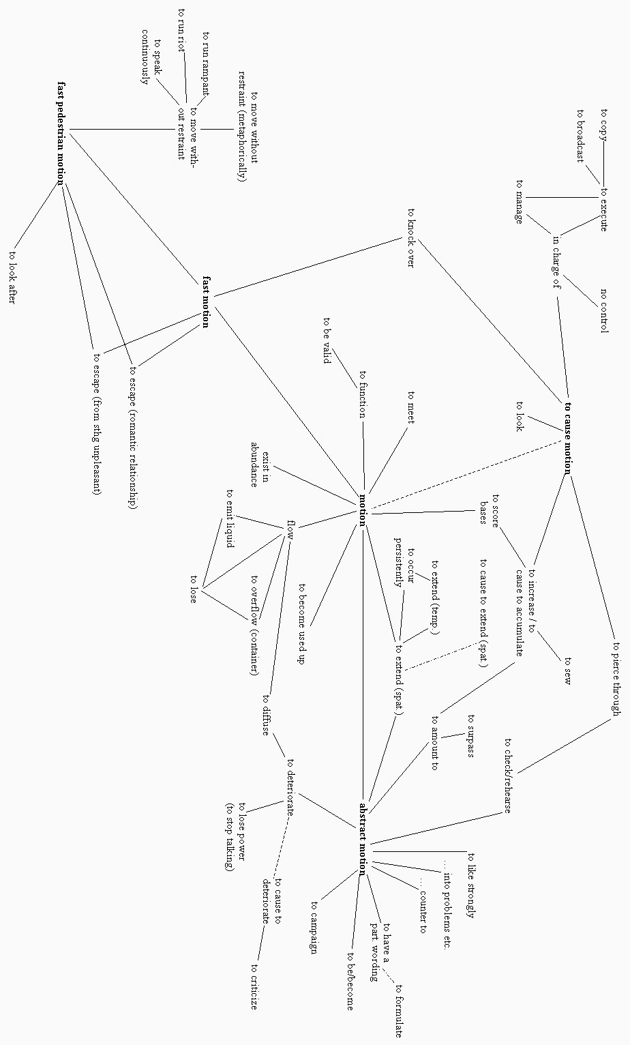

**Figure 2.4:** Semantic map of English *run* (Gries 2006: 74)

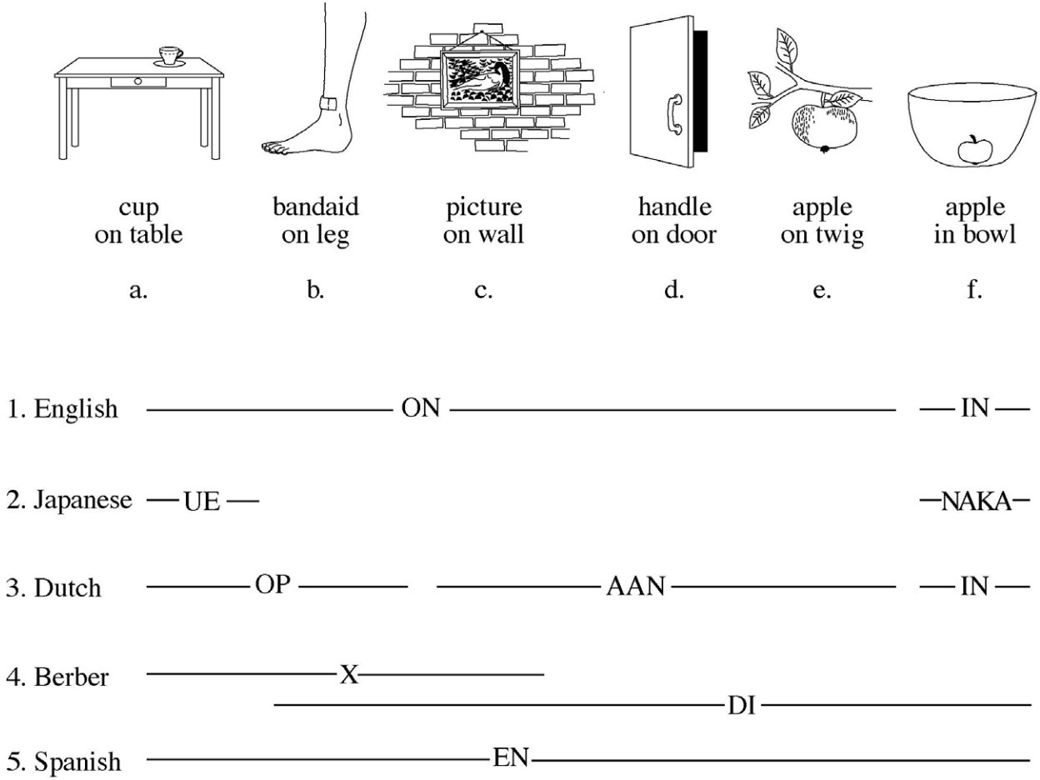

**Figure 2.5:** Crosslinguistic differences in the encoding of spatial relation- ships (Bowerman & Choi 2001: 485)

These examples illustrate that word meanings are polycentric and cover a range of possible uses, as mentioned in Section 2.3.1.4. Some of these uses may be more prototypical than others. The English expression *apple on a twig* is a slightly less prototypical use of *on* than *apple on a table*. The fact that lexical items cover a range of uses, and that some of these uses are more prototypical than others, is an important component of the typological markedness theory of lexical categories.

Even the formal categories that linguists use to describe linguistic structure tend to be prototypal (Taylor 2003: xii, 201). Taylor (2003: §11.1) argues that linguists’ conceptions of the formal labels *word*, *affix*, and *clitic* are prototypal in nature, with better and worse members of the category. Haspelmath (2005) likewise shows that simple structural definitions of these categories are inadequate and reframes the word–affix continuum in functional terms instead.

Much research in the Canonical Typology framework (Corbett 2005) also demonstrates the prototypal nature of linguists’ categories. Though Corbett is careful to distinguish between a *canon* and a *prototype* / *exemplar* (Corbett 2010: 142), his accumulated work nonetheless shows that linguists view phenomena in the world’s languages as better or worse instances of various descriptive categories.

What type of category are lexical categories then? Are word classes categories of human cognition, categories within particular languages, categories of languages generally, or ana- lytic categories of linguists? Or some combination of these? Typological markedness theory posits that parts of speech like noun, verb, and adjective are not categories of particular lan- guages. Languages have constructions, not parts of speech. Speakers, however, have *mental prototypes* of objects, actions, and properties. And although there is no *one* Noun construc- tion in English that would correspond to the mental category of object, there are numerous constructions in English which have the function of indicating *reference to an object*, such as the Definite Article construction or the Transitive Subject construction. Likewise, there is no one construction—in English or any language—that can be definitively called the Verb con- struction or the Adjective construction, but there are plenty of constructions which have the function of predicating or attributing properties. Naturally, then, speakers are more likely to use referring constructions when talking about something which they mentally categorize as an object, predicating constructions when talking about something they conceive of as an action, and modifying constructions when talking about something they conceptualize as a property.

Speakers’ conceptualizations, however, are fluid. Speakers often conceptualize things in non-prototypical ways. They may construe events as bounded entities that they can refer to, or objects as properties with duration. As a result, speakers often use lexical items in constructions that do not align particularly well with the item’s meaning, such as the appear- ance of an action word like *sing* in a referring construction like the Gerund in the phrase *his singing was beautiful*. When speakers use words in this atypical manner, those uses are much

more likely to be marked in some way—whether morphologically, behaviorally, semantically, or frequentially (Croft 1991: §2.2). As a consequence of this tendency, clear asymmetries emerge between the prototypical vs. non-prototypical uses of object words, action words, and property words. It is the unmarked use of these lexical items that most closely aligns with linguists’ traditional conceptions of noun, verb, and adjective. Parts of speech as tradi- tionally conceived are nothing more than the emergent effects of our cognitive prototypes on language. They do not have any real status in grammar or individual grammars. This is the fundamental idea behind typological markedness theory. Section 2.4.2 lays out this theory in more detail.

A last clarifying point is in order. Recognizing the existence of prototype-based categories, many linguists have described parts of speech as prototypal. Dixon (2004: 1–2), for example, says that the word classes noun, verb, and adjective each have a “prototypical conceptual basis” and “prototypical grammatical functions”. Taylor (2003: 217) states, “A prototype view of noun entails that some nouns are better examples of the category, while others have a more marginal status.” But languages have constructions, not parts of speech, and individual constructions are not gradient (Croft 2007). What linguists are in fact observing when they say that parts of speech are prototypal is not gradation in *linguistic categories* like noun, verb, and adjective (since those are not categories of particular languages), but rather gradation in the *mental categories* of objects, actions, and properties, which do indeed exhibit prototype structures, and which therefore have emergent effects on the organization of constructions in languages.

### **Typological markedness theory**

I have already previewed various aspects of typological markedness theory at different points in this thesis. In this section I present a concise overview of the specific claims made by this theory, and some of the evidence for those claims. The phrase *typological markedness* or *typological markedness asymmetries* simply refers to an implicational universal regarding the

behavior of basic versus non-basic members of a conceptual category. At its simplest, the theory posits that less basic or prototypical members of a category are marked in some way; basic or prototypical category members are unmarked by comparison (Greenberg 1966). This *cognitive* markedness is then realized *linguistically* in several ways. The marked member of a category *may* be literally marked with an affix or other overt morphological indicator, but this is just one of the ways an item can be a marked member of a category. The marked member of a category may also be less frequent, or have a smaller range of inflectional / distributional possibilities, or be semantically more complex. It is important to emphasize that *typological* markedness does *not* always entail *formal* markedness. Typological markedness is an *implicational* universal rather than an *absolute* universal. The more marked members of a category must be *at least as marked* as the unmarked member, but this does not preclude the possibility of all members being *equally* marked. Formal markedness is merely an emergent tendency of structures to reflect cognitive markedness.

As applied to word classes, typological markedness theory states that the most unmarked discourse functions for object, action, and property words are reference, predication, and modification, respectively. Therefore, when a lexical item is used for a function that does not align with its prototypical meaning, typological markedness theory predicts that it will be marked. Again, it must be emphasized that not *every* instance of a lexical item being used in a non-prototypical function will be marked in comparison to its prototypical function; but it will always be *at least as* marked. This theory of typological markedness for the major dis- course functions is laid out in detail by Croft in various publications (Croft 1991; 2000; 2001b; Croft & van Lier 2012). It is also important to understand that typological markedness theory is *not* a theory of parts of speech in the sense of large partitionings of the lexicon into cate- gories like noun, verb, and adjective. Instead, noun, verb, and adjective are epiphenomenal, crosslinguistic markedness patterns that arise from the interaction of semantic prototypes (object, action, property) and their use in different discourse functions (reference, predica- tion, and modification). They are not categories of particular languages.

Throughout this thesis, I have used the term *discourse function* to refer to the functions of reference, predication, or modification. These are what Croft (1991: 51) calls *pragmatic func- tions* or *propositional act functions* following the tradition of pragmatics and speech act theory in philosophy (Austin 1962; Searle 1969). These three functions are taken as fundamental to human communication, arising out of the communicative intent behind what speakers are attempting to *do* with language. This perspective was articulated early on by Sapir:

There must be something to talk about and something must be said about this subject of discourse once it is selected. This distinction is of such fundamental importance that the vast majority of languages have emphasized it by creating some sort of formal barrier between the two terms of the proposition. (Sapir 1921: 87)

A similar point is made by Croft while articulating his theory of typological markedness as applied to lexical categories: “[N]o matter how complex a given situation is in terms of the number of entities involved and the number and kinds of relations that hold between them, a human being attempting to describe it in natural language must split it into a series of reference-predication pairs[.]” (Croft 1991: 124)

Modification is generally seen as less central a function than reference and predication, as illustrated by its lack of mention in the quotes above. For example, Hengeveld (1992: 55) takes the reference-predication dichotomy to be fundamental, yielding the major cate- gories of noun and verb, while the modification function then combines with these two func- tions to yield the major categories of adjective and adverb, respectively. The primacy of the reference-predication distinction also appears to be reflected structurally in the world’s lan- guages, which do not always have dedicated morphological means for encoding modification but appear to always have constructions dedicated to reference and predication.

Croft (1991: 123) defines the pragmatic functions in terms of their discourse functions, following work in the discourse-functional tradition (Chafe 1976; Hopper & Thompson 1984; Chafe 1987; Du Bois 1987). Previous research defines *referents* as “discourse-manipulable par- ticipants” (Hopper & Thompson 1984: 711; Kibrik 2011), *predicates* as reported events (Hopper & Thompson 1984: 726), and *modifiers* as a mix of these two functions (Thompson 1989). Croft

(1991: 123) synthesizes ideas from this body of research and offers the following revised def- initions instead:

* the act of *reference* identifies a referent and establishes a cognitive file for that referent
* the act of *predication* ascribes something to a referent
* the act of *modification* enriches the cognitive image of the referent with an additional feature

The exact pragmatic function chosen for any given mention of a concept is then just a matter of how the speaker chooses to portray or construe that concept—whether as a referent, predicate, or modifier (Croft 1991: 100); as Croft & van Lier note, “apparent instances of ‘fuzziness’ are actually variable construals” (Croft & van Lier 2012: 63).

With this understanding of discourse functions in mind, we can restate the thesis of typological markedness theory as applied to lexical categories: Noun, verb, and adjective are epiphenomenal markedness patterns that arise from the use of different semantic proto- types (objects, actions, and properties) in different discourse functions (reference, predication, modification). Uses of these semantic classes in non-prototypical functions are typologically marked. As mentioned, there are four ways in non-prototypical uses can be marked: struc- turally, behaviorally, semantically, and/or frequentially.

The first type of marking, *structural coding* or *formal marking*, refers to the fact that non- prototypical uses of lexical items are at least as formally marked as prototypical ones. Struc- tural coding in this context refers specifically to “dedicated formal markers in a specific lan- guage that indicate a lexeme’s syntactic function” (Croft & van Lier 2012: 62). Figure 2.6 is a schematic representation of some of the formal realizations of these markedness patterns. In indicates the different morphosyntactic means that languages tend to develop for marking each of the non-prototypical uses of lexical items. For instance, participle constructions are one way that languages have of indicating the non-prototypical case of an action word being used for modification.

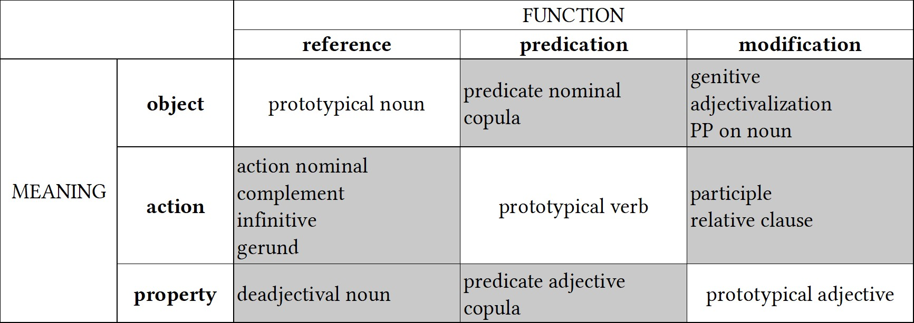

**Figure 2.6:** Typological prototypes for noun, verb, and adjective (adapted from Croft (2000: 89) and van Lier (2012: 62))

The second way in which non-prototypical uses of lexical items can be marked is in terms of their *behavioral potential*, that is, the range of combinatorial possibilities for that lexical item. This is most clearly illustrated with an example from inflection: in many languages, property words used in predicate constructions are limited in their inflectional possibilities. In Munya, for example, property words functioning as predicates cannot inflect for person and number of the subject, and cannot take the imperfective marker, perfective marker, or direct evidential marker (Bai 2019: 96–97). The only grammatical markers allowed in property predication clauses are the stative aspect marker, a clause-final particle, and an egophoric marker. Hopper & Thompson’s (1984) study of the discourse functions of different parts of speech is largely a study of behavioral potential. They conclude that “the closer a form is to signaling this prime [prototypical] function, the more the language tends to recognize its function through morphemes typical of the category—e.g. deictic markers for [Nouns], tense markers for [Verbs].” (Hopper & Thompson 1984: 703, abstract). Croft advances a cognitive explanation for these behavioral markedness patterns:

In general, only the core members of the syntactic category will display the full gram- matical behavior characteristic of their category because only they have all the semantic characteristics that the characteristic inflections tap into. This is to say that the inflec- tional categories of the major syntactic categories have been “tailored” to their semanti- cally core members. This is an example of a processing constraint: languages inflect only for those properties that are of relevance to core members of the category; they do not

inflect for properties of peripheral members of the category that are not of relevance to the core members of the category. (Croft 1991: 86)

Non-prototypical uses of lexical items may also be marked semantically by a *semantic shift* in their meaning towards the semantic class prototypically associated with the discourse function they are found in (Croft 2000: 96; 2001b: 73; Croft & van Lier 2012: 68). I have already discussed the semantic shifts that occur in functional expansion in some detail in Section 2.3.3.2. Croft (1991: 60–61) makes the even stronger claim that non-prototypical uses of lexical items will *always* be marked semantically, making semantic markedness an absolute rather than implicational universal.

These semantic shifts are caused by a combination of conventionalization and *coercion*, wherein the meaning of the constructional context is imposed on the meaning of the lexical item (Pustejovsky 1991; Croft 1991: 69, 108; Panther & Thornburg 2007: 252; Audring & Booij 2016). For example, predicate nominals (where an object word is used in a predicate construction) involve coercion of lexical items from denoting objects to denoting classifying or equational relations (Croft 1991: 69). In Nuuchahnulth, for instance, nominal predicates are always semantically durative and interpreted as either existential, classifying, or identifying expressions (Nakayama 2001: 47).

The final way in which lexical items used in atypical functions may be marked is in terms of their frequency. Croft (1991: 59, 87) also refers to this as *textual markedness*. Frequential markedness predicts that lexical items are used more frequently in their prototypical functions than in non-prototypical ones. This means that object words should be most frequent in their use in referring constructions, and that referring constructions should most frequently denote objects (Croft 1991: 87).

The field of linguistics has accumulated a good deal of empirical evidence in support of the typological markedness theory of lexical categories. Croft (1991) provides empirical evi- dence from 12 languages for each of these markedness patterns. Dixon (1977) also provides evidence of typological markedness patterns as they relate to property words, using a com-

bination of structural and behavioral evidence. As mentioned, Hopper & Thompson’s (1984) study also provides empirical support from a variety of languages for markedness in terms of behavioral potential. Stassen (1997) is a massive study of intransitive predication in 410 languages, demonstrating the marked behavior of non-action words when used in predicate constructions.

Having explicated the basic tenets of typological markedness theory, I now turn to re- framing the concept of lexical flexibility in a way that utilizes this framework.

## **Lexical flexibility: A functional definition**

Within the framework of typological markedness asymmetries, lexical flexibility can be un- derstood as follows:

**lexical flexibility** The use of a lexical item (root, stem, or inflected word) in more than one discourse function (reference, predication, or modification) with no difference in struc- tural coding.

This definition qualifies as a valid *comparative concept* in the sense of Haspelmath (2010a) because it is couched in terms of universal *functions* rather than language-specific *structures* (Croft 2016). It also has the advantage of being intentionally equivocal with respect to the lexical and cognitive unity of the item, and with respect to the linguistic level (root, stem, or inflected word) at which the flexibility is realized. In some cases when a single lexical form appears in more than one discourse function, speakers may have a close cognitive association between the two uses. This is most likely the case for the predicative and referential uses of the word *run* in the phrases *I run every morning* and *I’m going for a run* respectively. In other cases, speakers may have little to no awareness of the diachronic connection between uses of a form. For example, the use of *run* in the sense of *to run a print job* is extremely distant from the prototypical “fast pedestrian motion” sense in the semantic network for that form (Gries 2006: 74; see also Figure 2.4). It is unlikely that these two senses are closely cognitively connected by

most speakers, even though they both share a predicating function. The definition of lexical flexibility given here allows for any degree of semantic shift. Croft admits this possibility explicitly: “It of course a priori possible to construct a typological classification of parts-of- speech systems using only structural coding and allowing any degree of semantic shift.” (Croft 2001b: 68) Of course, I am not concerned here with constructing a classification of parts of speech—quite the opposite, in fact. This definition of lexical flexibility is intended to delimit exactly those cases where a language does *not* provide formal indicators of discourse function. Allowing for any degree of semantic shift does *not* imply that semantic shift is in any way unimportant for understanding lexical flexibility. On the contrary, semantic shift is a key component of the process of functional expansion that leads to flexibility in the first place (see below). Moreover, carefully circumscribing the phenomenon of lexical flexibility without regard to the degree and type of semantic shifts involved puts us in a position to then compare the semantic shifts that occur in cases of lexical flexibility with those that occur in cases of overt derivation. This raises the intriguing question of whether semantic shifts in flexible cases differ in principled ways from overt derivation. Mithun (2017: 165) shows that for Central Alaskan Yup’ik the types of semantic relationships between flexible uses of words mirror those between basic and derived words. This would suggest that functional expansion follows the same principles as overt derivation. However, much more research is needed in

this area.

As we have seen, a great abundance of evidence also shows that the meaning of any given combination of form and discourse function is a matter of convention, and often highly idiosyncratic (§2.3.2.4; §2.3.3.2). This fact suggests that flexible items are not truly “flexible” in the sense that speakers can use any lexical item for any discourse function and expect hearers to be able to infer their meaning from context. We know that item-specific gaps in usage exist. Certainly, novel cases of forms being used in new discourse functions do occur, or else it would not be possible for functional shift to happen in the first place. But these cases are necessarily restricted by the cognitive limits on our ability to deal with ambiguity.

If it were truly the case that any lexical item could be used in any discourse function at any time, it would barely be possible for hearers to interpret the intended pragmatic effects of each word. Instead, flexibility must rely on a degree of *conventionalization*. Conventionalization in turn implies *time*—conventionalization is a diachronic process. Thus, *lexical flexibility is best understood as a synchronic pattern resulting from the diachronic process of functional expansion*, where functional expansion is defined as follows:

**functional expansion** A diachronic expansion in the use of a lexical item (root, stem, or in- flected word) into a new discourse function (reference, predication, or modification) with no additional structural coding.

Cases of lexical flexibility therefore arise whenever a new combination of form and discourse function is conventionalized in a community of speakers. This understanding of lexical flex- ibility is in line with cognitive research on lexicalization and constructional change. Func- tional expansion occurs because of speakers’ need to construe concepts in different ways—as objects, actions, or properties. The semantic shifts that occur during functional expansion are the result of coercion by the new constructional context, and the resultant meaning then becomes conventionalized as the meaning of that particular form in that particular discourse function (Croft 1991: 108).

If lexical flexibility is the result of a diachronic process, it should be possible to enumerate some of the specific pathways which give rise to it. Here I will mention just a few. One path- way is insubordination, whereby subordinate clauses in a language are reanalyzed as main clauses (Evans 2007; Mithun 2008; Evans & Watanabe 2016) (see also §2.3.2.2). Insubordi- nation frequently results in formal similarities between noun phrases and verb phrases, and this formal ambiguity can abet the functional expansion of lexical items from referential to predicative uses and vice versa.

A second pathway to lexical flexibility is relexicalization (or more precisely, reconven- tionalization). This is the process that occurred in the case of morphological verbs being reanalyzed as nouns in many North American languages (see §2.3.2.3) and certain English

plurals like *brethren* or *arms*. In these cases, the conventionalized meaning associated with the form changed (e.g. from Cayuga ‘it hauls logs’ to ‘horse’), so that the meaning more closely reflected its new discourse context.

A third pathway is topicalization, exemplified in the Wakashan family. Jacobsen (1979: 122, 142) observes the formal similarity between the Definite Article and the Third Person Singular Indicative markers in Wakashan languages, and argues for a diachronic connection between the two. It is likely that cleft constructions such as ‘it was the dog that ran’ became so common that speakers started to reanalyze the topicalized cleft as a definite noun phrase, ‘the dog’, thereby creating a formal similarity between referring expressions and predicating expressions.

Each of these pathways results in the functional expansion of lexical items into new dis- course contexts with no new overt structural coding. Of course, functional expansion can also occur without any other accompanying grammatical changes. This happens in any instance where speakers simply use stems in new discourse functions. Lexical flexibility is the natu- ral and expected result of the fact that non-prototypical uses of lexical items are *not* always structurally marked—as allowed for by the fact that typological markedness is implicational and not absolute—even if they are marked in other ways. The use of additional structural coding in cases of functional expansion is not obligatory, but merely a statistical tendency. Lexical flexibility occupies the theoretical space where structural coding asymmetries fail to apply.

When viewed in this light, *lexical flexibility is not so much a problem as it is a design feature of language*. The presence of lexical flexibility should be *expected* in every language, not treated as exotic. The cognitive-typological approach outlined in this chapter inverts the lexical flexibility question: the interesting question is not why some languages fail to make distinctions in parts of speech (thereby framing lexical flexibility as a *deficit* in a way similar to colonial researchers), but rather why languages develop specialized constructions for different discourse functions in the first place (see Gil [2012] for an attempt to answer this question for

predication). Lexical flexibility exists in any area of the grammar where specialized function- indicating morphology has yet to develop, or where such distinctions have been leveled via diachronic changes. Flexibility should therefore be considered the default state of affairs for language. Gil (2005; 2006) has in fact argued, partially on the basis of data from highly flexible languages, that early human language must have been *isolating-monocategorial-associational* before the development of dedicated function-indicating morphology.

The idea that the “natural state” of language is monocategorial or acategorial would seem to conflict with the point made above that lexical flexibility can result from diachronic pro- cesses, but the two positions are not mutually exclusive. Languages develop constructions which indicate different discourse functions, but languages are also subject to counteracting pressures. This is a classic case of competing motivations: on the one hand, the frequency with which speakers need to perform the discourse functions of reference, predication, and modification all but ensures the development of constructions dedicated to indicating those functions; on the other hand, speakers need to construe states of affairs in various ways— as objects, actions, or properties—creating pressures which have the potential to level or cut across those formally marked distinctions. Reconventionalization and the reanalysis of cleft constructions could both be viewed as diachronic processes motivated by this latter pressure.

In sum, then, lexical flexibility is a natural result of the cognitive and diachronic forces at work in language. Defining lexical flexibility in terms of typological markedness (or more accurately, the lack of formal marking for otherwise marked uses) provides a crosslinguis- tically applicable definition of the phenomenon which avoids methodological opportunism while still recognizing that lexical flexibility requires some degree of semantic shift and con- ventionalization. This cognitive-typological definition of lexical flexibility is the primary the- oretical contribution of this thesis. With this definition in place, the remainder of this thesis turns to exploring the prevalence of lexical flexibility in English and Nuuchahnulth and the semantic behavior of lexical items in cases of functional expansion.

# **Chapter 3**

**Data & Methods**

This chapter describes the data used for this study and how those data were analyzed. It covers the languages chosen, the corpora used, and how samples from each corpus were created and annotated (Section 3.2). I describe the methods used to annotate the data, and the factors that influenced annotation decisions (Section 3.3). I also discuss the specific statistical measures used in this study in Section 3.4. Section 3.4.1 introduces a metric for quantifying the flexibility of individual lexical items in a corpus. This formulation of lexical flexibility is a key methodological contribution of this thesis. Section 3.4.2 explains how I examine the relationship between lexical flexibility and corpus size, by comparing average flexibility ratings for differently-sized portions of the same corpus. Finally, Section 3.4.3 presents and motivates a measure of corpus dispersion (Deviation of Proportions, or *DP* ) that is used partly in place of, and partly as a complement to, raw token frequencies.

## **Introduction**

The process of collecting, annotating, and analyzing the data for this study adheres to several self-imposed principles. First and foremost, the data in this study consist of naturalistic dis- course data rather than elicited data. This principle has two motivations: First, as discussed in Section 1.2, few studies examine token frequencies of lexical items used for different discourse

functions, and those that do only report aggregated results. Most extant research consists of lexicon-based counts. This study therefore explores a previously unexamined aspect of lexi- cal flexibility. Second, corpus-based methods study real-world instances of language in use, rather than made-up examples or examples produced by introspection, which are subject to various cognitive and social biases (P. Baker 2018: 168). Corpus data are also more likely to reveal prototype effects through statistical tendencies. For this study, I rely on specialized corpora of spoken narratives and conversational texts only. This ensures greater comparabil- ity between the corpora used in this study and other documentary corpora that these methods may be applied to in the future, since most documentary corpora likewise consist of spoken narratives and conversations.

The second self-imposed requirement for this study is adherence to the [Austin principles](https://site.uit.no/linguisticsdatacitation/) [of data citation in linguistics](https://site.uit.no/linguisticsdatacitation/) (Berez-Kroeker et al. 2018). In particular, the source for each data point discussed in this thesis is uniquely identified with its location in the corpus, and the data used in this study are made freely available on GitHub at [https://github.com/](https://github.com/dwhieb/dissertation) [dwhieb/dissertation](https://github.com/dwhieb/dissertation). All of the data and my annotations on that data may be viewed there.

Finally, as a matter of scientific accountability, this study is designed to be replicable using the same or other datasets. All of the technical details regarding how to acquire the data, an- notate it, and run statistical analyses for those data are documented in the GitHub repository for this project, which may be viewed at <https://github.com/dwhieb/dissertation>. The remainder of this chapter details the methods used to answer each of the major re- search questions presented in Chapter 1. The core empirical question addressed by this study is R1: “How flexible are lexical items in English and Nuuchahnulth?” The other two research questions build on this one. To answer this core question, I count the frequency with which stems are used for each of the three functions of reference, predication, and modification in corpora for each language. Section 3.2 describes the corpora used, where to acquire the data, and how lexical items in the corpora were selected for annotation. Section 3.3 describes the

details of this annotation procedure. Finally, Section 3.4 explains the specific statistical mea- sures used in this study. Section 3.4.1 describes how to use the annotated data to calculate a measure of lexical flexibility for each of the lexical items in the sample. This procedure for quantifying lexical flexibility based on corpus data is the primary methodological con- tribution of this thesis. Section 3.4.3 then discusses some shortcomings in the use of token frequencies, and presents a measure of corpus dispersion (Deviation of Proportions, or *DP* ) as an alternative.

## **Data**

In Section 1.3, I discussed the motivations for using English and Nuuchahnulth as the lan- guages of focus in this study. Both languages have featured prominently in the literature on lexical flexibility. Some researchers have called these languages flexible, while others have claimed that they are rigid. For English, I opted to use the [Open American National Corpus](http://www.anc.org/) (OANC), a 15-million-token open access corpus of American English (Ide & Suderman 2005). I restricted my analysis to just the spoken portion of the corpus, comprising approximately

* 1. million tokens, so that the data would be comparable to the spoken corpus of Nuuchah- nulth and other documentary corpora. The spoken portion of the corpus itself consists of two distinct subcorpora—the [Charlotte Narrative & Conversation Collection](https://newsouthvoices.uncc.edu/) (the “Charlotte corpus”) and the [Switchboard Corpus](https://catalog.ldc.upenn.edu/LDC97S62). The Open American National Corpus can be obtained for free at <http://www.anc.org/>.

The data for Nuuchahnulth come from a documentary corpus compiled by Toshihide Nakayama and published in Little (2003) and Louie (2003). The corpus consists of 24 texts by two speakers (Caroline Little and George Louie), containing 2,081 utterances and 8,366 tokens. The texts are personal narratives, traditional stories, and procedural texts. I manually retyped the corpus in [scription](https://scription.digitallinguistics.io/) format (Hieber 2021a), which is a simple way of formatting interlinear texts so as to make them computationally parsable. I then converted the corpus

to the Data Format for Digital Linguistics (DaFoDiL) (Hieber 2021b), which is a way of repre- senting interlinearized data in JSON, allowing programmers to easily and programmatically work with linguistic data. The resulting corpus is available in both formats on GitHub at <https://github.com/dwhieb/Nuuchahnulth>.

The sheer size of the Open American National Corpus—even when considering just the smaller, spoken portion of 3.2 million tokens—made it practically impossible to tag every to- ken in the corpus for its discourse function for the time being. At the opposite end of the spectrum, the Nuuchahnulth corpus is small enough (*∼*8,300 tokens) that it was possible to tag every single lexical token in the corpus. Given this size disparity, it was important to sample lexical items from each corpus in such a way as to make them reasonably comparable. I did this by extracting two kinds of samples from each corpus: 1) a 100-item sample of lex- emes randomly selected from different frequency bins, and 2) a small corpus sample (*<*10,000 tokens) for which all lexical items in the sample were annotated.

To create the 100-item samples, I first *lemmatized* each corpus. For every lexical to- ken in the corpus, I programmatically determined the lemma associated with that partic- ular wordform. For example, the English wordforms *knows* and *knew* are associated with the lemma *know*. For English, lemmatization was accomplished with the [Natural Language](http://www.nltk.org/) [Toolkit](http://www.nltk.org/) for Python (Bird, Klein & Loper 2009), using the Wordnet lemmatizer. The OANC includes Penn tags for parts of speech, so I was able to use those part-of-speech tags with Wordnet’s lemmatize() method to improve lemmatization. For Nuuchahnulth, lemmati- zation simply involved programmatically stripping away the inflectional morphology from each token, leaving just the stem. For example, token in (31) is lemmatized as an instance of the stem *ʔam‑umɬ‑* ‘first‑be.born’. Since the entire Nuuchahnulth corpus is interlinearized with glosses and stored in DLx JSON format (Hieber 2021b), this was accomplished with a simple Node (JavaScript) script.

1. Nuuchahnulth (Wakashan > Southern Wakashan)

ʔaamumɬʔaƛquu ʔam‑umɬ‑ʼaƛ‑quː first‑be.born‑fin‑cond when.first.born

‘when [a baby] was born’ (Little 2003: Afterbirth 1)

It is important to mention that annotating the Nuuchahnulth corpus for discourse function would not have been practical without the detailed descriptive work of Toshihide Nakayama. The creation of text collections is often underappreciated as a worthwhile academic endeavor, but this process requires a high level of analytical skill and theory creation / testing. Moreover, this is the only way we gain new corpora of naturalistic discourse for minority languages. The empirical and theoretical findings of this project would not have been possible without this important work.

After lemmatizing each corpus, I calculated the raw frequencies for each lexeme. I then grouped lexemes into 100 bins based on their frequencies, and randomly selected one lexeme from each bin. This produced a sample of lexemes from a range of different frequencies. The frequencies of lexemes in the English sample, for instance, ranged from 44,687 for the word *know* to 53 for the word *central*. Lexemes with a frequency *<*4 were excluded, because the lexical flexibility measure described in Section 3.4.1 requires a minimum token frequency of 4 in order to return a statistically significant value.

Various other types of words were excluded from this process as well:

* words written using numeric characters (e.g. *12%* or *117* )
* obvious cases of code-switching or code-mixing (e.g. *union mančiʔaƛ* ‘became a union man’)
* transcategorial words (those with both lexical and grammatical uses) (e.g. *be*, *do*)
* discourse markers (e.g. *uh*, *well*)

Some types of items that were *not* excluded are compounds written as a single word (e.g. *guidepost*) and proper names (e.g. *San Francisco*), although neither of these wound up in the final list.

The output of this selection process was a list of 100 lexical items in each language to be examined for lexical flexibility. The list of 100 lexical items for each corpus is given in Appendix B, along with statistics about their frequencies, corpus dispersions, and flexibility. I then created a list of every instance of these 100 lexical items in each corpus. For English, this resulted in a list of 382,512 tokens to be annotated. For Nuuchahnulth, there were just 1,632 tokens to annotate. I annotated each one of these approximately four hundred thousand tokens for discourse function by hand. This procedure is described in the following section.

Having created the 100-item samples, I next created a small corpus sample (*<*10,000 to-

kens) for each language. The smaller size of these samples allowed me to annotate every single lexical item in the sample for its discourse function. The Nuuchahnulth sample simply con- sists of the entirety of the corpus (8,300 tokens), while the English sample consists of the first four texts in the corpus, totaling *∼*9,700 tokens. These two subcorpora are both available in the GitHub repository for this study at <https://github.com/dwhieb/dissertation>.

With the two samples prepared, I next turned to the process of annotating each lexical item in the sample for its discourse function. This annotation procedure is described in the following section.

## **Methods**

Within each of the samples, not every token was annotated for its discourse function. This section discusses the various reasons why tokens might be excluded from the analysis, and the factors that contribute to the determination of the discourse function for each token.

First, I only annotated lexical uses of words. Grammatical/functional words and discourse markers were ignored. Among lexical words, adverbial uses were also excluded. Ignoring adverbial uses of words sometimes results in lexical items with a very high overall corpus frequency, but very low occurrences of use for reference, predication, or modification. For example, the English word *never* has a high overall frequency (3,024 tokens), but has exactly

1 modifying use (*that’s a* ***never*** *touch*). The rest of its uses are adverbial. Proper names *were* included, a decision which turned out to be fortuitous since proper names displayed flexible, non-referential uses in both English and Nuuchahnulth, as in (32) and (33).

1. English (Indo-European > Germanic)

they settled down in the **Chicago** suburbs (Ide & Suderman 2005: JamiesonSean)

1. Nuuchahnulth (Wakashan > Southern Wakashan)

qʷaa qʷaː thus thus

y̓ uuqʷaa y̓ uːqʷaː also also

**w̓iikinanišitquu w̓iːkinaniš‑it‑quː**

**name‑past‑cond.3 who.was.W̓ iikinaniš**

‘So was the one whose name was *W̓ iikinaniš*’ (Louie 2003: GL 19)

The function of each lexical item was determined in relation to its most immediate syn- tactic constituent. As an illustration, consider how to analyze the word *time* in the phrase *all time favorite*. The phrase *all time* is functioning to modify the referring expression *favorite*, with the syntactic structure *[[all time] favorite]*. However, within the context of *all time*, the word *time* is a referent, not a modifier. Compare this to the expression *all time slots*, which has the syntactic structure *[all [time [slots]]]*, and where *time* is indeed modifying the referent *slots* directly. Thefore I annotated *time* as a referent in the phrase *all timeRef favorite* and as a modifier in the phrase *all timemod slots*. As another example, when annotating tokens of the word *woman* I excluded its appearance in the phrase *anti‑women statements*, because it forms one part of the complex word *anti‑women*, with the structure *[[anti-women]mod state- ments]*. If the phrase had been just *women statements* instead, I would have analyzed *women* as a modifier.

In the remainder of this section I discuss some analytical issues specific to English and Nuuchahnulth respectively. The following points are specific to English:

* Words related through stress shifts (e.g. *conˈduct* and *ˈconduct*) were treated as separate lexical items since their phonological forms are distinct. In the corpus, context always made it possible to determine which use was intended.
* Compound words were included in the analysis, but individual components of com- pound words were not. For example, when annotating tokens of the word *back*, in-

stances within the compounds *back yard* or *hard back book* or *back burner* were ex- cluded from the analysis. Instances of lexical items within noun-verb compounds (“noun incorporation”) were also excluded, such as *pie* in *pie baking*. However, compound words as a whole *were* included in the analysis. For example, the lexical item *back yard* was treated as a lexical unit and analyzed for its discourse function. Therefore I analyze *back yard* as a referent in *we were sitting in the [back yard]Ref* and a modifier in *it was a [back yard]mod party*.

* Lexicalized phrasal verbs such as *back up* were treated as a lexical unit, such that it was possible for the lexical item to appear in different discourse functions: *he doesn’t [back up]pRed that point* vs. *please make a [back up]Ref* vs. *you have a fairly good [back up]mod quarterback*.
* Tokens used as gerunds, infinitives, or predicate nominals / adjectives were tagged separately and ultimately excluded from the analysis, since most researchers would consider these to be instances of morphologically marked conversion in English.
* Adverbial uses of participles similar in function to the Latin ablative absolute were excluded from analysis, e.g. *talking about the golf thing, […]*.
* Stative (modificational) versus dynamic (predicational) uses of past participle forms required special consideration. It was not always possible to discern with certainty whether a given token of a past participle form was being used statively or dynamically. Compare the use of the word *relieved* in the phrases *she was relieved of duty* vs. *she was relieved to find her car*. The first use is arguably predicative while the second seems more like a predicate adjective. In cases where the discourse context does not make the intended use clear, I opted to code the data as a predicate, since this is the more conservative, historically prior form. Stative, predicate adjective uses were excluded from the analysis.

The analysis of discourse functions in Nuuchahnulth faces a different set of issues. A first difficulty arises from the holophrastic nature of Nuuchahnulth, in which it is extremely com- mon for a single word to constitute an entire clause (52.2% of the time according to Nakayama [2001: 149]). While an individual lexical item may be functioning as a predicate within its clause, the clause itself may be functioning to refer or to modify. Since the inflected word and the clause are coterminous, however, the potential for ambiguity arises. For example, Nakayama (2001: 113) states that “[i]n *modification* one predicate restricts the interpretation of the other semantically main predicate.” (Nakayama 2001: 113) This simultaneously treats a word as both a modifier and a predicate. This problem is exacerbated by the fact that, even

though Nuuchahnulth is highly polysynthetic, it is nonetheless quite common for stems to ap- pear with no inflectional morphology indicating their discourse function. To the researcher not familiar with Nuuchahnulth morphosyntax and discourse patterns, it can seem at first glance as though determining clausal boundaries with any certainty in the language is near impossible.

Thankfully, this impression is just superficial. While there are indeed tokens that are ambiguous as to their discourse function, this is generally not the case. Converging evidence from morphology, word order, topic continuity, word-level translations, and utterance-level translations is typically sufficient to determine the discourse function of any token with a high degree of confidence. The following paragraphs briefly summarize the relevant factors for determining the discourse function of a given token.

Two features of Nuuchahnulth grammar in particular are extremely helpful in determin- ing the discourse function of words. First, Nuuchahnulth is strongly predicate-initial. When a lexical argument is present, the predicate precedes the argument 84.9% of the time (Nakayama 2001: 149). Lexical arguments precede their predicates only in pragmatically marked situ- ations like contrast or disambiguation, which is typically made clear by an accompanying topicalization construction in the English translation. Second, Nuuchahnulth speakers have a strong dispreference for using more than one lexical argument in a clause. In a sample of 734 clauses, only 39 (3.8%) have two lexical arguments, and none have three (Nakayama 2001: 149). This disinclination is so strong that speakers often express a single event in successive clauses, repeating the predicate (Nakayama 2001: 75). Consider the examples in (34a) and (34b).

1. Nuuchahnulth (Wakashan > Southern Wakashan)
   1. **hinaačiʔaƛ**

**hin‑a·či(ƛ)‑ʼaƛ**

**there.mom‑go.out.to.meet‑fin went.out.to.meet**

ƛaʔuukʷiʔatḥ ƛaʔuːkʷiʔatḥ Clayoquot Clayoquot

**hinaačiƛ**

**hin‑a·či(ƛ)**

**there.mom‑go.out.to.meet went.out.to.meet**

minwaaʔathʔi minwaːʔath‑ʔi· British.soldiers‑def the.British.soldiers

‘The Clayoquots went [in their canoes] out to sea to meet the British soldiers.’

(Nakayama 2001: 75)

* 1. **sukʷiƛ**

**sikʷi(ƛ) take**

**take**

ḥaw̓ iɬuk ḥaw̓ iɬ‑uk chief‑poss their.chief

ƛaʔuukʷiʔatḥ ƛaʔuːkʷiʔatḥ Clayoquot Clayoquot

[…]

[…]

[…]

[…]

**sukʷiƛ sukʷi(ƛ) take**

**take**

miimixt miːmixt name name

‘The Clayoquot chief took Miimixt.’ (Nakayama 2001: 75)

In (34a), the arguments *ƛaʔuukʷiʔatḥ* ‘Clayoquot’ and *minwaaʔathʔi* ‘the British soldiers’ are distributed over two clauses, with the predicate *hinaačiƛ* is repeated in each clause. Example (34b) follows a similar pattern. Awareness of just these few abovementioned facts does most of the work of determining the discourse functions of words by establishing the predicate and referent in each clause.

Certain inflectional markers, when present, also unambiguously indicate the discourse function of the word they appear with. Words which take the definite suffix *‑ʔi·* (glossed as def) or one of the relative suffixes (glossed as Rel) always function to refer. Except when they co-occur with either the definite or relative markers, the following kinds of mood suffixes al- ways indicate a predicate. In Nuuchahnulth, most mood suffixes are fused with the following person suffixes, so each of the suffixes in this list has multiple realizations depending on the person and number of the clausal arguments.

* conditional (cond)
* dubitive (dub)
* imperative (imp)
* indicative (ind)
* interrogative (inteR)
* purposive (puRp)
* quotative (ot)
* subordinate (suboRd)

In Nuuchahnulth, verb serialization is quite common, and the above mood suffixes only ap- pear on the first (main) stem in a serial verb construction (Nakayama 2001: 42). Main pred- icates are also predominantly marked for person even if mood marking is not present (over 90% of main predicates in the first person) (Nakayama 2001: 29). Aspect markers, however, are not a completely reliable indicator of predication. Though it happens infrequently, aspect markers may occur with referents or modifiers as well (Nakayama 2001: 47–50).

Certain distributional behaviors also abet identification of the discourse function of a word. Nakayama notes the following in regard to referents: “Nominals can be modified with expressions of property concepts, quantity, or quantifiers, but not directly with qualifying expressions like *hiikʷaɬ* ‘almost’ or *ʔanatʼuu* ‘barely’.” (Nakayama 2001: 49). Syntactic pat- terns are also helpful: Negation is accomplished by means of a negative predicate *wik‑*, which takes another predicate as its complement. Modifiers generally precede their heads, whether the head is a referent or predicate. In serial verb constructions, only the main predicate takes person and mood marking, and the other members of the serialization immediately follow the main predicate as bare stems.

Finally, discourse-level considerations play an important role in determining the prag- matic function of each word. Most helpful is topic continuity, wherein a referent is already established in the discourse. This is accomplished either directly via an overt referent in a lex- ical argument or bound person marker, or indirectly via other kinds of inflectional affixes or features of a word that imply the existence of an referent (what Kibrik (2011) calls *referential aids*). Each successive lexical item encountered in a text must be interpreted in the context of the previously established discourse referents, so that certain interpretations of the item are much more sensible than others. Lastly, in a few particularly ambiguous cases, I consulted the audio files accompanying the corpus in order to prosodic information into account. Clear prosodic breaks in the discourse help to determine clausal boundaries.

Small annotated extracts from each corpus are given in Appendix C in order to illustrate

the resulting annotations. While the actual annotations are stored in JSON format, these extracts are presented in a more human-readable format instead. The discourse function of each token is written as a subscript (Ref, pRed, or mod). Tokens without their discourse function indicated were excluded from the analysis for one of the reasons mentioned above.

## **Analysis**

This section discusses the specific statistical measures used in this study. In Section 3.4.1, I present the measure used to quantify the lexical flexibility of individual items in a corpus, and in Section 3.4.3 I discuss the use of token frequencies versus dispersion.

### **Measuring lexical flexibility**

Once the lexical tokens in a corpus are annotated for their discourse functions, it is possible to calculate the flexibility of each lexical item using a measure known as Shannon’s diversity index. This section summarizes the rationale for using this metric and the procedure for calculating it.

Intuitively speaking, a lexical item is most flexible when it is used with equal frequency for reference, predication, and modification. A perfectly flexible lexical item which appears 300 times a corpus would therefore have a distribution like that in Table 3.1. By contrast, a perfectly rigid / inflexible lexical item with the same overall frequency would have a distri- bution like that in Table 3.2. What is needed is a metric that captures how evenly distributed the tokens of a lexical item are across the different discourse functions. A perfectly flexible item like that in Table 3.1 should receive a high rating (say, 1), while a perfectly rigid item

like that in Table 3.2 should receive a low rating (say, 0).

I elected to use Shannon’s diversity index (*H*) for this purpose (Shannon 1948; 1951). Originally devised as a measure of entropy in text (uncertainty or information content), the Shannon index has also become a popular measure of species diversity in ecology (Avolio

**Table 3.1:** Distribution of discourse functions for a perfectly flexible lexical item

lexical item reference predication modification

*stem* 100 100 100

**Table 3.2:** Distribution of discourse functions for a perfectly rigid/inflexible lexical item

lexical item reference predication modification

*stem* 300 0 0

et al. 2012) and attention diversity in political science (Boydstun, Bevan & Thomas 2014). Here I am using it as a measure of the functional diversity of lexical items. The normalized version of Shannon’s *H* yields a value between 0 (low diversity) and 1 (high diversity). For a categorical variable with *n* possible values, *Hnorm* is calculated using the formula in (35), where *pi* corresponds to the percent frequency of the *i*th possible value of the variable.

1. *Hnorm* =

*n*

(*pi* ln *pi*)

∑*− ·*

*i*=1

ln *n*

For this study, *n* will always be 3 (reference, predication, and modification). Future re- searchers may wish to adjust this number depending on the number of discourse functions examined (for example, if the predicate modifier function were included).

Frequently there will not be any instances of a lexical item being used in one discourse function or another. Since log 0 is undefined, the above formula cannot be resolved in these cases. One common workaround to this problem is to increment the frequencies of each discourse function by 1 before performing the calculation. Another is to simply treat log 0 as equal to 0 (Gries 2013: 120–121). I use the latter procedure in this study.

Applying Shannon’s *H* to the fabricated data in Table 3.1 and Table 3.2 produces the desired results: a value of 1 for *H* in the perfectly flexible case and a value of 0 in the perfectly rigid case.

One limitation of the Shannon diversity index as applied to this study stems from the fact

that there are so few discourse functions under consideration (just three: reference, predi- cation, and modification). This means that at low frequencies there are a limited number of possible values of Shannon’s *H*. For example, a lexical item with a frequency of 2 will either have an *H* value of 0 or *.*63, because there are only two ways those tokens can be distributed across discourse functions (2 0 0 or 1 1 0). A lexical item with a frequency of 3 will have an *H*

value of 0, *.*58, or 1, because there are only three ways those tokens can be distributed across discourse functions (3 0 0, 2 1 0, or 1 1 1), and so on.

To address this issue, I only included lexical items in the samples that had a raw frequency of at least 4. This cutoff was established based on the fact that 4 is the smallest frequency that can theoretically return a significant result for Shannon’s *H* when a lexical item is maximally flexible, in one of the two ways one can compute a multinomial test (probabilities vs. a χ2 test).

Shannon’s *H* was calculated for each of the lexical items in the samples from both corpora to produce a flexibility rating for each item. The resulting flexibility ratings for the 100-item samples are provided in Appendix B.

One final methodological point is merited: many common constructions recognized by all speakers nonetheless do not appear in even a 1.5-million-word corpus. For example, in the spoken portion of the Open American National Corpus, the word *hate* occurs as a predicate and a modifier but never as a referent. We know that referential uses of *hate* are possible (for instance in phrases like *five‑minute hate* or *don’t spread hate*), but they are not attested in the OANC. As a consequence, the English stem *hate* in this study shows no flexibility in the reference dimension, even though we know such cases are possible. The flexibility ratings in this study are necessarily approximations, based on a representative sample.

### **Flexibility and corpus size**

As discussed in Section 1.3, some researchers suggest that flexibility should increase as a function of corpus size. The intuition behind this claim is that the larger the corpus, the more

likely there are to be flexible uses of any given lexical item. This is the basis for R2, “Is there a correlation between degree of lexical flexibility and size of the corpus?”. To test this claim, I calculated the flexibility of each stem each time a new token of that stem was encountered in the corpus, thereby collecting data on the *cumulative* flexibility of each stem as the size of the corpus grows. For English I used the 100-item sample, and for Nuuchahnulth I used the entire corpus. Only stems with a frequency greater than 4 were included (see Section 3.4.1 for the motivation behind this restrictions). The resulting data allows us to examine how the flexibility ratings of each stem change as the corpus increases in size.

### **Frequency vs. dispersion**

Research question R3 asks, “Is there a correlation between degree of lexical flexibility for a lexical item and its frequency?”. The intuition behind the notion of frequency, however, can be understood and quantified in different ways. In this study I examine two different metrics and their relationship to lexical flexibility: relative token frequency and corpus dispersion. This section describes the rationale and procedures for each of these metrics.

*Token frequency* is by far the most common statistic used in corpus linguistics (Gries 2008: 403), and is central to usage-based theories of language (Bybee 1985; Tomasello 2003; Gold- berg 2006; Bybee 2007; 2010; Diessel 2019). It is computed by simply counting the number of instances (tokens) of a lexical item in a corpus. When working with multiple corpora it is important to normalize this statistic because the sizes of corpora vary. An item that occurs a large number of times in a million-word corpus may nonetheless be relatively infrequent compared to other items in the corpus. In order to compare the English and Nuuchahnulth corpora (which are drastically different in size), I report both the raw token frequency of lex- ical items as well as their *relative token frequencies*, calculated as the number of occurrences per 1,000 tokens in the corpus. Both metrics are reported for each lexical item in the 100-item samples in Appendix B.

Token frequencies can be misleading, however (Gries 2008; 2021; forthcoming). There

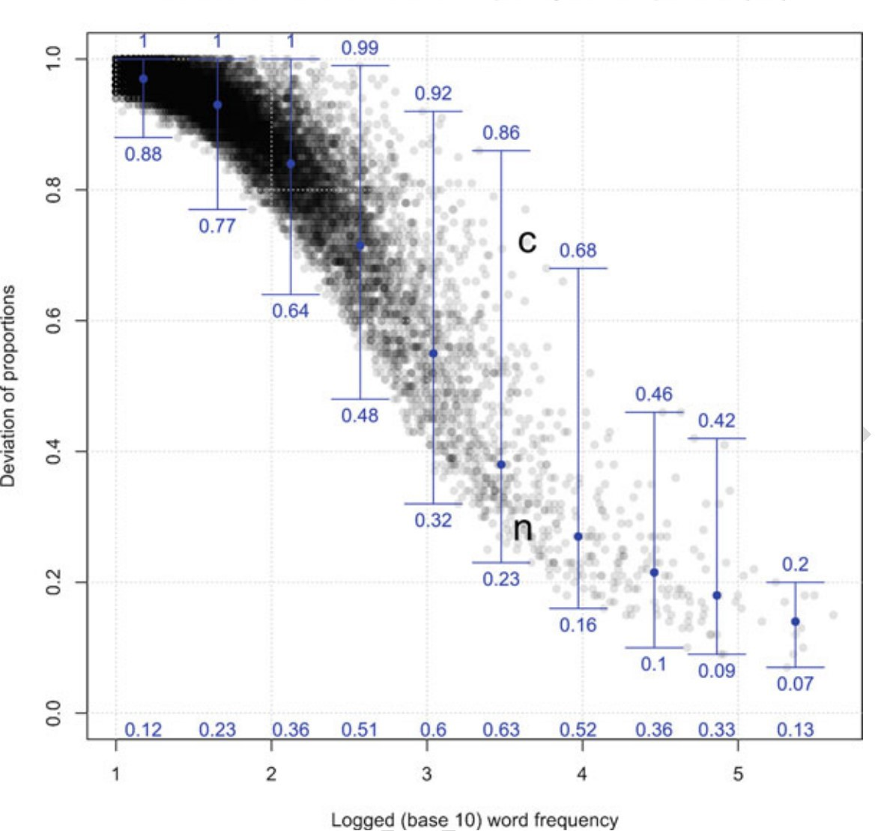

**Figure 3.1:** The relation between word frequency and dispersion (*DP* ) (from Gries [2021: 112])

is often a great deal of within-corpus and between-corpus variability in the frequency of a lexical item. Moreover, words with the same token frequencies may differ significantly in how evenly distributed or dispersed they are in a corpus. For example, while the words *enormous* and *staining* both occur 37 times in the Brown corpus, all 37 instances of *staining* are clustered within just one corpus part. By contrast, the tokens of *enormous* are distributed mostly evenly across 36 corpus parts, with 35 of those parts containing a single use of *enormous* (Gries 2021: 100).

Disparities between token frequency and dispersion are especially common for lexical

items in the middle frequencies (between 1,000 and 10,000 tokens), as demonstrated in Fig- ure 3.1 from Gries (2021: 112). In this plot, word frequency is shown on the x-axis (logged to the base of 10), and dispersion is shown on the y-axis (measured using *Deviation of Propor- tions* (*DP* ); see below for details). Each word in the corpus is represented by a gray point. Lexical items are divided into 10 bins based on frequency, and the blue whisker in each bin represents the range of dispersion values in that frequency bin. The plot makes clear just how widely words within the same frequency bin can vary in terms of their dispersion, especially in the middle frequencies.

If what we are intending to capture with these statistics is some idea of the regularity with which speakers encounter a word, it is clear that raw frequency is a deceptive measure. Instead, recent work has shown that *corpus dispersion*—how evenly an item is distributed in a corpus—more accurately represents frequency of exposure or lexical access (Gries 2008; 2010; forthcoming). Corpus dispersion correlates more strongly with reaction time data than does frequency, for example (Gries forthcoming).

Thus for this project I report a measure of corpus dispersion in addition to relative token frequency. I use a measure called *Deviation of Proportions* (*DP* ), created by Gries (2008). In a review of various measures of corpus dispersion, Gries (2008) discusses shortcomings with existing measures and proposes Deviation of Proportions as a conceptually simple alternative; it is also this measure which most strongly correlates with reaction time data, as mentioned above. In essence, Deviation of Proportions measures how much the frequency of an item within the various parts of a corpus deviates from what one would expect if the item were evenly distributed in the corpus. The procedure for calculating *DP* for a given lexical item is as follows:

* + - 1. Determine the sizes of each part of the corpus as a percentage of the overall corpus. These values represent the *expected* percentage of the time that one would expect the item to appear in each corpus part, if it were evenly distributed.
      2. Determine the frequencies with with the target item occurs in each part, as a percentage

of its overall frequency of occurrence. These values represent the *actual* or *observed*

percentage of the time that the item apperas in each corpus part.

* + - 1. Compute the pairwise absolute differences between the expected and observed percent- ages, sum them up, and divide the result by two.
      2. The result is *DP* , which theoretically ranges from 0 (the item is evenly distributed across the corpus, given the size of the parts) to 1 (the item is unevenly distributed across the corpus, given the size of the parts).

The mathematical formulization of *DP* is shown in (36), where *n* is the number of corpus parts, *v* is the frequencies of the target item in each corpus part, *f* is the overall frequency of the target item in the corpus, and *s* is the percent size of each corpus part.

*n*

(36) *DP* = 0*.*5 *×*

∑*i*=1

*vi*

*| f −*

*si|*

A more detailed explanation of this calculation, with examples, is in Gries (2008: §3). Note that while the theoretical range of *DP* is between 0 and 1, it will never actually reach these two limits because a particular proportion of the lexical item was expected to occur in each corpus part anyway. This issue is only noticeable in corpora with a very small number of parts.

Both the token frequencies and corpus dispersions of each lexical item in the 100-item samples are reported in Appendix B.

## **Summary**

This chapter has presented the methodological tools necessary for answering the research questions put forth in Chapter 1. The methods adopted in this study are novel for several reasons. First, this is the first study to utilize naturalistic discourse data from corpora to ex- amine lexical flexibility at the level of the individual lexical item. Second, this is the first

study to *quantify* the lexical flexibility of individual lexical items, in a crosslinguistically ap- plicable way. The calculation of lexical flexibility using Shannon’s *H* is intended as the main methodological contribution of this thesis. Finally, this study incorporates findings from re- cent research in corpus linguistics which suggest that corpus dispersion is a better measure of frequency of exposure than just raw token frequency. As such, I report on both token fre- quency and corpus dispersion and examine their interaction as they relate to lexical flexibility in Section 4.5. With these methodological prerequisites in place, I now turn to answering this study’s research questions in Chapter 4.

# **Chapter 4 Results**

This chapter reports the results of applying the procedures described in Chapter 3: Data & Methods. I begin by demonstrating for the reader how to interpret the ternary plots used to visually represent the degree of lexical flexibility for individual items (R1) (Sec- tion 4.2). Next I look at the flexibility of lexical items in English and Nuuchahnulth, both independently and in comparison (Section 4.3). I then I investigate whether lexical flexi- bility depends on corpus size (R2) (Section 4.4), followed by the relationship between the degree of lexical flexibility and frequency / dispersion (R3) (Section 4.5). Finally, I discuss the behavior of flexible items with respect to their semantics (R4) (Section 4.6).

So nice to see the précis! (But your probably don’t need to say it all twice.)

## **Introduction**

This chapter presents the empirical findings of this study, answering the research questions posed in Chapter 1. I employ a useful visualization for displaying information about lexical flexibility called a *ternary plot* or *triangle plot*; I explain how these ternary plots are to be read in Section 4.2. Section 4.3 focuses on answering R1, “How flexible are lexical items in English and Nuuchahnulth?”, both individually and in comparison. Section 4.4 is dedicated to answering R2, “Is there a correlation between degree of lexical flexibility and size of the cor- pus?”, and Section 4.5 answers R3, “Is there a correlation between degree of lexical flexibility for a lexical item and frequency (or corpus dispersion)?”. In the final section (§4.6), I look at the semantic behavior of more and less flexible items (question R4).

**Table 4.1:** Stems with different distributions of discourse functions and the same flexibility

|  |  |  |  |  |
| --- | --- | --- | --- | --- |
| stem | reference | predication | modification | flexibility |
| Stem A | 25 | 25 | 0 | 0.631 |
| Stem B | 25 | 0 | 25 | 0.631 |

I’m a bit surprised to see this table here. Did I miss something? I know some publishers just put tables at the top of the page, but I don’t think there’s any requirement for that here.

## **Interpreting the results**

In Section 3.4.1 I describe the procedure for quantifying the lexical flexibility of an item in a corpus using a Shannon diversity index (*H*). While the resulting values nicely align with our intuitions about when a lexical item is more or less flexible, some information is lost in the process. Reducing the lexical flexibility of an item to a single number obscures the fact that items can be equally flexible in different ways. Consider the fictional frequency data for two different stems in Table 4.1. Stem A displays a great deal of reference-predicate flexibility, but no instances of use as a modifier. Stem B, in contrast, displays extensive reference-modifier flexibility, but no instances of use as a predicate. However, the overall flexibility ratings of the two stems are the same.

One way to address this reduction in fidelity is to report frequencies and corpus disper- sions for each function in addition to the overall flexibility rating for each stem. I provide this information in Appendix B alongside each item’s flexibility rating. However, it is also possible to visualize the relative usage of an item for each discourse function in an intuitive way by using a *ternary plot* (also called a *triangle plot*, *simplex plot*, *Gibbs triangle*, or *de Finetti diagram*). A ternary plot depicts the ratios of three variables as points within an equilateral triangle. Each corner of the triangle corresponds to one of the three possible categories (in this case, reference, predication, or modification). The closer a data point is to a particular corner, the larger the ratio of that category is. To illustrate with an example: Figure 4.1 is a ternary plot for the functions of the word *difficult* in English, along with the underlying frequency data and resulting flexibility rating. Because the word *difficult* only appears as a

**Figure 4.1:** Flexibility of English *difficult*

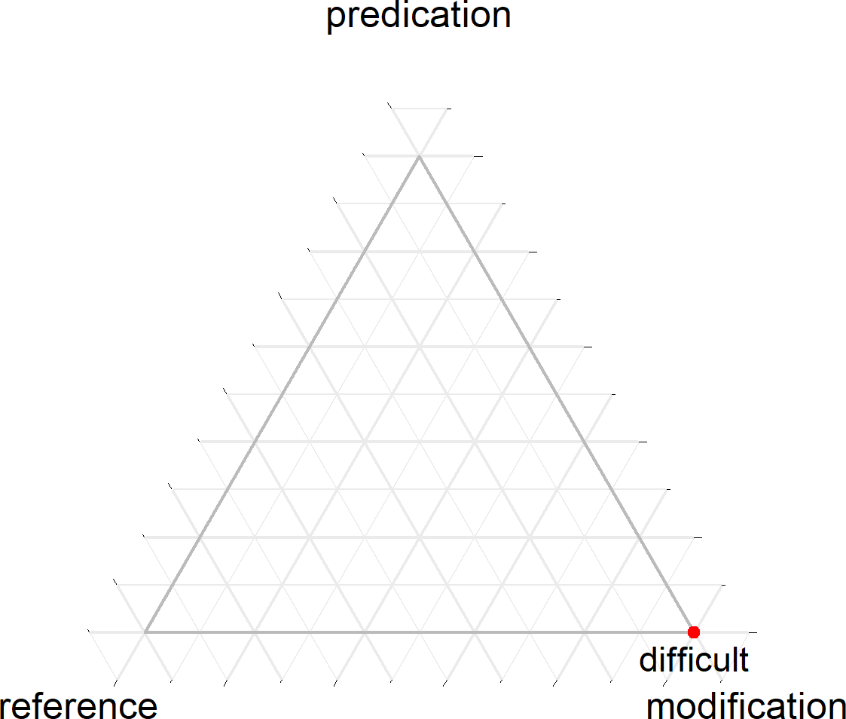

reference predication modification flexibility 0 0 54 0.000

modifier in the corpus, it has a flexibility rating of 0. In the ternary plot, this is evident from the fact that the plot point for *difficult* sits in the modification corner of the triangle.

Compare the plot for *difficult* in Figure 4.1 to that of *anything* in Figure 4.2. The stem *anything* also has a flexibility rating of 0 because all of its tokens are used for reference. Even though its flexibility rating is the same as that of *difficult*, it is plotted in a different corner of the ternary plot (reference).

Figure 4.3 shows a case where a stem (*childhood*) is flexible between reference and modifi- cation, but not predication. Finally, a perfectly flexible item which has equal use as a referent, predicate, and modifier, would sit exactly in the center of the triangle. The Nuuchahnulth stem *ʔu·q* ‘good’ is one such case, shown in Figure 4.4. The closer a point is towards the center of the triangle, the more flexible it is.

**Figure 4.2:** Flexibility of English *anything*

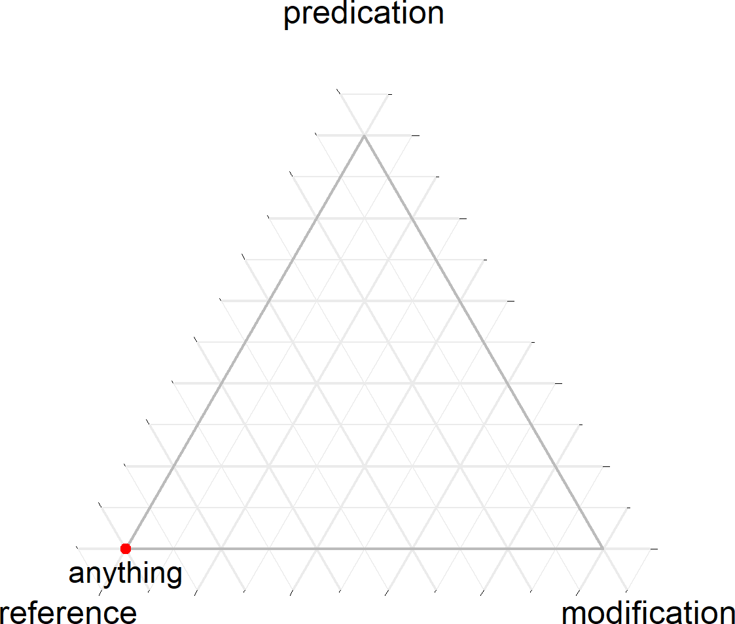

reference predication modification flexibility 2,081 0 0 0.000

**Figure 4.3:** Flexibility of English *childhood*

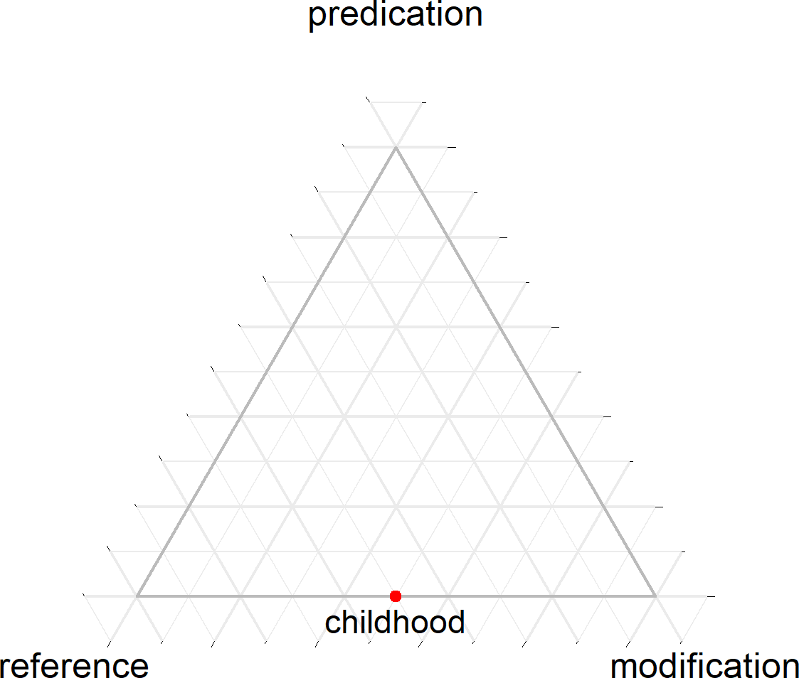

reference predication modification flexibility 2 0 2 0.631

**Figure 4.4:** Flexibility of Nuuchahnulth *ʔu·q* ‘good’

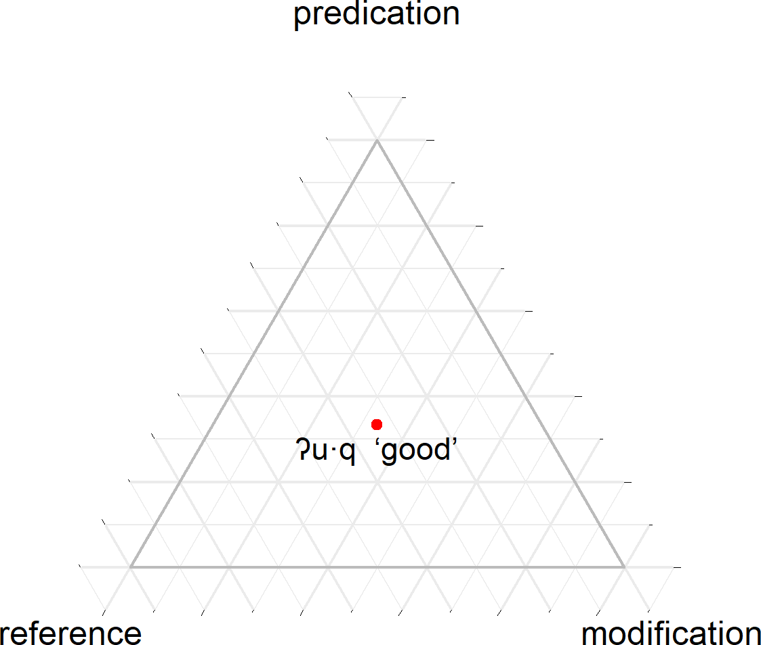

reference predication modification flexibility 1 1 1 1.000

Also remember from Chapter 3 that corpus dispersion is a better measure of frequency of exposure than just raw frequency. Thus in addition to relative frequency data, I also report corpus dispersions for the discourse functions of each lexical item in Appendix B. Note that the corpus dispersions are calculated separately for each discourse function (in addition to the overall corpus dispersion of the lexical item). A particular lexical item might be used for one function evenly throughout the corpus, and thus have a low *DP* for that function, but might only be used for another function in one or two texts, thus giving that function a high *DP* . The ratios of these corpus dispersions for each function can be plotted on a ternary plot just like frequency. Plots based on corpus dispersions are sometimes notably different from plots based on frequencies, as Figure 4.5 illustrates for the English word *favorite*. In most cases however the plots are identical or near-identical. As such, for the remainder of this study I will use ternary plots based on corpus dispersion rather than frequency, noting where the two diverge only when relevant.

*Draft as of January 28, 2021*

111

v0.7.0

**Figure 4.5:** Flexibility using frequency vs. corpus dispersion for English *favorite*

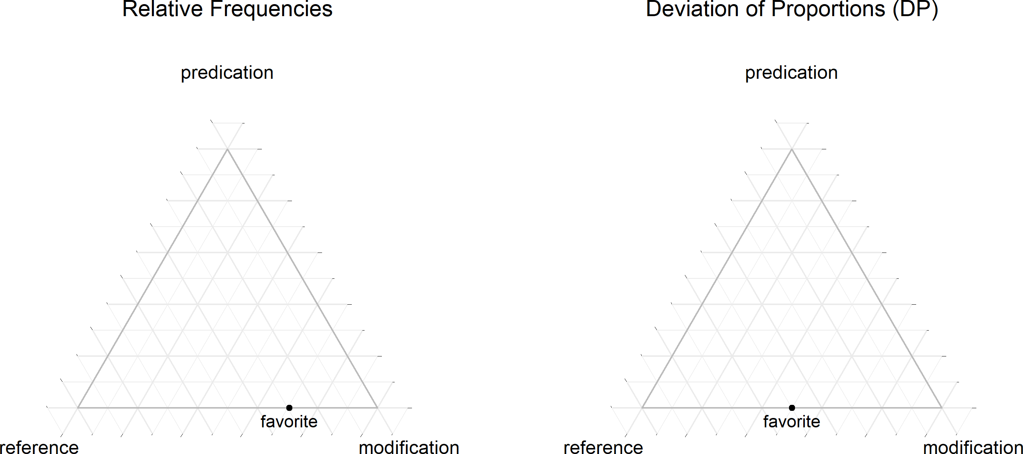

Frequency Flexibility Dispersion Frequencies Dispersions (*DP* ) (Shannon’s *H*) (*DP* ) Reference Predication Modification Reference Predication Modification

17 0.551 0.999 5 0 12 0.999 1.000 0.999

## **R1: Degree of lexical flexibility**

In this section I examine the degree of lexical flexibility for words in English and Nuuchah- nulth from several angles, both independently and in comparison, using the lexical flexibility ratings calculated with the methods in Section 3.4.1. The result of these calculations for the 100-item samples are shown in Appendix B.

Figure 4.6 visualizes the distributions of the flexibility ratings for the 100-item samples from English (lefthand side) and Nuuchahnulth (righthand side). The top portion of each figure is a histogram showing the number of lexical items at different flexibility ratings. Be- neath the histograms are boxplots showing the median flexibility rating for each language. Figure 4.7 shows the same visualizations for the small corpus samples.

One immediately obvious observation to be made from these flexibility ratings is that in- dividual lexical items may vary widely in their flexibility, both within and across languages. While this finding is entirely unsurprising, the results very well could have been otherwise. The way Nuuchahnulth is often described, one might expect all the lexical items in the lan- guage to fall within a more limited range of high-flexibility values. This is clearly not the case. Flexibility ratings for Nuuchahnulth range from the theoretical minimum of 0 to a maximum

of 0*.*920 (100-item sample) or 0*.*985 (small corpus sample). However, 282 of 483 stems in the

small corpus Nuuchahnulth sample (69.97%) have a flexibility rating of 0 (58 of stems in the 100-item sample), potentially challenging the claim that all Nuuchahnulth stems are flexible. Likewise, those who claim that English parts of speech are well-defined must confront the fact that the range of flexibility values for English is nearly the same as for Nuuchahnulth for both samples: 0 on the lower end and *.*919 (100-item sample) or 0*.*865 (small corpus sample) on the upper end. In fact, in the 100-item samples there are fewer English stems with a flexibility rating of 0 than there are Nuuchahnulth stems with a flexibility rating of 0 (8 stems out of 100). The percentage of zero-flexibility stems in the small corpus samples are about equal (125 of 166 stems, or 75.30%). In this respect, then, English could be viewed as similarly flexible

**Figure 4.6:** Distribution of flexibility ratings for the 100-item samples of English and Nuuchahnulth

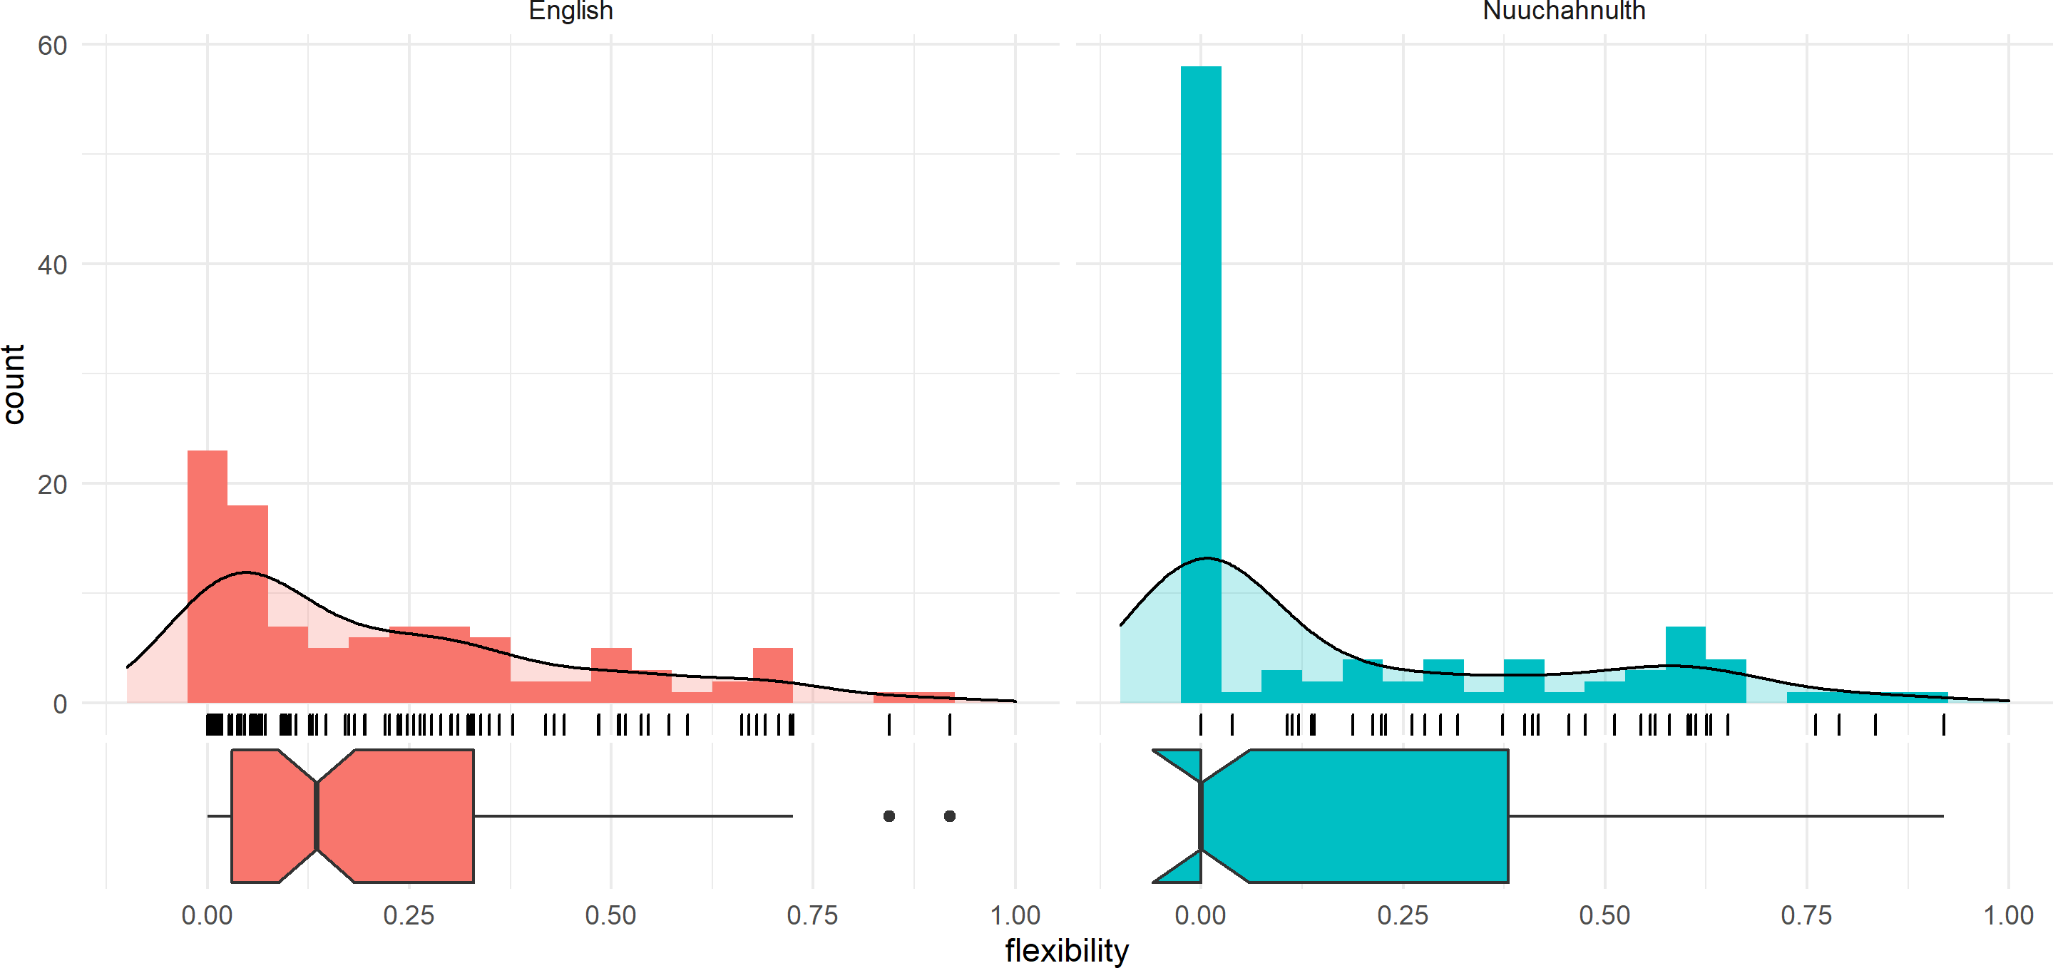

|  |  |  |
| --- | --- | --- |
|  | English | Nuuchahnulth |
| mean | 0.223 | 0.183 |
| median | 0.134 | 0.000 |
| standard deviation | 0.230 | 0.259 |

**Figure 4.7:** Distribution of flexibility ratings for the small corpus samples of English and Nuuchahnulth

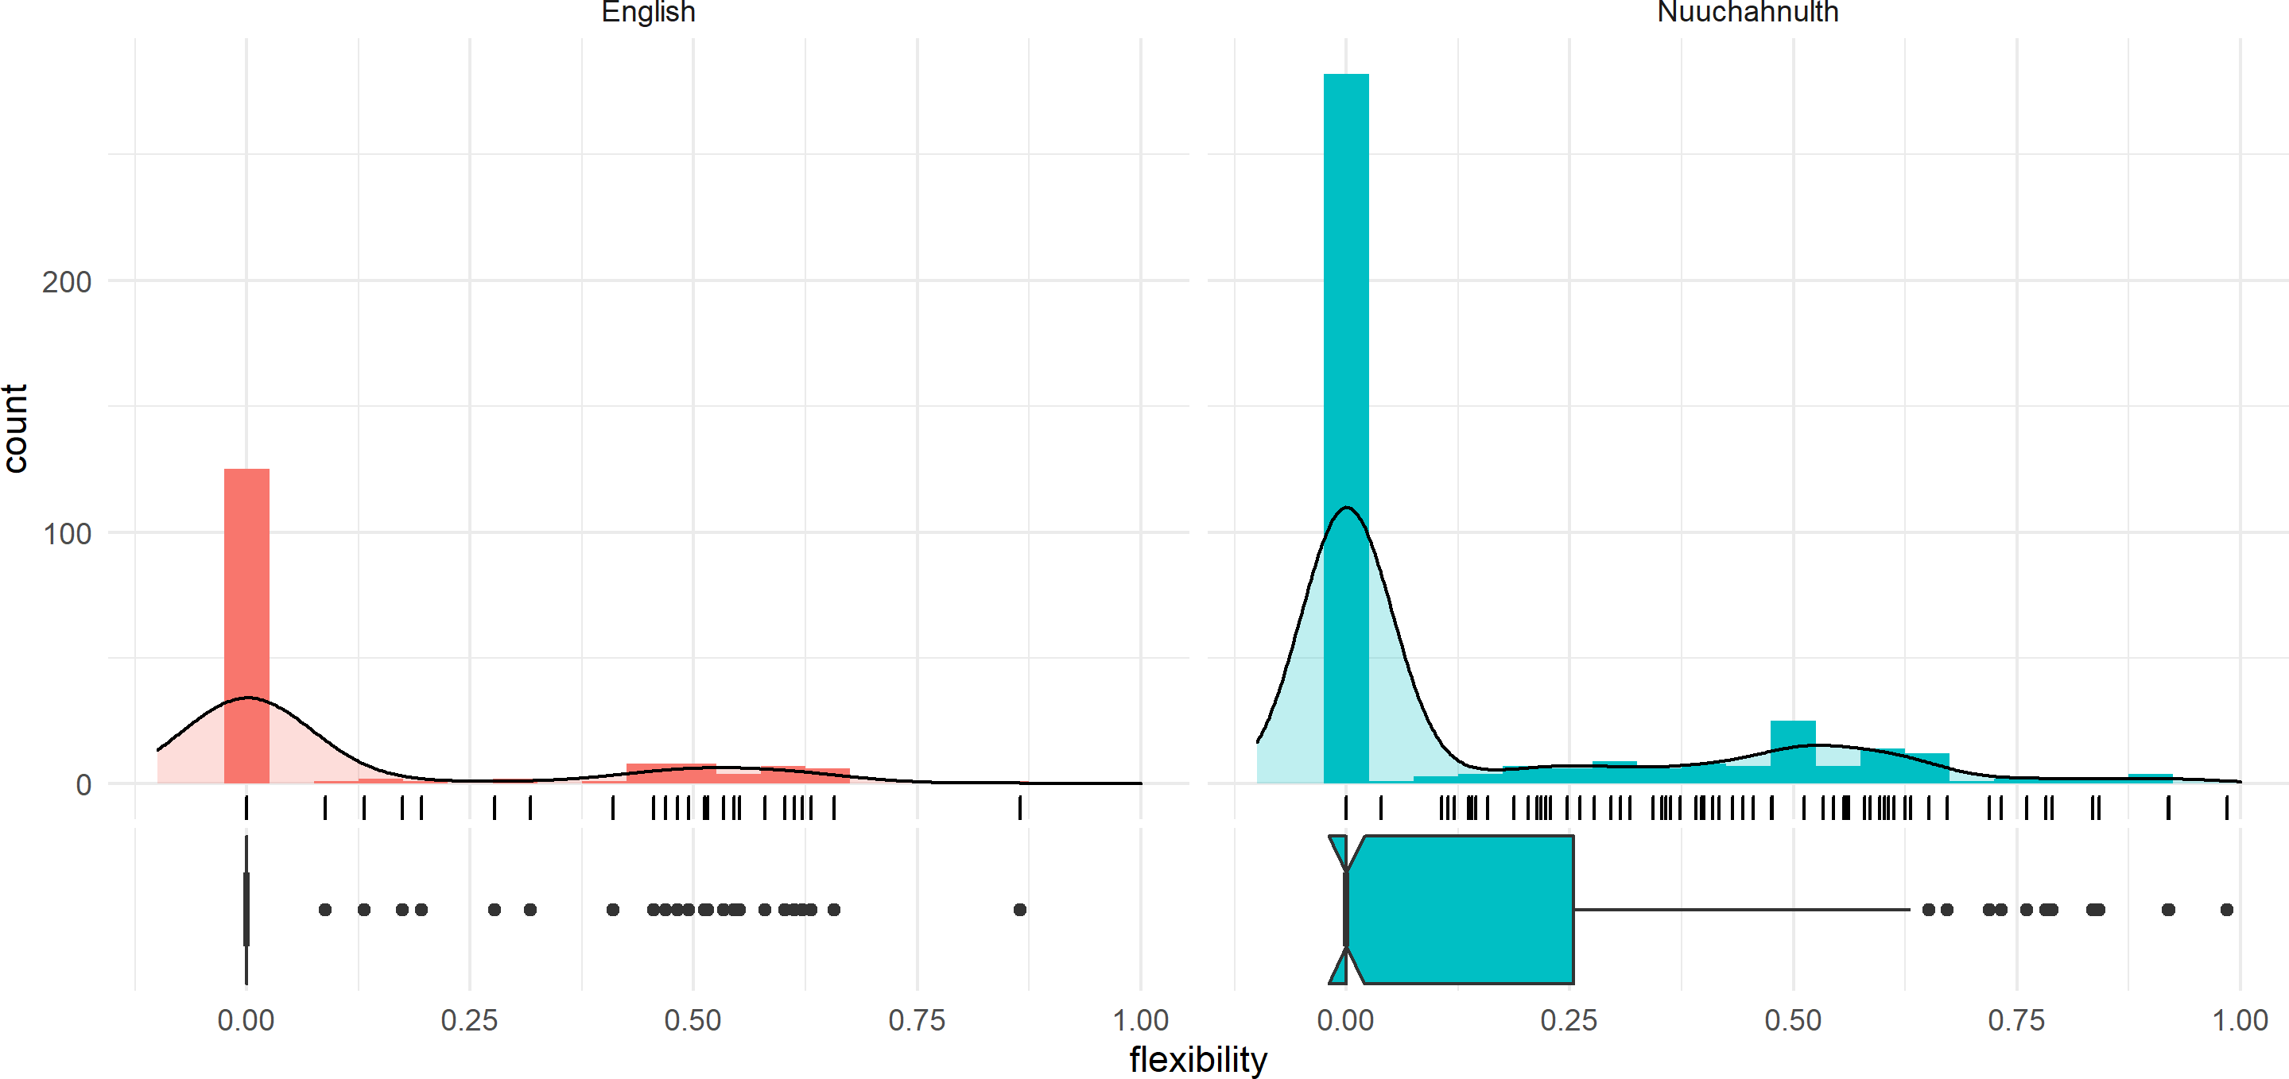

|  |  |  |
| --- | --- | --- |
|  | English | Nuuchahnulth |
| mean | 0.122 | 0.143 |
| median | 0.000 | 0.000 |
| standard deviation | 0.226 | 0.243 |

**Table 4.2:** One-sided, one-sample sign tests for deviation from zero for each corpus sample

|  |  |  |
| --- | --- | --- |
| sample | V | p-value |
| English 100 items | 4371 | p < .0001 |
| Nuuchahnulth 100 items | 903 | p < .0001 |
| English small corpus | 861 | p < .0001 |
| Nuuchahnulth small corpus | 7381 | p < .0001 |

to Nuuchahnulth. Of course, it may be that this difference is due to the large difference in corpus sizes between English and Nuuchahnulth, an issue which is explored in Section 4.4.

Thus the answer to the question, “Are some lexical items more flexible than others?” is unsurprisingly “yes”. To pose a related question, “Can it be shown empirically and quantita- tively that some lexical items are more flexible than others, as many linguists have claimed?”. The answer is again, “yes”. If we want to evaluate the claim that some languages are more or less flexible than others, it must be possible to quantify that flexibility at the level of the individual lexical item and compare them in a meaningful way. The data and methods in this thesis show that this is indeed possible, and that we can provide clear empirical answers to these kinds of questions. The flexibility of individual lexical items varies widely both within and between languages.

A slightly different question than whether individual stems vary in their flexibility is whether they exhibit flexibility to any substantive degree in the first place. Or, to invert the question, is lexical flexibility a marginal / rare phenomenon which has merely been given dis- proportionate attention in the literature? A quick look at the flexibility data above shows that this is not the case. When lexical items in English and Nuuchahnulth exhibit flexibility, it is typically not to a marginal degree. A stem is more likely to have a flexibility of, say, *.*200 than

something like *.*002. According to one-sided, one-sample sign tests, the median flexibility in

all samples differs highly significantly from zero (see the summary table in Table 4.2).

This result may seem obvious, but it must be recognized that the result could have been different. Flexibility for English stems could have been so marginal as to not significantly de-

viate from zero. This would have supported an analysis of lexical flexibility in English as mere occasional language play, something exceptional rather than rampant or productive. The data show otherwise: lexical flexibility is a prevalent feature of both English and Nuuchahnulth, though to different degrees.

Another question to ask of these data is whether English and Nuuchahnulth differ in their overall flexibility. The answer to this is not immediately obvious, given how similar the mean and median flexibility ratings for English and Nuuchahnulth are in Figure 4.6 and Figure 4.7. But to reduce the entire lexicon of a language to a single measure of central tendency obscures important details. The *way* in which the two languages exhibit flexibility is arguably more interesting.

How then is lexical flexibility realized in English and Nuuchahnulth? In addition to the histograms in Figure 4.6 and Figure 4.7, the ternary plots in Figure 4.8 and Figure 4.9 illustrate the way that flexibility operates in these two languages. In these figures, each lexical item is represented by a single point on the ternary plot.

**Figure 4.8:** Distribution of functions for the 100-item samples of English and Nuuchahnulth

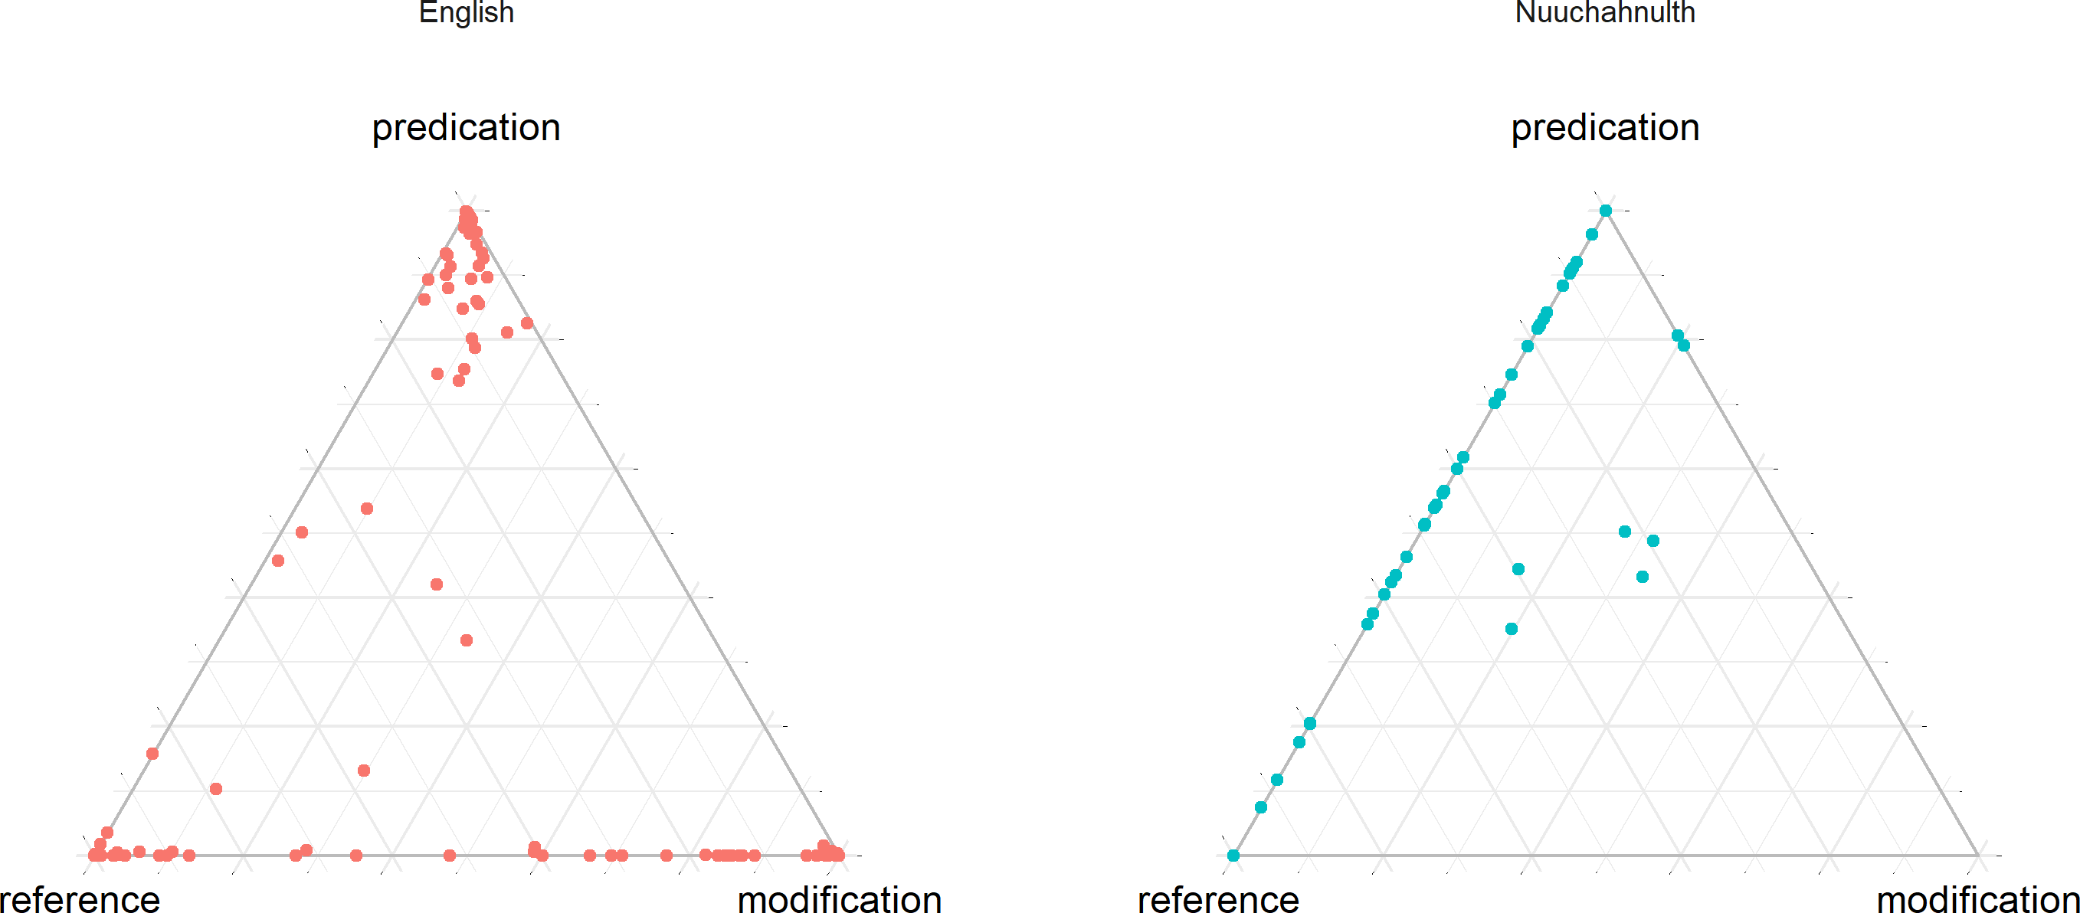

Beginning with English, we can see that most lexical items exhibit some flexibility, but

**Figure 4.9:** Distribution of functions for the small corpus samples of En- glish and Nuuchahnulth

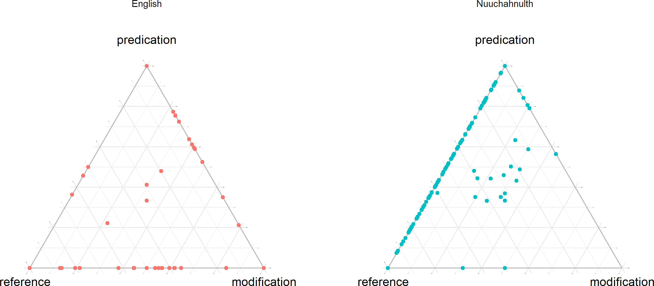

to a relatively small degree. After zero-flexibility cases, the next most frequent flexibility rating is in the 0–0*.*05 range. This is also evident from the ternary plots, where lexical items tend to cluster near (but not precisely on) the corners for their most prototypical functions. Interestingly, the small English corpus appears to show *more* flexibility than the 100-item sample. This could be an effect of the specific words chosen, but it could also be the case that it takes a certain number of tokens for the prototypical function of an item to become evident. This possibility is examined further in Section 4.4.

Nuuchahnulth differs from English in several notable ways. First, a much higher pro- portion of items display no flexibility whatsoever. (This is so surprising!)However, for those items which do exhibit flexibility, the average flexibility rating is generally higher than that of English stems. In both samples, the biggest cluster of items with non-zero flexibility ratings have ratings around *.*6. English items with non-zero flexibility, by comparison, generally have ratings closer to *.*2. Thus for Nuuchahnulth lexical items are either totally inflexible or generally strongly flexi- ble.

This bifurcation of the data is very likely due to the small size of the Nuuchahnulth corpus,

as will be discussed in Section 4.4. It may be that Nuuchahnulth words are generally highly flexible, but that more tokens are needed to see this trend. Alternatively, it may be that cer- tain Nuuchahnulth stems are strongly associated with a specific discourse function and thus inflexible, while others are generally flexible. This would suggest a probabilistic division of Nuuchahnulth stems into two classes: those that are productively flexible, and those that are not.

This second possibility would challenge existing analyses of Nuuchahnulth. The exis- tence of a productively flexible class of stems would be counterevidence to the many claims that Nuuchahnulth word classes can in fact be clearly defined using selectional criteria such as ability to take possession or the definite suffix (Jacobsen 1979; Davis, Gillon & Matthew- son 2014; Braithwaite 2015). Similarly, Nakayama (2001: 57) characterizes word classes in Nuuchahnulth as strong statistical tendencies in discourse. For many Nuuchahnulth stems, however, there is no clear prototypical use. The data show that many stems are used roughly equally for predication as they are for reference, making it difficult to assess which use is more basic or unmarked.

As the ternary plots for Nuuchahnulth in Figure 4.8 and Figure 4.9 make clear, the distribu- tion of lexical items across functions in Nuuchahnulth differs strongly from that of English. For starters, there is very little clustering around prototypical functions in the corners, in direct contrast to English. Secondly, Nuuchahnulth shows very little flexibility in the modi- fication direction, but rampant flexibility along the reference-predication axis. For the small corpus sample in particular, there is a smooth cline of values between reference and pred- ication. Nuuchahnulth stems sit anywhere on a continuum from prototypical referents to prototypical predicates, but none show prototypical modifier behavior. (This is so interesting)

These findings nicely reflect the intuitions of many researchers about these two languages. English is mostly rigid, but most words exhibit a marginal degree of flexibility. English words are *primarily* associated with one discourse function, but not exclusively so. Nuuchahnulth, by contrast, shows a very high degree of reference-predicate flexibility. However, Nuuchah-

nulth stems are not frequently used for modification. This is in line with the analysis of most researchers regarding lexical categories in Nuuchahnulth. Nakayama (2001: 50), for example, says that the categories noun and verb must be recognized for Nuuchahnulth, but that there is not sufficient evidence to justify an adjective category, even as a statistical tendency. He instead treats “adjectivals” as a subclass of verbs. The central location of the points in the Nuuchahnulth plot in Figure 4.9, however, suggest that Nuuchahnulth modifiers are as noun- like as they are verblike. The low frequency with which stems are used for modification also mirrors the results from Croft’s (1991: 88–89) four-language survey of the textual frequency of different lexical classes. He also finds that “the overall frequency of roots denoting proper- ties and occurrences of modifiers is extremely low compared to the frequencies of object and action roots and of referring expressions and predications” (Croft 1991: 88–89).

(There’s the question of attributive vs predicative, right?)

## **R2: Lexical flexibility and corpus size**

It seems intuitively plausible that the more tokens of a word one encounters, the more likely one is to find flexible uses of a word. With a large enough corpus, all items would exhibit flexibility. This has been claimed by Mosel & Hovdhaugen (1992: 77). It may be the case that larger corpora are statistically more flexible than smaller corpora. However, to my knowledge this claim has never been tested empirically, although the fact that the median flexibility for the small corpus sample of English is 0 while the median flexibility of the much larger 100- item sample is 0*.*134 suggests that the hypothesis might be true. In this section I examine the results of comparing the number of tokens encountered for a stem to its cumulative flexibility rating, the question being, “Does the cumulative flexibility for the lexical item increase as one encounters more tokens?”.

It is important to understand here that number of tokens encountered is not the same thing as frequency (add where?). A very low frequency word could nonetheless have a high number of tokens in a given corpus if that corpus is very large. Likewise, a high frequency word could

have a low number of tokens in a small corpus.

Only stems with a frequency of at least 4 were studied (see §3.4.1 for the motivation behind this restriction). For English, I examined the 100-item sample, and for Nuuchahnulth I used the entire corpus. Using a script and going sequentially through the corpora, each time I encountered a new token of a lexical item, I recalculated its flexibility and recorded that value and token frequency at that point in the corpus.

Figure 4.10 shows the result of these calculations for the ten most frequent words in the English corpus, and Figure 4.11 shows the same for Nuuchahnulth. The number of tokens encountered is shown on the x-axis, and the cumulative flexibility is shown on the y-axis. I show only the most frequent words here merely because they provide the clearest visual representation of the data; more comprehensive (but difficult to read) plots for each language are given in Figure 4.12 and Figure 4.13. For ease of visualization, a version of the English data with log10 frequency on the x-axis is also given in Figure 4.14.

**Figure 4.10:** Cumulative lexical flexibility for English (10 most frequent words)

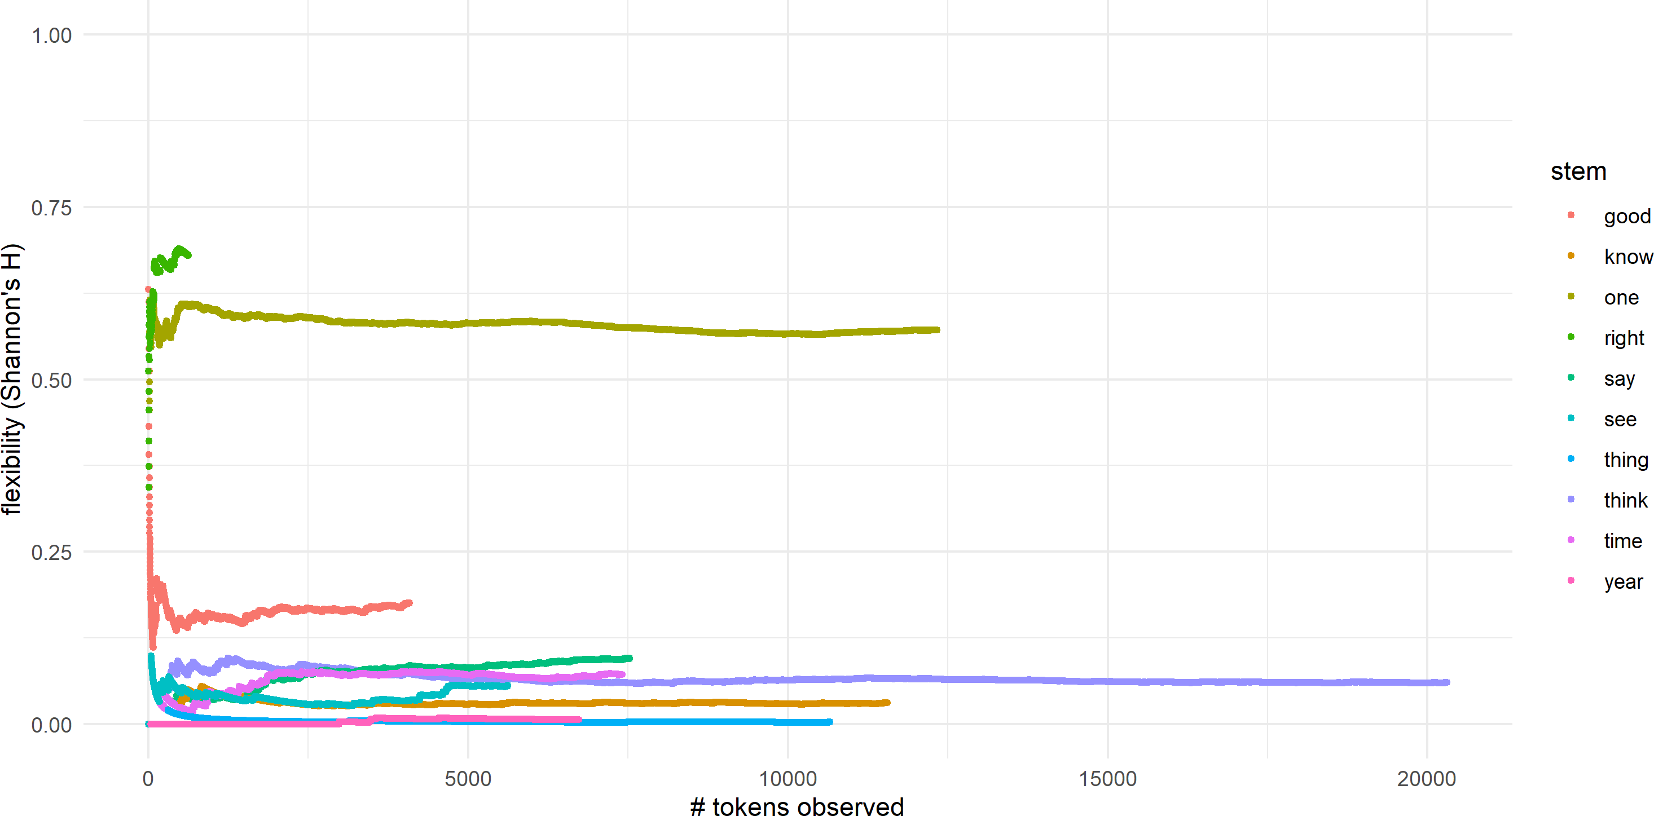

The first thing to notice from both plots of high-frequency words is that it takes a certain number of tokens for the flexibility of a word to become evident and stable. For English, the

**Figure 4.11:** Cumulative lexical flexibility for Nuuchahnulth (10 most fre- quent words)

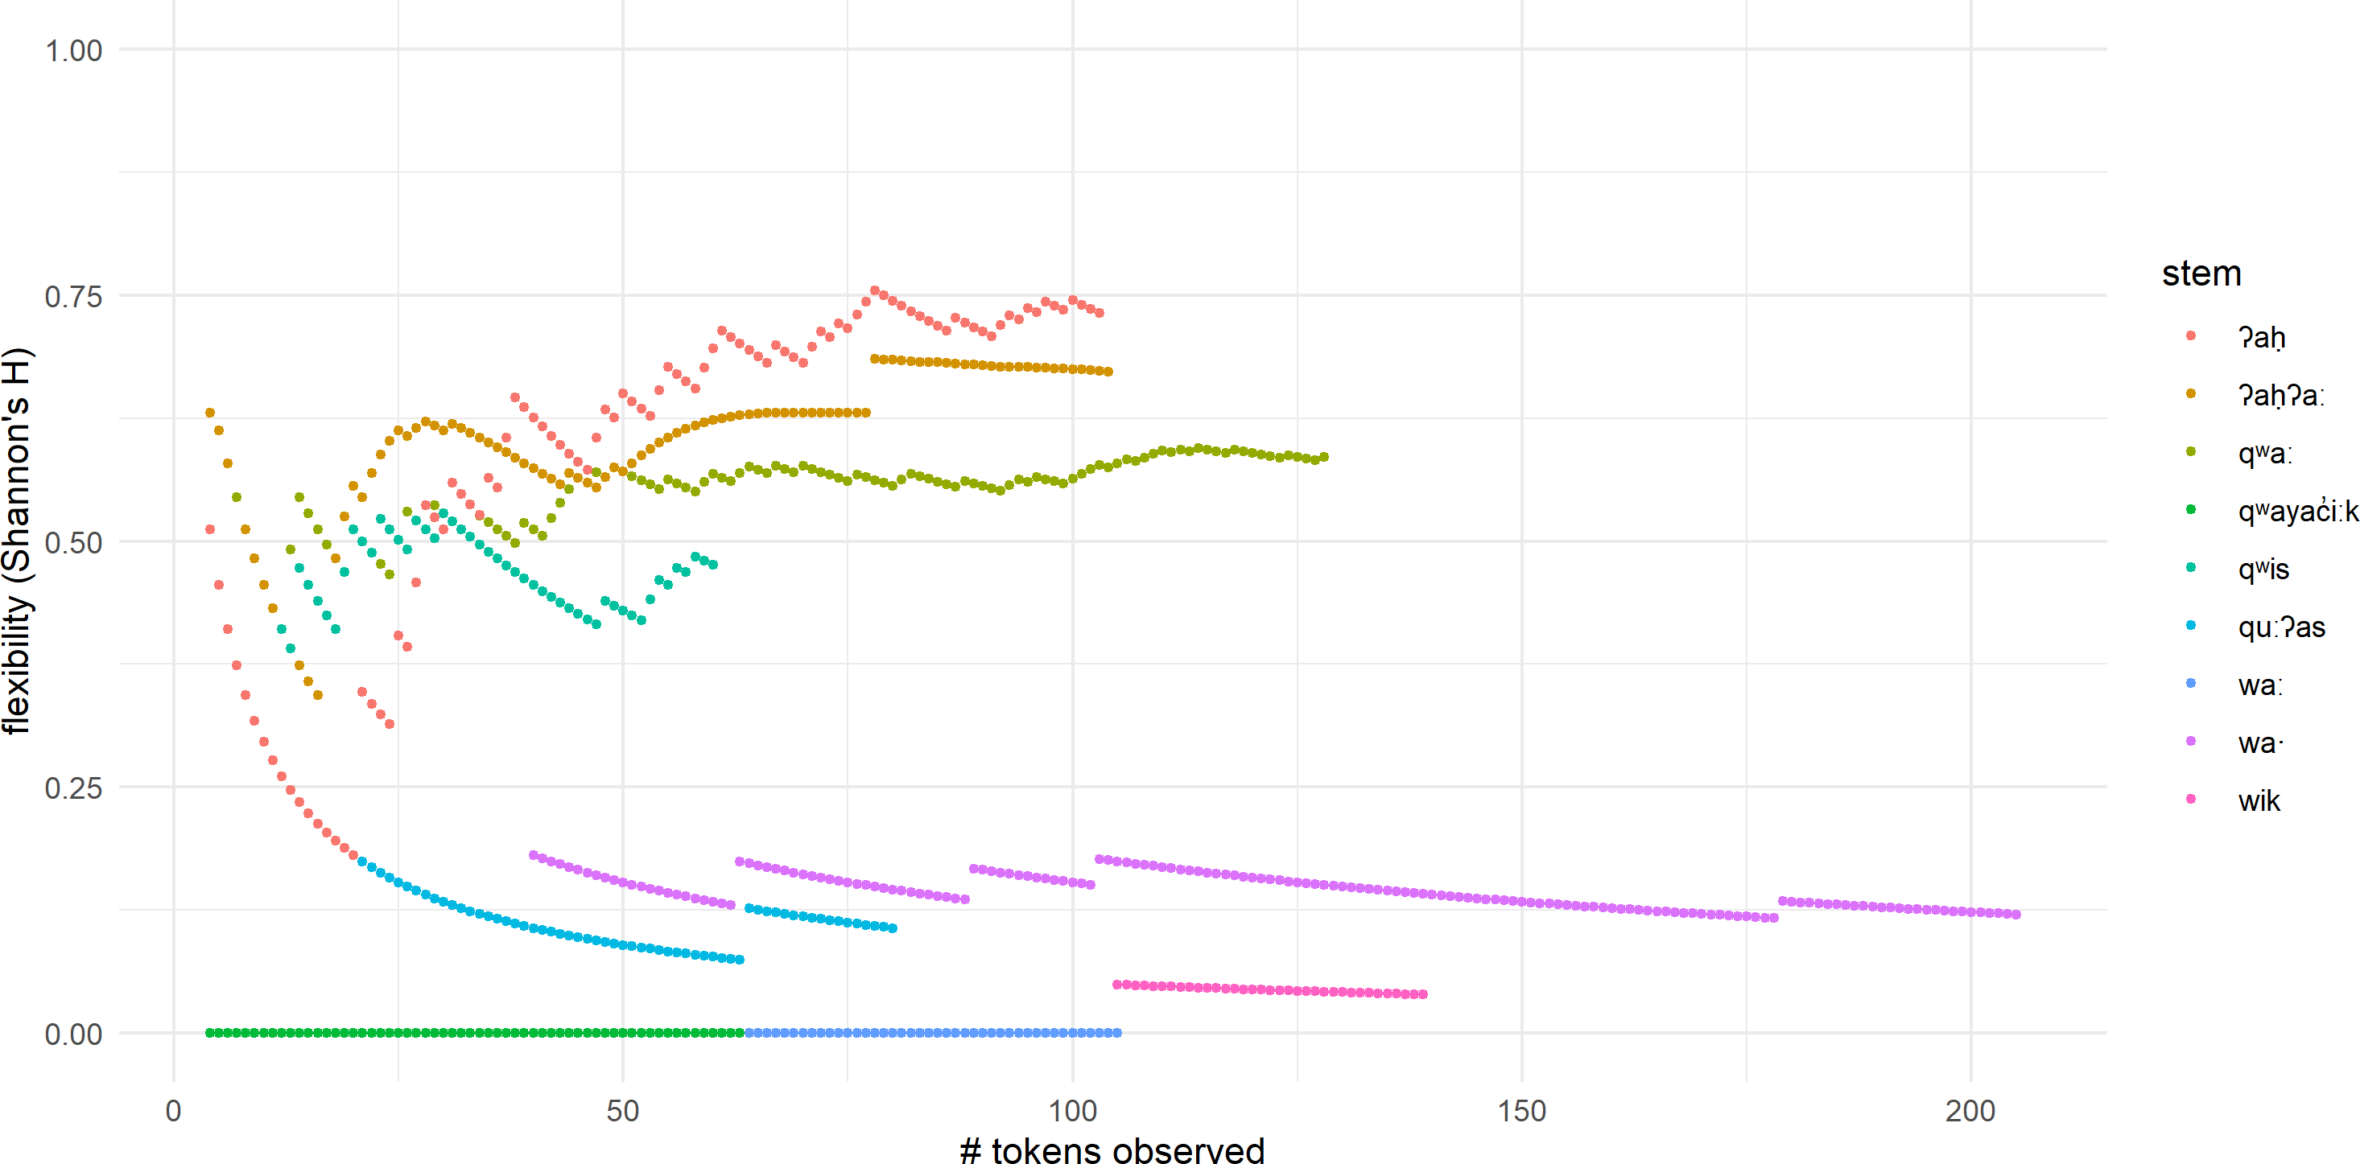

**Figure 4.12:** Cumulative lexical flexibility for English (all words)

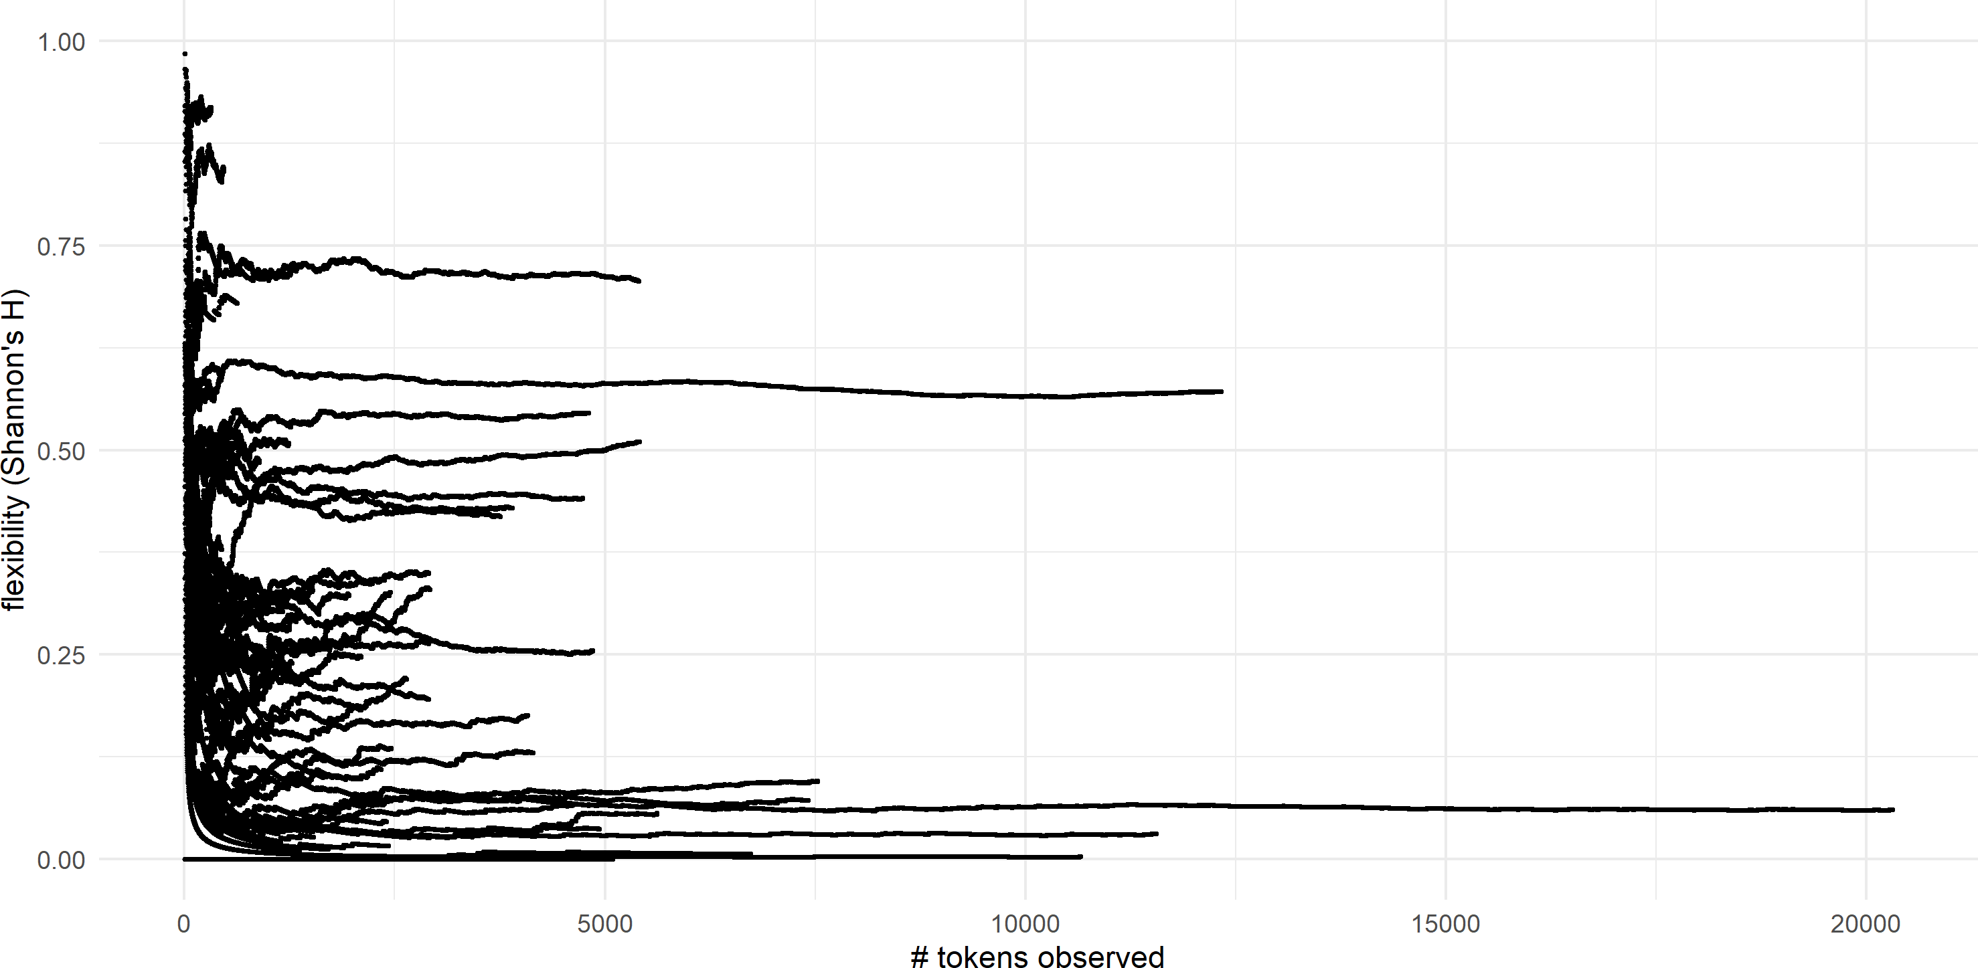

trend lines are generally no longer stochastic after *∼*1,000 tokens encountered (this can be more easily seen in Figure 4.14). If we take 1,000 tokens as a reliability threshhold for deter- mining the flexibility of a lexical item, then no Nuuchahnulth item appears with sufficient frequency in the corpus to be certain of its flexibility. That said, the flexibility of the ten

**Figure 4.13:** Cumulative lexical flexibility for Nuuchahnulth (all words)

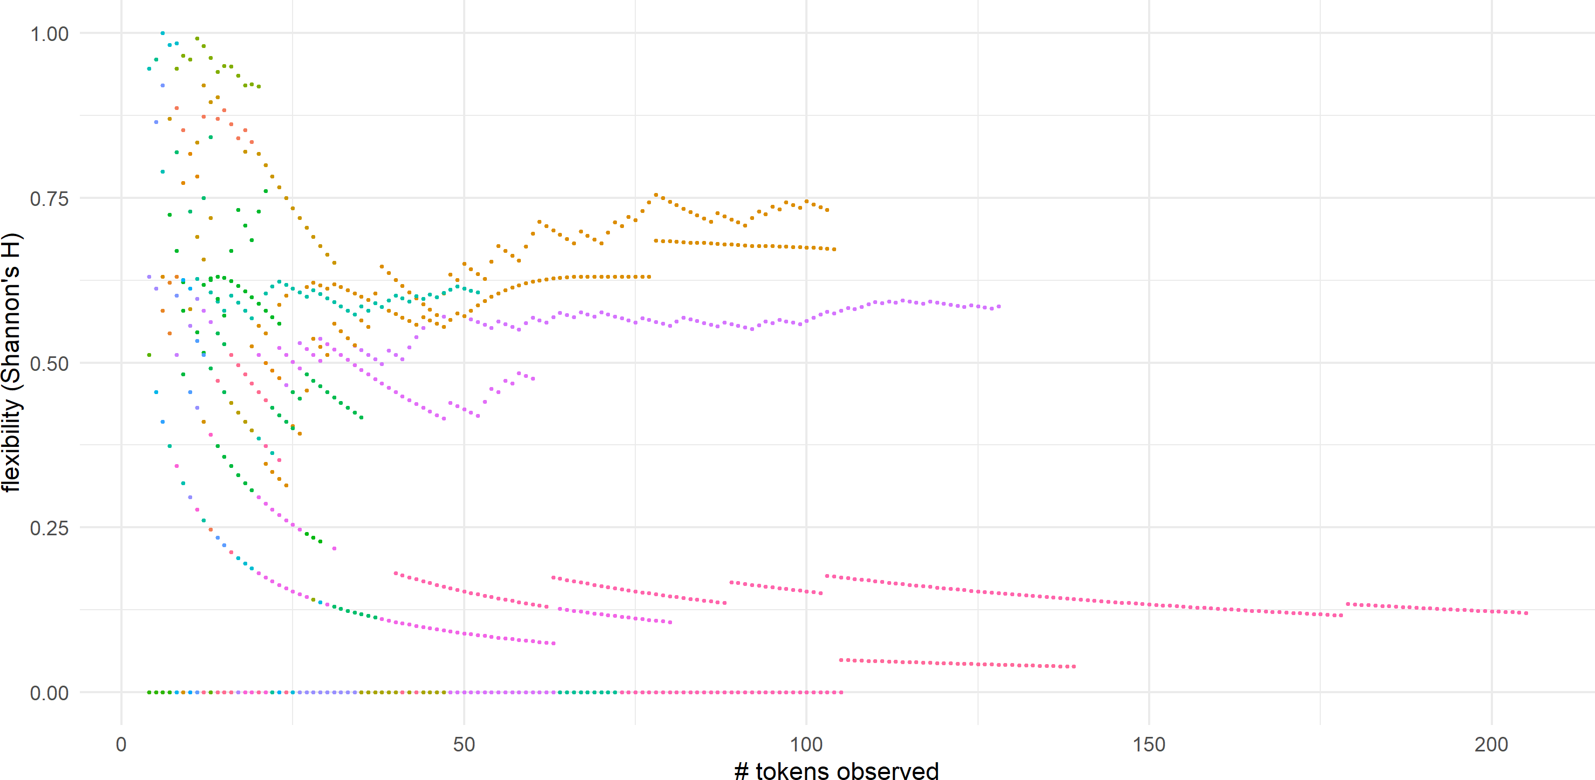

**Figure 4.14:** Cumulative lexical flexibility for English (*log*10 scale)

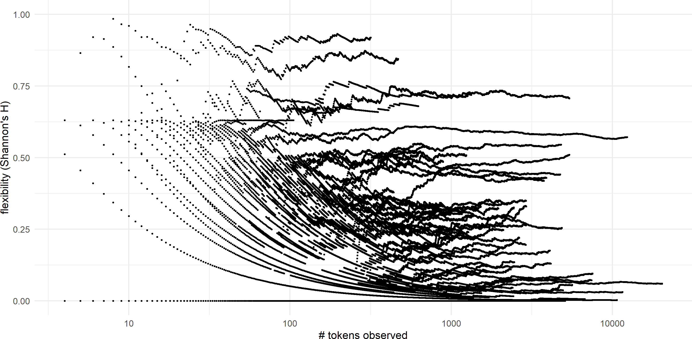

words in the Nuuchahnulth sample appears to be relatively stable after 50–75 tokens. There are some words in the English sample which achieve a relatively stable flexibility rating as early as 100 tokens as well. One way to interpret these data is that, since some stems appear in a wider range of discourse contexts than others, it takes a higher number of tokens before the overall flexibility of those stems becomes evident; in contrast, the flexibility of stems that

appear in a relatively small range of discourse contexts should become clear right away.

The second observation to make regarding these data is that, once the trend line for cumu- lative flexibility becomes smooth, it stays flat. This shows that corpora do not become more flexible as they increase in size. If this were true, we would expect to see a continual and gradual increase in flexibility for many of the stems in the dataset, and this is not the case.

On the other hand, by the time one encounters 5,000 tokens of a word in English, there are no stems with a flexibility of zero. English flexibility ratings cluster in the lower range (*∼* 0*.*3), but when sufficient tokens are encountered, there do not seem to be any truly inflexible words. Therefore it does seem to be true (for English at least) that words will eventually display *some* flexibility as the size of the corpus increases, but not that the overall flexibility of the word will increase.

We can also look at the data for each language in aggregate. Figure 4.15 shows the cu- mulative mean flexibility for English per token encountered. Each time a new token of a lexical item was encountered, I calculated the current flexibility ratings of each lexical item encountered up to that point, and calculated their average. The resulting plot shows number of tokens encountered on the x-axis and mean flexibility for the entire corpus up to that point on the y-axis. Figure 4.16 shows parallel data for Nuuchahnulth. Both graphs clearly show that the average flexibility of the corpus does not increase as the corpus grows larger. Instead it remains flat after a sufficient number of tokens are encountered.

To summarize, once enough tokens of a word are encountered to give a reliable flex- ibility rating, that flexibility rating does not increase as the number of tokens encountered continues to grow. Lexical items appear to have (synchronically) fixed degrees of flexibility, that vary from word to word. This suggests that the discourse functions of any given stem are conventionalized, so that speakers know which uses a word has, and generally use them with the same proportionate frequency. Logically, aggregating the data at the language level produces the same result: languages have (synchronically) fixed degrees of flexibility, that vary from language to language. (This is so interesting.)

**Figure 4.15:** Cumulative mean flexibility for English

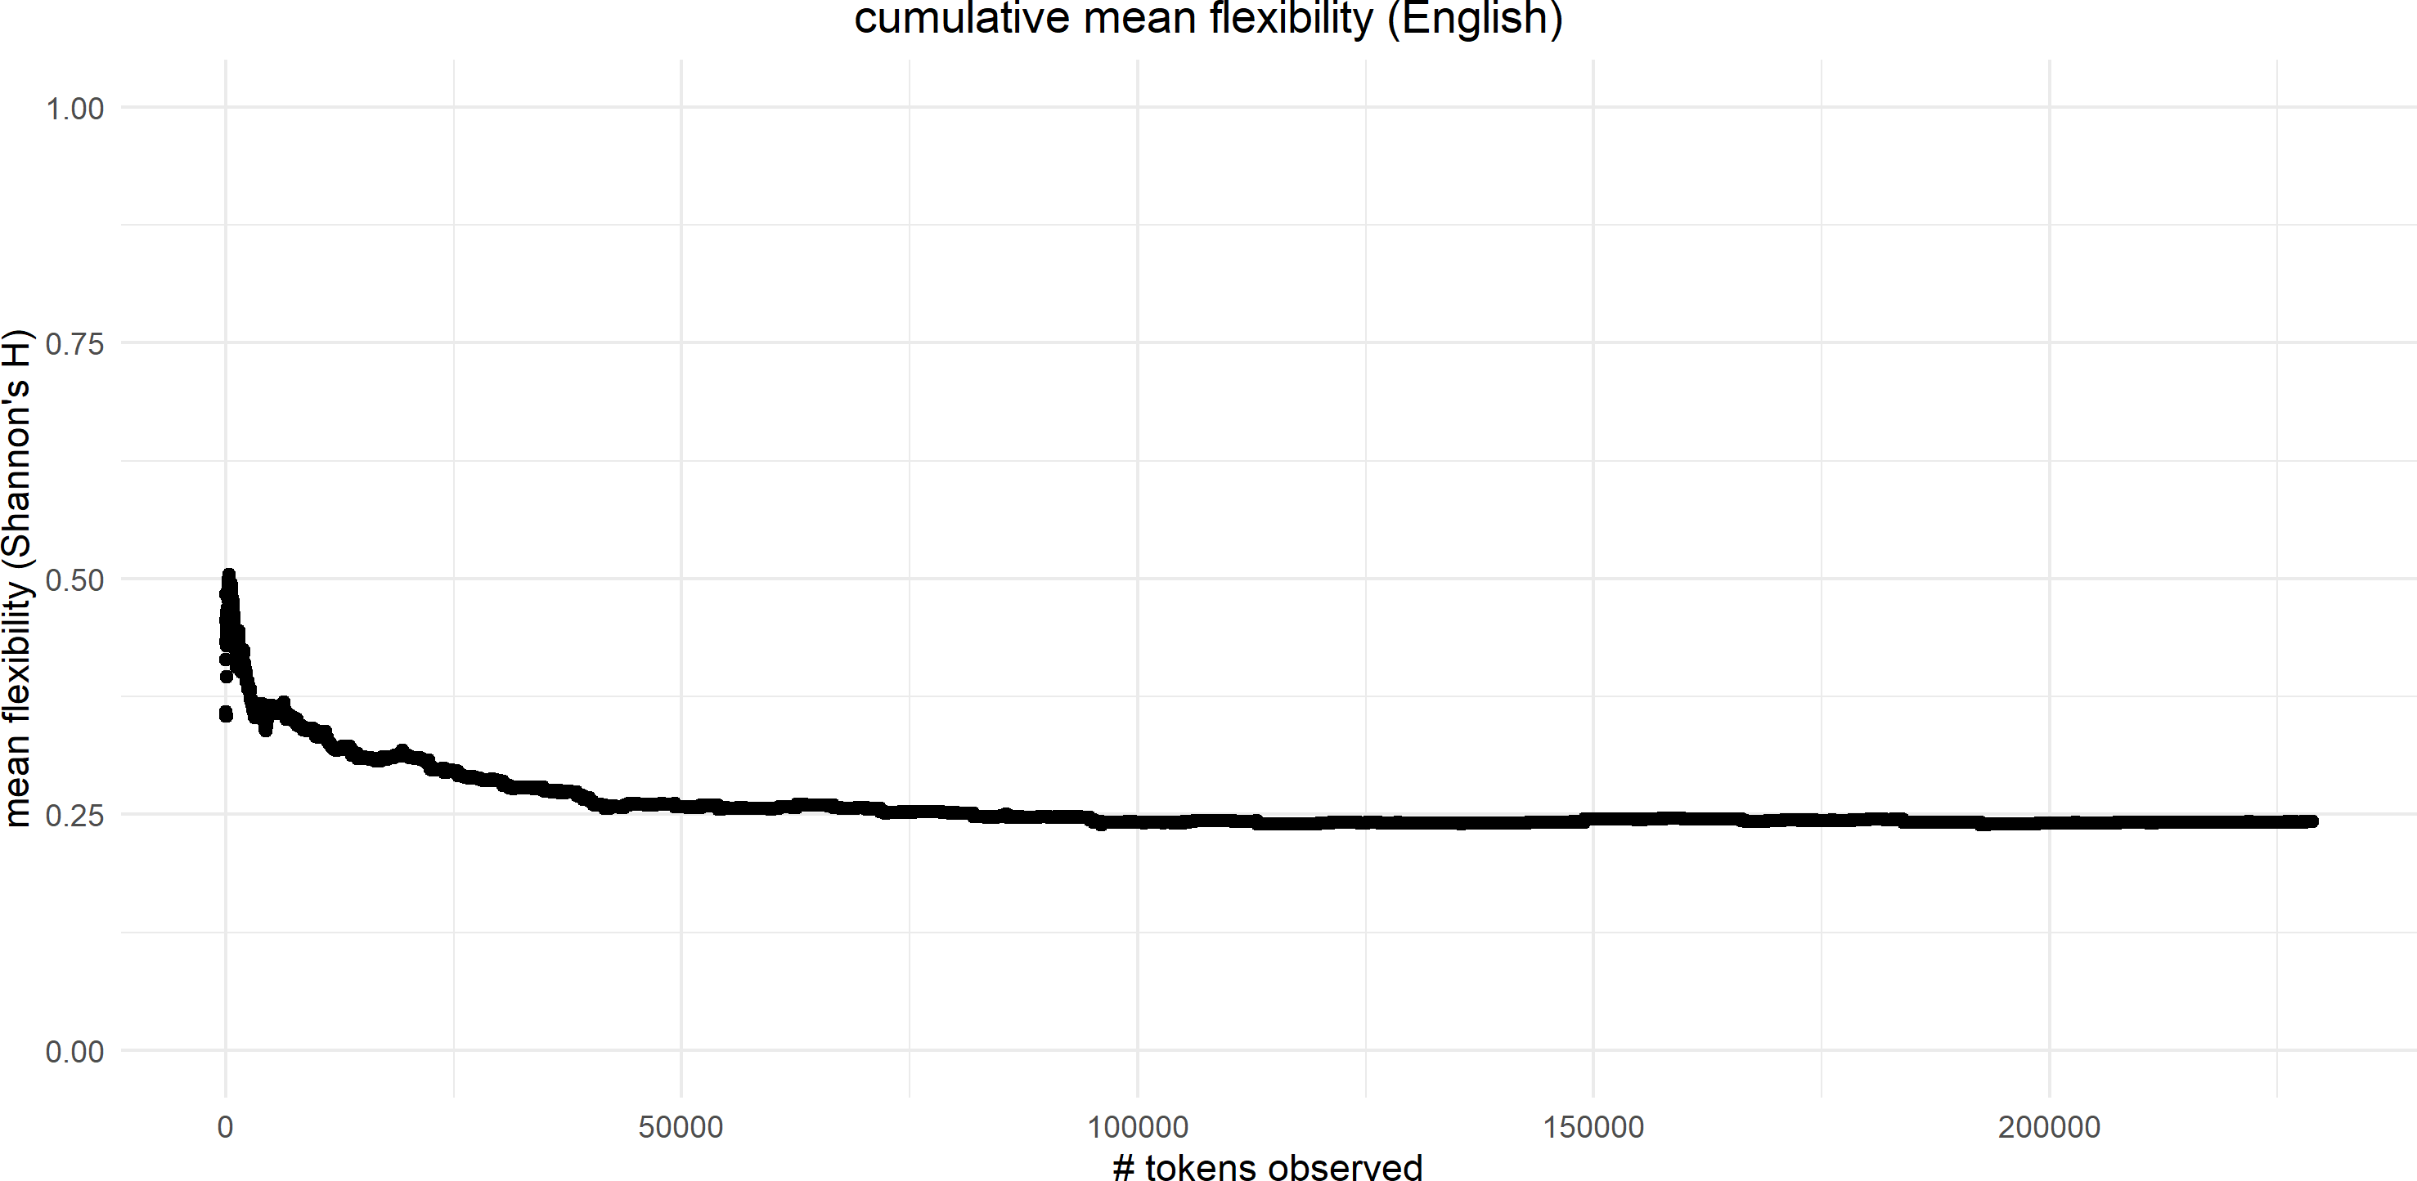

**Figure 4.16:** Cumulative mean flexibility for Nuuchahnulth

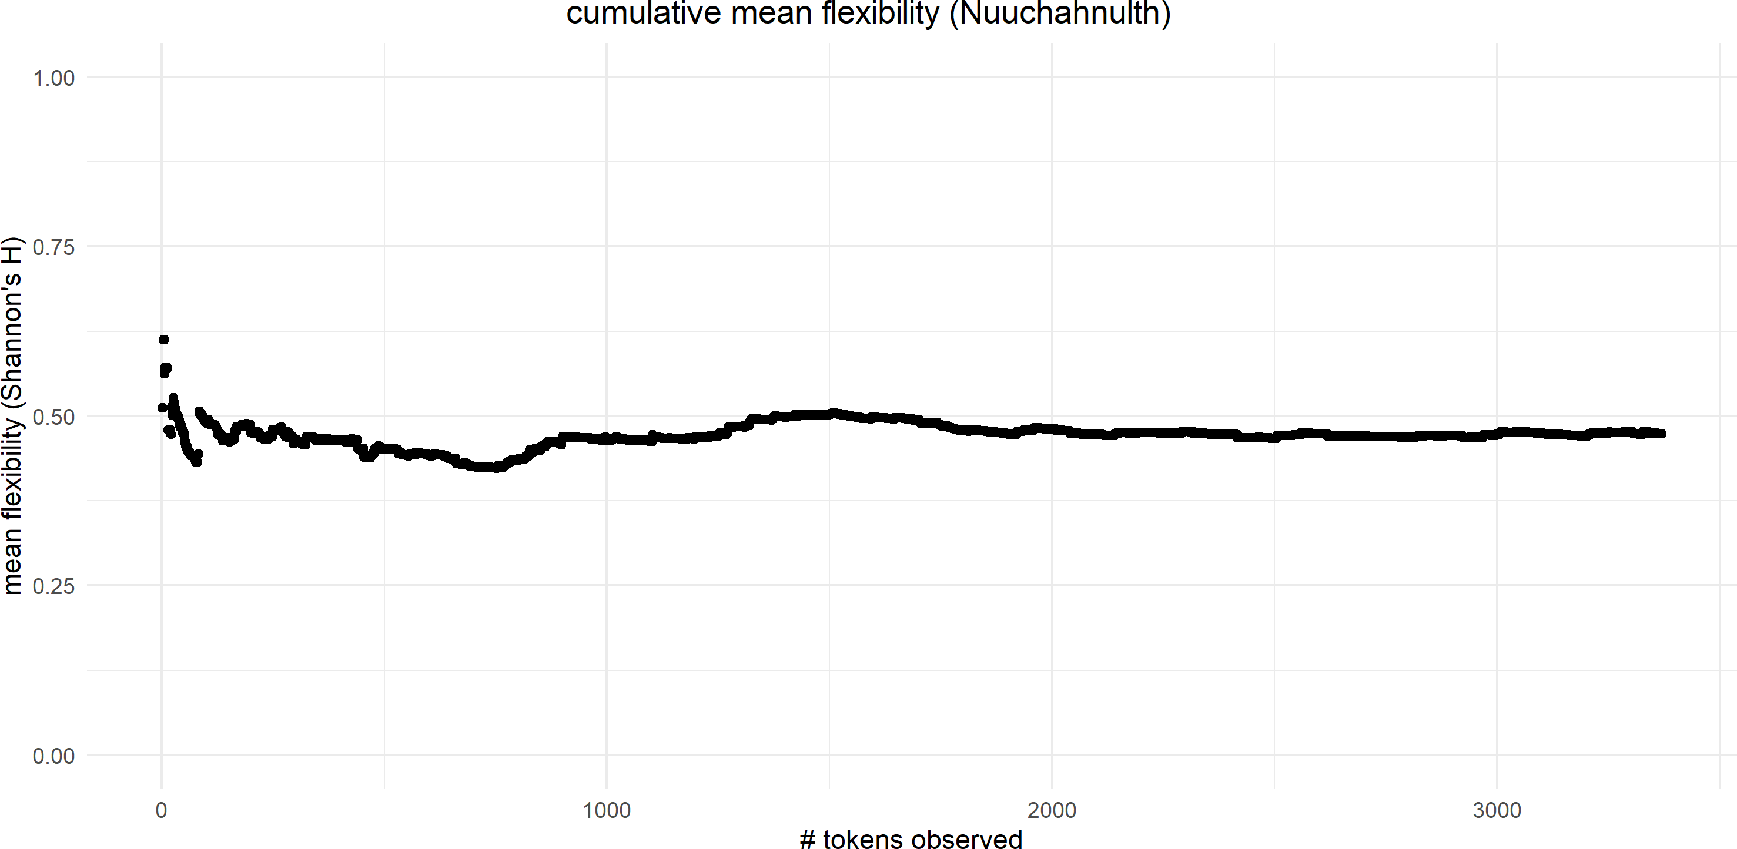

## **R3: Lexical flexibility and frequency / dispersion**

In this section I examine the interactions between lexical flexibility, token frequency, and cor- pus dispersion for individual lexical items. Given that many linguistic phenomena correlate with frequency / corpus dispersion, it is reasonable to investigate whether lexical flexibility

displays such correlations as well. Are high frequency or evenly dispersed words more flexi- ble than low frequency or unevenly dispersed words? This is an interesting question in part because if such a correlation were found the direction of causation could go in either direc- tion. It may be that stems are more frequent precisely because they are more flexible—there is a wider range of discourse contexts that they can occur in. On the other hand, it could be that high frequency words are more cognitively accessible and therefore more prone to novel uses in discourse. Or, in contrast, a higher frequency could also result in a greater degree of entrenchment, so that high frequency words are less likely to be flexible.

To investigate the possible interactions among flexibility, frequency, and dispersion I de- ploy a Generalized Additive Model (GAM) in order to account for the possibility of inter- actions not just between flexibility and frequency / dispersion, but for interactions between frequency and dispersion as well. For example, it may be the case that there are correlations between flexibility and dispersion, but only for high frequency words. A Generalized Additive Model allows for the exploration of multiple interactions in this way.

Frequency is represented in this model as log2 of the relative frequency of the stem. Since relative frequency and corpus dispersion utilize different scales, I also use a tensor smooth to examine the combined contribution of frequency and dispersion to flexibility, over and above

their individual contributions. I again used the 100-item sample for the English model, and the entire corpus for Nuuchahnulth.

Figure 4.17 shows heat maps of the interactions of the three variables for English and Nuuchahnulth. The x-axis shows *log*2 of relative frequency, and the y-axis shows corpus dispersion as Deviation of Propotions (*DP* ), with more evenly dispersed items to the bottom of the scale and less evenly dispersed items to the top of the scale. Light-colored areas indicate a high degree of flexibility, while dark-colored areas indicate a low degree of flexibility.

Figure 4.18 shows 3D representations of the same data, rotated for ease of visualization. log2 relative frequency is shown on the x-axis (with higher relative frequency to the left—the reverse of Figure 4.17), flexibility is shown on the y-axis (with higher flexibility at the top of

**Figure 4.17:** Interactions among frequency, dispersion, and flexibility for English vs. Nuuchahnulth (heat map)

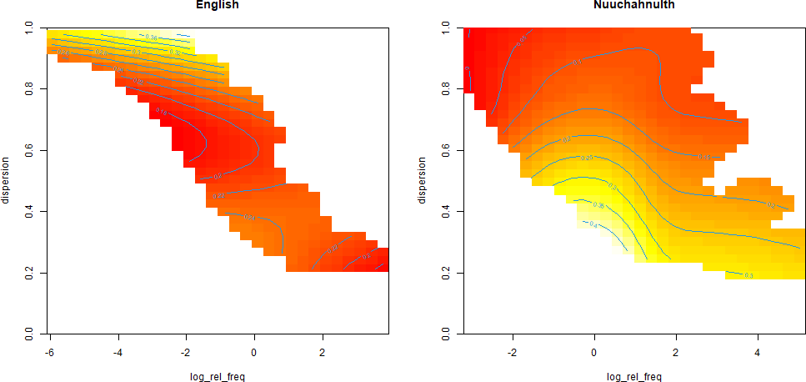

the scale), and corpus dispersion is shown on the z-axis (with more evenly dispersed values further away).

In English, high frequency, evenly dispersed items appear to have low flexibility ratings, while low frequency, unevenly dispersed items appear to have high flexibility ratings. How- ever, none of the interactions for the English model are significant. The reason for this be- comes apparent when we look at the same 3D interaction plot but with maps added at a stan- dard deviation of 2, as in Figure 4.19. There is so much variability in the data for English that no firm conclusions can be drawn.

The model for Nuuchahnulth, on the other hand, shows a couple of significant interac- tions. First, higher-frequency words show a greater degree of flexibility than lower-frequency words. This correlation is highly significant (*F* = 37*.*582, *p < .*001). Corpus dispersion, how- ever, shows only a marginally significant correlation with flexibility (*F* = 2*.*384, *p < .*1), so no conclusion can be drawn regarding the direct relationship between corpus dispersion and flexibility. However, the combined interaction of corpus dispersion and relative frequency does correlate with flexibility, above and beyond the contribution provided by relative fre-

**Figure 4.18:** Interactions among frequency, dispersion, and flexibility for English vs. Nuuchahnulth (3D map)

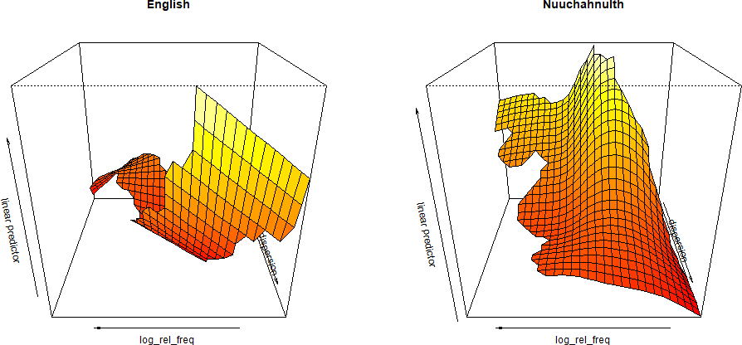

**Figure 4.19:** Interactions among frequency, dispersion, and flexibility for English vs. Nuuchahnulth, with standard deviations (3D map)

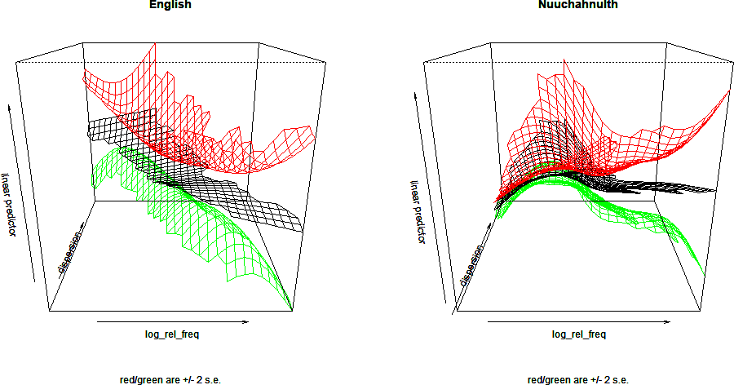

quency alone (*F* = 2*.*979, *p < .*05). In total, these factors account for 18.2% of the deviance in the data. Low frequency, unevenly dispersed items have low flexibility ratings, while high frequency, evenly dispersed items have higher flexibility ratings.

These results for Nuuchahnulth should not be accepted unquestioningly as representative of the overall state of affairs for the language, however. Remember from §4.4 that a certain minimum threshhold of number of tokens is required in order to be certain of that word’s flexibility. Given the relatively low frequencies of items in the Nuuchahnulth corpus, the flexibility ratings of many stems are likely inaccurate. In particular, the high incidence of items with zero-flexibility ratings is almost undoubtedly due to the small number of tokens encountered for those items. In fact, the 3D interaction plot for Nuuchahnulth in Figure 4.19 shows that as stems increase in frequency, the standard deviation for their flexibility ratings grows dramatically, resembling that of English. Therefore it is likely that the strong correla- tions that currently appear for the Nuuchahnulth data would disappear with a larger corpus.

In summary, the data on lexical flexibility and frequency / corpus dispersion are not clear enough to draw any firm conclusions regarding their interactions.

## **R4: The semantics of lexical flexibility**

In this section I take a brief look at the semantics of lexical flexibility, in particular whether there are semantic commonalities to high or low flexibility words. I restrict myself here to aspects of the semantics of lexical items which can be discerned from the existing data and annotations used to answer other research questions for this project. Little additional data coding or annotation was done for the specific purpose of answering this research question. This section is therefore primarily exploratory, with the aim of discovering just what conclu- sions can be drawn about the semantics of lexical flexibility using merely the simple annota- tions of discourse functions prepared for this study. I begin with English before moving on to Nuuchahnulth.

### **English**

The first observation about the semantics of lexical flexibility in English is purely anecdotal but nonetheless merits comment: the second most flexible word in the 100-item sample of English is *back*, used 272 times for reference, 54 times for predication, and 143 times for modification, with a flexibility rating of *.*844. Going into this study, I postulated that body part terms would display a high degree of flexibility. The motivation for this hypothesis is that body part terms commonly undergo metaphorical extension into other domains, and in general make themselves available for all sorts of extensions of meaning. This is undoubtedly due to the fact that our experience of the world is necessarily mediated through our own bodies (Lakoff & Johnson 1980). The methods I chose to adopt in thesis prevented any detailed exploration of this hypothesis, but it is notable that the only body part term in either of the 100-item samples is one of the single most flexible items in this study, anecdotally supporting the hypothesis that body part terms are in general highly flexible.

Several semantic classes stand out as being among the lowest flexibility words in the 100- item English sample: indefinites; adult human animates (less so for non-adult humans, as the data for *child* shows); property words denoting size, age, or physical properties; and words of cognition and perception generally have flexibility ratings lower than 0*.*100, and most are within the 25 lowest flexibility words in the sample (exceptions are *feel*, *need*, and *won- der*). Indefinites in particular rank lowest among the ratings (all with a flexibility rating of 0). Table 4.3 shows the statistical data from the sample for each of the semantic classes just discussed, and their rank in terms of flexibility (out of the 100 items sampled). (Note that there are some ties for rank.)

It is easy to see why some of these classes of words would have such low flexibility ratings: each is highly prototypical of one particular discourse function. Adult human animates are one of the most prototypical classes of nouns crosslinguistically, while *thing* and its variants are the most generic terms there are for referents. Words denoting size, age, or physical

|  |  |  |  |  |  |  |
| --- | --- | --- | --- | --- | --- | --- |
| need 0.833 | 0.501 | 0.220 | 164 | 2,475 | 3 | 43 |
| wonder 0.206 | 0.793 | 0.194 | 26 | 589 | 4 | 46 |
| feel 0.832 | 0.529 | 0.135 | 73 | 2,382 | 5 | 51 |
| decide 0.242 | 0.752 | 0.097 | 3 | 652 | 10 | 57 |
| think 6.477 | 0.262 | 0.060 | 162 | 20,089 | 58 | 66 |
| consider 0.146 | 0.834 | 0.058 | 0 | 336 | 4 | 67 |
| see 2.540 | 0.343 | 0.056 | 46 | 5,563 | 11 | 68 |
| understand 0.275 | 0.724 | 0.053 | 4 | 752 | 3 | 71 |
| want 1.552 | 0.374 | 0.037 | 7 | 4,899 | 23 | 75 |
| know 13.729 | 0.214 | 0.030 | 7 | 11,496 | 51 | 76 |
| hate 0.140 | 0.840 | 0.026 | 0 | 442 | 2 | 78 |
| believe 0.312 | 0.709 | 0.014 | 0 | 953 | 2 | 81 |
| enjoy 0.481 | 0.677 | 0.005 | 0 | 1,485 | 1 | 90 |
| like 1.158 | 0.447 | 0.003 | 1 | 3,105 | 0 | 94 |
| Human Animates |  |  |  |  |  |  |
| child 0.784 | 0.677 | 0.326 | 2,165 | 0 | 283 | 28 |
| woman 0.342 | 0.827 | 0.146 | 969 | 0 | 38 | 50 |
| man 0.287 | 0.765 | 0.101 | 752 | 1 | 16 | 56 |
| father 0.137 | 0.867 | 0.040 | 401 | 0 | 3 | 74 |
| person 0.360 | 0.690 | 0.013 | 1,011 | 1 | 1 | 84 |
| friend 0.390 | 0.653 | 0.012 | 1,237 | 1 | 1 | 85 |
| husband 0.424 | 0.668 | 0.011 | 1,281 | 0 | 2 | 86 |
| Indefinites |  |  |  |  |  |  |
| anything 0.755 | 0.449 | 0.000 | 2081 | 0 | 0 | 94 |
| everything 0.606 | 0.518 | 0.000 | 1960 | 0 | 0 | 94 |
| something 1.665 | 0.341 | 0.000 | 5092 | 0 | 0 | 94 |
| thing 3.277 | 0.267 | 0.000 | 10649 | 0 | 0 | 94 |
| Property Words |  |  |  |  |  |  |
| little 1.738 | 0.362 | 0.511 | 1,345 | 0 | 4,062 | 15 |
| pretty 1.170 | 0.440 | 0.170 | 1 | 1 | 51 | 49 |
| old 0.607 | 0.565 | 0.054 | 5 | 3 | 838 | 70 |
| big 0.830 | 0.474 | 0.046 | 21 | 0 | 2,381 | 72 |
| large 0.156 | 0.845 | 0.042 | 2 | 1 | 428 | 73 |
| hard 0.486 | 0.587 | 0.000 | 0 | 0 | 380 | 94 |

**Table 4.3:** Low-flexibility stems in English

Stem Rel. Freq. Disp. Flex. Ref. Pred. Mod. Rank Cognition & Perception

properties are among the core semantic classes for modifiers crosslinguistically (Dixon 1977). It is entirely unsurprising that these categories of words would nearly always be construed by speakers in the discourse functions that they are the most prototypical exemplars of. At the same time, these data show that such classification is not absolute. Even words that are strongly prototypical of a given discourse function are still occasionally used for other functions.

It is less clear why words of cognition or perception have low flexibility ratings, except that in most cases there are corresponding overtly-derived referential terms which potentially block the use of the word as a referent: *enjoy* is blocked by *enjoyment*; *believe* is blocked by *belief* ; *hate* is blocked by *hatred*; *know* is blocked by *knowledge*; and so on. These referential counterparts do not necessarily *prevent* the use of these stems as referents (e.g. *to be in the* ***know***), but they are likely a significant contributing factor. In fact, the highest flexibility words in this category are ones which do not have morphologically-derived counterparts: *feel*, *need*, and *wonder*. Regardless, it is unclear why these words have morphologically derived referential counterparts but most of the highest-flexibility words such as *paint*, *work*, *order*, and *transfer* do not.

### **Nuuchahnulth**

When looking at the semantic classes that align with high and low flexibility in Nuuchahnulth, (dangling participle) one class in particular stands out as being especially flexible: property-denoting words, and especially numerals and quantifiers. 12 of the top 20 most flexible stems in Nuuchahnulth are property words. With few exceptions, property-denoting words in Nuuchahnulth have high flexibility ratings, above 0*.*5. All of the core deictic stems in Nuuchahnulth also feature in the top 25 most flexible words. The statistical data for both these classes of stems, along with their rank in terms of flexibility, are listed in Table 4.4.

What accounts for the consistently high flexibility rating for property words? Why is it that property words are so rigid in English yet so flexibile in Nuuchahnulth? First, Nuuchah-

**Table 4.4:** High-flexibility stems in Nuuchahnulth

|  |  |  |  |  |  |  |  |  |
| --- | --- | --- | --- | --- | --- | --- | --- | --- |
| Stem | Gloss | Rel. Freq. | Disp. | Flex. | Ref. | Pred. | Mod. | Rank |
| Property Words |  |  |  |  |  |  |  |  |
| hiš | all | 0.956 | 0.580 | 0.985 | 3 | 3 | 2 | 1 |
| ʔaƛakʷaɬ | eight | 0.956 | 0.614 | 0.921 | 2 | 3 | 1 | 2 |
| muː | four | 0.837 | 0.755 | 0.921 | 2 | 3 | 1 | 3 |
| čamiḥta | proper(ly) | 0.717 | 0.566 | 0.921 | 2 | 3 | 1 | 4 |
| ʔuːš | some | 2.391 | 0.556 | 0.920 | 9 | 8 | 3 | 5 |
| c̓awaːk | one | 1.673 | 0.437 | 0.842 | 3 | 8 | 2 | 6 |
| ƛaʔuː | another | 2.271 | 0.322 | 0.835 | 11 | 6 | 2 | 7 |
| hiːtkin | strange | 0.717 | 0.773 | 0.790 | 1 | 4 | 1 | 8 |
| ʔaƛa | two | 1.434 | 0.423 | 0.783 | 1 | 7 | 3 | 9 |
| ʔiːḥ | big | 1.554 | 0.561 | 0.719 | 1 | 9 | 3 | 12 |
| ʔaya | many | 4.064 | 0.424 | 0.652 | 2 | 23 | 6 | 14 |
| mixt | aged | 0.478 | 0.886 | 0.631 | 2 | 2 | 0 | 21 |
| ʔiːč̓im | old | 0.598 | 0.801 | 0.613 | 2 | 3 | 0 | 29 |
| Deictic Words |  |  |  |  |  |  |  |  |
| ḥaːɬ | there | 2.510 | 0.506 | 0.761 | 5 | 14 | 2 | 10 |
| ʔaḥ | this | 12.551 | 0.317 | 0.732 | 73 | 16 | 14 | 11 |
| ʔaḥʔaː | that | 12.790 | 0.275 | 0.672 | 55 | 48 | 1 | 13 |
| ʔaḥku· | right.here | 0.717 | 0.688 | 0.631 | 3 | 3 | 0 | 20 |
| hiɬ | there | 6.216 | 0.393 | 0.606 | 20 | 32 | 0 | 30 |

nulth does not have any dedicated morphosyntactic constructions that express the function of modification, except that modifiers precede their head syntactically and take no inflectional affixes when they do so. Yet while this syntactic construction is available to speakers, its use is fairly uncommon. Instead, speakers avail themselves of two strategies for communi- cating property concepts: a) lexical affixation, and b) construing property concepts as either referents or predicates.

Wakashan languages and the languages of the Pacific Northwest in general are well known for their use of *lexical affixes*, affixes with concrete lexical meanings rather than grammatical

/ functional ones (Mithun 1997). Nuuchahnulth’s large set of lexical suffixes allows speakers to use property-denoting roots in complex stems, where the root denotes the property being attributed, and the lexical suffix denotes the referent being modified. Example (37) shows two such uses of property-denoting roots.

1. Nuuchahnulth (Wakashan > Southern Wakashan)
   1. niyasu

ni‑yasu· dip‑in.water sink.under.water

hihiqtup **hihiq**‑tu·p **all**‑thing

everything

‘everything was under the water’ (Little 2003: Flood 027)

* 1. ʔaƛc̓iq

**ʔaƛ**‑c̓iq

**two**‑canoes two.canoes

‘there were two boats’ (Louie 2003: GL 099)

The use of property-denoting roots with lexical affixes is by far the most common strategy for attributing properties to referents in Nuuchahnulth. The choice between a bare modifier and the use of lexical affixes is intimately connected with information flow in discourse. Already-activated discourse referents are typically expressed through lexical affixes, whereas newly-introduced discourse referents are presented as independent noun phrases (Mithun 1984: 887–889). Nakayama (2001: 144) also shows that referentiality is a key deciding factor between the two constructions.

The other manner by which speakers express property concepts is with either referring or predicating constructions. The fact that speakers use *either* referring or predicating construc- tions (as opposed to just referring constructions or just predicating constructions) likely has to do with the dual function of property concepts identified by Thompson (1989). In a corpus analysis of English and Mandarin, Thompson finds that property words have primarily two functions in discourse: to introduce new discourse-manipulable referents, and to predicate attributes of an already-known referent. In English these two functions are realized via at- tributive adjectives and predicative adjectives respectively. Nuuchahnulth appears to follow a similar pattern: when a property word is used to introduce a new referent into the discourse, it typically appears as an independent word modifying a nominal head. As with the English data from Thompson’s (1989) study, the head is typically a semantically empty or generic referent whose primary function is to serve as a carrier of the property word. Example (38) demonstrates this phenomenon in Nuuchahnulth.

1. Nuuchahnulth (Wakashan > Southern Wakashan)
   1. ʔatquu

ʔat‑quː even.if‑cond.3 although

**čamiḥta čamiḥta proper proper**

quuʔas quːʔas person person

qawiqaaɬ qawiqaːɬ Qawiqaalth Qawiqaalth

‘although Qawiqaalth was a proper person’ (Louie 2003: Qawiqaalth 011)

* 1. ʔucḥinƛ ʔu‑cḥinƛ she‑marry.to get.married.to

ƛuɬaqakʔi

**ƛuɬ**‑aq‑ak‑ʔi·

**nice**‑very‑duR‑def very.beautiful

ḥakʷaaƛ ḥaːkʷaːƛ girl

girl

muuḥinƛas muːḥinƛ‑as sawbill‑female Sawbill.woman

‘He got married to very beautiful Sawbill Woman’ (Louie 2003: Mink 287)

By contrast, when a property is being predicated of an already-established discourse referent, the lexical affix strategy is used instead.

Returning to the discussion of semantic classes, if we focus on just the numerals, we find a potential trend: for the numerals 1–3, the flexibility of the stems decrease as their numeric values increase. The cardinal numbers and their flexibility ratings are shown in numeric order in Table 4.5 for those stems that occur in the corpus. Given the low frequencies involved for

these stems, it would be unwise to make strong claims about the potential trend in this table. The irregularity here is of course for the numerals ‘four’ and ‘eight’. However, since all the instances of ‘four’ and ‘eight’ appear in the same text, the values for these stems may not be representative. As such, the data are potentially suggestive of the idea that cardinal numerals adhere to an implicational hierarchy, wherein the flexibility of a numeral decreases as its numeric value increases. If true, this trend would be in line with other well-documented implicational universals for cardinal numerals (Dehaene & Mehler 1992; Croft 2003: 141).

**Table 4.5:** Flexibility of numerals in Nuuchahnulth

|  |  |  |  |  |  |  |  |
| --- | --- | --- | --- | --- | --- | --- | --- |
| Stem | Gloss | Rel. Freq. | Disp. | Flex. | Ref. | Pred. | Mod. |
| c̓awaːk | one | 1.673 | 0.437 | 0.842 | 3 | 8 | 2 |
| ʔaƛa | two | 1.434 | 0.423 | 0.783 | 1 | 7 | 3 |
| qacc̓a | three | 0.598 | 0.694 | 0.512 | 0 | 3 | 1 |
| muː | four | 0.837 | 0.755 | 0.921 | 2 | 3 | 1 |
| ʔaƛakʷaɬ | eight | 0.956 | 0.614 | 0.921 | 2 | 3 | 1 |

Much as in English, animate human beings are generally among the lower-flexibility stems in Nuuchahnulth (below 0*.*5), although their ratings are still higher than those for English. The animate human stems and their flexibility ratings are shown in Table 4.6. Of particular note is the fact that the word *quːʔas* ‘person, man’ has one of the lowest flexibility ratings in the Nuuchahnulth corpus (excluding those with ratings of zero). Yet this was the very stem that Swadesh (1939b) used to demonstrate Nuuchahnulth’s extreme flexibility! ! This is an excellent example of why we need more empirical coverage for the study of lexical flexibility—this claim about the flexibility of the word ‘person, man’ in Nuuchahnulth has been repeated verbatim for nearly a century, but entirely unbacked by the kind of comprehensive data needed to support it. The marginal flexibility of ‘person, man’ and other human animates does however illustrate that even highly prototypical referents exhibit degrees of flexibility.

Because the Nuuchahnulth corpus is a fully glossed interlinear corpus, it is possible to answer certain questions that cannot be as easily answered for the English corpus. In partic- ular, it is a fairly straightforward task to analyze relationships between specific kinds of mor-

**Table 4.6:** Low-flexibility stems in Nuuchahnulth

|  |  |  |  |  |  |  |  |
| --- | --- | --- | --- | --- | --- | --- | --- |
| Stem | Gloss | Rel. Freq. | Disp. | Flex. | Ref. | Pred. | Mod. |
| ɬuːcma | wife | 2.988 | 0.559 | 0.477 | 18 | 5 | 0 |
| ḥaw̓ iɬ | chief | 4.184 | 0.549 | 0.417 | 26 | 6 | 0 |
| ḥaːkʷa·ƛ | girl | 2.869 | 0.868 | 0.158 | 23 | 1 | 0 |
| quːʔas | person | 9.682 | 0.341 | 0.106 | 78 | 2 | 0 |

phemes and discourse function. Nuuchahnulth has a definite suffix *‑ʔi·*, for example, which is sometimes said to have a disambiguating function (Mithun 1999: 60-63; Nakayama 2001: 48). In most cases, context and the meaning of the stem serve to disambiguate referential ver- sus predicative uses of the same stem. However, in cases where a stem is non-prototypically serving as a referent, the definite suffix is more likely to appear.

I set out to investigate the possible connection between the use of the definite marker and non-prototypical uses of stems by examining the frequency with which the definite marker occurs with stems marked for different aspects. (Note that in Nuuchahnulth, aspect markers are not limited to just predicative stems. They may appear with referential uses of stems as well [Nakayama 2001: 47–48].) The intuition behind this procedure is that some Nuuchah- nulth aspects, like the continuative or progressive aspects, are more prototypically predicative in their meaning than others, such as the durative or momentaneous aspects. Thus, I hypoth- esized that the definite marker would occur more frequently on continuative and progressive aspects than the durative or momentaneous aspects.

Unfortunately, there were insufficient data to answer this question. The reason the data are insufficient is telling, however. To begin with, the definite marker appears on 213 of the 1935 attested stems in the corpus (11.01%). However, only 17 of those stems (7.98%) also ever appear with an aspect marker (either continuative, durative, momentaneous, or telic). The dataset is simply too small to draw any conclusions about the interaction of definiteness and aspect. That said, the *near* mutually exclusive distribution of aspect markers and the definite marker in Nuuchahnulth is noteworthy precisely because it provides additional support for Hopper & Thompson’s (1984) claim that the prototypical uses of lexical items exhibit inflec-

tional behaviors characteristic of their class. Even in a language with extensive flexibility like Nuuchahnulth, that flexibility is constrained by typological universals.

# **Chapter 5 Conclusion**

This chapter summarizes the methods and main findings of this study, and the considers the implications of those results for theories of lexical categories. I argue that the data provide compelling evidence in favor of functional approaches to lexical categorization, most especially cognitive prototype theory and Croft’s theory of lexical categories as typological markedness patterns. I also argue for a reversal of the canonical position on parts of speech: instead of working from the default assumption that all languages have clearly-defined or even loosely-defined parts of speech, we should begin from the understanding that dedicated referring, predicating, or modifying constructions develop diachronically, and that even when they do, they do not do so for the entire lexicon, or in all areas of the grammar equally. Even languages like English whose lexemes pattern strongly with the standard prototypes of noun, verb, and adjectives nonetheless exhibit varying degrees of flexibility for different lexemes. Lexical categories are not a given in grammar. I conclude by discussing some limitations of the present study and avenues for future research, followed by closing remarks.

# **Appendices**

**Appendix A**

# **Early grammatical descriptions**

The table below contains publication information on some of the first grammatical descrip- tions of languages other than Latin and Greek.

**Table A.1:** Some first grammatical descriptions of European vs. American languages

Language Year Title Author

Irish 600s *Auraicept na n-Éces*

‘The scholars’ primer’

Occitan 1327 *Leys d’amors*

‘Laws of love’

Welsh 1382–1410 *Llyfr Coch Hergest*

‘Red book of Hergest’

Tuscan 1437–1441 *Grammatica della lingua toscana*

‘Grammar of the Tuscan language’

Castilian 1492 *Gramática de la lengua castellana*

‘Grammar of the Castilian language’

French 1530 *L’Éclaircissement de la langue fran-*

*coyse*

‘Explication of the French language’

German 1534 *Ein Teutsche Grammatica*

‘A German grammar’

Basque 1545 *Linguæ Vasconum Primitiæ*

‘First fruits of the Basque language’

Longarad Guilhèm Molinièr unknown

Leon Battista Alberti Antonio de Nebrija John Palsgrave

Valentin Ickelsamer Bernard Etxepare

**Table A.1:** Some first grammatical descriptions of European vs. American languages

Language Year Title Author

Totonac 1539–1554 *Arte de la lengua totonaca*

‘Grammar of the Totonac language’

Nahuatl 1547 *Arte para aprender la lengua mexicana*

‘Grammar for learning the Mexican language’

Tarascan 1558 *Arte de la lengua tarasca de Michoacán*

‘Grammar of the Tarascan language of Michoacán’

Dutch 1559 *Den schat der Duytsscher Talen*

‘The treasure of the Dutch language’

Quechua 1560 *Grammatica o arte de la lengua gen-*

*eral de los Indios de los Reynos del Peru* ‘Grammar or Art of the General Lan- guage of the Indians of the Royalty of Peru’

Tzeltal Maya 1571 *Ars Tzeldaica*

‘Tzeltal Grammar’

Zapotec 1578 *Arte en lengua Zapoteca*

‘Grammar in the Zapotec language’

Andrés de Olmos Andrés de Olmos

Maturino Gilberti

John III van de Werve Domingo de Santo Tomás

Fray Domingo de Hara Juan de Córdova

English 1586 *Pamphlet for Grammar* William Bullokar

Mixtec 1593 *Arte de lengua Mixteca*

‘Grammar of the Mixtec language’

Timucua 1614 *Gramatica de la lengua Timuquana de Florida*

‘Grammar of the Timucua language of Florida’

Antonio de los Reyes Francisco Pareja

Narragansett 1643 *A key into the language of America* Roger Williams

142

# **Appendix B**

**100-item samples**

Table B.1 and Table B.2 list various statistics for each lexical item in the 100-item samples of English and Nuuchahnulth, respectively. See Chapter 3 for how these samples were selected and their accompanying statistics calculated.

## **English**

**Table B.1:** Corpus statistics for the 100-item English sample

|  |  |  |  |
| --- | --- | --- | --- |
| Stem | Frequencies Flexibility Dispersion Raw Relative (Shannon’s *H*) (*DP* ) | Frequencies  Reference Predication Modification | Dispersions (*DP* )  Reference Predication Modification |

|  |  |  |  |  |  |  |  |  |  |  |
| --- | --- | --- | --- | --- | --- | --- | --- | --- | --- | --- |
| able | 1207 | 0.371 | 0.000 | 0.650 | 0 | 0 | 5 | — | — | 0.998 |
| anything | 2458 | 0.755 | 0.000 | 0.449 | 2081 | 0 | 0 | 0.488 | — | — |
| area | 1544 | 0.474 | 0.027 | 0.652 | 1526 | 0 | 7 | 0.656 | — | 0.997 |
| away | 1208 | 0.371 | 0.000 | 0.636 | 5 | 0 | 0 | 0.997 | — | — |
| back | 3757 | 1.154 | 0.844 | 0.411 | 272 | 54 | 143 | 0.886 | 0.974 | 0.941 |
| believe | 1014 | 0.312 | 0.014 | 0.709 | 0 | 953 | 2 | — | 0.723 | 0.999 |
| best | 777 | 0.239 | 0.537 | 0.742 | 201 | 0 | 526 | 0.915 | — | 0.807 |
| big | 2701 | 0.830 | 0.046 | 0.474 | 21 | 0 | 2381 | 0.991 | — | 0.489 |
| bill | 328 | 0.101 | 0.127 | 0.920 | 310 | 10 | 0 | 0.923 | 0.997 | — |
| business | 629 | 0.193 | 0.517 | 0.818 | 460 | 0 | 158 | 0.852 | — | 0.945 |

*Draft as of January 28, 2021*

143

v0.7.0

**Table B.1:** Corpus statistics for the 100-item English sample

|  |  |  |  |
| --- | --- | --- | --- |
| Stem | Frequencies Flexibility Dispersion Raw Relative (Shannon’s *H*) (*DP* ) | Frequencies  Reference Predication Modification | Dispersions (*DP* )  Reference Predication Modification |

|  |  |  |  |  |  |  |  |  |  |  |
| --- | --- | --- | --- | --- | --- | --- | --- | --- | --- | --- |
| central | 53 | 0.016 | 0.091 | 0.977 | 1 | 0 | 48 | 0.999 | — | 0.978 |
| certain | 733 | 0.225 | 0.018 | 0.767 | 2 | 0 | 706 | 0.999 | — | 0.775 |
| child | 2551 | 0.784 | 0.326 | 0.677 | 2165 | 0 | 283 | 0.682 | — | 0.954 |
| come | 5446 | 1.673 | 0.255 | 0.330 | 64 | 4528 | 263 | 0.969 | 0.351 | 0.881 |
| consider | 474 | 0.146 | 0.058 | 0.834 | 0 | 336 | 4 | — | 0.874 | 0.998 |
| day | 3082 | 0.947 | 0.329 | 0.478 | 2577 | 0 | 343 | 0.491 | — | 0.945 |
| decide | 789 | 0.242 | 0.097 | 0.752 | 3 | 652 | 10 | 0.999 | 0.780 | 0.996 |
| different | 2130 | 0.654 | 0.012 | 0.524 | 3 | 0 | 1705 | 0.999 | — | 0.580 |
| difficult | 380 | 0.117 | 0.000 | 0.868 | 0 | 0 | 54 | — | — | 0.978 |
| door | 430 | 0.132 | 0.093 | 0.866 | 420 | 0 | 9 | 0.868 | — | 0.996 |
| down | 3369 | 1.035 | 0.277 | 0.457 | 1 | 0 | 10 | 0.999 | — | 0.995 |
| end | 1368 | 0.420 | 0.721 | 0.614 | 604 | 693 | 34 | 0.781 | 0.766 | 0.987 |
| enjoy | 1565 | 0.481 | 0.005 | 0.677 | 0 | 1485 | 1 | — | 0.686 | 0.999 |
| everybody | 1228 | 0.377 | 0.302 | 0.635 | 1044 | 120 | 0 | 0.671 | 0.939 | — |
| everything | 1971 | 0.606 | 0.000 | 0.518 | 1960 | 0 | 0 | 0.520 | — | — |
| fan | 217 | 0.067 | 0.067 | 0.942 | 211 | 0 | 3 | 0.942 | — | 0.998 |
| father | 447 | 0.137 | 0.040 | 0.867 | 401 | 0 | 3 | 0.875 | — | 0.999 |
| feel | 2707 | 0.832 | 0.135 | 0.529 | 73 | 2382 | 5 | 0.971 | 0.549 | 0.997 |
| figure | 577 | 0.177 | 0.378 | 0.788 | 50 | 384 | 5 | 0.977 | 0.840 | 0.998 |
| first | 2130 | 0.654 | 0.328 | 0.498 | 178 | 0 | 1345 | 0.924 | — | 0.609 |
| five | 2222 | 0.683 | 0.302 | 0.512 | 141 | 0 | 1226 | 0.938 | — | 0.631 |
| four | 1757 | 0.540 | 0.301 | 0.578 | 140 | 0 | 1223 | 0.939 | — | 0.660 |
| friend | 1270 | 0.390 | 0.012 | 0.653 | 1237 | 1 | 1 | 0.658 | 0.999 | 1.000 |
| fun | 913 | 0.280 | 0.594 | 0.761 | 267 | 0 | 149 | 0.895 | — | 0.943 |
| good | 6868 | 2.110 | 0.175 | 0.355 | 196 | 0 | 3888 | 0.925 | — | 0.410 |
| grow | 1227 | 0.377 | 0.310 | 0.701 | 3 | 885 | 96 | 0.999 | 0.757 | 0.950 |
| hard | 1583 | 0.486 | 0.000 | 0.587 | 0 | 0 | 380 | — | — | 0.868 |
| hate | 455 | 0.140 | 0.026 | 0.840 | 0 | 442 | 2 | — | 0.845 | 0.999 |
| here | 4859 | 1.493 | 0.055 | 0.425 | 451 | 5 | 0 | 0.841 | 0.997 | — |
| house | 2159 | 0.663 | 0.182 | 0.668 | 1994 | 3 | 98 | 0.682 | 0.998 | 0.964 |
| husband | 1381 | 0.424 | 0.011 | 0.668 | 1281 | 0 | 2 | 0.679 | — | 0.999 |
| idea | 826 | 0.254 | 0.009 | 0.736 | 823 | 0 | 1 | 0.737 | — | 1.000 |
| important | 590 | 0.181 | 0.063 | 0.839 | 2 | 0 | 151 | 0.999 | — | 0.942 |

*Draft as of January 28, 2021*

144

v0.7.0

**Table B.1:** Corpus statistics for the 100-item English sample

|  |  |  |  |
| --- | --- | --- | --- |
| Stem | Frequencies Flexibility Dispersion Raw Relative (Shannon’s *H*) (*DP* ) | Frequencies  Reference Predication Modification | Dispersions (*DP* )  Reference Predication Modification |

|  |  |  |  |  |  |  |  |  |  |  |
| --- | --- | --- | --- | --- | --- | --- | --- | --- | --- | --- |
| job | 1283 | 0.394 | 0.239 | 0.693 | 1185 | 0 | 94 | 0.701 | — | 0.971 |
| know | 44687 | 13.729 | 0.030 | 0.214 | 7 | 11496 | 51 | 0.998 | 0.265 | 0.977 |
| large | 509 | 0.156 | 0.042 | 0.845 | 2 | 1 | 428 | 0.999 | 0.999 | 0.868 |
| like | 3768 | 1.158 | 0.003 | 0.447 | 1 | 3105 | 0 | 0.999 | 0.505 | — |
| little | 5657 | 1.738 | 0.511 | 0.362 | 1345 | 0 | 4062 | 0.610 | — | 0.409 |
| live | 3399 | 1.044 | 0.349 | 0.480 | 132 | 2626 | 148 | 0.946 | 0.529 | 0.938 |
| look | 3614 | 1.110 | 0.263 | 0.432 | 89 | 2713 | 103 | 0.965 | 0.470 | 0.945 |
| make | 5712 | 1.755 | 0.129 | 0.352 | 25 | 4029 | 91 | 0.991 | 0.387 | 0.960 |
| man | 933 | 0.287 | 0.101 | 0.765 | 752 | 1 | 16 | 0.805 | 0.999 | 0.994 |
| manage | 150 | 0.046 | 0.195 | 0.943 | 1 | 119 | 5 | 0.999 | 0.953 | 0.997 |
| money | 2293 | 0.704 | 0.066 | 0.622 | 2220 | 1 | 29 | 0.625 | 1.000 | 0.988 |
| more | 6191 | 1.902 | 0.545 | 0.355 | 1294 | 12 | 3500 | 0.606 | 0.994 | 0.429 |
| move | 1267 | 0.389 | 0.236 | 0.678 | 41 | 948 | 18 | 0.982 | 0.738 | 0.994 |
| much | 5470 | 1.680 | 0.429 | 0.330 | 3240 | 15 | 640 | 0.406 | 0.993 | 0.765 |
| name | 922 | 0.283 | 0.485 | 0.755 | 755 | 66 | 70 | 0.781 | 0.971 | 0.969 |
| need | 2711 | 0.833 | 0.220 | 0.501 | 164 | 2475 | 3 | 0.943 | 0.517 | 0.999 |
| never | 3024 | 0.929 | 0.725 | 0.441 | 2 | 10 | 2 | 0.999 | 0.995 | 0.999 |
| old | 1977 | 0.607 | 0.054 | 0.565 | 5 | 3 | 838 | 0.998 | 0.998 | 0.749 |
| one | 13052 | 4.010 | 0.571 | 0.245 | 8384 | 1 | 3944 | 0.310 | 1.000 | 0.368 |
| order | 300 | 0.092 | 0.691 | 0.893 | 92 | 65 | 3 | 0.969 | 0.973 | 0.999 |
| other | 4845 | 1.488 | 0.441 | 0.338 | 895 | 0 | 3841 | 0.683 | — | 0.370 |
| paint | 490 | 0.151 | 0.919 | 0.954 | 131 | 139 | 47 | 0.981 | 0.976 | 0.986 |
| pay | 2979 | 0.915 | 0.322 | 0.648 | 89 | 1789 | 80 | 0.971 | 0.701 | 0.975 |
| person | 1171 | 0.360 | 0.013 | 0.690 | 1111 | 1 | 1 | 0.698 | 1.000 | 1.000 |
| pretty | 3808 | 1.170 | 0.170 | 0.440 | 1 | 1 | 51 | 1.000 | 1.000 | 0.978 |
| problem | 2429 | 0.746 | 0.016 | 0.548 | 2422 | 0 | 6 | 0.549 | — | 0.997 |
| put | 3571 | 1.097 | 0.109 | 0.458 | 16 | 2288 | 36 | 0.994 | 0.522 | 0.980 |
| real | 3500 | 1.075 | 0.010 | 0.434 | 0 | 1 | 655 | — | 0.999 | 0.765 |
| right | 9104 | 2.797 | 0.680 | 0.308 | 312 | 7 | 305 | 0.918 | 0.997 | 0.880 |
| run | 1662 | 0.511 | 0.509 | 0.608 | 97 | 1038 | 106 | 0.964 | 0.702 | 0.955 |
| say | 8784 | 2.699 | 0.095 | 0.303 | 45 | 7385 | 96 | 0.981 | 0.324 | 0.956 |
| see | 8267 | 2.540 | 0.056 | 0.343 | 46 | 5563 | 11 | 0.991 | 0.395 | 0.994 |
| seven | 695 | 0.214 | 0.361 | 0.767 | 54 | 0 | 344 | 0.976 | — | 0.868 |

*Draft as of January 28, 2021*

145

v0.7.0

**Table B.1:** Corpus statistics for the 100-item English sample

|  |  |  |  |
| --- | --- | --- | --- |
| Stem | Frequencies Flexibility Dispersion Raw Relative (Shannon’s *H*) (*DP* ) | Frequencies  Reference Predication Modification | Dispersions (*DP* )  Reference Predication Modification |

|  |  |  |  |  |  |  |  |  |  |  |
| --- | --- | --- | --- | --- | --- | --- | --- | --- | --- | --- |
| six | 1185 | 0.364 | 0.288 | 0.648 | 81 | 0 | 760 | 0.960 | — | 0.733 |
| something | 5418 | 1.665 | 0.000 | 0.341 | 5092 | 0 | 0 | 0.347 | — | — |
| sound | 1150 | 0.353 | 0.268 | 0.679 | 54 | 1048 | 24 | 0.974 | 0.702 | 0.992 |
| stick | 377 | 0.116 | 0.670 | 0.853 | 33 | 182 | 28 | 0.985 | 0.922 | 0.987 |
| take | 6186 | 1.900 | 0.066 | 0.341 | 21 | 4570 | 34 | 0.991 | 0.374 | 0.985 |
| talk | 3308 | 1.016 | 0.247 | 0.420 | 58 | 1974 | 70 | 0.975 | 0.528 | 0.969 |
| thing | 10666 | 3.277 | 0.003 | 0.267 | 10649 | 4 | 0 | 0.267 | 0.998 | — |
| think | 21082 | 6.477 | 0.060 | 0.262 | 162 | 20089 | 58 | 0.930 | 0.267 | 0.970 |
| three | 2560 | 0.786 | 0.338 | 0.477 | 269 | 1 | 1964 | 0.897 | 0.999 | 0.524 |
| time | 7523 | 2.311 | 0.071 | 0.309 | 7310 | 11 | 93 | 0.313 | 0.996 | 0.957 |
| transfer | 80 | 0.025 | 0.662 | 0.968 | 7 | 49 | 9 | 0.996 | 0.978 | 0.997 |
| try | 3814 | 1.172 | 0.195 | 0.407 | 28 | 2764 | 109 | 0.986 | 0.454 | 0.951 |
| two | 4232 | 1.300 | 0.419 | 0.383 | 648 | 0 | 3106 | 0.764 | — | 0.424 |
| understand | 896 | 0.275 | 0.053 | 0.724 | 4 | 752 | 3 | 0.998 | 0.756 | 0.999 |
| want | 5053 | 1.552 | 0.037 | 0.374 | 7 | 4899 | 23 | 0.997 | 0.379 | 0.989 |
| watch | 2134 | 0.656 | 0.226 | 0.730 | 36 | 1329 | 40 | 0.986 | 0.793 | 0.980 |
| way | 3962 | 1.217 | 0.004 | 0.376 | 3730 | 1 | 1 | 0.388 | 1.000 | 0.999 |
| week | 1493 | 0.459 | 0.013 | 0.627 | 1476 | 0 | 3 | 0.629 | — | 0.999 |
| whole | 1753 | 0.539 | 0.102 | 0.546 | 41 | 0 | 1682 | 0.980 | — | 0.551 |
| woman | 1112 | 0.342 | 0.146 | 0.827 | 969 | 0 | 38 | 0.837 | — | 0.993 |
| wonder | 669 | 0.206 | 0.194 | 0.793 | 26 | 589 | 4 | 0.988 | 0.814 | 0.998 |
| work | 6368 | 1.956 | 0.707 | 0.423 | 1381 | 3698 | 323 | 0.645 | 0.475 | 0.905 |
| worst | 152 | 0.047 | 0.484 | 0.937 | 32 | 0 | 111 | 0.986 | — | 0.955 |
| year | 6773 | 2.081 | 0.006 | 0.355 | 6728 | 2 | 3 | 0.355 | 0.999 | 0.999 |

*Draft as of January 28, 2021*

146

v0.7.0

## **Nuuchahnulth**

**Table B.2:** Corpus statistics for the 100-item Nuuchahnulth sample

|  |  |  |  |
| --- | --- | --- | --- |
| Stem Gloss | Frequencies Flexibility Dispersion Raw Relative (Shannon’s *H*) (*DP* ) | Frequencies  Reference Predication Modification | Dispersions (*DP* )  Reference Predication Modification |

|  |  |  |  |  |  |  |  |  |  |  |  |
| --- | --- | --- | --- | --- | --- | --- | --- | --- | --- | --- | --- |
| ƛ̓aːq | fat | 7 | 0.837 | 0.000 | 0.830 | 7 | 0 | 0 | 0.830 | — | — |
| ƛ̓ay̓ ix | swift | 6 | 0.717 | 0.000 | 0.773 | 0 | 6 | 0 | — | 0.773 | — |
| ƛaʔuː | another | 19 | 2.271 | 0.835 | 0.322 | 11 | 6 | 2 | 0.505 | 0.614 | 0.784 |
| ƛaqmis | oil | 5 | 0.598 | 0.000 | 0.843 | 5 | 0 | 0 | 0.843 | — | — |
| ƛatw̓ a | paddling.steadily | 4 | 0.478 | 0.000 | 0.710 | 0 | 4 | 0 | — | 0.710 | — |
| ƛawa | hear | 7 | 0.837 | 0.000 | 0.909 | 0 | 7 | 0 | — | 0.909 | — |
| ƛuɬ | nice | 7 | 0.837 | 0.545 | 0.631 | 2 | 5 | 0 | 0.895 | 0.736 | — |
| ɬuːcsaːmiːḥ | women | 5 | 0.598 | 0.000 | 0.613 | 5 | 0 | 0 | 0.613 | — | — |
| ʔaḥku· | right.here | 6 | 0.717 | 0.631 | 0.688 | 3 | 3 | 0 | 0.881 | 0.807 | — |
| ʔac | go.out.hunting | 6 | 0.717 | 0.000 | 0.614 | 0 | 6 | 0 | — | 0.614 | — |
| ʔac‑yu· | go.out.hunting‑done | 14 | 1.673 | 0.000 | 0.693 | 0 | 14 | 0 | — | 0.693 | — |
| ʔana | only | 12 | 1.434 | 0.410 | 0.462 | 0 | 10 | 2 | — | 0.482 | 0.863 |
| ʔana‑’i·c | only‑eat | 4 | 0.478 | 0.000 | 0.640 | 0 | 4 | 0 | — | 0.640 | — |
| ʔatḥ | night | 4 | 0.478 | 0.000 | 0.678 | 0 | 4 | 0 | — | 0.678 | — |
| ʔaya | many | 34 | 4.064 | 0.652 | 0.424 | 2 | 23 | 6 | 0.801 | 0.496 | 0.669 |
| ʔiːqḥ | telling | 19 | 2.271 | 0.000 | 0.494 | 0 | 19 | 0 | — | 0.494 | — |
| ʔu‑(w)aƛ | it‑find | 4 | 0.478 | 0.000 | 0.788 | 0 | 4 | 0 | — | 0.788 | — |
| ʔu‑ḥta· | it‑doing.to | 7 | 0.837 | 0.000 | 0.776 | 0 | 7 | 0 | — | 0.776 | — |
| ʔu‑ca‑ḥta | it‑go.to‑apart | 11 | 1.315 | 0.000 | 0.659 | 0 | 11 | 0 | — | 0.659 | — |
| ʔu‑kɬa· | it‑having.as.name | 21 | 2.510 | 0.000 | 0.542 | 0 | 21 | 0 | — | 0.542 | — |
| ʔu‑na·k | it‑having | 28 | 3.347 | 0.140 | 0.448 | 1 | 27 | 0 | 0.887 | 0.478 | — |
| ʔu‑y̓ i·ḥa | it‑because.of | 7 | 0.837 | 0.000 | 0.589 | 0 | 7 | 0 | — | 0.589 | — |
| ʔuːš | some | 20 | 2.391 | 0.920 | 0.556 | 9 | 8 | 3 | 0.647 | 0.603 | 0.857 |
| ʔuːš‑ckʷi· | some‑remains.of | 5 | 0.598 | 0.000 | 0.634 | 0 | 5 | 0 | — | 0.634 | — |
| ʔuḥ | being.it | 28 | 3.347 | 0.000 | 0.312 | 0 | 28 | 0 | — | 0.312 | — |
| ʔucq | foggy | 4 | 0.478 | 0.000 | 0.957 | 0 | 4 | 0 | — | 0.957 | — |
| ʔunic | how.much.time.spent | 9 | 1.076 | 0.625 | 0.601 | 4 | 5 | 0 | 0.794 | 0.693 | — |
| ʔunw̓ iːƛ | there.is.a.reason | 13 | 1.554 | 0.000 | 0.620 | 0 | 13 | 0 | — | 0.620 | — |
| ʕaʔuk | lake | 4 | 0.478 | 0.512 | 0.755 | 3 | 1 | 0 | 0.887 | 0.868 | — |

*Draft as of January 28, 2021*

147

v0.7.0

**Table B.2:** Corpus statistics for the 100-item Nuuchahnulth sample

|  |  |  |  |
| --- | --- | --- | --- |
| Stem Gloss | Frequencies Flexibility Dispersion Raw Relative (Shannon’s *H*) (*DP* ) | Frequencies  Reference Predication Modification | Dispersions (*DP* )  Reference Predication Modification |

|  |  |  |  |  |  |  |  |  |  |  |  |
| --- | --- | --- | --- | --- | --- | --- | --- | --- | --- | --- | --- |
| ḥaːɬ | there | 21 | 2.510 | 0.761 | 0.506 | 5 | 14 | 2 | 0.803 | 0.559 | 0.759 |
| ḥaːḥuːp | instructing | 8 | 0.956 | 0.000 | 0.827 | 0 | 8 | 0 | — | 0.827 | — |
| ḥaːkʷaːƛ | girl | 6 | 0.717 | 0.000 | 0.721 | 6 | 0 | 0 | 0.721 | — | — |
| ḥacw̓ aḥs | bowl | 5 | 0.598 | 0.000 | 0.978 | 5 | 0 | 0 | 0.978 | — | — |
| ḥamip | knowing | 7 | 0.837 | 0.000 | 0.650 | 0 | 7 | 0 | — | 0.650 | — |
| ḥaw̓ iɬ | chief | 35 | 4.184 | 0.417 | 0.549 | 29 | 6 | 0 | 0.594 | 0.649 | — |
| ḥuː | over.there | 25 | 2.988 | 0.400 | 0.489 | 4 | 21 | 0 | 0.778 | 0.477 | — |
| ḥuːɬ | over.there | 15 | 1.793 | 0.455 | 0.385 | 3 | 12 | 0 | 0.887 | 0.398 | — |
| ḥumiːs | red.cedar | 7 | 0.837 | 0.373 | 0.859 | 6 | 1 | 0 | 0.859 | 0.891 | — |
| č̓aʔak | water | 4 | 0.478 | 0.000 | 0.759 | 4 | 0 | 0 | 0.759 | — | — |
| č̓aḥ | adze | 4 | 0.478 | 0.000 | 0.891 | 0 | 3 | 0 | — | 0.891 | — |
| č̓apac | canoe | 38 | 4.542 | 0.113 | 0.579 | 36 | 1 | 0 | 0.576 | 0.891 | — |
| č̓iːq | sing | 11 | 1.315 | 0.277 | 0.728 | 1 | 10 | 0 | 0.990 | 0.728 | — |
| č̓u | move | 5 | 0.598 | 0.000 | 0.920 | 0 | 5 | 0 | — | 0.920 | — |
| camaqƛ | take.time | 4 | 0.478 | 0.000 | 0.891 | 0 | 4 | 0 | — | 0.891 | — |
| ciq | speak | 16 | 1.913 | 0.213 | 0.467 | 1 | 15 | 0 | 0.957 | 0.499 | — |
| haʔukʷ | eat | 4 | 0.478 | 0.000 | 0.842 | 0 | 4 | 0 | — | 0.842 | — |
| hapt | hide | 12 | 1.434 | 0.261 | 0.597 | 1 | 11 | 0 | 0.957 | 0.597 | — |
| hiɬ | there | 52 | 6.216 | 0.606 | 0.393 | 20 | 32 | 0 | 0.512 | 0.374 | — |
| hiɬ‑’a·ʔa | here‑on.the.rock | 6 | 0.717 | 0.579 | 0.628 | 2 | 4 | 0 | 0.954 | 0.651 | — |
| hiʔiːs | there.on.the.ground | 10 | 1.195 | 0.296 | 0.514 | 1 | 9 | 0 | 0.868 | 0.503 | — |
| hiːhiːq‑šaḥap | various‑doing | 4 | 0.478 | 0.000 | 0.912 | 0 | 4 | 0 | — | 0.912 | — |
| hiːnip | obtain | 4 | 0.478 | 0.000 | 0.967 | 0 | 4 | 0 | — | 0.967 | — |
| hiːtkin | strange | 6 | 0.717 | 0.790 | 0.773 | 1 | 4 | 1 | 0.920 | 0.853 | 0.887 |
| hicnup | couple | 5 | 0.598 | 0.613 | 0.699 | 3 | 2 | 0 | 0.863 | 0.836 | — |
| hin‑ʔaɬ | there‑aware.of | 5 | 0.598 | 0.000 | 0.867 | 0 | 5 | 0 | — | 0.867 | — |
| hin‑in | there‑come | 9 | 1.076 | 0.000 | 0.577 | 0 | 9 | 0 | — | 0.577 | — |
| hiniːp | take.long | 6 | 0.717 | 0.000 | 0.821 | 0 | 6 | 0 | — | 0.821 | — |
| his | beat | 8 | 0.956 | 0.000 | 0.643 | 0 | 8 | 0 | — | 0.643 | — |
| his‑i·k | there‑going.along | 9 | 1.076 | 0.625 | 0.743 | 4 | 5 | 0 | 0.755 | 0.743 | — |
| his‑taq | there‑come.from | 19 | 2.271 | 0.188 | 0.432 | 1 | 18 | 0 | 0.886 | 0.470 | — |
| hiš‑umɬ | all‑in.a.bunch | 4 | 0.478 | 0.000 | 0.960 | 0 | 4 | 0 | — | 0.960 | — |
| huːʔak | long.ago | 29 | 3.466 | 0.137 | 0.421 | 0 | 28 | 1 | — | 0.449 | 0.868 |

*Draft as of January 28, 2021*

148

v0.7.0

**Table B.2:** Corpus statistics for the 100-item Nuuchahnulth sample

|  |  |  |  |
| --- | --- | --- | --- |
| Stem Gloss | Frequencies Flexibility Dispersion Raw Relative (Shannon’s *H*) (*DP* ) | Frequencies  Reference Predication Modification | Dispersions (*DP* )  Reference Predication Modification |

|  |  |  |  |  |  |  |  |  |  |  |  |
| --- | --- | --- | --- | --- | --- | --- | --- | --- | --- | --- | --- |
| huḥtak | know | 32 | 3.825 | 0.000 | 0.356 | 0 | 32 | 0 | — | 0.356 | — |
| kʷis | different | 10 | 1.195 | 0.296 | 0.627 | 1 | 9 | 0 | 0.920 | 0.605 | — |
| kʷis‑tu·p | different‑thing | 8 | 0.956 | 0.000 | 0.899 | 0 | 8 | 0 | — | 0.899 | — |
| k̓ʷac | hit.the.right.spot | 6 | 0.717 | 0.000 | 0.561 | 0 | 6 | 0 | — | 0.561 | — |
| k̓aḥ‑kʷa | split‑in.pieces | 5 | 0.598 | 0.000 | 0.886 | 0 | 5 | 0 | — | 0.886 | — |
| kamatq | running | 23 | 2.749 | 0.000 | 0.792 | 0 | 23 | 0 | — | 0.792 | — |
| kuːciɬ | filleting.fish | 4 | 0.478 | 0.000 | 0.809 | 0 | 4 | 0 | — | 0.809 | — |
| kuːkuḥʷ’isa | hair.seal | 15 | 1.793 | 0.223 | 0.831 | 14 | 1 | 0 | 0.826 | 0.977 | — |
| m̓ uksy̓ i | stone | 11 | 1.315 | 0.000 | 0.763 | 11 | 0 | 0 | 0.763 | — | — |
| ma‑maɬ‑n̓ i· | dwell‑move‑come | 6 | 0.717 | 0.000 | 0.664 | 6 | 0 | 0 | 0.664 | — | — |
| maːʔak | gray.whale | 12 | 1.434 | 0.000 | 0.852 | 12 | 0 | 0 | 0.852 | — | — |
| maːmaːti | bird | 6 | 0.717 | 0.410 | 0.708 | 5 | 1 | 0 | 0.708 | 0.977 | — |
| mamaɬn̓ i | white.man | 16 | 1.913 | 0.213 | 0.476 | 15 | 1 | 0 | 0.465 | 0.886 | — |
| muː‑ci·ɬ | four‑days.long | 9 | 1.076 | 0.602 | 0.721 | 3 | 5 | 0 | 0.755 | 0.853 | — |
| muː‑qʔicḥ | four‑year | 6 | 0.717 | 0.613 | 0.875 | 2 | 3 | 0 | 0.988 | 0.886 | — |
| n̓ aːs | day | 7 | 0.837 | 0.000 | 0.511 | 7 | 0 | 0 | 0.511 | — | — |
| n̓ up‑ci·ɬ | one‑days.long | 10 | 1.195 | 0.613 | 0.610 | 2 | 3 | 0 | 0.759 | 0.744 | — |
| naʔaː | hear | 21 | 2.510 | 0.000 | 0.532 | 0 | 21 | 0 | — | 0.532 | — |
| nani·qsu | grandparent | 10 | 1.195 | 0.556 | 0.873 | 7 | 3 | 0 | 0.873 | 0.907 | — |
| nas | try.in.vain | 6 | 0.717 | 0.000 | 0.793 | 0 | 6 | 0 | — | 0.793 | — |
| nunuːk | singing | 13 | 1.554 | 0.562 | 0.824 | 4 | 9 | 0 | 0.944 | 0.790 | — |
| piḥ | observe | 9 | 1.076 | 0.000 | 0.734 | 0 | 9 | 0 | — | 0.734 | — |
| qʷayač̓iːk‑štaqumɬ | wolf‑groups | 13 | 1.554 | 0.000 | 0.901 | 13 | 0 | 0 | 0.901 | — | — |
| qʷis | do.so | 60 | 7.172 | 0.476 | 0.294 | 13 | 47 | 0 | 0.517 | 0.372 | — |
| qaɬaːtik | younger.brother | 5 | 0.598 | 0.000 | 0.671 | 4 | 0 | 0 | 0.671 | — | — |
| qaḥ | dead | 29 | 3.466 | 0.228 | 0.491 | 2 | 27 | 0 | 0.834 | 0.512 | — |
| qiː‑sasa | for.a.long.time‑precisely | 5 | 0.598 | 0.000 | 0.566 | 0 | 5 | 0 | — | 0.566 | — |
| quːʔas | person | 81 | 9.682 | 0.106 | 0.341 | 78 | 2 | 0 | 0.355 | 0.834 | — |
| qum̓ aː | amount | 8 | 0.956 | 0.602 | 0.481 | 5 | 3 | 0 | 0.565 | 0.704 | — |
| siːḥ‑iɬ | you.all‑to | 4 | 0.478 | 0.000 | 0.943 | 0 | 4 | 0 | — | 0.943 | — |
| sukʷiƛ | take | 8 | 0.956 | 0.000 | 0.785 | 0 | 8 | 0 | — | 0.785 | — |
| sut‑(c)iɬ | you‑doing.to | 13 | 1.554 | 0.000 | 0.469 | 0 | 13 | 0 | — | 0.469 | — |
| t̓aːtn̓ a | children | 9 | 1.076 | 0.318 | 0.653 | 8 | 1 | 0 | 0.764 | 0.868 | — |

*Draft as of January 28, 2021*

149

v0.7.0

**Table B.2:** Corpus statistics for the 100-item Nuuchahnulth sample

|  |  |  |  |
| --- | --- | --- | --- |
| Stem Gloss | Frequencies Flexibility Dispersion Raw Relative (Shannon’s *H*) (*DP* ) | Frequencies  Reference Predication Modification | Dispersions (*DP* )  Reference Predication Modification |

|  |  |  |  |  |  |  |  |  |  |  |  |
| --- | --- | --- | --- | --- | --- | --- | --- | --- | --- | --- | --- |
| t̓an̓ a | child | 9 | 1.076 | 0.000 | 0.659 | 9 | 0 | 0 | 0.659 | — | — |
| tup̓ aɬ | sea | 4 | 0.478 | 0.000 | 0.750 | 4 | 0 | 0 | 0.750 | — | — |
| wa· | say | 273 | 32.632 | 0.120 | 0.261 | 6 | 199 | 0 | 0.844 | 0.306 | — |
| wa·ɬ‑’aqstuƛ | word‑inside | 4 | 0.478 | 0.000 | 0.929 | 0 | 4 | 0 | — | 0.929 | — |
| wik | not | 139 | 16.615 | 0.039 | 0.190 | 1 | 138 | 0 | 0.920 | 0.188 | — |

# **Appendix C**

**Sample annotations**

This appendix contains small sample annotations from the English and Nuuchahnulth cor- pora. Each token that was included in this study is given an annotation indicating its dis- course function—Ref, pRed, or mod for reference, predication, or modification, respectively. Lexical items that are excluded from this study for one of the reasons discussed in Section 3.3 are not given an annotation. Recall from Chapter 3 that for English, predicate adjectives and non-finite verbs are *not* included. For English, the annotation is given as a subscript after the word. For Nuuchahnulth, the discourse function is indicated as a 5th line in the interlinear gloss.

## **C.1 English**

Well lifeRef there in the countryRef is nice and tranquil. I livedpRed workingmod all of my lifeRef with livestockRef. I always had to getpRed up early milkpRed the cowsRef and uh runpRed runpRed them as we saypRed because it’s a— to the pasturesRef until timesRef gotpRed pretty bad and onemod dayRef I sentpRed my daughterRef to to the pastureRef to bring in the cowsRef. We broughtpRed them back in the afternoonRef when I sawpRed that behind her there camepRed a bigmod groupRef of they lookedpRed like soldiersRef but in streetmod clothesRef. Then she camepRed my daughterRef camepRed almost green pale and she saidpRed to me ”Mama” she saidpRed to me ”Those are guerillasRef!” That was the firstmod timeRef I sawpRed them the gue— the guerillasRef. (Ide & Suderman 2005: ArguetaBertila-ENG)

150

## **C.2 Nuuchahnulth**

qiiʔaƛ qiː‑ʼaƛ

for.a.long.time‑fin happened.long.ago pRed

qiit̓an̓ aƛ qiː‑t̓an̓ a‑ʼaƛ

for.a.long.time‑slightly‑fin quite.a.while.ago

pRed

qʷiyuckʷiʔitq qʷiyu‑ckʷi·‑ʔi·tq time‑done‑Rel.3 when.it.occurred Ref

qʷis qʷis

happen.thus happen.thus pRed

ʔaḥ ʔaḥ this this Ref

‘This happened a long time ago.’

siikc̓inƛ siːk‑c̓inƛ

sailing‑into.a.bay sail.into.a.bay pRed

siikaa siːk‑(y)a· sailing‑cont sailing

pRed

hitac̓inƛ hita‑c̓inƛ

there.mom‑into.a.bay entered.into.a.bay pRed

maaqtusiis maːqtusiːs name name

Ref

‘They sailed into the bay of Maaqtusiis.’

yuupickʷimatak yuːpi‑ckʷi·‑matak breeze‑done‑probably probably.there.was.a.breeze pRed

yuupi yuːpi breeze breeze Ref

yuksaaʔa yu‑ksa·ʔa

blowing‑come.to.land breeze.along.the.shoreline pRed

‘There probably was a little wind, blowing towards the land.’

qʷiyimtii qʷiyu‑imt‑(y)iː when‑past‑indef.3 whenever.it.was pRed

n̓ aas n̓ aːs day day Ref

hitac̓inƛ hita‑c̓inƛ

there.mom‑in.a.bay entered.a.bay

pRed

‘They came into the bay one day.’

hitac̓u hitac̓u name name

ʔukɬaakʔakna ʔu‑kɬa·‑ak‑ʔa·k‑na· it‑called‑duR‑poss‑1pl we.also.call.it

pRed

y̓ uuqʷaa y̓ uːqʷaː also also pRed

‘We also call it (the bay) “*hitac̓u*”.’

waɬyuu waɬ‑yu· go.home‑done gone.home pRed

maaqtusiis maːqtusiːs name name

Ref

wiiḥaaqsusiis wiːḥaːqsusiːs name

name

‘They went to Maaqtusiis — [to be exact,] *Wiiḥaaqsusiis*.’

ʔuʔiiyačištckʷi ʔu‑ʔi·ya‑ačišt‑ckʷi· it‑reach‑on.the.sea‑done reached

pRed

wiiḥaaqsusiis wiːḥaːqsusiːs name

name Ref

t̓ayuukʷiƛ t̓ayuː‑kʷi(ƛ) anchored‑mom anchored pRed

kuunaa kuːnaː schooner schooner Ref

‘The schooner reached *Wiiḥaaqsusiis* and dropped anchor.’

wik wik not not pRed

ʔiiḥ ʔiːḥ large large pRed

wikckʷii wik‑ckʷi· not‑done was.not pRed

ʔiiḥ ʔiːḥ large large pRed

‘It (the schooner) was not so big.’

ʔaƛa ʔaƛa two two pRed

ʔaƛista ʔaƛa‑ista

two‑people.on.board two.people.on.board Ref

qacc̓istamitquu qacc̓a‑ista‑mit‑quː

three‑people.on.board‑past‑cond.3 there.could.have.been.three.people.on.board pRed

‘There were two crewmen, or there could have been three, on the ship.’

hinaačiƛ̓aɬ hin‑a·či(ƛ)‑ʔa·ɬ

there.mom‑go.out.to.meet‑pl they.go.out.to.meet

pRed

yaqitii yaq‑it‑(y)iː

who‑past‑indef.3 whoever.it.was Ref

‘Some people went out to meet them (the people on the schooner).’

ʔin ʔin since since

ʔutwiickʷiʔaaɬ ʔutwiː‑ckʷi·‑ʔaːɬ first‑done‑always they.were.the.first.one pRed

hinaačiƛ hin‑a·či(ƛ)

there.mom‑go.out.to.meet go.out.to.meet

pRed

wiʔakʔi wiʔak‑ʔi· brave‑def the.brave.one Ref

wiiʔaksaʔi wiʔak‑sa‑ʔi· brave‑real‑def the.bravest.one Ref

ḥaaʔak̓atʔi ḥaːʔak‑ʼat‑ʔi· strong‑poss‑def the.one.with.strong.one Ref

ɬim̓ aqsti ɬim̓ aqsti mind mind Ref

‘The first ones to go out were the bravest ones, the ones with strong minds.’

ʔin ʔin

⁇

⁇

naʔaackʷaƛ naʔaː‑ckʷi·‑ʼaƛ hear‑done‑fin understood pRed

ʔaya ʔaya many many mod

mamaɬn̓ i mamaɬn̓ i white.man white.man Ref

hisiickʷiʔitqʔaɬ hisiː‑ckʷi·‑ʔi·tq‑ʔa·ɬ

⁇‑done‑Rel.3‑pl the.way.they.spoke Ref

hiistiƛ hiːstiƛ from from pRed

ciqy̓ ak ciq‑y̓ akʷ

speak‑instrument language

Ref

čiinuukʔatḥ č̓iːnuːk‑ʼatḥ Chinook‑belonging.to Chinook

pRed

‘Many white men could understand Chinook Jargon.’

čiičiinukʷackʷaƛ dup‑čiːnu·k‑(y)a‑ckʷi·‑ʼaƛ distR‑speak.Chinook‑Rep‑done‑fin spoke.Chinook.Jargon

pRed

‘Some of them spoke Chinook Jargon.’

ʔuuš ʔuːš some some Ref

hist̓atḥckʷaƛukʔaɬ hist‑ʼatḥ‑ckʷi·‑ʼaƛ‑uk‑ʔa·ɬ there‑belonging.to‑done‑fin‑poss‑pl they.got.theirs.from.there

pRed

ʔaḥ ʔaḥ this they Ref

[Hudson Bay]

‘They got theirs (= their knowledge of Chinook Jargon) from Hudson Bay Company.’

yaqʷiiyii yaqʷ‑wi·‑(y)iː who‑first‑indef.3

the.ones.who.were.first Ref

šipʔii šip‑ʔi· ship‑def the.ship Ref

naʔaaʔaƛ naʔaː‑ʼaƛ hear‑fin understood pRed

Captainmitquu Captain‑mit‑quː captain‑past‑cond.3 one.who.was.Captain pRed

yaqʷacʔitq yaqʷ‑ac‑ʔi·tq who‑belonging.to‑Rel.3 owner.of

Ref

‘Among the first ones that [learned to] understand the language might have been the Captain who was taking command of the ship.’

(Louie 2003: Kingfisher)

update page number

# **References**

Andrade, Manuel J. 1933. Quileute. In Franz Boas (ed.), *Handbook of American Indian lan- guages*, vol. 3, 151–292. Columbia University Press.

Ansaldo, Umberto, Jan Don & Roland Pfau (eds.). 2010. *Parts of speech: Empirical and theoret- ical advances* (Benjamins Current Topics 25). John Benjamins. doi:[10.1075/bct.25](https://doi.org/10.1075/bct.25).

Anward, Jan. 2000. A dynamic model of part-of-speech differentiation. In Petra M. Vogel & Bernard Comrie (eds.), *Approaches to the typology of word classes* (Empirical Approaches to Language Typology 23), 3–46. Mouton de Gruyter. doi:[10.1515/9783110806120](https://doi.org/10.1515/9783110806120).

Arad, Maya. 2005. *Roots and patterns: Hebrew morpho-syntax* (Studies in Natural Language & Linguistic Theory 63). Springer. doi:[10.1007/1-4020-3244-7](https://doi.org/10.1007/1-4020-3244-7).

Audring, Jenny & Geert Booij. 2016. Cooperation and coercion. *Linguistics* 54(4). 617–637. doi:[10.1515/ling-2016-0012](https://doi.org/10.1515/ling-2016-0012).

Austin, J. L. 1962. *How to do things with words*. Clarendon Press.

Avolio, Meghan L., Jeremy M. Beaulieu, Eugenia Y. Y. Lo & Melinda D. Smith. 2012. Measuring genetic diversity in ecological studies. *Plant Ecology* 213(7). 1105–1115. doi:[10 . 1007 /](https://doi.org/10.1007/s11258-012-0069-6) [s11258-012-0069-6](https://doi.org/10.1007/s11258-012-0069-6).

Bai, Junwei. 2019. *A grammar of Munya*. James Cook University. (Ph.D. thesis). doi:[10.25903/](https://doi.org/10.25903/2shv-x307) [2shv-x307](https://doi.org/10.25903/2shv-x307).

Baker, Mark C. 2003. *Lexical categories: Verbs, nouns, and adjectives* (Cambridge Studies in Linguistics 102). Cambridge University Press. doi:[10.1017/CBO9780511615047](https://doi.org/10.1017/CBO9780511615047).

Baker, Mark C. 2015. Nouns, verbs, and verbal nouns: Their structures and their structural cases. In Joanna Błaszczak, Dorota Klimek-Jankowska & Krzysztof Migdalski (eds.), *How categorical are categories?: New approaches to the old questions of noun, verb, and adjec- tive* (Studies in Generative Grammar 122), 13–46. Mouton de Gruyter. doi:[10 . 1515 /](https://doi.org/10.1515/9781614514510-003) [9781614514510-003](https://doi.org/10.1515/9781614514510-003).

Baker, Paul. 2018. Corpus methods in linguistics. In Lia Litosseliti (ed.), *Research methods in linguistics*, 2nd edn., 167–192. Bloomsbury.

Beck, David. 2002. *The typology of parts of speech systems: The markedness of adjectives* (Out- standing Dissertations in Linguistics). Routledge. doi:[10.4324/9780203475201](https://doi.org/10.4324/9780203475201).

Beck, David. 2013. Unidirectional flexibility and the noun-verb distinction in Lushootseed. In Jan Rijkhoff & Eva van Lier (eds.), *Flexible word classes: Typological studies of under-*

*specified parts of speech*, 185–220. Oxford University Press. doi:10.1093/acprof:oso/ 9780199668441.003.0007.

Berez-Kroeker, Andrea L., Helene N. Andreassen, Lauren Gawne, Gary Holton, Susan Smythe Kung, Peter Pulsifer, Lauren B. Collister & The Data Citation & Attribution in Linguistics Group. 2018. *The Austin principles of data citation in linguistics*. [https://site.uit.](https://site.uit.no/linguisticsdatacitation/austinprinciples) [no/linguisticsdatacitation/austinprinciples](https://site.uit.no/linguisticsdatacitation/austinprinciples).

Bickel, Balthasar, Bernard Comrie & Martin Haspelmath. 2015. *The Leipzig glossing rules: Con- ventions for interlinear morpheme-by-morpheme glosses*. Max Planck Institute for Evolu- tionary Anthropology. Leipzig: Department of Linguistics. [https:// www. eva. mpg.](https://www.eva.mpg.de/lingua/resources/glossing-rules.php) [de/lingua/resources/glossing-rules.php](https://www.eva.mpg.de/lingua/resources/glossing-rules.php).

Bird, Steven, Ewan Klein & Edward Loper. 2009. *Natural language processing with Python: Analyzing text with the Natural Language Toolkit*. O’Reilly.

Bisang, Walter. 2008. Precategoriality and syntax-based parts of speech: The case of Late Ar- chaic Chinese. *Studies in Language* 32(3). 568–589. doi:[10.1075/sl.32.3.05bis](https://doi.org/10.1075/sl.32.3.05bis).

Bisang, Walter. 2013. Word class systems between flexibility and rigidity: An integrative ap- proach. In Jan Rijkhoff & Eva van Lier (eds.), *Flexible word classes: Typological studies of underspecified parts of speech*, 275–303. Oxford University Press. doi:10.1093/acprof: oso/9780199668441.003.0010.

Błaszczak, Joanna, Dorota Klimek-Jankowska & Krzysztof Migdalski (eds.). 2015. *How categor- ical are categories?: New approaches to the old questions of noun, verb, and adjective* (Studies in Generative Grammar 122). Mouton de Gruyter. doi:[10.1515/9781614514510](https://doi.org/10.1515/9781614514510).

Bloomfield, Leonard. 1933. *Language*. George Allen & Unwin.

Boas, Franz. 1911. Introduction. In Franz Boas (ed.), *Handbook of American Indian languages*, vol. 1 (Bureau of American Ethnology Bulletin 40), 1–84. Smithsonian Institution.

Bolinger, Dwight & Donald A. Sears. 1981. *Aspects of language*. 3rd edn. Harcourt Brace. Booij, Geert & Jenny Audring. 2018. Category change in construction morphology. In Kris-

tel Van Goethem, Muriel Norde, Evie Coussé & Gudrun Vanderbauwhede (eds.), *Cate- gory change from a constructional perspective* (Constructional Approaches to Language 20), 209–228. John Benjamins. doi:[10.1075/cal.20.08boo](https://doi.org/10.1075/cal.20.08boo).

Bowerman, Melissa & Soonja Choi. 2001. Shaping meanings for language: Universal and language-specific in the acquisition of spatial semantic categories. In Melissa Bowerman & Stephen C. Levinson (eds.), *Language acquisition and conceptual development* (Language, Culture & Cognition 3). Cambridge University Press. doi:[10.1017/CBO9780511620669.](https://doi.org/10.1017/CBO9780511620669.018) [018](https://doi.org/10.1017/CBO9780511620669.018).

Boydstun, Amber E., Shaun Bevan & Herschel F. Thomas. 2014. The importance of attention diversity and how to measure it. *Policy Studies Journal* 42(2). 173–196. doi:[10.1111/psj.](https://doi.org/10.1111/psj.12055) [12055](https://doi.org/10.1111/psj.12055).

Braithwaite, Ben. 2015. Nuu-chah-nulth nouns and verbs revisited: Root allomorphy and the structure of nominal predicates. In Joanna Błaszczak, Dorota Klimek-Jankowska & Krzysz-

tof Migdalski (eds.), *How categorical are categories?: New approaches to the old questions of noun, verb, and adjective* (Studies in Generative Grammar 122), 47–74. Mouton de Gruyter. doi:[10.1515/9781614514510-003](https://doi.org/10.1515/9781614514510-003).

Broschart, Jürgen. 1997. Why Tongan does it differently: Categorial distinctions in a language without nouns and verbs. *Linguistic Typology* 1(2). 123–165. doi:[10.1515/lity.1997.](https://doi.org/10.1515/lity.1997.1.2.123) [1.2.123](https://doi.org/10.1515/lity.1997.1.2.123).

Bybee, Joan L. 1985. *Morphology: A study of the relation between meaning and form* (Typolog- ical Studies in Language 9). John Benjamins. doi:[10.1075/tsl.9](https://doi.org/10.1075/tsl.9).

Bybee, Joan L. 2007. *Frequency of use and the organization of language*. Oxford University Press. doi:10.1093/acprof:oso/9780195301571.001.0001.

Bybee, Joan L. 2010. *Language, usage and cognition*. Cambridge University Press. doi:[10 .](https://doi.org/10.1017/CBO9780511750526)

[1017/CBO9780511750526](https://doi.org/10.1017/CBO9780511750526).

Cannon, Garland. 1985. Functional shift in English. *Linguistics* 23(3). 411–432. doi:[10.1515/](https://doi.org/10.1515/ling.1985.23.3.411) [ling.1985.23.3.411](https://doi.org/10.1515/ling.1985.23.3.411).

Carter, Richard. 2006. Polycategoriality and predictability: Problems and prospects. In Ximena Lois & Valentina Vapnarsky (eds.), *Lexical categories and root classes in Amerindian lan- guages*, 343–390. Peter Lang.

Chafe, Wallace L. 1976. Givenness, contrastiveness, definiteness, subjects, topics and points of view. In Charles Li (ed.), *Subject and Topic*, 25–56. Academic Press.

Chafe, Wallace L. 1987. Cognitive constraints on information flow. In Russell S. Tomlin (ed.), *Coherence and grounding in discourse* (Typological Studies in Language 11), 21–52. John Benjamins. doi:[10.1075/tsl.11.03cha](https://doi.org/10.1075/tsl.11.03cha).

Chafe, Wallace L. 2012. Are adjectives universal?: The case of Northern Iroquoian. *Linguistic Typology* 16(1). 1–39. doi:[10.1515/lingty-2012-0001](https://doi.org/10.1515/lingty-2012-0001).

Chomsky, Noam. 1957. *Syntactic structures*. 1st edn. Mouton & Co.

Chung, Sandra. 2012. Are lexical categories universal?: The view from Chamorro. *Theoretical Linguistics* 38(1-2). 1–56. doi:[10.1515/tl-2012-0001](https://doi.org/10.1515/tl-2012-0001).

Comrie, Bernard. 1976. *Aspect: An introduction to the study of verbal aspect and related problems*

(Cambridge Textbooks in Linguistics). Cambridge University Press.

Corbett, Greville G. 1978. Universals in the syntax of cardinal numerals. *Lingua* 46. 355–368. doi:[10.1016/0024-3841(78)90054-2](https://doi.org/10.1016/0024-3841(78)90054-2).

Corbett, Greville G. 2000. *Number* (Cambridge Textbooks in Linguistics). Cambridge Univer- sity Press. doi:[10.1017/CBO9781139164344](https://doi.org/10.1017/CBO9781139164344).

Corbett, Greville G. 2005. The canonical approach in typology. In Zygmunt Frajzyngier, Adam Hodges & David S. Rood (eds.), *Linguistic diversity and language theories* (Studies in Lan- guage Companion Series 72), 25–50. John Benjamins. doi:[10.1075/slcs.72.03cor](https://doi.org/10.1075/slcs.72.03cor).

Corbett, Greville G. 2010. Canonical derivational morphology. *Word Structure* 3(2). 141–155. doi:[10.3366/word.2010.0002](https://doi.org/10.3366/word.2010.0002).

Creissels, Denis. 2017. The flexibility of the noun/verb distinction in the lexicon of Mandinka. In Valentina Vapnarsky & Edy Veneziano (eds.), *Lexical polycategoriality: Cross-linguistic, cross-theoretical and language acquisition approaches* (Studies in Language Companion Se- ries 182). John Benjamins. doi:[10.1075/slcs.182.02cre](https://doi.org/10.1075/slcs.182.02cre).

Croft, William. 1984. Semantic and pragmatic correlates to syntactic categories. *Chicago Lin- guistic Society* 20. 53–71.

Croft, William. 1991. *Syntactic categories and grammatical relations: The cognitive organization of information*. University of Chicago Press.

Croft, William. 1995. Modern syntactic typology. In Masayoshi Shibatani & Theodora Bynon (eds.), *Approaches to language typology*, 85–144. Oxford University Press.

Croft, William. 2000. Parts of speech as typological universals and language particular cat- egories. In Petra M. Vogel & Bernard Comrie (eds.), *Approaches to the typology of word classes* (Empirical Approaches to Language Typology 23), 65–102. Mouton de Gruyter. doi:[10.1515/9783110806120.65](https://doi.org/10.1515/9783110806120.65).

Croft, William. 2001a. Grammar: Functional approaches. In *International encyclopedia of the social & behavioral sciences*, 6323–6330. Elsevier. doi:[10 . 1016 / b0 - 08 - 043076 - 7 /](https://doi.org/10.1016/b0-08-043076-7/02946-6) [02946-6](https://doi.org/10.1016/b0-08-043076-7/02946-6).

Croft, William. 2001b. *Radical Construction Grammar: Syntactic theory in typological perspec- tive*. Oxford University Press. doi:10 . 1093 / acprof : oso / 9780198299554 . 001 . 0001.

Croft, William. 2003. *Typology and universals*. 2nd edn. (Cambridge Textbooks in Linguistics).

Cambridge University Press. doi:[10.1017/CBO9780511840579](https://doi.org/10.1017/CBO9780511840579).

Croft, William. 2005. Word classes, parts of speech, and syntactic argumentation. *Linguistic Typology* 9(3). 431–441. doi:[10.1515/lity.2005.9.3.391](https://doi.org/10.1515/lity.2005.9.3.391).

Croft, William. 2007. Beyond Aristotle and gradience: A reply to Aarts. *Studies in Language*

31(2). 409–430. doi:[10.1075/sl.31.2.05cro](https://doi.org/10.1075/sl.31.2.05cro).

Croft, William. 2014. Comparing categories and constructions crosslinguistically (again): The diversity of ditransitives. *Linguistic Typology* 18(3). 533–551. doi:[10 . 1515 / lingty -](https://doi.org/10.1515/lingty-2014-0021) [2014-0021](https://doi.org/10.1515/lingty-2014-0021).

Croft, William. 2016. Comparative concepts and language-specific categories: Theory and practice. *Linguistic Typology* 20(2). 377–393. doi:[10.1515/lingty-2016-0012](https://doi.org/10.1515/lingty-2016-0012).

Croft, William. Forthcoming. Word classes in Radical Construction Grammar. In Eva van Lier (ed.), *The Oxford handbook of word classes*. Oxford University Press.

Croft, William & D. Alan Cruse. 2004. *Cognitive linguistics* (Cambridge Textbooks in Linguis- tics). Cambridge University Press.

Croft, William & Eva van Lier. 2012. Language universals without universal categories. *Theo- retical Linguistics* 38(1-2). 57–72. doi:[10.1515/tl-2012-0002](https://doi.org/10.1515/tl-2012-0002).

Crystal, David. 1967. English. *Lingua* 17(3-4). 24–56. doi:[10.1016/0024-3841(66)90003-](https://doi.org/10.1016/0024-3841(66)90003-9)

[9](https://doi.org/10.1016/0024-3841(66)90003-9).

Crystal, David. 2008. *A dictionary of linguistics and phonetics*. 6th edn. (The Language Library).

Blackwell. doi:[10.1002/9781444302776](https://doi.org/10.1002/9781444302776).

Culicover, Peter W. 1999. *Syntactic nuts: Hard cases, syntactic theory, and language acquisition*

(Foundations of Syntax 1). Oxford University Press.

Cuyckens, Hubert, Liesbet Heyvaert & Stefan Hartmann (eds.). 2019. *Language Sciences* 73:

*Categorial shift: From description to theory and back again*.

Davis, Henry, Carrie Gillon & Lisa Matthewson. 2014. How to investigate linguistic diversity: Lessons from the Pacific Northwest. *Language* 90(4). e180–e226. doi:[10 . 1353 / lan .](https://doi.org/10.1353/lan.2014.0076) [2014.0076](https://doi.org/10.1353/lan.2014.0076).

De Smet, Hendrik. 2012. The course of actualization. *Language* 88(3). 601–633. doi:[10.1353/](https://doi.org/10.1353/lan.2012.0056) [lan.2012.0056](https://doi.org/10.1353/lan.2012.0056).

Dehaene, Stanislas & Jacques Mehler. 1992. Cross-linguistic regularities in the frequency of number words. *Cognition* 43(1). 1–29. doi:[10.1016/0010-0277(92)90030-L](https://doi.org/10.1016/0010-0277(92)90030-L).

Denison, David. 2001. Gradience and linguistic change. In Laurel J. Brinton (ed.), *Histori- cal linguistics 1999* (Current Issues in Linguistic Theory 215), 119–144. John Benjamins. doi:[10.1075/cilt.215.10den](https://doi.org/10.1075/cilt.215.10den).

Denison, David. 2018. Why would anyone *take long*?: Word classes and Construction Gram- mar in the history of *long*. In Kristel Van Goethem, Muriel Norde, Evie Coussé & Gudrun Vanderbauwhede (eds.), *Category change from a constructional perspective* (Constructional Approaches to Language 20), 119–148. John Benjamins. doi:[10.1075/cal.20.05den](https://doi.org/10.1075/cal.20.05den).

Diessel, Holger. 2019. *The grammar network: How linguistic structure is shaped by language use*. Cambridge University Press. doi:[10.1017/9781108671040](https://doi.org/10.1017/9781108671040).

Dixon, R. M. W. 1977. Where have all the adjectives gone? *Studies in Language* 1(1). 19–80. doi:[10.1075/sl.l.l.04dix](https://doi.org/10.1075/sl.l.l.04dix).

Dixon, R. M. W. 2004. Adjective classes in typological perspective. In R. M. W. Dixon & Alexandra Y. Aikhenvald (eds.), *Adjective classes: A cross-linguistic typology* (Explorations in Linguistic Typology 1), 1–49. Oxford University Press.

Dixon, R. M. W. 2010. *Basic Linguistic Theory, Vol. 1: Methodology*. Oxford University Press. Dixon, R. M. W. 2011. *I am a linguist*. Brill. doi:[10.5749/j.ctv6zd95b.13](https://doi.org/10.5749/j.ctv6zd95b.13).

Don, Jan & Eva van Lier. 2013. Derivation and categorization in flexible and differentiated languages. In Jan Rijkhoff & Eva van Lier (eds.), *Flexible word classes: Typological studies of underspecified parts of speech*. Oxford University Press.

Dryer, Matthew S. 2013. Coding of nominal plurality. In Matthew S. Dryer & Martin Haspel- math (eds.), *The World Atlas of Language Structures Online*. Max Planck Institute for Evo- lutionary Anthropology. <http://wals.info/chapter/33>.

Du Bois, John W. 1987. The discourse basis of ergativity. *Language* 63(4). 805–855. doi:[10 .](https://doi.org/10.2307/415719)

[2307/415719](https://doi.org/10.2307/415719).

Duncan, Philip T., Valerie (Lamxayat) Switzler & Henry B. Zenk. Forthcoming. Chinookan. In Carmen Jany, Marianne Mithun & Keren Rice (eds.), *The languages and linguistics of indigenous North America: A comprehensive guide* (The World of Linguistics 13). Mouton de Gruyter.

van Eijk, Jan P. & Thom Hess. 1986. Noun and verb in Salish. *Lingua* 69(4). 319–331. doi:[10.](https://doi.org/10.1016/0024-3841(86)90061-6)

[1016/0024-3841(86)90061-6](https://doi.org/10.1016/0024-3841(86)90061-6).

Evans, Nicholas. 2007. Insubordination and its uses. In Irina Nikolaeva (ed.), *Finiteness: Theo- retical and empirical advances*, 366–431. Oxford University Press.

Evans, Nicholas & Toshiki Osada. 2005. Mundari: The myth of a language without word classes. *Linguistic Typology* 9(3). 351–390. doi:[10.1515/lity.2005.9.3.351](https://doi.org/10.1515/lity.2005.9.3.351).

Evans, Nicholas & Honoré Watanabe. 2016. The dynamics of insubordination: An overview. In Nicholas Evans & Honoré Watanabe (eds.), *Insubordination* (Typological Studies in Lan- guage 115), 1–38. John Benjamins. doi:[10.1075/tsl.115.01eva](https://doi.org/10.1075/tsl.115.01eva).

Evans, Vyvyan & Melanie Green. 2006. *Cognitive linguistics: An introduction*. Edinburgh Uni- versity Press.

Farrell, Patrick. 2001. Functional shift as category underspecification. *English Language & Lin- guistics* 5(1). 109–130. doi:[10.1017/S1360674301000156](https://doi.org/10.1017/S1360674301000156).

Fillmore, Charles J., Paul Kay & Mary Catherin O’Connor. 1988. Regularity and idiomaticity in grammatical constructions: The case of *let alone*. *Language* 64(3). 501–538. doi:[10.2307/](https://doi.org/10.2307/414531) [414531](https://doi.org/10.2307/414531).

Finch, Geoffrey. 2003. *How to study linguistics: A guide to understanding language*. 2nd edn. (Palgrave Study Guides). Palgrave Macmillian. doi:[10.1007/978-0-230-80213-1](https://doi.org/10.1007/978-0-230-80213-1).

Floyd, Simeon. 2011. Re-discovering the Quechua adjective. *Linguistic Typology* 15(2011). 25– 63. doi:[10.1515/LITY.2011.003](https://doi.org/10.1515/LITY.2011.003).

Frachtenberg, Leo J. 1922. Coos. In Franz Boas (ed.), *Handbook of American Indian languages*, vol. 2 (Bureau of American Ethnology Bulletins 40), 297–430. Smithsonian Institution.

Franchetto, Bruna & Mara Santos. 2017. The ontology of roots and the emergence of nouns and verbs in Kuikuro: Adult speech and children’s acquisition. In Valentina Vapnarsky & Edy Veneziano (eds.), *Lexical polycategoriality: Cross-linguistic, cross-theoretical and lan- guage acquisition approaches* (Studies in Language Companion Series 182), 275–306. John Benjamins. doi:[10.1075/slcs.182.10fra](https://doi.org/10.1075/slcs.182.10fra).

Gallatin, Albert. 1836. *A synopsis of the Indian tribes within the United States* (Transactions of the American Antiquarian Society 2).

Genetti, Carol & Kristine Hildebrandt. 2004. The two adjective classes in Manange. In R. M. W. Dixon & Alexandra Y. Aikhenvald (eds.), *Adjective classes: A cross-linguistic typology* (Ex- plorations in Linguistic Typology 1), 74–76. Oxford University Press.

Gil, David. 1994. The structure of Riau Indonesian. *Nordic Journal of Linguistics* 17(2). 179–200. doi:[10.1017/S0332586500003000](https://doi.org/10.1017/S0332586500003000).

Gil, David. 1995. Parts of speech in Tagalog. *Southeast Asian Linguistics Society* 3. 67–90.

Gil, David. 2001. Escaping Eurocentrism: Fieldwork as a process of unlearning. In Paul New- man & Martha Ratliff (eds.), *Linguistic fieldwork*. Cambridge University Press.

Gil, David. 2005. Isolating-monocategorial-associational language. In Henri Cohen & Claire Lefebvre (eds.), *Handbook of categorization in cognitive science*, 348–380. Elsevier. doi:[10.](https://doi.org/10.1016/B978-008044612-7/50070-6) [1016/B978-008044612-7/50070-6](https://doi.org/10.1016/B978-008044612-7/50070-6).

Gil, David. 2006. Early human language was isolating-monocategorial-associational. In An- gelo Cangelosi, Andrew D. M. Smith & Kenny Smith (eds.), *The evolution of language*, vol. 6, 91–98. World Scientific. doi:[10.1142/9789812774262_0012](https://doi.org/10.1142/9789812774262_0012).

Gil, David. 2012. Where does predication come from? *Canadian Journal of Linguistics* 57(2).

32–36. doi:[10.1353/cjl.2012.0030](https://doi.org/10.1353/cjl.2012.0030).

Goldberg, Adele E. 1995. *Constructions: A Construction Grammar approach to argument struc- ture* (Cognitive Theory of Language & Culture). University of Chicago Press.

Goldberg, Adele E. 2006. *Constructions at work: The nature of generalization in language*. Oxford University Press. doi:10.1093/acprof:oso/9780199268511.001.0001.

Greenberg, Joseph H. 1966. *Language universals, with special reference to feature hierarchies*.

Mouton de Gruyter. doi:[10.1515/9783110899771](https://doi.org/10.1515/9783110899771).

Gries, Stefan Th. 2006. Corpus-based methods and cognitive semantics: The many senses of *to run*. In Stefan Th. Gries & Anatol Stefanowitsch (eds.), *Corpora in cognitive linguistics: Corpus-based approaches to syntax and lexis* (Trends in Linguistics: Studies & Monographs 172), 57–100. Mouton de Gruyter. doi:[10.1515/9783110197709.57](https://doi.org/10.1515/9783110197709.57).

Gries, Stefan Th. 2008. Dispersions and adjusted frequencies in corpora. *International Journal of Corpus Linguistics* 13(4). 403–437. doi:[10.1075/ijcl.13.4.02gri](https://doi.org/10.1075/ijcl.13.4.02gri).

Gries, Stefan Th. 2010. Dispersions and adjusted frequencies in corpora: Further explorations. In Stefan Th. Gries, Stefanie Wulff & Mark Davies (eds.), *Corpus-linguistic applications: Current studies, new directions* (Language & Computers: Studies in Practical Linguistics 71), 197–212. Rodopi. doi:[10.1163/9789042028012](https://doi.org/10.1163/9789042028012).

Gries, Stefan Th. 2013. *Statistics for linguistics with R*. 2nd edn. Mouton de Gruyter. doi:[10.](https://doi.org/10.1515/9783110216042)

[1515/9783110216042](https://doi.org/10.1515/9783110216042).

Gries, Stefan Th. 2021. Analyzing dispersion. In Magali Paquot & Stefan Th. Gries (eds.), *A practical handbook of corpus linguistics*, 99–118. Springer. doi:[10 . 1007 / 978 - 3 - 030 -](https://doi.org/10.1007/978-3-030-46216-1_5) [46216-1_5](https://doi.org/10.1007/978-3-030-46216-1_5).

Gries, Stefan Th. Forthcoming. On, or against?, (just) frequency. In Hans C. Boas (ed.), *Appli- cations of cognitive linguistics*. Mouton de Gruyter.

Gries, Stefan Th. & Dagmar Divjak. 2009. Behavioral profiles: A corpus-based approach to cognitive semantic analysis. In Vyvyan Evans & Stéphanie Pourcel (eds.), *New directions in cognitive linguistics* (Human Cognitive Processing 24). John Benjamins.

Gross, Maurice. 1979. On the failure of generative grammar. *Language* 55(4). 859–885. doi:[10.](https://doi.org/10.2307/412748)

[2307/412748](https://doi.org/10.2307/412748).

Haag, Marcia. 2017. What determines constraints on the relationships between roots and lex- ical categories?: Evidence from Choctaw and Cherokee. In Valentina Vapnarsky & Edy Veneziano (eds.), *Lexical polycategoriality: Cross-linguistic, cross-theoretical and language*

*acquisition approaches* (Studies in Language Companion Series 182). John Benjamins. doi:[10.](https://doi.org/10.1075/slcs.182.07haa) [1075/slcs.182.07haa](https://doi.org/10.1075/slcs.182.07haa).

Halle, Morris & Alec Marantz. 1994. Some key features of Distributed Morphology. *MIT Work- ing Papers in Linguistics* 21. 275–288.

Hammarström, Harald, Robert Forkel & Martin Haspelmath. 2019. *Glottolog 4.0*. Max Planck Institute for the Science of Human History. [https://glottolog.org](https://glottolog.org/).

Hardjadibrata, R. R. 1985. *Sundanese: A syntactical analysis* (Pacific Linguistics Series D 65).

Australian National University.

Harris, Zellig S. 1951. *Methods in structural linguistics*. University of Chicago Press. Haspelmath, Martin. 2001. *Word classes and parts of speech*. doi:[10.1016/B0-08-043076-](https://doi.org/10.1016/B0-08-043076-7/02959-4)

[7/02959-4](https://doi.org/10.1016/B0-08-043076-7/02959-4).

Haspelmath, Martin. 2003. The geometry of grammatical meaning: Semantic maps and cross- linguistic comparison. In Michael Tomasello (ed.), *The new psychology of language*, vol. 2, 211–242. Lawrence Erlbaum.

Haspelmath, Martin. 2005. Defining vs. diagnosing linguistic categories: A case study of clitic phenomena. In Joanna Błaszczak (ed.), *How categorical are categories?: New approaches to the old questions of noun, verb, and adjective* (Studies in Generative Grammar 122). Mouton de Gruyter. doi:[10.1515/9781614514510-009](https://doi.org/10.1515/9781614514510-009).

Haspelmath, Martin. 2007. Pre-established categories don’t exist: Consequences for language description and typology. *Linguistic Typology* 11(1). 119–132. doi:[10 . 1515 / LINGTY .](https://doi.org/10.1515/LINGTY.2007.011) [2007.011](https://doi.org/10.1515/LINGTY.2007.011).

Haspelmath, Martin. 2010a. Comparative concepts and descriptive categories in crosslinguis- tic studies. *Language* 86(3). 663–687. doi:[10.1353/lan.2010.0021](https://doi.org/10.1353/lan.2010.0021).

Haspelmath, Martin. 2010b. Framework-free grammatical theory. In Bernd Heine & Heiko Narrog (eds.), *The Oxford handbook of linguistic analysis* (Oxford Handbooks in Linguis- tics), 341–366. Oxford University Press. doi:[10 . 1093 / oxfordhb / 9780199544004 .](https://doi.org/10.1093/oxfordhb/9780199544004.013.0014) [013.0014](https://doi.org/10.1093/oxfordhb/9780199544004.013.0014).

Haspelmath, Martin. 2010c. The interplay between comparative concepts and descriptive cat- egories (Reply to Newmeyer). *Language* 86(3). 696–699. doi:[10.1353/lan.2010.0021](https://doi.org/10.1353/lan.2010.0021).

Haspelmath, Martin. 2012. Escaping ethnocentrism in the study of word-class universals. *The- oretical Linguistics* 38(1-2). 91–102. doi:[10.1515/tl-2012-0004](https://doi.org/10.1515/tl-2012-0004).

Haspelmath, Martin. 2017. Some principles for language names. *Language Documentation & Conservation* 11. 81–93. doi:[10125/24725](https://doi.org/10125/24725).

Haspelmath, Martin. 2019. How comparative concepts and descriptive linguistic categories are different. In Daniël Van Olmen, Tanja Mortelmans & Frank Brisard (eds.), *Aspects of linguistic variation* (Trends in Linguistics: Studies & Monographs 324). Mouton de Gruyter. doi:[10.1515/9783110607963-004](https://doi.org/10.1515/9783110607963-004).

Hébert, Yvonne M. 1983. Noun and Verb in a Salishan language. *Kansas Working Papers in Linguistics* 8(2). 31–82. doi:[10.17161/KWPL.1808.478](https://doi.org/10.17161/KWPL.1808.478).

Hengeveld, Kees. 1992. *Non-verbal predication: Theory, typology, diachrony* (Functional Gram- mar Series 15). Mouton de Gruyter. doi:[10.1515/9783110883282](https://doi.org/10.1515/9783110883282).

Hengeveld, Kees. 2007. Parts-of-speech systems and morphological types. *ACLC Working Pa- pers* 2(1). 34–48. doi:[11245/1.270937](https://doi.org/11245/1.270937).

Hengeveld, Kees. 2013. Parts-of-speech systems as a basic typological determinant. In Jan Rijkhoff & Eva van Lier (eds.), *Flexible word classes: Typological studies of underspecified parts of speech*. Oxford University Press. doi:10.1093/acprof:oso/9780199668441. 003.0002.

Hengeveld, Kees & Eva van Lier. 2012. An implicational map of parts of speech. *Linguistic Discovery* 8(1). 129–156. doi:[10.1349/ps1.1537-0852.a.348](https://doi.org/10.1349/ps1.1537-0852.a.348).

Hengeveld, Kees & Jan Rijkhoff. 2005. Mundari as a flexible language. *Linguistic Typology* 9(3).

406–431. doi:[10.1515/lity.2005.9.3.391](https://doi.org/10.1515/lity.2005.9.3.391).

Hengeveld, Kees, Jan Rijkhoff & Anna Siewierska. 2004. Parts-of-speech systems and word order. *Journal of Linguistics* 40(3). 527–570. doi:[10.1017/S0022226704002762](https://doi.org/10.1017/S0022226704002762).

Hengeveld, Kees & Marieke Valstar. 2010. Parts-of-speech systems and lexical subclasses. *Lin- guistics in Amsterdam* 3(1). 1–24. doi:[11245/1.325466](https://doi.org/11245/1.325466).

Hieber, Daniel W. 2013. On linguistics, linguists, and our times: A linguist’s personal narrative reviewed. *Linguistic Typology* 17(2). 291–321. doi:[10.1515/lity-2013-0013](https://doi.org/10.1515/lity-2013-0013).

Hieber, Daniel W. 2021a. *Scription*. doi:[10.5281/zenodo.2595548](https://doi.org/10.5281/zenodo.2595548).

Hieber, Daniel W. 2021b. *The Data Format for Digital Linguistics (DaFoDiL)*. doi:[10 . 5281 /](https://doi.org/10.5281/zenodo.1438589) [zenodo.1438589](https://doi.org/10.5281/zenodo.1438589).

Hieber, Daniel W. Forthcoming. Word classes. In Carmen Jany, Marianne Mithun & Keren Rice (eds.), *The languages and linguistics of indigenous North America: A comprehensive guide* (The World of Linguistics 13). Mouton de Gruyter.

Hopper, Paul J. & Sandra A. Thompson. 1980. Transitivity in grammar and discourse. *Language*

56(2). 251. doi:[10.2307/413757](https://doi.org/10.2307/413757).

Hopper, Paul J. & Sandra A. Thompson. 1984. The discourse basis for lexical categories in Universal Grammar. *Language* 60(4). 703–752. doi:[10.2307/413797](https://doi.org/10.2307/413797).

Hopper, Paul J. & Elizabeth Closs Traugott. 2003. *Grammaticalization*. 2nd edn. (Cambridge Textbooks in Linguistics). Cambridge University Press. doi:[10.1017/CBO9781139165525](https://doi.org/10.1017/CBO9781139165525).

Hudson, Richard. 1994. About 37% of word-tokens are nouns. *Language* 70(2). 331–339. doi:[10.](https://doi.org/10.2307/415831)

[2307/415831](https://doi.org/10.2307/415831).

Ide, Nancy & Keith Suderman. 2005. *Open American National Corpus*. [http://www.anc.](http://www.anc.org/) [org/](http://www.anc.org/).

Jacobsen, Jr., William H. 1979. Noun and verb in Nootkan. In Barbara S. Efrat (ed.), *The Vic- toria conference on northwestern languages* (Heritage Record 4), 83–153. British Columbia Provincial Museum.

Jacobson, Steven A. 2012. *Yup’ik Eskimo dictionary*. 2nd edn. Alaska Native Language Center. Jelinek, Eloise & Richard A. Demers. 1994. Predicates and prenominal arguments in Straits

Salish. 70(4). 68–111. doi:[10.4324/9780203068236](https://doi.org/10.4324/9780203068236).

Kastovsky, Dieter. 1996. Verbal derivation in English: A historical survey, or, much ado about nothing. In Derek Britton (ed.), *English historical linguistics 1994* (Current Issues in Lin- guistic Theory 135), 93–118. John Benjamins. doi:[10.1075/cilt.135.09kas](https://doi.org/10.1075/cilt.135.09kas).

Kibrik, Andrej. 2011. *Reference in discourse* (Oxford Studies in Typology & Linguistic Theory).

Oxford University Press. doi:10.1093/acprof:oso/9780199215805.001.0001.

Kihm, Alain. 2017. Categorial flexibility as an emergent phenomenon: A comparison of Arabic, Wolof, and French. In Valentina Vapnarsky & Edy Veneziano (eds.), *Lexical polycategorial- ity: Cross-linguistic, cross-theoretical and language acquisition approaches* (Studies in Lan- guage Companion Series 182), 79–99. John Benjamins. doi:[10.1075/slcs.182.04lio](https://doi.org/10.1075/slcs.182.04lio).

Kinkade, M. Dale. 1983. Salish evidence against the universality of ‘noun’ and ‘verb’. *Lingua*

60(1). 25–39. doi:[10.1016/0024-3841(83)90045-1](https://doi.org/10.1016/0024-3841(83)90045-1).

Kuipers, Aert H. 1968. The categories verb-noun and transitive-intransitive in English and Squamish. *Lingua* 21. 610–626. doi:[10.1016/0024-3841(68)90080-6](https://doi.org/10.1016/0024-3841(68)90080-6).

Lakoff, George. 1987. *Women, fire, and dangerous things: What categories reveal about the mind*.

University of Chicago Press.

Lakoff, George & Mark Johnson. 1980. *Metaphors we live by*. Chicago: University of Chicago Press.

Langacker, Ronald W. 1987. Nouns and verbs. *Language* 63(1). 53–94. doi:[10.2307/415384](https://doi.org/10.2307/415384).

Langacker, Ronald W. 1988. A usage-based model. In B. Rudzka-Ostyn (ed.), *Topics in cognitive linguistics*, 127–161. John Benjamins. doi:[10.1075/cilt.50.06lan](https://doi.org/10.1075/cilt.50.06lan).

LaPolla, Randy J. 2016. On categorization: Stick to the facts of the languages. *Linguistic Ty- pology* 20(2). 365–375. doi:[10.1515/lingty-2016-0011](https://doi.org/10.1515/lingty-2016-0011).

Launey, Michel. 1994. *Une grammaire omniprédicative: Essai sur la morphosyntaxe du nahuatl classique* (Sciences du Langage). CNRS.

Launey, Michel. 2004. The features of omnipredicativity in Classical Nahuatl. *STUF* 57(1). 49– 69. doi:[10.1524/stuf.2004.57.1.49](https://doi.org/10.1524/stuf.2004.57.1.49).

Lewandowska-Tomaszczyk, Barbara. 2007. Polysemy, prototypes, and radial categories. In Dirk Geeraerts & Hubert Cuyckens (eds.), *The Oxford handbook of cognitive linguistics*, 139–169. Oxford University Press. doi:[10 . 1093 / oxfordhb/ 9780199738632 . 013 .](https://doi.org/10.1093/oxfordhb/9780199738632.013.0006) [0006](https://doi.org/10.1093/oxfordhb/9780199738632.013.0006).

Lichtenberk, Frantisek. 1991. Semantic change and heterosemy in grammaticalization. *Lan- guage* 67(3). 475–509. doi:[10.1353/lan.1991.0009](https://doi.org/10.1353/lan.1991.0009).

van Lier, Eva. 2006. Parts-of-speech systems and dependent clauses: A typological study. *Folia Linguistica* 40(3-4). 239–304. doi:[10.1515/flin.40.3-4.239](https://doi.org/10.1515/flin.40.3-4.239).

van Lier, Eva. 2012. Reconstructing multifunctionality. *Theoretical Linguistics* 38(1-2). 119–135. doi:[10.1515/tl-2012-0006](https://doi.org/10.1515/tl-2012-0006).

van Lier, Eva. 2016. Lexical flexibility in Oceanic languages. *Linguistic Typology* 20(2). 197– 232. doi:[10.1515/lingty-2016-0005](https://doi.org/10.1515/lingty-2016-0005).

van Lier, Eva. 2017. The typology of property words in Oceanic languages. *Linguistics* 55(6).

1237–1280. doi:[10.1515/ling-2017-0027](https://doi.org/10.1515/ling-2017-0027).

van Lier, Eva & Jan Rijkhoff. 2013. Flexible word classes in linguistic typology and grammatical theory. In Jan Rijkhoff & Eva van Lier (eds.), *Flexible word classes: Typological studies of underspecified parts of speech*, 1–30. Oxford University Press. doi:10 . 1093 / acprof : oso/9780199668441.001.0001.

Little, Caroline. 2003. *Caroline Little’s Nuu-chah-nulth (Ahousaht) texts with grammatical anal- ysis*. Toshihide Nakayama (ed.) (Endangered Languages of the Pacific Rim A2-27). Naka- nishi Press.

Lois, Ximena & Valentina Vapnarsky. 2003. *Polyvalence of root classes in Yukatekan Mayan languages* (LINCOM Studies in Native American Linguistics). LINCOM Europa.

Lois, Ximena, Valentina Vapnarsky, Cédric Becquey & Aurore Monod Becquelin. 2017. Poly- categoriality and hybridity across Mayan languages: Action nouns and ergative splits. In Valentina Vapnarsky & Edy Veneziano (eds.), *Lexical polycategoriality: Cross-linguistic, cross-theoretical and language acquisition approaches* (Studies in Language Companion Se- ries 182), 101–154. John Benjamins. doi:[10.1075/slcs.182.05loi](https://doi.org/10.1075/slcs.182.05loi).

Louie, George. 2003. *George Louie’s Nuu-chah-nulth (Ahousaht) texts with grammatical anal- ysis*. Toshihide Nakayama (ed.) (Endangered Languages of the Pacific Rim A2-028). Naka- nishi Press.

Luuk, Erkki. 2010. Nouns, verbs and flexibles: Implications for typologies of word classes.

*Language Sciences* 32(3). 349–365. doi:[10.1016/j.langsci.2009.02.001](https://doi.org/10.1016/j.langsci.2009.02.001).

Malouf, Robert P. 1999. *Mixed categories in the hierarchical lexicon* (Studies in Constraint- Based Lexicalism). CSLI Publications.

Marchand, Haus. 1969. *The categories and types of present-day English word-formation: A synchronic- diachronic approach*. 2nd edn. Verlag C. H.

Matthews, Peter. 2001. *A short history of structural linguistics*. Cambridge University Press. doi:[10.1017/CBO9780511612596](https://doi.org/10.1017/CBO9780511612596).

Matthews, Peter H. 2014. *The concise Oxford dictionary of linguistics*. 3rd edn. Oxford Univer- sity Press. doi:[10.1093/acref/9780199675128.001.0001](https://doi.org/10.1093/acref/9780199675128.001.0001).

Mattina, Nancy J. 1996. *Aspect and category in Okanagan word formation*. Simon Fraser Uni- versity. (Ph.D. thesis).

Mattiola, Simone. 2020. Pluractionality: A cross-linguistic perspective. *Language & Linguistics Compass* 14(3). 1–35. doi:[10.1111/lnc3.12366](https://doi.org/10.1111/lnc3.12366).

McDonald, Edward. 2013. The creation of ‘parts of speech’ for Chinese: ‘Translingual practice’ across Graeco-Roman and Sinitic traditions. *History & Philosophy of the Language Sciences*. [https:// hiphilangsci. net/ 2013 / 06 / 12 / the- creation- of- parts- of-](https://hiphilangsci.net/2013/06/12/the-creation-of-parts-of-speech-for-chinese-translingual-practice-across-graeco-roman-and-sinitic-traditions/) [speech - for - chinese - translingual - practice - across - graeco - roman -](https://hiphilangsci.net/2013/06/12/the-creation-of-parts-of-speech-for-chinese-translingual-practice-across-graeco-roman-and-sinitic-traditions/) [and-sinitic-traditions/](https://hiphilangsci.net/2013/06/12/the-creation-of-parts-of-speech-for-chinese-translingual-practice-across-graeco-roman-and-sinitic-traditions/).

McGinnis-Archibald, Martha. 2016. Distributed Morphology. In Andrew Hippisley & Gregory Stump (eds.), *The Cambridge handbook of morphology* (Cambridge Handbooks in Language & Linguistics). Cambridge: Cambridge University Press. doi:[10.1017/9781139814720.](https://doi.org/10.1017/9781139814720.015) [015](https://doi.org/10.1017/9781139814720.015).

McGregor, William B. 2013. Lexical categories in Gooniyandi, Kimberley, Western Australia. In Jan Rijkhoff & Eva van Lier (eds.), *Flexible word classes: Typological studies of under- specified parts of speech*, 221–246. Oxford University Press. doi:10.1093/acprof:oso/ 9780199668441.003.0008.

Mithun, Marianne. 1984. The evolution of noun incorporation. *Language* 60(4). 847–894. doi:[10.](https://doi.org/10.1353/lan.1984.0038)

[1353/lan.1984.0038](https://doi.org/10.1353/lan.1984.0038).

Mithun, Marianne. 1988. Lexical categories and the evolution of number marking. In Michael Hammond & Michael Noonan (eds.), *Theoretical morphology: Approaches in modern lin- guistics*, 211–234. Academic Press.

Mithun, Marianne. 1997. Lexical affixes and morphological typology. In Joan Bybee, John Haiman & Sandra A. Thompson (eds.), *Essays on language function and language type: Dedicated to t. givón*, 357–372. John Benjamins. doi:[10.1075/z.82.20mit](https://doi.org/10.1075/z.82.20mit).

Mithun, Marianne. 1999. *The languages of Native North America* (Cambridge Language Sur- veys). Cambridge University Press.

Mithun, Marianne. 2000. Noun and verb in Iroquoian: Multicategorisation from multiple cri- teria. In Petra M. Vogel & Bernard Comrie (eds.), *Approaches to the typology of word classes*, 397–420. Mouton de Gruyter. doi:[10.1515/9783110806120.397](https://doi.org/10.1515/9783110806120.397).

Mithun, Marianne. 2008. The extension of dependency beyond the sentence. *Language* 84(1).

69–119. doi:[10.1353/lan.2008.0054](https://doi.org/10.1353/lan.2008.0054).

Mithun, Marianne. 2017. Polycategoriality and zero derivation: Insights from Central Alaskan Yup’ik Eskimo. In Valentina Vapnarsky & Edy Veneziano (eds.), *Lexical polycategoriality: Cross-linguistic, cross-theoretical and language acquisition approaches* (Studies in Language Companion Series 182), 155–176. John Benjamins. doi:[10.1075/slcs.182.06mit](https://doi.org/10.1075/slcs.182.06mit).

Mithun, Marianne. 2019. Categorial shift: Foundations, extensions, and consequences. *Lan- guage Sciences* 73. 10–31. doi:[10.1016/j.langsci.2018.08.014](https://doi.org/10.1016/j.langsci.2018.08.014).

Montler, Timothy. 2003. Auxiliaries and other categories in Straits Salishan. *International Jour- nal of American Linguistics* 69(2). 103–134. doi:[10.1086/379680](https://doi.org/10.1086/379680).

Morgan, Lawrence. 1991. *A description of the Kutenai language*. University of California, Berke- ley. (Ph.D. thesis). <https://escholarship.org/uc/item/0f76g7f2>.

Mosel, Ulrike & Even Hovdhaugen. 1992. *Samoan reference grammar*. Scandanavian Univer- sity Press.

Nakayama, Toshihide. 2001. *Nuuchahnulth (Nootka) morphosyntax* (University of California Publications in Linguistics 134). University of California Press.

Newmeyer, Frederick J. 2010. On comparative concepts and descriptive categories: A reply to Haspelmath. *Language* 86(3). 688–695. doi:[10.1353/lan.2010.0000](https://doi.org/10.1353/lan.2010.0000).

Nikolaeva, Irina & Andrew Spencer. 2020. *Mixed categories: The morphosyntax of noun mod- ification* (Cambridge Studies in Linguistics). Cambridge University Press. doi:[10.1017/](https://doi.org/10.1017/9781108233903) [9781108233903](https://doi.org/10.1017/9781108233903).

Palmer, Bill. 2017. Categorial flexibility as an artefact of the analysis: Pronouns, articles, and the DP in Hoava and Standard Fijian. *Studies in Language* 41(2). 408–444. doi:[10.1075/](https://doi.org/10.1075/sl.41.2.05pal) [sl.41.2.05pal](https://doi.org/10.1075/sl.41.2.05pal).

Panther, Klaus-Uwe & Linda L. Thornburg. 2007. Metonymy. In Dirk Geeraerts & Hubert Cuyckens (eds.), *The Oxford handbook of cognitive linguistics*, 236–263. Oxford University Press.

Payne, Thomas E. 1997. *Describing morphosyntax: A guide for field linguists*. Cambridge Uni- versity Press. doi:[10.1017/CBO9780511805066](https://doi.org/10.1017/CBO9780511805066).

Pfeiler, Barbara. 2017. The acquisition of action nouns in Yucatec Maya. In Valentina Vap- narsky & Edy Veneziano (eds.), *Lexical polycategoriality: Cross-linguistic, cross-theoretical and language acquisition approaches* (Studies in Language Companion Series 182), 443–

466. John Benjamins. doi:[10.1075/slcs.182.15pfe](https://doi.org/10.1075/slcs.182.15pfe).

Plag, Ingo. 2003. *Word-formation in English* (Cambridge Textbooks in Linguistics). Cambridge University Press. doi:[10.1017/9781316771402](https://doi.org/10.1017/9781316771402).

Plank, Frans (ed.). 2016. *Linguistic Typology* 20(2): *Of categories: Language-particular – com- parative – universal*.

Polinsky, Maria & Lilla Magyar. 2020. Headedness and the lexicon: The case of verb-to-noun ratios. *Languages* 5(1). 1–25. doi:[10.3390/languages5010009](https://doi.org/10.3390/languages5010009).

Pustejovsky, James. 1991. The generative lexicon. *Computational Linguistics* 17(4). 409–441. doi:[10.5555/176321.176324](https://doi.org/10.5555/176321.176324).

Pustet, Regina. 2003. *Copulas: Universals in the categorization of the lexicon* (Oxford Studies in Typology & Linguistic Theory). Oxford University Press. doi:10.1093/acprof:oso/ 9780199258505.001.0001.

Rauh, Gisa. 2010. *Syntactic categories: Their identification and description in linguistic theories*

(Oxford Surveys in Syntax & Morphology 7). Oxford University Press.

Rijkhoff, Jan. 2000. When can a language have adjectives?: An implicational universal. In Pe- tra M. Vogel & Bernard Comrie (eds.), *Approaches to the typology of word classes* (Empiri- cal Approaches to Language Typology 23), 217–258. Mouton de Gruyter. doi:[10.1515/](https://doi.org/10.1515/9783110806120.217) [9783110806120.217](https://doi.org/10.1515/9783110806120.217).

Rijkhoff, Jan. 2002. Verbs and nouns from a cross-linguistic perspective. *Italian Journal of Linguistics* 14(1). 115–147.

Rijkhoff, Jan. 2003. When can a language have nouns and verbs? *Acta Linguistica Hafniensia*

35(1). 7–38. doi:[10.1080/03740463.2003.10416072](https://doi.org/10.1080/03740463.2003.10416072).

Rijkhoff, Jan. 2007. Word classes. *Language & Linguistics Compass* 1(6). 709–726. doi:[10 .](https://doi.org/10.1111/j.1749-818x.2007.00030.x%20Word)

[1111/j.1749-818x.2007.00030.xWord](https://doi.org/10.1111/j.1749-818x.2007.00030.x%20Word).

Rijkhoff, Jan & Eva van Lier (eds.). 2013. *Flexible word classes: Typological studies of underspeci-*

*fied parts of speech*. Oxford University Press. doi:10.1093/acprof:oso/9780199668441. 001.0001.

Robert, Stéphane (ed.). 2003. *Perspectives synchroniques sur la grammaticalisation* (Afrique et Langage 5). Peeters.

Robins, R. H. 1968. Basic sentence structures in Sundanese. *Lingua* 21(C). 351–358. doi:[10.](https://doi.org/10.1016/0024-3841(68)90061-2)

[1016/0024-3841(68)90061-2](https://doi.org/10.1016/0024-3841(68)90061-2).

Rogers, Phillip. 2016. *Illustrating the prototype structures of parts of speech: A multidimensional scaling analysis*. University of New Mexico. (M.A. thesis).

Rosch, Eleanor. 1973. Natural categories. *Cognitive Psychology* 4. 328–350. doi:[10 . 1016 /](https://doi.org/10.1016/0010-0285(73)90017-0)

[0010-0285(73)90017-0](https://doi.org/10.1016/0010-0285(73)90017-0).

Rosch, Eleanor. 1975. Cognitive representations of semantic categories. *Journal of Experimen- tal Psychology: General* 104(3). 192–233. doi:[10.1037/0096-3445.104.3.192](https://doi.org/10.1037/0096-3445.104.3.192).

Rosch, Eleanor. 1978. Principles of categorization. In Eleanor Rosch & B. B. Lloyd (eds.), *Cog- nition and categorization*. Lawrence Erlbaum.

Rosch, Eleanor H. 1973. On the internal structure of perceptual and semantic categories. In *Cognitive development and the acquisition of language*, 111–144. Academic Press. doi:[10.](https://doi.org/10.1016/b978-0-12-505850-6.50010-4) [1016/b978-0-12-505850-6.50010-4](https://doi.org/10.1016/b978-0-12-505850-6.50010-4).

Rosch, Eleanor H., Carolyn B. Mervis, Wayne D. Gray, David M. Johnson & Penny Boyes- Braem. 1976. Basic objects in natural categories. *Cognitive Psychology* 8. 382–439. doi:[10.](https://doi.org/10.1016/B978-0-12-505850-6.50010-4) [1016/B978-0-12-505850-6.50010-4](https://doi.org/10.1016/B978-0-12-505850-6.50010-4).

Rosch, Eleanor & Carolyn B. Mervis. 1975. Family resemblances: Studies in the internal struc- ture of categories. *Cognitive Psychology* 7(4). 573–605. doi:[10.1016/0010- 0285(75)](https://doi.org/10.1016/0010-0285(75)90024-9) [90024-9](https://doi.org/10.1016/0010-0285(75)90024-9).

Ross, John Robert. 1972. The category squish: Endstation Hauptwort. *Chicago Linguistic Soci- ety* 8. 316–328.

Sadock, Jerrold M. 1999. The nominalist theory of Eskimo: A case study in scientific self- deception. *International Journal of American Linguistics* 65(4). 383–406. doi:[10 . 1086 /](https://doi.org/10.1086/466400) [466400](https://doi.org/10.1086/466400).

Sapir, Edward. 1921. *Language: An introduction to the study of speech*. Harcourt Brace.

Sasse, Hans Jürgen. 1988. Der irokesische Sprachtyp. *Zeitschrift für Sprachwissenschaft* 7. 173– 213. doi:[10.1515/ZFSW.1988.7.2.173](https://doi.org/10.1515/ZFSW.1988.7.2.173).

Schachter, Paul & Timothy Shopen. 2007. Parts-of-speech systems. In Timothy Shopen (ed.), *Language typology and syntactic description, Vol. 1: Clause structure*, 2nd edn., 1–60. Cam- bridge University Press. doi:[10.1017/CBO9780511619427.001](https://doi.org/10.1017/CBO9780511619427.001).

Searle, John R. 1969. *Speech acts: An essay in the philosophy of language*. Cambridge University Press.

Shannon, Claude E. 1948. A mathematical theory of communication. *The Bell System Technical Journal* 27(3). 379–423. doi:[10.1002/j.1538-7305.1948.tb01338.x](https://doi.org/10.1002/j.1538-7305.1948.tb01338.x).

Shannon, Claude E. 1951. Prediction and entropy of printed English. *The Bell System Technical Journal* 30(1). 50–64. doi:[10.1002/j.1538-7305.1951.tb01366.x](https://doi.org/10.1002/j.1538-7305.1951.tb01366.x).

Siddiqi, Daniel. 2018. Distributed Morphology. In Jenny Audring & Francesca Masini (eds.), *The Oxford handbook of morphological theory* (Oxford Handbooks in Linguistics), 143–165. Oxford University Press. doi:[10.1093/oxfordhb/9780199668984.013.15](https://doi.org/10.1093/oxfordhb/9780199668984.013.15).

Simon, Walter. 1937. Has the Chinese language parts of speech? *Transactions of the Philological Society* 36(1). 99–119. doi:[10.1111/j.1467-968X.1937.tb00675.x](https://doi.org/10.1111/j.1467-968X.1937.tb00675.x).

Simone, Raffaele & Francesca Masini (eds.). 2014. *Word classes: Nature, typology and represen- tations* (Current Issues in Linguistic Theory 332). John Benjamins. doi:[10.1075/cilt.](https://doi.org/10.1075/cilt.332) [332](https://doi.org/10.1075/cilt.332).

Song, Jae Jung. 2001. *Linguistic typology: Morphology and syntax* (Longman Linguistics Li- brary). Routledge. doi:[10.4324/9781315840628](https://doi.org/10.4324/9781315840628).

Song, Jae Jung. 2018. *Linguistic typology* (Oxford Textbooks in Linguistics). Oxford University Press.

Stassen, Leon. 1997. *Intransitive predication* (Oxford Studies in Typology & Linguistic Theory).

Clarendon Press.

Stassen, Leon. 2011. The problem of cross-linguistic identification. In Jae Jung Song (ed.), *The Oxford handbook of linguistic typology* (Oxford Handbooks in Linguistics), 90–99. Oxford University Press. doi:[10.1093/oxfordhb/9780199281251.013.0006](https://doi.org/10.1093/oxfordhb/9780199281251.013.0006).

Stevick, Robert D. 1968. *English and its history: The evolution of a language*. Allyn & Bacon. Suárez, Jorge A. 1983. *The Mesoamerican Indian languages* (Cambridge Language Surveys).

Cambridge University Press. doi:[10.1017/CBO9780511554445](https://doi.org/10.1017/CBO9780511554445).

Sun, Linlin. 2020. *Flexibility in the parts-of-speech system of Classical Chinese* (Trends in Lin- guistics: Studies & Monographs 334). Mouton de Gruyter. doi:[10.1515/9783110660791](https://doi.org/10.1515/9783110660791).

Swadesh, Morris. 1939a. *Chitimacha-English dictionary (Copy 1)* (American Council of Learned Societies Committee on Native American Languages Mss.497.3 B63c G6.5). American Philo- sophical Society Library.

Swadesh, Morris. 1939b. Nootka internal syntax. *International Journal of American Linguistics*

9(2). 77–102. doi:[10.1086/463820](https://doi.org/10.1086/463820).

Taylor, John R. 2003. *Linguistic categorization*. 3rd edn. (Oxford Textbooks in Linguistics).

Oxford University Press.

Thalbitzer, William. 1922. Eskimo. In Franz Boas (ed.), *Handbook of American Indian languages*, vol. 2 (Bureau of American Ethnology Bulletins 40), 971–1069. Smithsonian Institution.

Thompson, Sandra A. 1989. A discourse approach to the cross-linguistic category ‘Adjective’. In Roberta Corrigan, Fred R. Eckman & Michael Noonan (eds.), *Linguistic categorization* (Current Issues in Linguistic Theory 61), 245–266. John Benjamins. doi:[10.1075/cilt.](https://doi.org/10.1075/cilt.61.16tho) [61.16tho](https://doi.org/10.1075/cilt.61.16tho).

Tomasello, Michael. 2003. *Constructing a language: A usage-based theory of language acquisi- tion*. Harvard University Press.

Traugott, Elizabeth Closs & Graeme Trousdale (eds.). 2010. *Gradience, gradualness and gram- maticalization* (Typological Studies in Language 90). John Benjamins. doi:[10.1075/tsl.](https://doi.org/10.1075/tsl.90) [90](https://doi.org/10.1075/tsl.90).

Tuggy, David. 1993. Ambiguity, polysemy, and vagueness. *Cognitive Linguistics* 4(3). 273–290. doi:[10.1515/cogl.1993.4.3.273](https://doi.org/10.1515/cogl.1993.4.3.273).

Vapnarsky, Valentina & Edy Veneziano (eds.). 2017a. *Lexical polycategoriality: Cross-linguistic, cross-theoretical and language acquisition approaches* (Studies in Language Companion Se- ries 182). John Benjamins. doi:[10.1075/slcs.182](https://doi.org/10.1075/slcs.182).

Vapnarsky, Valentina & Edy Veneziano. 2017b. Lexical polycategoriality – Cross-linguistic, cross-theoretical and language acquisition approaches: An introduction. In Valentina Vap- narsky & Edy Veneziano (eds.), *Lexical polycategoriality: Cross-linguistic, cross-theoretical and language acquisition approaches* (Studies in Language Companion Series 182), 1–33. John Benjamins. doi:[10.1075/slcs.182.01val](https://doi.org/10.1075/slcs.182.01val).

Velupillai, Viveka. 2012. *An introduction to linguistic typology*. John Benjamins. doi:[10.1075/](https://doi.org/10.1075/z.176) [z.176](https://doi.org/10.1075/z.176).

Vogel, Petra M. 2000. Grammaticalisation and part-of-speech systems. In Petra M. Vogel & Bernard Comrie (eds.), *Approaches to the typology of word classes* (Empirical Approaches to Language Typology 23), 259–284. Mouton de Gruyter. doi:[10.1515/9783110806120](https://doi.org/10.1515/9783110806120).

Vogel, Petra M. & Bernard Comrie (eds.). 2000. *Approaches to the typology of word classes* (Empirical Approaches to Language Typology 23). Mouton de Gruyter. doi:[10 . 1515 /](https://doi.org/10.1515/9783110806120) [9783110806120](https://doi.org/10.1515/9783110806120).

Vonen, Arnfinn M. 1994. Multifunctionality and morphology in Tokelau and English. *Nordic Journal of Linguistics* 17(2). 155–178. doi:[10.1017/S0332586500002997](https://doi.org/10.1017/S0332586500002997).

de Vries, Lourens. 1989. *Studies in Wambon and Kombai*. University of Amsterdam. (Ph.D. thesis).

Wetzer, Harrie. 1992. “Nouny” and “verby” adjectivals: A typology of predicative adjectival constructions. In Michel Kefer & Johan van der Auwera (eds.), *Meaning and grammar: Cross-linguistic perspectives* (Empirical Approaches to Language Typology 10), 223–263. Mouton de Gruyter. doi:[10.1515/9783110851656.223](https://doi.org/10.1515/9783110851656.223).

Wetzer, Harrie. 1996. *The typology of adjectival predication* (Empirical Approaches to Language Typology 17). Mouton de Gruyter. doi:[10.1515/9783110813586](https://doi.org/10.1515/9783110813586).

Whaley, Lindsay J. 1997. *Introduction to typology: The unity and diversity of language*. SAGE Publications. doi:[10.4135/9781452233437](https://doi.org/10.4135/9781452233437).

Young, Robert W. 1989. Lexical elaboration in Navajo. In Mary Ritchie Key & Henry M. Hoenigswald (eds.), *General and Amerindian ethnolinguistics: In remembrance of Stanley Newman* (Contributions to the Sociology of Language 55), 303–320. De Gruyter. doi:[10.](https://doi.org/10.1515/9783110862799-027) [1515/9783110862799-027](https://doi.org/10.1515/9783110862799-027).

update page number

# **Language Index**

Arabic, 44, 45

Basque, 140 Castilian, *see* Spanish

Cayuga, 6, 53, 60, 62, 65, 83

Central Alaskan Yup’ik, 50, 52, 54, 55, 57,

60, 61, 81, *see* Yup’ik

Chamorro, 5, 41

Cherokee, 43

Chimakuan, 19

Chinookan, 19

Chitimacha, 53, 65, 66

Classical Greek, 27

Classical Nahuatl, 50, *see* Nahuatl Coosan, 19

Dutch, 38, 39, 141

English, xx, 2, 4, 9, 11–13, 18, 20, 31–33, 43,

50, 51, 57, 61, 62, 64–66, 69–73, 82,

84, 87–89, 91, 105–108, 111–124,

126, 127, 129–131, 135, 141–145

French, 32, 35, 140

German, 140

Gooniyandi, 43

Greek, *see* Classical Greek

Indo-European, 6, 19, 28, 29

Indonesian, 20, 45

Irish, 28, 140

Iroquoian, 6

Kuikuro, 43

Kutenai, 19

Latin, 27, 28

Mandarin, 6, 11, 12, 27

Mandinka, 3, 52, 54–57, 61

Middle English, 43

Mixtec, 141

Mundari, 3, 6, 10, 11, 20, 58, 59

Munya, 78

Nahuatl, 5, 20, 28, 141

Narragansett, 141

Navajo, 53

Nguna, *see* North Efate Nootka, *see* Nuuchahnulth North Efate, 12

Nuuchahnulth, 3, 18–20, 22, 50, 79, 84, 87,

88, 90–95, 106, 109, 112–118,

120–124, 126–128, 131–136,

146–149

Occitan, 140

Old English, 43

Proto-Indo-European, *see* Indo-European Purépecha, *see* Tarascan

Quechua, 3, 5, 6, 141

Quiché Maya, 12

Riau Indonesian, 6, *see* Indonesian Romance, 28, 50

Russian, 10, 32, 34

Sahaptian, 19, *see* Ichishkin Salishan, 19

Soddo, 12

Spanish, 28, 140

Standard Arabic, 44, *see* Arabic Sundanese, 6

Tagalog, 6, 45

Tarascan, 141

Timucua, 141

Tongan, 4, 6, 61

Totonac, 141

Tsimshianic, 19

Tuscan, 140

Tzeltal Maya, 141

Ute, 12

Wakashan, 83, 133

Wambon, 38, 39

Welsh, 140

Wolof, 61

Yucatec Maya, 43

Yup’ik, 4, 10, 11, 20

Zapotec, 141

# **To Do**

add Dedication iv

o o o o o

add Acknowledgments v

add Abstract ix

update page number 108

update page number 124